Module 1: Design and implement Azure networking solutions AZ-700

Table of Contents

1. Configure public IP services 1

2. Design name resolution for your virtual network 2

2.1 Public DNS services 2

2.2 Private DNS services 3

2.3 Azure provided DNS 4

2.4 Azure Private DNS Zones 4

2.5 Create a private DNS zone by using the portal 5

2.6 Link VNets to private DNS zones 6

2.7 Integrating on-premises DNS with Azure VNets 6

3. Enable cross-virtual network connectivity with peering 7

3.2 Configure VNet Peering 9

4. Implement virtual network traffic routing 11

4.1 System routes 11

4.1.1 Default routes 11

4.1.2 Optional default routes 12

4.2 Custom routes 13

4.2.1 User-defined routes 13

5. Configure User-defined routes 14

5.1 Create a Routing Table 15

5.2 Create a Custom Route 16

5.3 Associate the Route Table 17

6. Secure a VNet by using forced tunneling 17

6.2 Configure forced tunneling 18

6.4 Configure Azure Route Server 19

7. Configure internet access with Azure Virtual NAT 19

7.1 How to deploy NAT 20

7.2 Coexistence of inbound and outbound 20

7.3 Limitations of NAT 21

8. Module 2: Design and implement hybrid networking 22

9. Design and implement Azure VPN Gateway 22

10. Azure VPN Gateways 23

11. Plan a VPN gateway 23

11.1 Planning factors 23

12. VPN Gateway types 23

12.1 PolicyBased 24

12.2 RouteBased 24

13. VPN Gateway configuration requirements 25

13.1 Create the VPN Gateway 25

13.2 Gateway subnet 26

13.3 Create the Local Network Gateway 27

13.4 Configure the on-premises VPN device 28

13.5 Create the VPN Connection 28

13.6 Verify the VPN Connection 29

14. High availability options for VPN connections 29

14.1 VPN Gateway redundancy 29

14.2 Multiple on-premises VPN devices 30

14.3 Active-active VPN gateways 30

15. High availability options for VPN connections 31

15.1 VPN Gateway redundancy 31

15.2 Multiple on-premises VPN devices 31

15.3 Active-active VPN gateways 32

15.4 Dual-redundancy: active-active VPN gateways for both Azure and on-premises networks 33

16. Highly Available VNet-to-VNet 34

17. Troubleshoot Azure VPN Gateway using diagnostic logs 34

18. Connect networks with Site-to-site VPN connections 35

18.1.1 Using this architecture offers several benefits, including: 36

19. Connect devices to networks with Point-to-site VPN connections 36

19.1.1 Point-to-site protocols 37

19.2 Point-to-site authentication methods 37

19.2.1 Authenticate using native Azure certificate authentication 37

19.2.2 Authenticate using native Microsoft Entra authentication 38

19.3 Authenticate using Active Directory (AD) Domain Server 38

19.4 Configure point-to-site clients 39

20. Connect remote resources by using Azure Virtual WANs 40

20.1 What is Azure Virtual WAN 40

To configure an end-to-end virtual WAN 41

20.1.1 Virtual WAN SKU 41

20.1.2 Hub private address space 42

20.1.3 Connect cross-tenant VNets to a Virtual WAN hub 43

20.1.4 Virtual Hub routing 43

20.1.5 Hub route table 43

21. Create a network virtual appliance (NVA) in a virtual hub 44

21.1 Manage an NVA in a Virtual Hub 44

21.2 Deploy an NVA in your Virtual Hub 44

21.3 Create the Network Virtual Appliance in the hub 45

21.4 NVA Infrastructure Units 48

22. Module 3: Design and implement Azure ExpressRoute 48

22.1 ExpressRoute capabilities 49

22.2 Understand use cases for Azure ExpressRoute 49

22.3 ExpressRoute connectivity models 50

Design considerations for ExpressRoute deployment 52

22.4 Choose between provider and direct model (ExpressRoute Direct) 52

23. Bidirectional Forwarding Detection 53

23.1 Enabling BFD 54

24. Configure encryption over ExpressRoute 54

24.1 Topology and routing 54

24.2 Traffic from on-premises networks to Azure 55

24.3 Traffic from Azure to on-premises networks 55

25. Design redundancy for an ExpressRoute deployment 56

25.1 Configure ExpressRoute and site to site coexisting connections 56

25.2 Create a zone redundant VNet gateway in Azure availability zones 57

25.2.1 Zone-redundant gateways 57

25.2.2 Zonal gateways 58

25.2.3 Gateway SKUs 58

25.2.4 Public IP SKUs 59

26. Configure a Site-to-Site VPN as a failover path for ExpressRoute 59

27. Design an ExpressRoute deployment 60

27.1 ExpressRoute circuit SKUs 60

27.1.1 Explore pricing based on ExpressRoute SKU 61

27.2 Choose a peering location 61

27.2.1 Azure regions 61

27.2.2 ExpressRoute locations (Peering locations) 61

27.2.3 Azure regions to ExpressRoute locations within a geopolitical region. 61

27.2.4 ExpressRoute connectivity providers 62

27.2.5 Connectivity through Exchange providers 62

27.2.6 Connectivity through satellite operators 62

28. Choose the right ExpressRoute circuit and billing model 62

28.1 Choose a billing model 62

29. Configure peering for an ExpressRoute deployment 63

29.1 Create Peering configuration 64

29.2 Choose between private peering only, Microsoft peering only, or both 64

29.3 Configure private peering 65

29.4 Configure Microsoft peering 65

30. Configure route filters for Microsoft Peering 65

30.1 About route filters 66

31. Create a route filter and a filter rule 66

31.1 Create a filter rule 68

31.2 Attach the route filter to an ExpressRoute circuit 70

31.3 To update the properties of a route filter 72

31.4 To detach a route filter from an ExpressRoute circuit 73

31.5 Clean up resources 74

32. Reset peering 75

33. Connect an ExpressRoute circuit to a virtual network 77

33.1 Connect a virtual network to an ExpressRoute circuit 78

34. Add a VPN to an ExpressRoute deployment 78

35. Connect geographically dispersed networks with ExpressRoute global reach 79

35.1 Use cross-region connectivity to link multiple ExpressRoute locations 80

35.1.1 Connectivity to all regions within a geopolitical region 80

35.1.2 Global connectivity with ExpressRoute Premium 80

35.1.3 Local connectivity with ExpressRoute Local 80

35.1.4 Across on-premises connectivity with ExpressRoute Global Reach 80

35.1.5 ExpressRoute Direct 81

36. Choose when to use ExpressRoute global reach 82

36.1 Configure ExpressRoute global reach 83

36.1.1 Before you begin 83

36.1.2 Identify circuits 83

36.1.3 Enable connectivity 84

36.1.4 ExpressRoute circuits in the same Azure subscription 84

36.1.5 Verify the configuration 87

36.1.6 Disable connectivity 88

37. Improve data path performance between networks with ExpressRoute FastPath 89

37.1 Gateway requirements for ExpressRoute FastPath 90

37.2 Limitations 90

37.2.1 Configure ExpressRoute FastPath 90

37.2.2 Prerequisites 91

38. Connect a VNet to a circuit - same subscription 91

39. Administration - About circuit owners and circuit users 94

39.1 Circuit owner operations 94

39.1.1 To create a connection authorization 94

39.1.2 To redeem a connection authorization 95

39.1.3 Clean up resources: 97

40. Troubleshoot ExpressRoute connection issues 98

40.1 Verify circuit provisioning and state through the Azure portal 98

40.2 Validate peering configuration 99

40.3 Validate Address Resolution Protocol (ARP) 100

40.4 ExpressRoute monitoring tools 101

41. Module 4 : Explore load balancing 102

41.1 Load Balancing options for Azure 102

42. Categorizing load balancing services 103

42.1 Global versus regional 103

42.2 HTTP(S) versus non-HTTP(S) 103

43. Choosing a load balancing option for Azure 104

44. Selecting a load balancing solution by using the Azure portal 105

45. Design and implement Azure load balancer using the Azure portal 107

45.1 Load balancer type 107

45.2 Azure load balancer and availability zones 108

45.2.1 Zonal 110

45.3 Selecting an Azure load balancer SKU 111

45.4 Creating and configuring an Azure load balancer 111

45.4.1 Create the load balancer 111

45.4.2 Add a backend pool 115

45.4.3 Add virtual machines to the backend pool 116

45.4.4 Add health probes 119

45.4.5 Add a load balancer rule 121

45.4.6 Test the load balancer 124

46. Azure Traffic Manager 125

46.1 Key features of Traffic Manager 125

46.2 How Traffic Manager works 126

46.2.1 Traffic Manager deployment 126

46.2.2 Traffic Manager client usage 127

46.3 Traffic routing methods 129

46.3.1 Routing method 130

46.3.2 Traffic Manager profiles 134

46.3.3 Nested Traffic Manager profiles 134

46.4 Combining 'performance' and 'weighted' traffic routing methods using nested profiles 135

47. Traffic Manager endpoints 136

47.1 Configuring Traffic Manager profiles 137

47.2 Configuring endpoint monitoring 144

47.3 How endpoint monitoring works 147

48. Module 5: Load balance HTTP(S) traffic in Azure 148

49. Design Azure Application Gateway 148

49.1 Application Gateway features 150

49.2 Determine Application Gateway routing 150

49.2.1 Path-based routing 151

49.2.2 Multiple site routing 151

49.3 Azure Application Gateway SKU 152

49.4 Scaling Application Gateway and WAF v2 152

50. Configure Azure Application Gateway 153

50.1 Frontend configuration 154

50.2 Backend configuration 154

50.3 Configure health probes 154

50.3.1 Default health probe 155

50.3.2 Probe matching 156

50.4 Configure listeners 156

50.4.1 Listener type 158

50.4.2 Order of processing listeners 158

50.4.3 Front-end IP address 159

50.4.4 Front-end port 159

50.4.5 Protocol 159

50.5 Redirection overview 159

50.6 Application Gateway request routing rules 160

50.6.1 Order of processing rules 161

50.7 Redirection setting 162

50.8 Rewrite HTTP headers and URL 162

50.9 Configure URL-based routing 163

50.10 UrlPathMap configuration element 163

50.11 PathPattern 163

50.12 Configure rewrite policies in Application Gateway 164

50.13 Supported rewrite types 164

50.13.1 Request and response headers 164

50.14 Rewrite actions 165

50.15 Rewrite conditions 166

50.16 Rewrite configuration 166

51. Design and configure Azure Front Door 167

51.1 Azure Front Door tier comparison 168

51.2 Create a Front Door in the Azure portal 169

51.3 Routing architecture overview 169

51.4 Configure redirection rules in Front Door 170

51.4.1 Front Door route rules configuration structure 170

51.4.2 Redirection types 172

51.4.3 Redirection protocol 173

51.4.4 Destination host 173

51.4.5 Destination path 173

51.4.6 Destination fragment 173

51.5 Configure health probes, including customization of HTTP response codes 174

51.5.1 Supported HTTP methods for health probes 174

51.5.2 Health probe responses 174

51.6 Secure Front Door with SSL 175

52. Design and implement network security 176

52.1 Network Security 177

52.1.1 NS-1: Establish network segmentation boundaries 177

52.1.2 NS-2: Secure cloud services with network controls 178

52.1.3 NS-3: Deploy firewall at the edge of enterprise network 178

52.1.4 NS-4: Deploy intrusion detection/intrusion prevention systems (IDS/IPS) 178

52.1.5 NS-5: Deploy DDOS protection 179

52.1.6 NS-6: Deploy web application firewall 179

52.1.7 NS-7: Simplify network security configuration 180

52.1.8 NS-8: Detect and disable insecure services and protocols 180

52.1.9 NS-9: Connect on-premises or cloud network privately 180

52.1.10 NS-10: Ensure Domain Name System (DNS) security 181

52.2 Microsoft cloud security benchmark 182

52.2.1 Implement Microsoft cloud security benchmark 182

52.2.2 Terminology 183

52.3 Using Microsoft Defender for Cloud for regulatory compliance 183

52.3.1 Regulatory compliance dashboard 183

52.3.2 Compliance controls 184

52.3.3 Exploring the details of compliance with a specific standard 185

52.4 Alerts in Microsoft Defender for Cloud 186

52.4.1 Manage your security alerts 186

52.4.2 Respond to security alerts 188

53. Deploy Azure DDoS Protection by using the Azure portal 190

53.1 Distributed Denial of Service (DDoS) 190

53.2 DDoS implementation 190

53.3 Types of DDoS attacks 191

53.4 Azure DDoS protection features 192

53.4.1 Always-on traffic monitoring 192

53.4.2 Adaptive real-time tuning 193

53.4.3 Attack metrics, alerts, and logs 194

53.4.4 Multi-layered protection 195

53.5 Deploying a DDoS protection plan 196

54. Deploy Network Security Groups by using the Azure portal 196

54.1 NSG security rules 197

54.2 Application Security Groups 200

54.3 Filter network traffic with an NSG using the Azure portal 200

55. Design and implement Azure Firewall 202

55.1 Azure Firewall features 202

55.2 Rule processing in Azure Firewall 204

55.2.1 Rule processing with classic rules 204

55.2.2 Rule processing with Firewall Policy 204

55.2.3 Outbound connectivity using network rules and application rules 205

55.2.4 Inbound connectivity using DNAT rules and network rules 205

55.3 Deploying and configuring Azure Firewall 206

55.3.1 Deploying Azure Firewall with Availability Zones 206

55.3.2 Methods for deploying an Azure Firewall with Availability Zones 207

56. Secure networks with Azure Firewall Manager 207

56.1 Working with Azure Firewall Manager 207

56.2 Azure Firewall Manager features 209

56.3 Azure Firewall Manager policies 210

56.4 Deploying Azure Firewall Manager for Hub Virtual Networks 211

56.5 Deploying Azure Firewall Manager for Secured Virtual Hubs 212

57. Implement a Web Application Firewall on Azure Front Door 213

57.1 Web Application Firewall policy modes 213

57.2 Web Application Firewall Default Rule Set rule groups and rules 214

57.2.1 Managed rules 214

57.2.2 Custom rules 215

57.3 Create a Web Application Firewall policy on Azure Front Door 216

58. Module 7: Design and implement private access to Azure Services 217

59. Virtual network service endpoints 218

59.1 What is a virtual network service endpoint? 218

59.2 Preparing to Implement Service Endpoints 218

59.3 Create Service Endpoints 219

59.4 Configure service tags 220

59.5 Available service tags 221

60. Private Link Service and private endpoint 222

60.1 What is Azure Private Link? 222

60.2 What is Azure Private Endpoint? 223

60.2.1 How is Azure Private Endpoint different from a service endpoint? 224

60.3 What is Azure Private Link Service? 224

60.4 Private Endpoint properties 225

60.5 Private Endpoint Details: 225

61. Integrate private endpoint with DNS 226

61.1 Azure Private Endpoint DNS configuration 226

61.2 Significance of IP address 168.63.129.16 228

61.3 Azure services Private DNS zone configuration examples 228

61.4 DNS configuration scenarios 228

61.4.1 On-premises workloads using a DNS forwarder 229

61.4.2 Virtual network and on-premises workloads using Azure DNS Private Resolver 230

62. Monitor your networks using Azure monitor 231

62.1 What is Azure Monitor 231

62.2 Monitor data types in Azure Monitor 232

62.3 Azure Monitor metrics 233

62.4 Azure Monitor metrics sources 234

63. Metrics Explorer 235

63.1 Access Metrics in the Azure portal 236

63.2 Create metric charts with metrics explorer 237

64. Monitor network resources with Azure Monitor Network Insights 240

64.1 Network health and metrics 241

64.2 Connectivity 244

64.3 Traffic 245

64.4 Diagnostic Toolkit 247

65. Monitor your networks using Azure network watcher 248

65.1 Azure Network Watcher 248

65.2 configure Network Watcher 250

65.3 Configure NSG Flow Logs 254

65.4 Connection Monitor 256

66. Configure NSG Flow Logs 258

67. Connection Monitor 260

67.1 Connection Monitor overview 261

67.2 Set up Connection Monitor 262

67.3 Create a Connection Monitor 263

68. Traffic Analytics 270

68.1 Traffic Analytics works 270

69. Azure Backup service 272

69.1 What can be back up 272

69.2 Azure Backup Benifits 274

69.3 How Azure Backup protects from ransomware 275

70. Troubleshooting backup failures on Azure virtual machines 275

70.1 Basic troubleshooting 276

70.2 Common issues with backup failure 277

70.2.1 VMRestorePointInternalError 277

70.2.2 CopyingVHDsFromBackUpVaultTakingLongTime 277

70.2.3 UserErrorVmNotInDesirableState 278

70.2.4 UserErrorFsFreezeFailed 278

70.2.5 ExtensionFailedVssWriterInBadState 279

70.2.6 UserErrorSkuNotAvailable 280

70.2.7 UserErrorMarketPlaceVMNotSupported 280

70.2.8 ExtensionStuckInDeletionState 281

70.2.9 ExtensionFailedSnapshotLimitReachedError 281

70.2.10 ExtensionFailedTimeoutVMNetworkUnresponsive 282

70.2.11 ResourceNotFound ,320001 / 400094, BCMV2VMNotFound 283

70.2.12 UserErrorBCMPremiumStorageQuotaError 283

70.2.13 AzureVmOffline , 380008 284

70.2.14 ExtensionSnapshotBitlockerError 284

70.2.15 VmNotInDesirableState 284

70.2.16 ExtensionSnapshotFailedNoSecureNetwork 285

70.2.17 ExtensionVCRedistInstallationFailure 285

70.2.18 UserErrorUnableToOpenMount 286

71. Restore 286

71.1 Disks appear offline after File Restore 286

71.2 UserErrorInstantRpNotFound 287

71.3 UserErrorMigrationFromTrustedLaunchVM ToNonTrustedVMNotAllowed 287

71.4 UserErrorCrossSubscriptionRestoreNotSuppportedForUnManagedAzureVM 288

71.5 UserErrorCrossSubscriptionRestoreNotSuppportedForCRR 288

71.6 UserErrorCrossSubscriptionRestoreNotSuppportedFromSnapshot 288

71.7 UserErrorCrossSubscriptionRestoreInvalidTenant 288

71.8 UserErrorCrossSubscriptionRestoreInvalidTargetSubscription 289

71.9 UserErrorCrossSubscriptionRestoreNotSuppportedForEncryptedAzureVM 289

71.10 UserErrorCrossSubscriptionRestoreNotSuppportedForTrustedLaunchAzureVM 289

71.11 UserErrorCrossSubscriptionRestoreInvalidTargetSubscription 290

72. Backup or restore takes time 290

73. Troubleshoot VM snapshot issues 291

74. Troubleshoot Azure Backup failure: Issues with the agent or extension 292

74.1 UserErrorGuestAgentStatusUnavailable 294

75. Step-by-step guide to troubleshoot backup failures 294

75.1 UserErrorGuestAgentStatusUnavailable 296

75.2 UserErrorVmProvisioningStateFailed 297

75.3 UserErrorRpCollectionLimitReached 297

76. Configure virtual network peering between two virtual networks 298

76.1 Configure virtual network peering with hub-spoke topology that uses on-premises resources 298

76.1.1 For a site-to-site connection or an ExpressRoute connection 298

76.1.2 For point-to-site connections 298

76.2 Configure virtual network peering with hub-spoke topology virtual network 299

76.2.1 The virtual networks are in the same region 299

76.2.2 The virtual networks are in different regions 299

76.3 Troubleshoot a connectivity issue between two peered virtual networks 300

76.3.1 The peering status is "Connected" 300

76.4 Both the hub virtual network and the spoke virtual network do not have a VPN gateway 301

77. Configure and validate virtual network or VPN connections 302

77.1 Network-to-network VPN connection 302

77.2 Configure virtual network peering for two virtual networks in the same region 303

77.3 Connect a Resource Manager virtual network to another Resource Manager virtual network 304

77.4 Validate the VPN connection between Resource Manager virtual networks 304

77.5 Connect a classic virtual network to a Resource Manager virtual network 305

77.6 Create a point-to-site VPN connection 306

77.7 Configure server settings for P2S VPN Gateway connections - certificate authentication - Azure portal 307

77.7.1 Create a VNet 309

77.7.2 Create the VPN gateway 311

77.8 Generate certificates 315

77.9 Generate a root certificate 315

77.10 Generate client certificates 316

77.11 Add the address pool 317

77.12 Specify tunnel and authentication type 318

77.13 Tunnel type 319

77.14 Authentication type 320

77.15 Upload root certificate public key information 320

77.16 Generate VPN client profile configuration files 322

77.17 Configure VPN clients and connect to Azure 323

77.18 Verify your connection 323

77.19 Add or remove trusted root certificates 325

77.20 Revoke a client certificate 325

78. Configure a Point-to-Site connection by using certificate authentication (classic) 326

78.1 Settings and requirements 327

78.1.1 Requirements 327

78.1.2 Example settings 327

78.2 Create a virtual network 328

78.3 Create a VPN gateway 329

78.4 Create certificates 330

78.4.1 Acquire the public key (.cer) for the root certificate 330

78.4.2 Generate a client certificate 331

79. Azure DNS troubleshooting 332

79.1 can't create a DNS zone 333

79.2 can't create a DNS record 333

79.3 can't resolve my DNS record 334

80. DNS zone status and unhealthy delegation scenarios 334

80.1 Unknown 334

80.2 Available 335

80.3 Degraded 335

80.4 Configuration error scenario 336

80.4.1 Unhealthy Delegation 336

80.5 How do I specify the ‘service’ and ‘protocol’ for an SRV record? 338

81. Use Azure DNS to provide custom domain settings for an Azure service 338

81.1 Azure Function App 339

81.2 Public IP address 343

82. Name resolution for resources in Azure virtual networks 346

82.1 Features 346

82.2 Considerations 347

82.3 DNS client configuration 349

82.3.1 Client-side caching 349

82.3.2 Client-side retries 350

82.4 Name resolution that uses your own DNS server 351

82.4.1 VMs and role instances 351

82.5 Web apps 354

82.6 Specify DNS servers 355

83. Azure DNS metrics and alerts 355

83.1 Azure DNS metrics 356

83.2 Query volume 356

83.3 Record Set Count 357

83.4 Record Set Capacity Utilization 358

83.5 Alerts in Azure DNS 358

# Configure public IP services

Public IP addresses are created with an IPv4 or IPv6 address, which can be either static or dynamic.

**A dynamic public IP address** is an assigned address that can change over the lifespan of the Azure resource. The dynamic IP address is allocated when you create or start a VM. The IP address is released when you stop or delete the VM. In each Azure region, public IP addresses are assigned from a unique pool of addresses. The default allocation method is dynamic.

**A static public IP address** is an assigned address that won't change over the lifespan of the Azure resource. To ensure that the IP address for the resource remains the same, set the allocation method explicitly to static. In this case, an IP address is assigned immediately. It's released only when you delete the resource or change the IP allocation method to dynamic.

**Create a public IP address prefix:**

Public IP prefixes are assigned from a pool of addresses in each Azure region. You create a public IP address prefix in an Azure region and subscription by specifying a name and prefix size. The prefix size is the number of addresses available for use. Public IP address prefixes consist of IPv4 or IPv6 addresses. After the public IP prefix is created, you can create public IP addresses.

# **Design name resolution for your virtual network**

Depending on how you use Azure to host IaaS, PaaS, and hybrid solutions, you might need to allow the virtual machines (VMs), and other resources deployed in a virtual network to communicate with each other. Although you can enable communication by using IP addresses, it is much simpler to use names that can be easily remembered, and do not change.

DNS is split into two areas: Public, and Private DNS for resources accessible from your own internal networks.

## Public DNS services

Public DNS services resolve names and IP addresses for resources and services accessible over the internet such as web servers. Azure DNS is a hosting service for DNS domain that provides name resolution by using Microsoft Azure infrastructure. DNS domains in Azure DNS are hosted on Azure's global network of DNS name servers. Azure DNS uses anycast networking. Each DNS query is answered by the closest available DNS server to provide fast performance and high availability for your domain.

In Azure DNS, you can create address records manually within relevant zones. The records most frequently used will be:

* Host records: A/AAAA (IPv4/IPv6)
* Alias records: CNAME

Note:

* The name of the zone must be unique within the resource group, and the zone must not exist already.
* The same zone name can be reused in a different resource group or a different Azure subscription.
* Where multiple zones share the same name, each instance is assigned different name server addresses.
* Root/Parent domain is registered at the registrar and pointed to Azure NS.
* Child domains are registered in AzureDNS directly.

**Delegate DNS Domains:**

Azure DNS allows you to host a DNS zone and manage the DNS records for a domain in Azure. In order for DNS queries for a domain to reach Azure DNS, the domain has to be delegated to Azure DNS from the parent domain. Keep in mind Azure DNS isn't the domain registrar.

To delegate your domain to Azure DNS, you first need to know the name server names for your zone. Each time a DNS zone is created Azure DNS allocates name servers from a pool. Once the Name Servers are assigned, Azure DNS automatically creates authoritative NS records in your zone.

Once the DNS zone is created, and you have the name servers, you need to update the parent domain. Each registrar has their own DNS management tools to change the name server records for a domain. In the registrar’s DNS management page, edit the NS records and replace the NS records with the ones Azure DNS created.

**Child Domains:**

If you want to set up a separate child zone, you can delegate a subdomain in Azure DNS. For example, after configuring contoso.com in Azure DNS, you could configure a separate child zone for partners.contoso.com.

Setting up a subdomain follows the same process as typical delegation. The only difference is that NS records must be created in the parent zone contoso.com in Azure DNS, rather than in the domain registrar.

## Private DNS services

Private DNS services resolve names and IP addresses for resources and services

When resources deployed in virtual networks need to resolve domain names to internal IP addresses, they can use one the three methods:

* Azure DNS Private Zones
* Azure-provided name resolution
* Name resolution that uses your own DNS server

The type of name resolution you use depends on how your resources need to communicate with each other.

Your name resolution needs might go beyond the features provided by Azure. For example, you might need to use Microsoft Windows Server Active Directory domains, resolve DNS names between virtual networks. To cover these scenarios, Azure provides the ability for you to use your own DNS servers.

DNS servers within a virtual network can forward DNS queries to the recursive resolvers in Azure. This enables you to resolve host names within that virtual network. For example, a domain controller (DC) running in Azure can respond to DNS queries for its domains and forward all other queries to Azure. Forwarding queries allows VMs to see both your on-premises resources (via the DC) and Azure-provided host names (via the forwarder). Access to the recursive resolvers in Azure is provided via the virtual IP 168.63.129.16.

DNS forwarding also enables DNS resolution between virtual networks and allows your on-premises machines to resolve Azure-provided host names. In order to resolve a VM's host name, the DNS server VM must reside in the same virtual network and be configured to forward host name queries to Azure. Because the DNS suffix is different in each virtual network, you can use conditional forwarding rules to send DNS queries to the correct virtual network for resolution.

## Azure provided DNS

Azure provides its own default internal DNS. It provides an internal DNS zone that always exists, supports automatic registration, requires no manual record creation, and is created when the VNet is created. And it's a free service. Azure provided name resolution provides only basic authoritative DNS capabilities. If you use this option, the DNS zone names and records will be automatically managed by Azure, and you will not be able to control the DNS zone names or the life cycle of DNS records.

Internal DNS defines a namespace as follows: .internal.cloudapp.net.

Any VM created in the VNet is registered in the internal DNS zone and gets a DNS domain name like myVM.internal.cloudapp.net. It's important to recognize that it's the Azure Resource name that is registered, not the name of the guest OS on the VM.

## Azure Private DNS Zones

Private DNS zones in Azure are available to internal resources only. They are global in scope, so you can access them from any region, any subscription, any VNet, and any tenant. If you have permission to read the zone, you can use it for name resolution. Private DNS zones are highly resilient, being replicated to regions all throughout the world. They are not available to resources on the internet.

For scenarios which require more flexibility than Internal DNS allows, you can create your own private DNS zones. These zones enable you to:

* Configure a specific DNS name for a zone.
* Create records manually when necessary.
* Resolve names and IP addresses across different zones.
* Resolve names and IP addresses across different VNets.

## Create a private DNS zone by using the portal

You can create a private DNS zone using the Azure portal, Azure PowerShell, or Azure CLI.

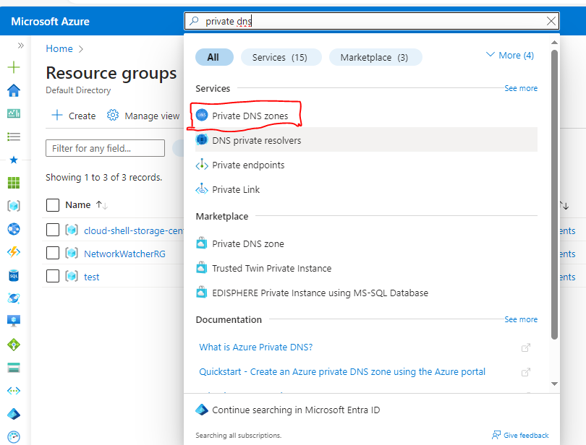

When the new DNS zone is deployed, you can manually create resource records, or use auto-registration, which will create resource records based on the Azure resource name.

Private DNS zones support the full range of records including pointers, MX, SOA, service, and text records.

## Link VNets to private DNS zones

In Azure, a VNet represents a group of 1 or more subnets, as defined by a CIDR range. Resources such as VMs are added to subnets.

At the VNet level, default DNS configuration is part of the DHCP assignments made by Azure, specifying the special address 168.63.129.16 to use Azure DNS services.

If necessary, you can override the default configuration by configuring an alternate DNS server at the VM NIC.

Two ways to link VNets to a private zone:

* **Registration:** Each VNet can link to one private DNS zone for registration. However, up to 100 VNets can link to the same private DNS zone for registration.
* **Resolution:** There may be many other private DNS zones for different namespaces. You can link a VNet to each of those zones for name resolution. Each VNet can link to up to 1000 private DNS Zones for name resolution.

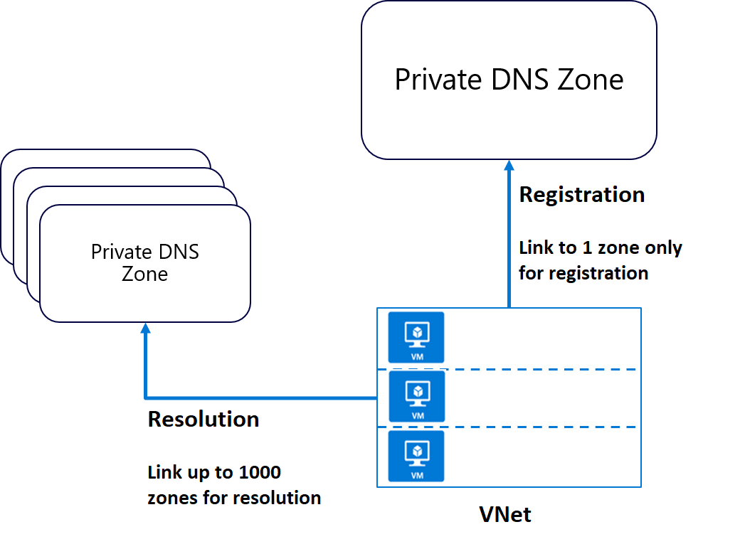

## Integrating on-premises DNS with Azure VNets

If you have an external DNS server, for example an on-premises server, you can use custom DNS configuration on your VNet to integrate the two.

Your external DNS can run on any DNS server: BIND on UNIX, Active Directory Domain Services DNS, and so on. If you want to use an external DNS server and not the default Azure DNS service, you must configure the desired DNS servers.

Organizations often use an internal Azure private DNS zone for auto registration, and then use a custom configuration to forward queries external zones from an external DNS server.

Forwarding takes two forms:

* Forwarding - specifies another DNS server (SOA for a zone) to resolve the query if the initial server cannot.
* Conditional forwarding - specifies a DNS server for a named zone, so that all queries for that zone are routed to the specified DNS server.

Note:

If the DNS server is outside Azure, it doesn't have access to Azure DNS on 168.63.129.16. In this scenario, setup a DNS resolver inside your VNet, forward queries for to it, and then have it forward queries to 168.63.129.16 (Azure DNS). Essentially, you're using forwarding because 168.63.129.16 is not routable, and therefore not accessible to external clients.

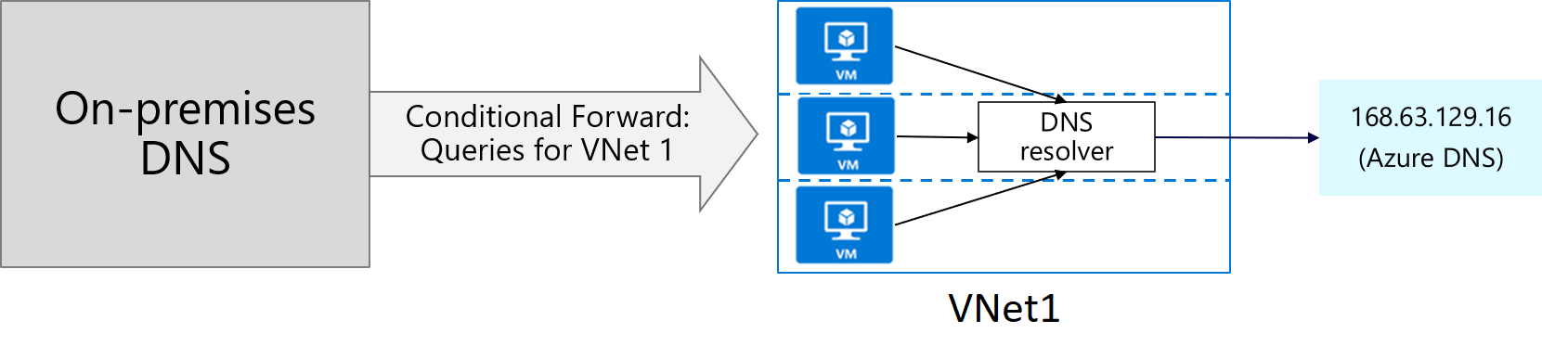

# **Enable cross-virtual network connectivity with peering**

Organizations with large scale operations will often need to create connections between different parts of their virtual network infrastructure. Virtual network peering enables you to seamlessly connect separate VNets with optimal network performance, whether they are in the same Azure region (VNet peering) or in different regions (Global VNet peering). Network traffic between peered virtual networks is private. The virtual networks appear as one for connectivity purposes. The traffic between virtual machines in peered virtual networks uses the Microsoft backbone infrastructure, and no public Internet, gateways, or encryption is required in the communication between the virtual networks.

Virtual network peering enables you to seamlessly connect two Azure virtual networks. Once peered, the virtual networks appear as one, for connectivity purposes. There are two types of VNet peering.

* **Regional VNet peering** connects Azure virtual networks in the same region.
* **Global VNet peering** connects Azure virtual networks in different regions. When creating a global peering, the peered virtual networks can exist in any Azure public cloud region or China cloud regions, but not in Government cloud regions. You can only peer virtual networks in the same region in Azure Government cloud regions.

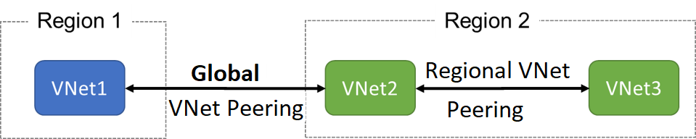

The benefits of using virtual network peering, whether local or global, include:

* A low-latency, high-bandwidth connection between resources in different virtual networks.
* The ability to apply network security groups in either virtual network to block access to other virtual networks or subnets.
* The ability to transfer data between virtual networks across Azure subscriptions, Microsoft Entra tenants, deployment models, and Azure regions.
* The ability to peer virtual networks created through the Azure Resource Manager.
* The ability to peer a virtual network created through Resource Manager to one created through the classic deployment model.
* No downtime to resources in either virtual network is required when creating the peering, or after the peering is created.

The following diagram shows a scenario where resources on the Contoso VNet and resources on the Fabrikam VNet need to communicate. The Contoso subscription in the US West region, is connected to the Fabrikam subscription in the US East region.

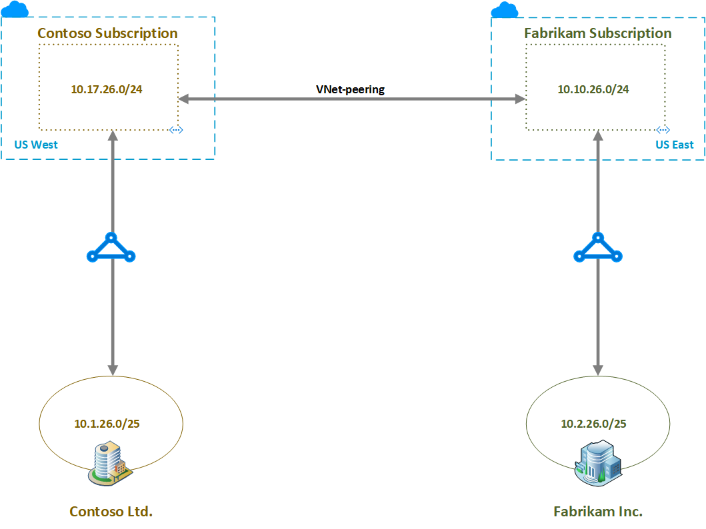

The routing tables show the routes known to the resources in each subscription. The following routing table shows the routes known to Contoso, with the final entry being the Global VNet peering entry to the Fabrikam 10.10.26.0/24 subnet.

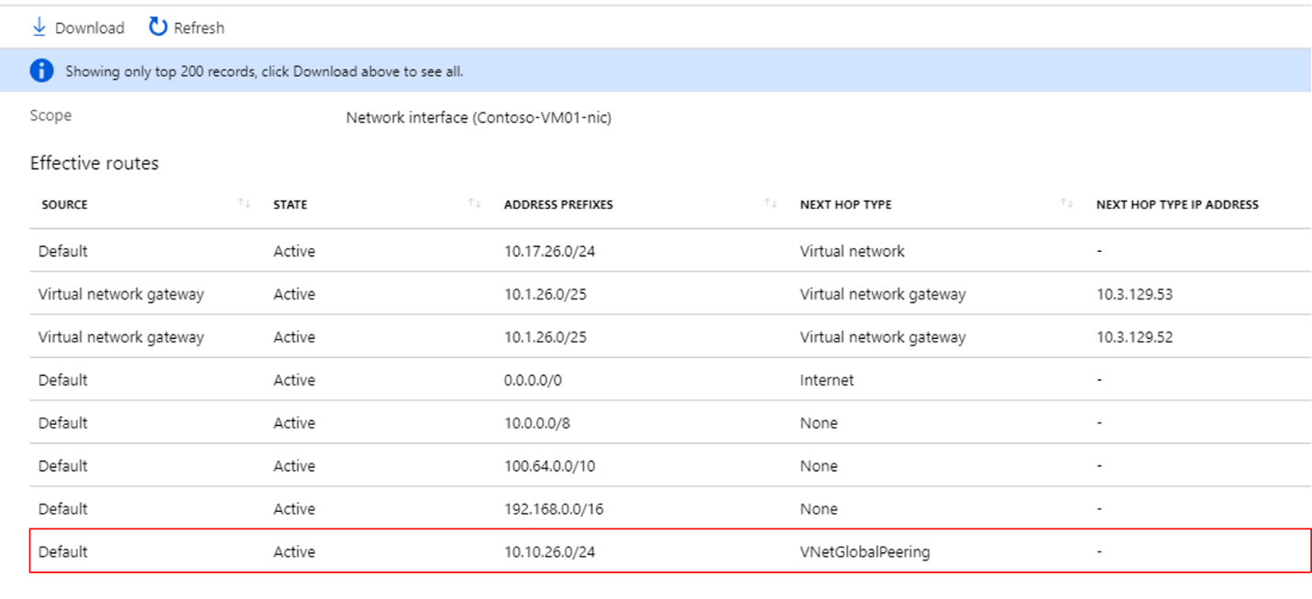

The following routing table shows the routes known to Fabrikam. Again, the final entry is the Global Vet peering entry, this time to the Contoso 10.17.26.0/24 subnet.

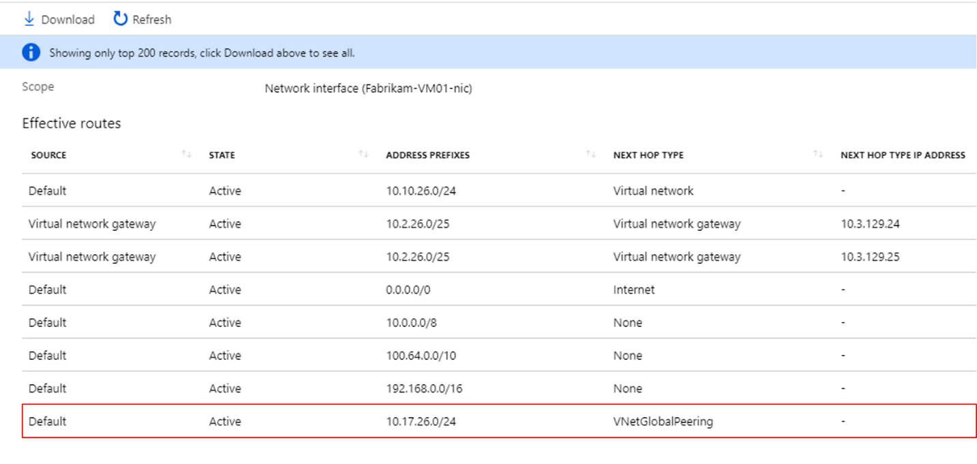

## Configure VNet Peering

Here are the steps to configure VNet peering. Notice you will need two virtual networks. To test the peering, you will need a virtual machine in each network. Initially, the VMs will not be able to communicate, but after configuration the communication will work. The step that is new is configuring the peering of the virtual networks.

1. Create two virtual networks.
2. **Peer the virtual networks**.
3. Create virtual machines in each virtual network.
4. Test the communication between the virtual machines.

To configure the peering use the **Add peering** page. There are only a few optional configuration parameters to consider.

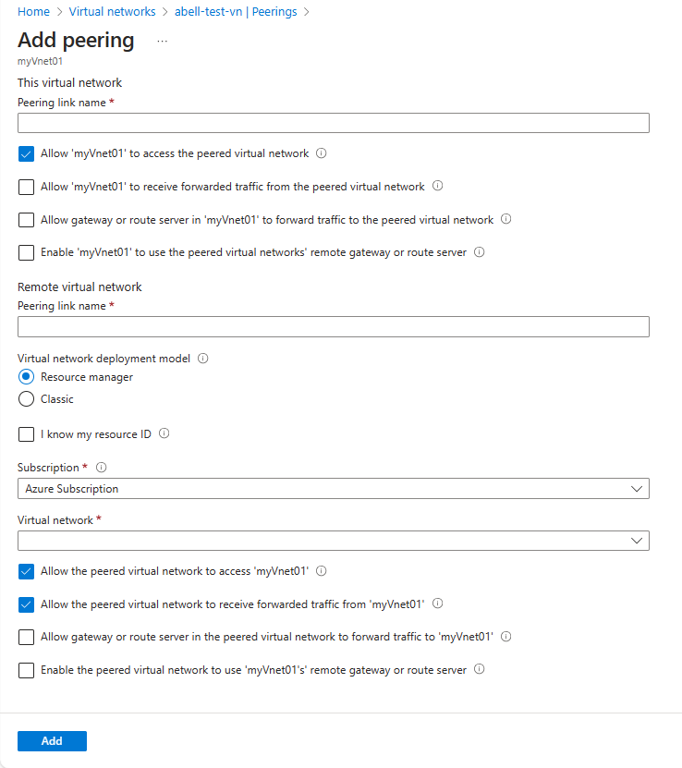

[AZ-700 Lab Simulation - Connect two Azure virtual networks using global virtual network peering (cloudguides.com)](https://mslabs.cloudguides.com/guides/AZ-700%20Lab%20Simulation%20-%20Connect%20two%20Azure%20virtual%20networks%20using%20global%20virtual%20network%20peering)

# **Implement virtual network traffic routing**

Azure automatically creates a route table for each subnet within an Azure virtual network and adds system default routes to the table. You can override some of Azure's system routes with [custom routes](https://learn.microsoft.com/en-us/azure/virtual-network/virtual-networks-udr-overview), and add additional custom routes to route tables. Azure routes outbound traffic from a subnet based on the routes in a subnet's route table.

## System routes

Azure automatically creates system routes and assigns the routes to each subnet in a virtual network. You can't create or remove system routes, but you can override some system routes with custom routes. Azure creates default system routes for each subnet, and adds additional optional default routes to specific subnets, or every subnet, when you use specific Azure capabilities.

### Default routes

Each route contains an address prefix and next hop type. When traffic leaving a subnet is sent to an IP address within the address prefix of a route, the route that contains the prefix is the route Azure uses. Whenever a virtual network is created, Azure automatically creates the following default system routes for each subnet within the virtual network:

|  |  |  |
| --- | --- | --- |
| **Source** | **Address prefixes** | **Next hop type** |
| Default | Unique to the virtual network | Virtual network |
| Default | 0.0.0.0/0 | Internet |
| Default | 10.0.0.0/8 | None |
| Default | 192.168.0.0/16 | None |
| Default | 100.64.0.0/10 | None |

In routing terms, a hop is a waypoint on the overall route. Therefore, the next hop is the next waypoint that the traffic is directed to on its journey to its ultimate destination. The next hop types listed in the previous table represent how Azure routes traffic destined for the address prefix listed. The next hop types are defined as follows:

* **Virtual network:** Routes traffic between address ranges within the address space of a virtual network. Azure creates a route with an address prefix that corresponds to each address range defined within the address space of a virtual network. Azure automatically routes traffic between subnets using the routes created for each address range.
* **Internet:** Routes traffic specified by the address prefix to the Internet. The system default route specifies the 0.0.0.0/0 address prefix. Azure routes traffic for any address not specified by an address range within a virtual network to the Internet, unless the destination address is for an Azure service. Azure routes any traffic destined for its service directly to the service over the backbone network, rather than routing the traffic to the Internet. You can override Azure's default system route for the 0.0.0.0/0 address prefix with a custom route.
* **None:** Traffic routed to the None next hop type is dropped, rather than routed outside the subnet. Azure automatically creates default routes for the following address prefixes:
  + 10.0.0.0/8, 172.16.0.0/12 and 192.168.0.0/16: Reserved for private use in RFC 1918.
  + 100.64.0.0/10: Reserved in RFC 6598.

If you assign any of the previous address ranges within the address space of a virtual network, Azure automatically changes the next hop type for the route from None to Virtual network. If you assign an address range to the address space of a virtual network that includes, but isn't the same as, one of the four reserved address prefixes, Azure removes the route for the prefix and adds a route for the address prefix you added, with Virtual network as the next hop type.

### **Optional default routes**

Azure adds default system routes for any Azure capabilities that you enable. Depending on the capability, Azure adds optional default routes to either specific subnets within the virtual network, or to all subnets within a virtual network. The additional system routes and next hop types that Azure may add when you enable different capabilities are:

|  |  |  |  |
| --- | --- | --- | --- |
| **Source** | **Address prefixes** | **Next hop type** | **Subnet within virtual network that route is added to** |
| Default | Unique to the virtual network, for example: 10.1.0.0/16 | VNet peering | All |
| Virtual network gateway | Prefixes advertised from on-premises via BGP, or configured in the local network gateway | Virtual network gateway | All |
| Default | Multiple | VirtualNetworkServiceEndpoint | Only the subnet a service endpoint is enabled for |

* **Virtual network (VNet) peering**: When you create a virtual network peering between two virtual networks, a route is added for each address range within the address space of each virtual network.
* **Virtual network gateway:** When you add a virtual network gateway to a virtual network, Azure adds one or more routes with Virtual network gateway as the next hop type. The source is listed as virtual network gateway because the gateway adds the routes to the subnet.
* If your on-premises network gateway exchanges border gateway protocol ([BGP](https://learn.microsoft.com/en-us/azure/virtual-network/virtual-networks-udr-overview)) routes with an Azure virtual network gateway, a route is added for each route propagated from the on-premises network gateway. There are limits to the number of routes you can propagate to an Azure virtual network gateway, so you should summarize on-premises routes to the largest address ranges possible. For more information on the number of routes you can propagate, see [Networking limits](https://learn.microsoft.com/en-us/azure/azure-resource-manager/management/azure-subscription-service-limits?toc=/azure/virtual-network/toc.json).

**VirtualNetworkServiceEndpoint:** Azure adds the public IP addresses for certain services to the route table when you enable a service endpoint to the service. Service endpoints are enabled for individual subnets within a virtual network, so the route is only added to the route table of a subnet a service endpoint is enabled for. The public IP addresses of Azure services change periodically, and Azure manages the updates to the routing tables when necessary.

The **VNet peering** and **VirtualNetworkServiceEndpoint** next hop types are only added to route tables of subnets within virtual networks created through the Azure Resource Manager deployment model. The next hop types are not added to route tables that are associated to virtual network subnets created through the classic deployment model.

## Custom routes

To control the way network traffic is routed more precisely, you can override the default routes that Azure creates by using your own user-defined routes (UDR). This technique can be useful when you want to ensure that traffic between two subnets passes through a firewall appliance, or if you want to ensure that no traffic from a VNet could be routed to the internet.

### User-defined routes

You can create custom, or user-defined(static), routes in Azure to override Azure's default system routes, or to add additional routes to a subnet's route table.

In Azure, each subnet can have zero or one associated route table. When you create a route table and associate it to a subnet, the routes within it are combined with, or override, the default routes Azure adds to a subnet.

You can specify the following next hop types when creating a user-defined route:

**Virtual appliance:** A virtual appliance is a virtual machine that typically runs a network application, such as a firewall. When you create a route with the virtual appliance hop type, you also specify a next hop IP address. The IP address can be:

* The private IP address of a network interface attached to a virtual machine.
* The private IP address of an Azure internal load balancer.

**Virtual network gateway**: Specify when you want traffic destined for specific address prefixes routed to a virtual network gateway. The virtual network gateway must be created with type **VPN**.

**None**: Specify when you want to drop traffic to an address prefix, rather than forwarding the traffic to a destination.

**Virtual network**: Specify when you want to override the default routing within a virtual network.

**Internet:** Specify when you want to explicitly route traffic destined to an address prefix to the Internet, or if you want traffic destined for Azure services with public IP addresses kept within the Azure backbone network.

# Configure User-defined routes

Here is an example where you have a virtual network that includes three subnets.

* The subnets are Frontend, DMZ, and Backend. In the DMZ subnet, there is a network virtual appliance (NVA). NVAs are VMs that help with network functions like routing and firewall optimization.
* You want to ensure all traffic from the Frontend subnet goes through the NVA to the Backend subnet.

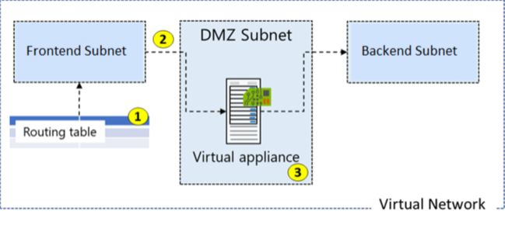

## Create a Routing Table

Creating a routing table is straightforward. You provide **Name**, **Subscription**, **Resource Group**, and **Location**. You also decide to use **Virtual network gateway route propagation**.

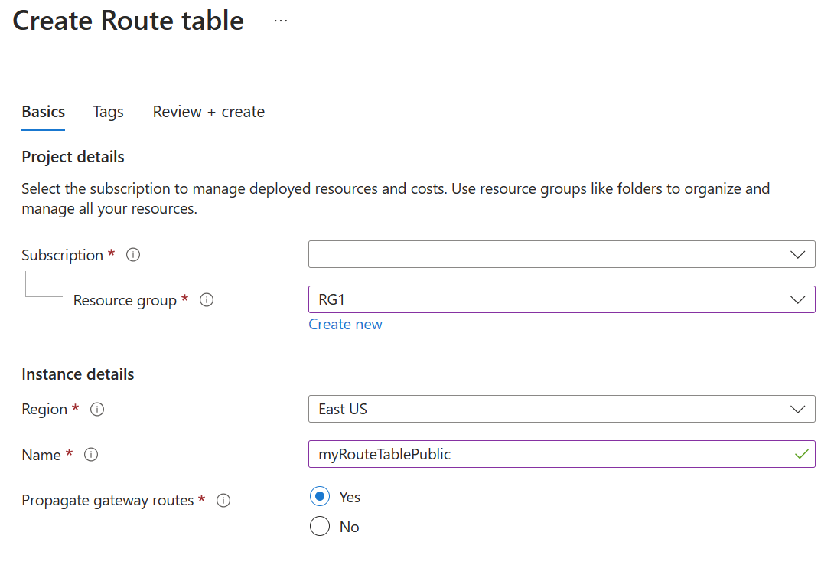

Routes are automatically added to the route table for all subnets with Virtual network gateway propagation enabled. When you are using ExpressRoute, propagation ensures all subnets get the routing information.

## Create a Custom Route

* The new route is named *ToPrivateSubnet*.
* The Private subnet is at 10.0.1.0/24.
* The route uses a virtual appliance. Notice the other choices for *Next hop type*: virtual network gateway, virtual network, internet, and none.
* The virtual appliance is at 10.0.2.4.

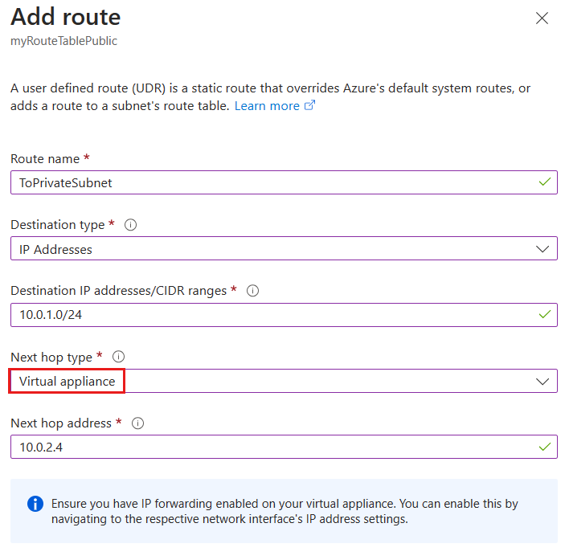

This route applies to any address prefixes in 10.0.1.0/24 (private subnet). Traffic headed to these addresses will be sent to the virtual appliance with a 10.0.2.4 address.

## Associate the Route Table

The last step in our example is to associate the Public subnet with the new routing table. Each subnet can have zero or one route table associated to it.

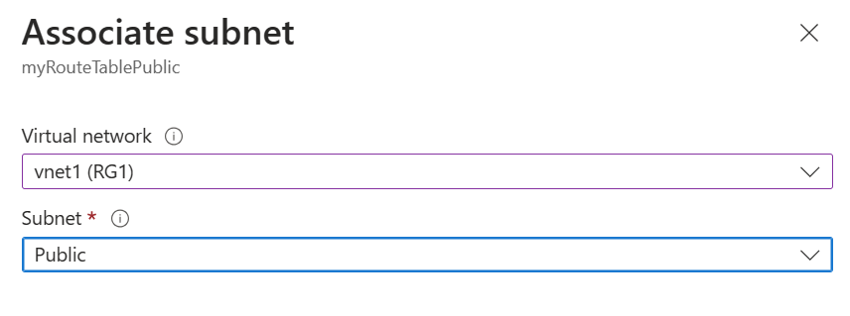

# **Secure a VNet by using forced tunneling**

Forced tunneling lets you redirect or "force" all Internet-bound traffic back to your on-premises location via a Site-to-Site VPN tunnel for inspection and auditing. This is a critical security requirement for most enterprise IT policies. If you don't configure forced tunneling, Internet-bound traffic from your VMs in Azure always traverses from the Azure network infrastructure directly out to the Internet, without the option to allow you to inspect or audit the traffic. Unauthorized Internet access can potentially lead to information disclosure or other types of security breaches. Forced tunneling can be configured by using Azure PowerShell. It can't be configured using the Azure portal.

The Frontend subnet is not force tunneled. The workloads in the Frontend subnet can continue to accept and respond to customer requests from the Internet directly. The Mid-tier and Backend subnets are forced tunneled. Any outbound connections from these two subnets to the Internet will be forced or redirected back to an on-premises site via one of the Site-to-site (S2S) VPN tunnels.

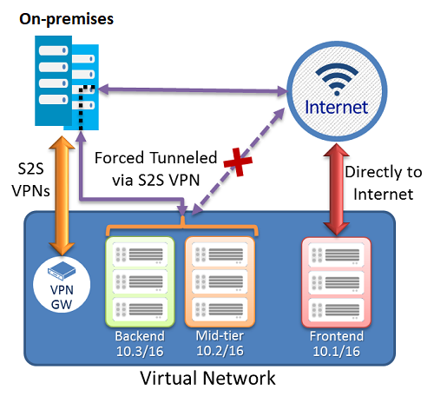

## Configure forced tunneling

Forced tunneling in Azure is configured using virtual network custom user-defined routes.

* Each virtual network subnet has a built-in, system routing table. The system routing table has the following three groups of routes:
  + Local VNet routes: Route directly to the destination VMs in the same virtual network.
  + On-premises routes: Route to the Azure VPN gateway.
  + Default route: Route directly to the Internet. Packets destined to the private IP addresses not covered by the previous two routes are dropped.
* To configure forced tunneling, you must:
  + Create a routing table.
  + Add a user-defined default route to the VPN Gateway.
  + Associate the routing table to the appropriate VNet subnet(s).
* Forced tunneling must be associated with a VNet that has a route-based VPN gateway.
  + You must set a default site connection among the cross-premises local sites connected to the virtual network.
  + The on-premises VPN device must be configured using 0.0.0.0/0 as traffic selectors.

Using forced tunneling allows you to restrict and inspect Internet access from your VMs and cloud services in Azure, while continuing to enable your multi-tier service architecture the Internet access it requires.

## Configure Azure Route Server

Azure Route Server simplifies dynamic routing between your network virtual appliance (NVA) and your virtual network. It allows you to exchange routing information directly through Border Gateway Protocol (BGP) routing protocol between any NVA that supports the BGP routing protocol and the Azure Software Defined Network (SDN) in the Azure Virtual Network (VNET) without the need to manually configure or maintain route tables. Azure Route Server is a fully managed service and is configured with high availability.

# **Configure internet access with Azure Virtual NAT**

Network Address Translation (NAT) services provide mappings for a single IP address, a range of IP addresses defined by an IP Prefix, and a range of ports associated with an IP address. NAT is compatible with standard SKU public IP address resources or public IP prefix resources or a combination of both. You can use a public IP prefix directly or distribute the public IP addresses of the prefix across multiple NAT gateway resources. NAT will map all traffic to the range of IP addresses of the prefix. NAT allows flows to be created from the virtual network to the Internet. Return traffic from the Internet is only allowed in response to an active flow.

The following diagram shows outbound traffic flow from Subnet 1 through the NAT gateway to be mapped to a Public IP address or a Public IP prefix.

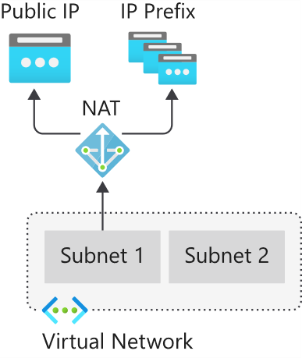

## How to deploy NAT

Configuring and using NAT gateway is a straightforward process:

**NAT gateway resource:**

1. Create regional or zonal (zone-isolated) NAT gateway resource,
2. Assign IP addresses,
3. If necessary, modify TCP idle timeout (optional).

**Virtual network:**

* Configure virtual network subnet to use a NAT gateway.
* User-defined routes are not necessary.

## Coexistence of inbound and outbound

NAT is compatible with the following standard SKU resources:

* Load balancer
* Public IP address
* Public IP prefix

NAT and compatible Standard SKU features are aware of the direction the flow was started. Inbound and outbound scenarios can coexist. These scenarios will receive the correct network address translations because these features are aware of the flow direction. When used together with NAT, these resources provide inbound Internet connectivity to your subnet(s).

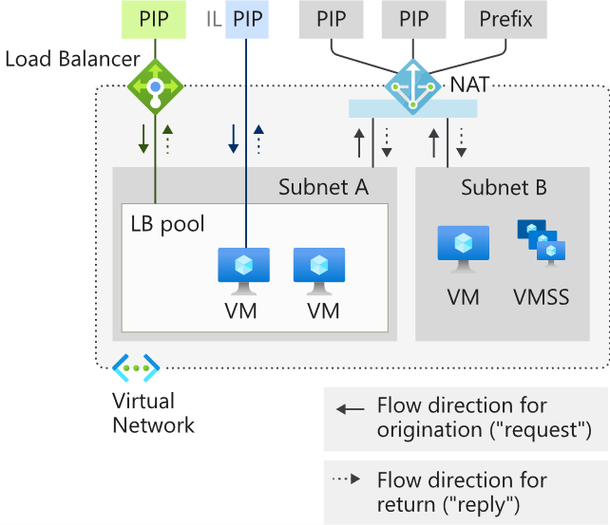

## Limitations of NAT

* NAT is compatible with standard SKU public IP, public IP prefix, and load balancer resources. Basic resources and any products derived from them aren't compatible with NAT. Basic resources must be placed on a subnet not configured with NAT.
* IPv4 address family is supported. NAT doesn't interact with IPv6 address family. NAT can't be deployed on a subnet with an IPv6 prefix.
* NAT can't span multiple virtual networks.
* IP fragmentation isn't supported.

# Module 2: Design and implement hybrid networking

# Design and implement Azure VPN Gateway

A virtual private network (VPN) provides a secure encrypted connection across another network. VPNs typically are deployed to connect two or more trusted private networks to one another over an untrusted network such as the internet. Traffic is encrypted while traveling over the untrusted network to prevent a third party from eavesdropping on the network communication.

One option for connecting an on-premises network to an Azure Virtual Network is a VPN connection.

# Azure VPN Gateways

An Azure VPN gateway is a specific type of virtual network gateway used to send and receive encrypted traffic between an Azure virtual network and an on-premises location over the public Internet. Azure VPN gateways can also be used to connect separate Azure virtual networks using an encrypted tunnel across the Microsoft network backbone.

**Note:**

A virtual network gateway is composed of two or more special VMs that are deployed to a specific subnet called the gateway subnet. Virtual network gateway VMs host routing tables and run specific gateway services. These VMs that constitute the gateway are created when you create the virtual network gateway and are managed automatically by Azure and do not require administrative attention.

# Plan a VPN gateway

When you're planning a VPN gateway, there are three architectures to consider:

* Point to site over the internet
* Site to site over the internet
* Site to site over a dedicated network, such as Azure ExpressRoute.

## Planning factors

Factors that you need to cover during your planning process include:

* Throughput - Mbps or Gbps
* Backbone - Internet or private?
* Availability of a public (static) IP address
* VPN device compatibility
* Multiple client connections or a site-to-site link?
* VPN gateway type
* Azure VPN Gateway SKU

# VPN Gateway types

The VPN type that you choose depends on the connection topology that you want to create. For example, a P2S connection requires a RouteBased VPN type. A VPN type can also depend on the hardware that you are using. S2S configurations require a VPN device. Some VPN devices only support a certain VPN type.

The VPN type you select must satisfy all the connection requirements for the solution you want to create. For example, if you want to create a S2S VPN gateway connection and a P2S VPN gateway connection for the same virtual network, use VPN type RouteBased because P2S requires a RouteBased VPN type. You would also need to verify that your VPN device supported a RouteBased VPN connection.

Once a virtual network gateway has been created, you can't change the VPN type. You must delete the virtual network gateway and create a new one. There are two VPN types:

## PolicyBased

PolicyBased VPNs were previously called static routing gateways in the classic deployment model. Policy-based VPNs encrypt and direct packets through IPsec tunnels based on the IPsec policies configured with the combinations of address prefixes between your on-premises network and the Azure VNet. The policy (or traffic selector) is usually defined as an access list in the VPN device configuration. The value for a PolicyBased VPN type is PolicyBased. When using a PolicyBased VPN, keep in mind the following limitations:

Policy based VPNs which support IKEv1 protocols can be used with Basic Gateway SKUs only.

You can have only 1 tunnel when using a PolicyBased VPN.

You can only use PolicyBased VPNs for S2S connections, and only for certain configurations. Most VPN Gateway configurations require a RouteBased VPN.

## RouteBased

RouteBased VPNs were previously called dynamic routing gateways in the classic deployment model. RouteBased VPNs use "routes" in the IP forwarding or routing table to direct packets into their corresponding tunnel interfaces. The tunnel interfaces then encrypt or decrypt the packets in and out of the tunnels. The policy (or traffic selector) for RouteBased VPNs are configured as any-to-any (or wild cards). The value for a RouteBased VPN type is RouteBased.

# VPN Gateway configuration requirements

The following table lists the requirements for PolicyBased and RouteBased VPN gateways. This table applies to both the Resource Manager and classic deployment models.

|  |  |  |  |  |
| --- | --- | --- | --- | --- |
| **Features** | **PolicyBased Basic VPN Gateway** | **RouteBased Basic VPN Gateway** | **RouteBased Standard VPN Gateway** | **RouteBased High Performance VPN Gateway** |
| Site-to-Site connectivity (S2S) | PolicyBased VPN configuration | RouteBased VPN configuration | RouteBased VPN configuration | RouteBased VPN configuration |
| Point-to-Site connectivity (P2S) | Not supported | Supported (Can coexist with S2S) | Supported (Can coexist with S2S) | Supported (Can coexist with S2S) |
| Authentication method | Pre-shared key | Pre-shared key for S2S connectivity, Certificates for P2S connectivity | Pre-shared key for S2S connectivity, Certificates for P2S connectivity | Pre-shared key for S2S connectivity, Certificates for P2S connectivity |
| Maximum number of S2S connections | 1 | 10 | 10 | 30 |
| Maximum number of P2S connections | Not supported | 128 | 128 | 128 |
| Active routing support (BGP) (*) | Not supported | Not supported | Supported | Supported |

## Create the VPN Gateway

The VPN gateway settings that you chose are critical to creating a successful connection.

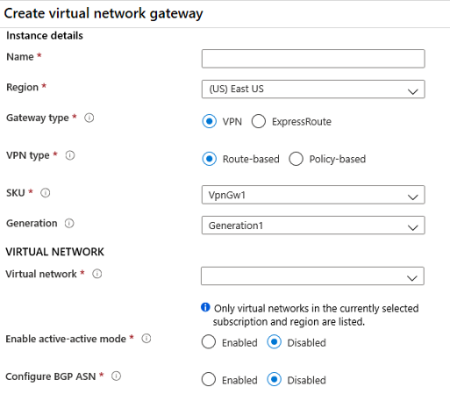

* Gateway type. VPN or ExpressRoute.
* VPN Type. Route based or Policy based. Most VPN types are Route-based. The type of VPN you choose depends on the make and model of your VPN device, and the kind of VPN connection you intend to create. Typical route-based gateway scenarios include point-to-site, inter-virtual network, or multiple site-to-site connections. Route-based is also selected when you coexist with an ExpressRoute gateway or if you need to use IKEv2. Policy-based gateways support only IKEv1.
* SKU. Use the drop-down to select a gateway SKU. Your choice will affect the number of tunnels you can have and the aggregate throughput benchmark. The benchmark is based on measurements of multiple tunnels aggregated through a single gateway. It is not a guaranteed throughput due to Internet traffic conditions and your application behaviors.
* Generation. Generation1 or Generation2. You cannot change generations or SKUs across generations. Basic and VpnGw1 SKUs are only supported in Generation1. VpnGw4 and VpnGw5 SKUs are only supported in Generation2.
* Virtual Networks. The virtual network can send and receive traffic through the virtual network gateway. A virtual network cannot be associated with more than one gateway.

**Note**

You can view the IP address assigned to the gateway. The gateway should appear as a connected device.

## Gateway subnet

VPN Gateways require a gateway subnet. You can create a Gateway subnet before you create a VPN gateway, or you can create it during the creation of the VPN Gateway. The gateway subnet contains the IP addresses that the virtual network gateway VMs and services use. When you create your virtual network gateway, gateway VMs are deployed to the gateway subnet and configured with the required VPN gateway settings.

When you create the gateway subnet, you specify the number of IP addresses that the subnet contains. The IP addresses in the gateway subnet are allocated to the gateway VMs and gateway services. Some configurations require more IP addresses than others.

## Create the Local Network Gateway

The local network gateway typically refers to the on-premises location. You give the site a name by which Azure can refer to it, then specify the IP address or FQDN of the on-premises VPN device for the connection. You also specify the IP address prefixes that will be routed through the VPN gateway to the VPN device. The address prefixes you specify are the prefixes located in the on-premises network.

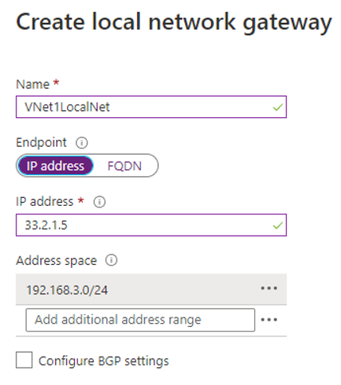

**IP Address.** The public IP address of the local gateway.

**Address Space.** One or more IP address ranges (in CIDR notation) that define your local network's address space. If you plan to use this local network gateway in a BGP-enabled connection, then the minimum prefix you need to declare is the host address of your BGP Peer IP address on your VPN device.

## Configure the on-premises VPN device

To configure your VPN device, you will need:

**A shared key**. The same shared key that you specify when creating the VPN connection.

**The public IP address of your VPN gateway**. The IP address can be new or existing.

## Create the VPN Connection

Once your VPN gateways are created, you can create the connection between them. If your VNets are in the same subscription, you can use the portal.

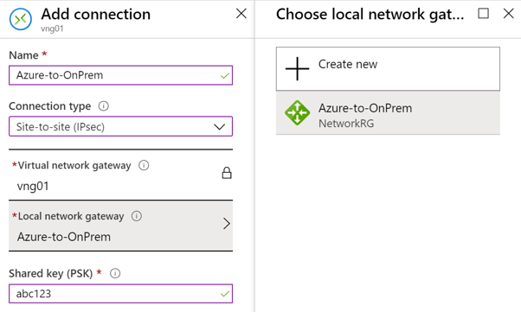

**Name**. Enter a name for your connection.

**Connection type**. Select Site-to-Site (IPSec) from the drop-down.

**Shared key (PSK)**. In this field, enter a shared key for your connection. You can generate or create this key yourself. In a site-to-site connection, the key you use is the same for your on-premises device and your virtual network gateway connection.

## Verify the VPN Connection

After you have configured all the Site-to-Site components, it is time to verify that everything is working. You can verify the connections either in the portal, or by using PowerShell.

# High availability options for VPN connections

To provide better availability for your VPN connections, there are a few options available:

* VPN Gateway redundancy (Active-standby)
* Multiple on-premises VPN devices
* Active-active Azure VPN gateway
* Combination of both

## VPN Gateway redundancy

Every Azure VPN gateway consists of two instances in an active-standby configuration. For any planned maintenance or unplanned disruption that happens to the active instance, the standby instance would take over (failover) automatically and resume the S2S VPN or VNet-to-VNet connections. The switch over will cause a brief interruption. For planned maintenance, the connectivity should be restored within 10 to 15 seconds. For unplanned issues, the connection recovery will be longer, about 1 to 3 minutes in the worst case. For P2S VPN client connections to the gateway, the P2S connections will be disconnected, and the users will need to reconnect from the client machines.

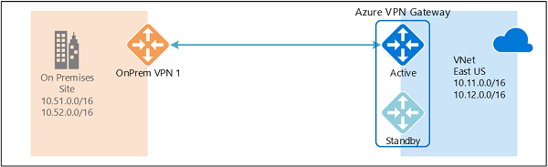

## Multiple on-premises VPN devices

You can use multiple VPN devices from your on-premises network to connect to your Azure VPN gateway, as shown in the following diagram:

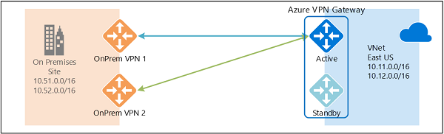

This configuration provides multiple active tunnels from the same Azure VPN gateway to your on-premises devices in the same location. There are some requirements and constraints:

1. You need to create multiple S2S VPN connections from your VPN devices to Azure. When you connect multiple VPN devices from the same on-premises network to Azure, you need to create one local network gateway for each VPN device, and one connection from your Azure VPN gateway to each local network gateway.
2. The local network gateways corresponding to your VPN devices must have unique public IP addresses in the GatewayIpAddress property.
3. BGP is required for this configuration. Each local network gateway representing a VPN device must have a unique BGP peer IP address specified in the BgpPeerIpAddress property.
4. You should use BGP to advertise the same prefixes of the same on-premises network prefixes to your Azure VPN gateway, and the traffic will be forwarded through these tunnels simultaneously.
5. You must use Equal-cost multi-path routing (ECMP).
6. Each connection is counted against the maximum number of tunnels for your Azure VPN gateway, 10 for Basic and Standard SKUs, and 30 for HighPerformance SKU.

## Active-active VPN gateways

You can create an Azure VPN gateway in an active-active configuration, where both instances of the gateway VMs will establish S2S VPN tunnels to your on-premises VPN device, as shown the following diagram:

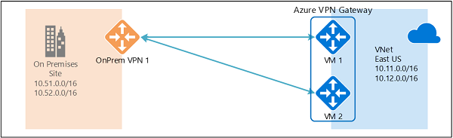

# High availability options for VPN connections

To provide better availability for your VPN connections, there are a few options available:

* VPN Gateway redundancy (Active-standby)
* Multiple on-premises VPN devices
* Active-active Azure VPN gateway
* Combination of both

## VPN Gateway redundancy

Every Azure VPN gateway consists of two instances in an active-standby configuration. For any planned maintenance or unplanned disruption that happens to the active instance, the standby instance would take over (failover) automatically and resume the S2S VPN or VNet-to-VNet connections. The switch over will cause a brief interruption. For planned maintenance, the connectivity should be restored within 10 to 15 seconds. For unplanned issues, the connection recovery will be longer, about 1 to 3 minutes in the worst case. For P2S VPN client connections to the gateway, the P2S connections will be disconnected, and the users will need to reconnect from the client machines.

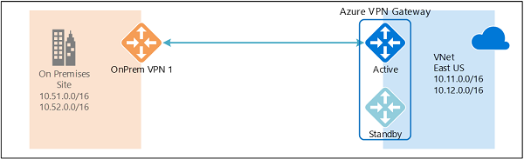

## Multiple on-premises VPN devices

You can use multiple VPN devices from your on-premises network to connect to your Azure VPN gateway, as shown in the following diagram:

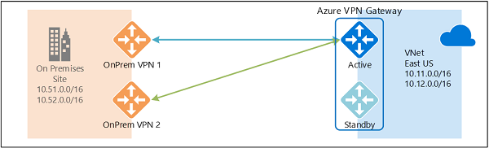

This configuration provides multiple active tunnels from the same Azure VPN gateway to your on-premises devices in the same location. There are some requirements and constraints:

1. You need to create multiple S2S VPN connections from your VPN devices to Azure. When you connect multiple VPN devices from the same on-premises network to Azure, you need to create one local network gateway for each VPN device, and one connection from your Azure VPN gateway to each local network gateway.
2. The local network gateways corresponding to your VPN devices must have unique public IP addresses in the GatewayIpAddress property.
3. BGP is required for this configuration. Each local network gateway representing a VPN device must have a unique BGP peer IP address specified in the BgpPeerIpAddress property.
4. You should use BGP to advertise the same prefixes of the same on-premises network prefixes to your Azure VPN gateway, and the traffic will be forwarded through these tunnels simultaneously.
5. You must use Equal-cost multi-path routing (ECMP).
6. Each connection is counted against the maximum number of tunnels for your Azure VPN gateway, 10 for Basic and Standard SKUs, and 30 for HighPerformance SKU.

In this configuration, the Azure VPN gateway is still in active-standby mode, so the same failover behavior and brief interruption will still happen as described above. But this setup guards against failures or interruptions on your on-premises network and VPN devices.

## Active-active VPN gateways

You can create an Azure VPN gateway in an active-active configuration, where both instances of the gateway VMs will establish S2S VPN tunnels to your on-premises VPN device, as shown the following diagram:

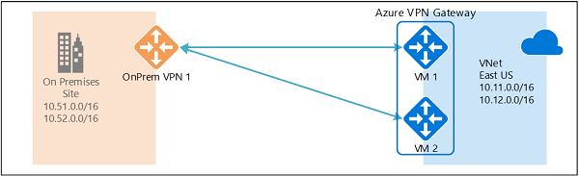

In this configuration, each Azure gateway instance will have a unique public IP address, and each will establish an IPsec/IKE S2S VPN tunnel to your on-premises VPN device specified in your local network gateway and connection. Note that both VPN tunnels are part of the same connection. You will still need to configure your on-premises VPN device to accept or establish two S2S VPN tunnels to those two Azure VPN gateway public IP addresses.

Because the Azure gateway instances are in active-active configuration, the traffic from your Azure virtual network to your on-premises network will be routed through both tunnels simultaneously, even if your on-premises VPN device may favor one tunnel over the other. For a single TCP or UDP flow, Azure attempts to use the same tunnel when sending packets to your on-premises network. However, your on-premises network could use a different tunnel to send packets to Azure.

When a planned maintenance or unplanned event happens to one gateway instance, the IPsec tunnel from that instance to your on-premises VPN device will be disconnected. The corresponding routes on your VPN devices should be removed or withdrawn automatically so that the traffic will be switched over to the other active IPsec tunnel. On the Azure side, the switch over will happen automatically from the affected instance to the active instance.

## Dual-redundancy: active-active VPN gateways for both Azure and on-premises networks

The most reliable option is to combine the active-active gateways on both your network and Azure, as shown in the diagram below.

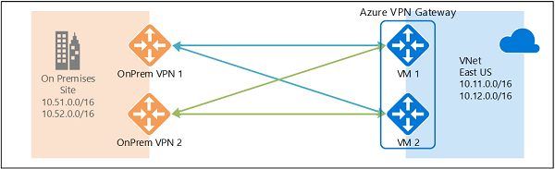

Here you create and set up the Azure VPN gateway in an active-active configuration and create two local network gateways and two connections for your two on-premises VPN devices as described above. The result is a full mesh connectivity of 4 IPsec tunnels between your Azure virtual network and your on-premises network.

All gateways and tunnels are active from the Azure side, so the traffic will be spread among all 4 tunnels simultaneously, although each TCP or UDP flow will again follow the same tunnel or path from the Azure side. Even though by spreading the traffic, you may see slightly better throughput over the IPsec tunnels, the primary goal of this configuration is for high availability. And due to the statistical nature of the spreading, it is difficult to provide the measurement on how different application traffic conditions will affect the aggregate throughput.

This topology will require two local network gateways and two connections to support the pair of on-premises VPN devices, and BGP is required to allow the two connections to the same on-premises network. These requirements are the same as the above.

# Highly Available VNet-to-VNet

The same active-active configuration can also apply to Azure VNet-to-VNet connections. You can create active-active VPN gateways for both virtual networks, and connect them together to form the same full mesh connectivity of 4 tunnels between the two VNets, as shown in the diagram below:

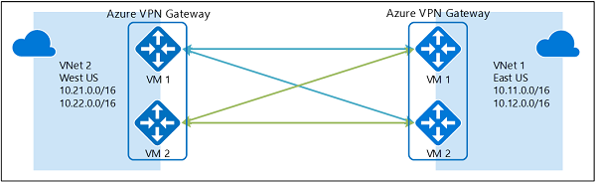

This ensures there are always a pair of tunnels between the two virtual networks for any planned maintenance events, providing even better availability. Even though the same topology for cross-premises connectivity requires two connections, the VNet-to-VNet topology shown above will need only one connection for each gateway. Additionally, BGP is optional unless transit routing over the VNet-to-VNet connection is required.

# Troubleshoot Azure VPN Gateway using diagnostic logs

Using diagnostic logs, you can troubleshoot multiple VPN gateway related events including configuration activity, VPN Tunnel connectivity, IPsec logging, BGP route exchanges, Point to Site advanced logging.

There are several diagnostic logs you can use to help troubleshoot a problem with your VPN Gateway.

* **GatewayDiagnosticLog** - Contains diagnostic logs for gateway configuration events, primary changes, and maintenance events.
* **TunnelDiagnosticLog** - Contains tunnel state change events. Tunnel connect/disconnect events have a summarized reason for the state change if applicable.
* **RouteDiagnosticLog** - Logs changes to static routes and BGP events that occur on the gateway.
* **IKEDiagnosticLog** - Logs IKE control messages and events on the gateway.
* **P2SDiagnosticLog** - Logs point-to-site control messages and events on the gateway.

Use Azure Monitor to analyze the data collected in the diagnostic logs.

# **Connect networks with Site-to-site VPN connections**

A site-to-site (S2S) VPN gateway connection lets you create a secure connection to your virtual network from another virtual network or a physical network. The following diagram illustrates how you would connect an on-premises network to the Azure platform. The internet connection uses an IPsec VPN tunnel.

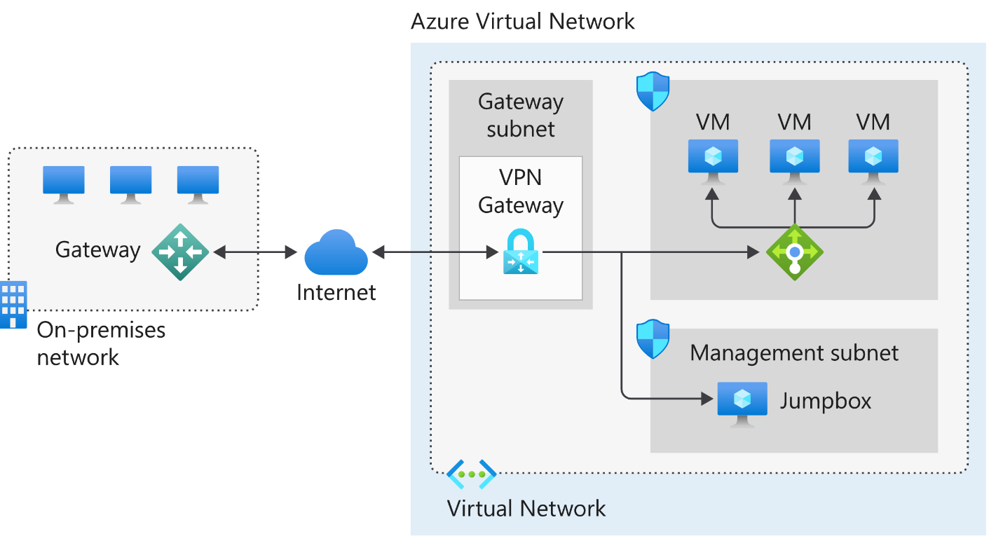

* The on-premises network represents your on-premises Active Directory and any data or resources.
* The gateway is responsible for sending encrypted traffic to a virtual IP address when it uses a public connection.
* The Azure virtual network holds all your cloud applications and any Azure VPN gateway components.
* An Azure VPN gateway provides the encrypted link between the Azure virtual network and your on-premises network. An Azure VPN gateway is made up of these elements:
  + Virtual network gateway
  + Local network gateway
  + Connection
  + Gateway subnet
* Cloud applications are the ones you've made available through Azure.
* An internal load balancer, located in the front end, routes cloud traffic to the correct cloud-based application or resource.

### Using this architecture offers several benefits, including:

* Configuration and maintenance are simplified.
* Having a VPN gateway helps ensure that all data and traffic are encrypted between the on-premises gateway and the Azure gateway.
* The architecture can be scaled and extended to meet your organization's networking needs.

This architecture isn't applicable in all situations because it uses an existing internet connection as the link between the two gateway points. Bandwidth constraints can cause latency issues that result from reuse of the existing infrastructure.

# **Connect devices to networks with Point-to-site VPN connections**

A Point-to-Site (P2S) VPN gateway connection lets you create a secure connection to your virtual network from an individual client computer. A P2S connection is established by starting it from the client computer. This solution is useful for telecommuters who want to connect to Azure VNets from a remote location, such as from home or a conference. P2S VPN is also a useful solution to use instead of S2S VPN when you have only a few clients that need to connect to a VNet.

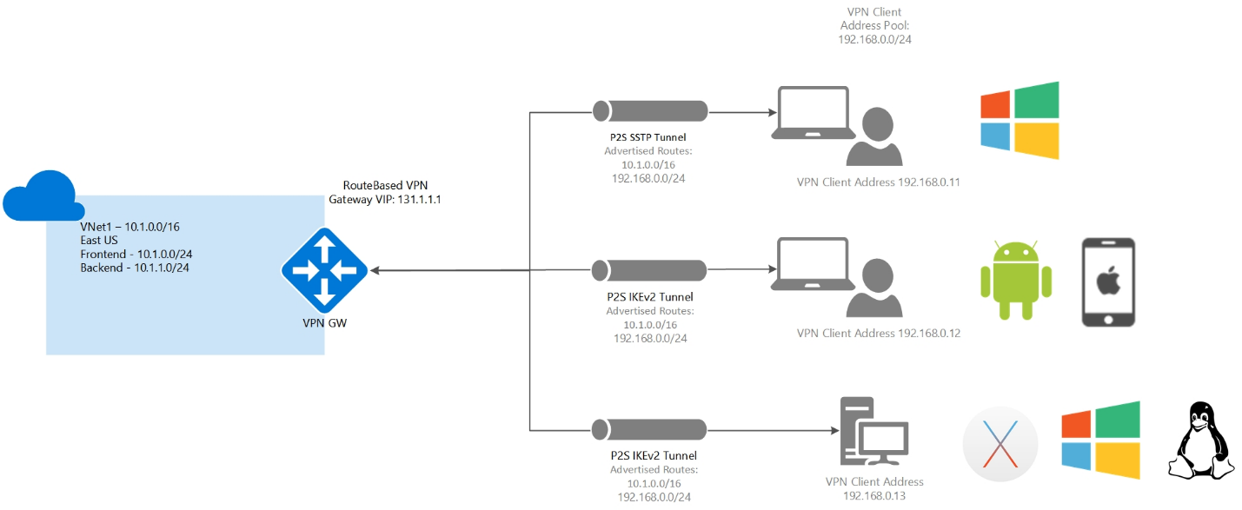

### Point-to-site protocols

Point-to-site VPN can use one of the following protocols:

* OpenVPN Protocol, an SSL/TLS based VPN protocol. A TLS VPN solution can penetrate firewalls, since most firewalls open TCP port 443 outbound, which TLS uses. OpenVPN can be used to connect from Android, iOS (versions 11.0 and above), Windows, Linux, and Mac devices (macOS versions 10.13 and above).
* Secure Socket Tunneling Protocol (SSTP), a proprietary TLS-based VPN protocol. A TLS VPN solution can penetrate firewalls, since most firewalls open TCP port 443 outbound, which TLS uses. SSTP is only supported on Windows devices. Azure supports all versions of Windows that have SSTP (Windows 7 and later).
* IKEv2 VPN, a standards-based IPsec VPN solution. IKEv2 VPN can be used to connect from Mac devices (macOS versions 10.11 and above).

## Point-to-site authentication methods

The user must be authenticated before Azure accepts a P2S VPN connection. There are two mechanisms that Azure offers to authenticate a connecting user.

### Authenticate using native Azure certificate authentication

When using the native Azure certificate authentication, a client certificate on the device is used to authenticate the connecting user. Client certificates are generated from a trusted root certificate and then installed on each client computer. You can use a root certificate that was generated using an Enterprise solution, or you can generate a self-signed certificate.

The validation of the client certificate is performed by the VPN gateway and happens during establishment of the P2S VPN connection. The root certificate is required for the validation and must be uploaded to Azure.

### Authenticate using native Microsoft Entra authentication

Microsoft Entra authentication allows users to connect to Azure using their Microsoft Entra credentials. Native Microsoft Entra authentication is only supported for OpenVPN protocol and Windows 10 and requires the use of the Azure VPN Client.

With native Microsoft Entra authentication, you can leverage Microsoft Entra Conditional Access as well as multifactor authentication (MFA) features for VPN.

At a high level, you need to perform the following steps to configure Microsoft Entra authentication:

* Configure a Microsoft Entra tenant
* Enable Microsoft Entra authentication on the gateway
* Download and configure Azure VPN Client

## Authenticate using Active Directory (AD) Domain Server

AD Domain authentication is a popular option because it allows users to connect to Azure using their organization domain credentials. It requires a RADIUS server that integrates with the AD server. Organizations can also leverage their existing RADIUS deployment.

The RADIUS server is deployed either on-premises or in your Azure VNet. During authentication, the Azure VPN Gateway passes authentication messages back and forth between the RADIUS server and the connecting device. Thus, the Gateway must be able to communicate with the RADIUS server. If the RADIUS server is present on-premises, then a VPN S2S connection from Azure to the on-premises site is required for reachability.

A RADIUS server can also integrate with other external identity systems. This opens many authentication options for P2S VPN, including multi-factor options.

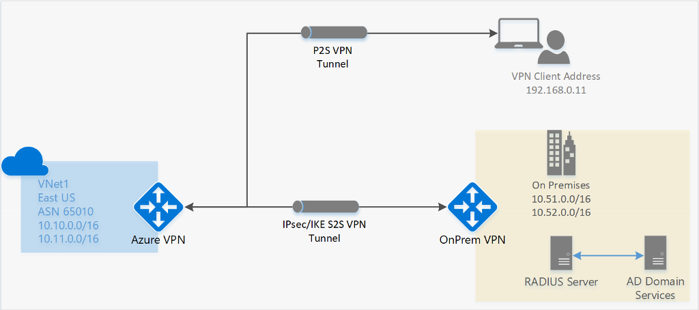

## Configure point-to-site clients

Users use the native VPN clients on Windows and Mac devices for P2S. Azure provides a VPN client configuration zip file that contains settings required by these native clients to connect to Azure.

* For Windows devices, the VPN client configuration consists of an installer package that users install on their devices.
* For Mac devices, it consists of the mobileconfig file that users install on their devices.

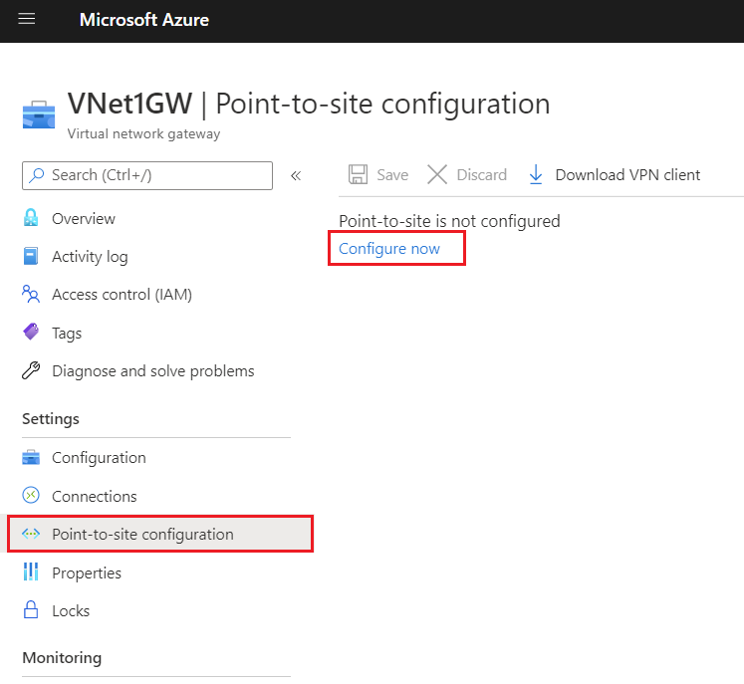

# Connect remote resources by using Azure Virtual WANs

## What is Azure Virtual WAN

Azure Virtual WAN is a networking service that brings many networking, security, and routing functionalities together to provide a single operational interface. Some of the main features include:

* Branch connectivity (via connectivity automation from Virtual WAN Partner devices such as SD-WAN or VPN CPE).
* Site-to-site VPN connectivity.
* Remote user VPN connectivity (point-to-site).
* Private connectivity (ExpressRoute).
* Intra-cloud connectivity (transitive connectivity for virtual networks).
* VPN ExpressRoute inter-connectivity.
* Routing, Azure Firewall, and encryption for private connectivity.

The following diagram shows an organization with two Virtual WAN hubs connecting the spokes. VNets, Site-to-site and point-to-site VPNs, SD WANs, and ExpressRoute connectivity are all supported

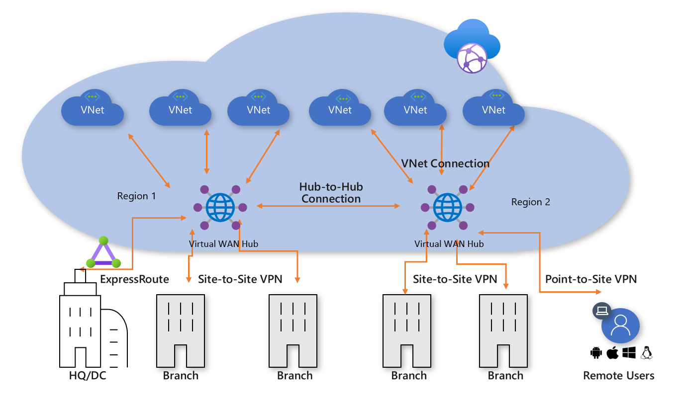

To configure an end-to-end virtual WAN, you create the following resources:

* **Virtual WAN**
* **Hub**
* **Hub virtual network connection**
* **Hub-to-hub connection**
* **Hub route table**

### Virtual WAN SKU

The virtual WAN resource represents a virtual overlay of your Azure network and is a collection of multiple resources. It contains links to all your virtual hubs that you would like to have within the virtual WAN. Virtual WANs are isolated from each other and can't contain a common hub. Virtual hubs in different virtual WANs don't communicate with each other.

There are two types of Virtual WANs: Basic and Standard. The following table shows the available configurations for each type.

|  |  |  |
| --- | --- | --- |
| **Virtual WAN type** | **Hub type** | **Available configurations** |
| Basic | Basic | Site-to-site VPN only |
| Standard | Standard | ExpressRoute User VPN (P2S) VPN (site-to-site) Inter-hub and VNet-to-VNet transiting through the virtual hub Azure Firewall NVA in a virtual WAN |

### Hub private address space

A virtual hub is a Microsoft-managed virtual network. The hub contains various service endpoints to enable connectivity. From your on-premises network (vpnsite), you can connect to a VPN gateway inside the virtual hub, connect ExpressRoute circuits to a virtual hub, or even connect mobile users to a point-to-site gateway in the virtual hub. The hub is the core of your network in a region. Multiple virtual hubs can be created in the same region.

The minimum address space is /24 to create a hub. If you use anything in the range from /25 to /32, it will produce an error during creation. You don't need to explicitly plan the subnet address space for the services in the virtual hub. Because Azure Virtual WAN is a managed service, it creates the appropriate subnets in the virtual hub for the different gateways/services (for example, VPN gateways, ExpressRoute gateways, User VPN point-to-site gateways, Firewall, routing, etc.).

**Gateway scale**

A hub gateway isn't the same as a virtual network gateway that you use for ExpressRoute and VPN Gateway. For example, when using Virtual WAN, you don't create a site-to-site connection from your on-premises site directly to your VNet. Instead, you create a site-to-site connection to the hub. The traffic always goes through the hub gateway. This means that your VNets don't need their own virtual network gateway. Virtual WAN lets your VNets take advantage of scaling easily through the virtual hub and the virtual hub gateway.

Gateway scale units allow you pick the aggregate throughput of the gateway in the virtual hub. Each type of gateway scale unit (site-to-site, user-vpn, and ExpressRoute) is configured separately.

### Connect cross-tenant VNets to a Virtual WAN hub

You can use Virtual WAN to connect a VNet to a virtual hub in a different tenant. This architecture is useful if you have client workloads that must be connected to be the same network but are on different tenants. For example, as shown in the following diagram, you can connect a non-Contoso VNet (the Remote Tenant) to a Contoso virtual hub (the Parent Tenant).

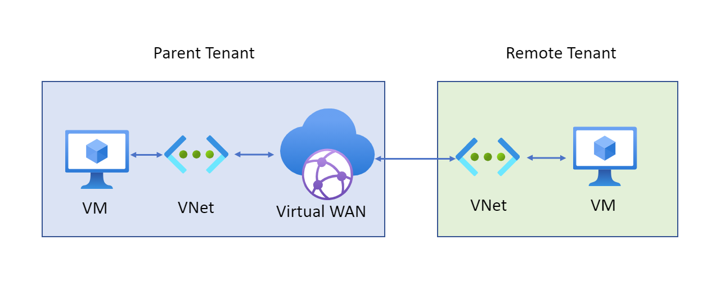

Before you can connect a cross-tenant VNet to a Virtual WAN hub, you must have the following configuration already set up:

* A Virtual WAN and virtual hub in the parent subscription.
* A virtual network configured in a subscription in the remote tenant.
* Non-overlapping address spaces in the remote tenant and address spaces within any other VNets already connected to the parent virtual hub.

### Virtual Hub routing

The routing capabilities in a virtual hub are provided by a router that manages all routing between gateways using Border Gateway Protocol (BGP). A virtual hub can contain multiple gateways such as a Site-to-site VPN gateway, ExpressRoute gateway, Point-to-site gateway, Azure Firewall. This router also provides transit connectivity between virtual networks that connect to a virtual hub and can support up to an aggregate throughput of 50 Gbps. These routing capabilities apply to Standard Virtual WAN customers.

To learn more about how to configure routing, see [How to configure virtual hub routing](https://learn.microsoft.com/en-us/azure/virtual-wan/how-to-virtual-hub-routing).

### Hub route table

You can create a virtual hub route and apply the route to the virtual hub route table. You can apply multiple routes to the virtual hub route table.

# Create a network virtual appliance (NVA) in a virtual hub

One of the benefits of Azure Virtual WAN is the ability to support reliable connections from many different technologies, whether Microsoft based, such as ExpressRoute or a VPN Gateway, or from a networking partner, such as Barracuda CloudGen WAN, Cisco Cloud OnRamp for Multi-Cloud, and VMware SD-WAN. These types of devices are known as network virtual appliances (NVAs); they are deployed directly into a Virtual WAN hub and have an externally facing public IP address. This capability enables customers who want to connect their branch Customer Premises Equipment (CPE) to the same brand NVA in the virtual hub to take advantage of proprietary end-to-end SD-WAN capabilities. Once VNets are connected to the virtual hub, NVAs enable transitive connectivity throughout the organization's Virtual WAN.

## Manage an NVA in a Virtual Hub

The NVAs available in the Azure Marketplace can be deployed directly into a virtual hub and nowhere else. Each is deployed as a Managed Application, which allows Azure Virtual WAN to manage the configuration of the NVA. They cannot be deployed within an arbitrary VNet.

The following diagram shows the NVA deployment process:

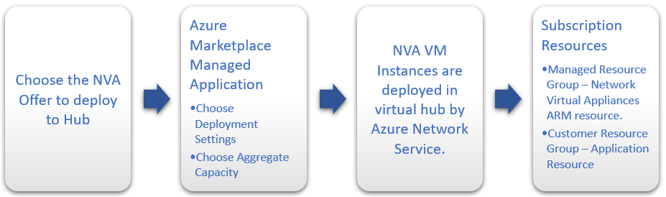

Although each NVA offers support for different CPEs and has a slightly different user experience, they all offer a Managed Application experience through Azure Marketplace, NVA Infrastructure Unit-based capacity and billing, and Health Metrics surfaced through Azure Monitor.

## Deploy an NVA in your Virtual Hub

To deploy an NVA in your virtual hub, you can access the Azure Marketplace through the Azure portal and select the Managed Application for the NVA partner that you need to enable connectivity for your devices. When you create an NVA in the Virtual WAN hub, like all Managed Applications, there will be two Resource Groups created in your subscription.

* **Customer Resource Group** - This will contain an application placeholder for the Managed Application. Partners can use this resource group to expose whatever customer properties they choose here.
* **Managed Resource Group** - Customers cannot configure or change resources in this resource group directly, as this is controlled by the publisher of the Managed Application. This Resource Group will contain the NetworkVirtualAppliances resource.

The NVA is configured automatically as part of the deployment process. Once the NVA has been provisioned into the virtual hub, any additional configuration must be performed via the NVA partners portal or management application. You cannot access the NVA directly.

Unlike Azure VPN Gateway configurations, you do not need to create Site resources, Site-to-Site connection resources, or point-to-site connection resources to connect your branch sites to your NVA in the Virtual WAN hub. This is all managed via the NVA partner.

You still need to create Hub-to-VNet connections to connect your Virtual WAN hub to your Azure VNets.

## Create the Network Virtual Appliance in the hub

In this step, you will create a Network Virtual Appliance in the hub. The procedure for each NVA will be different for each NVA partner's product. For this example, we are creating a Barracuda CloudGen WAN Gateway.

1. Locate the Virtual WAN hub you created in the previous step and open it.

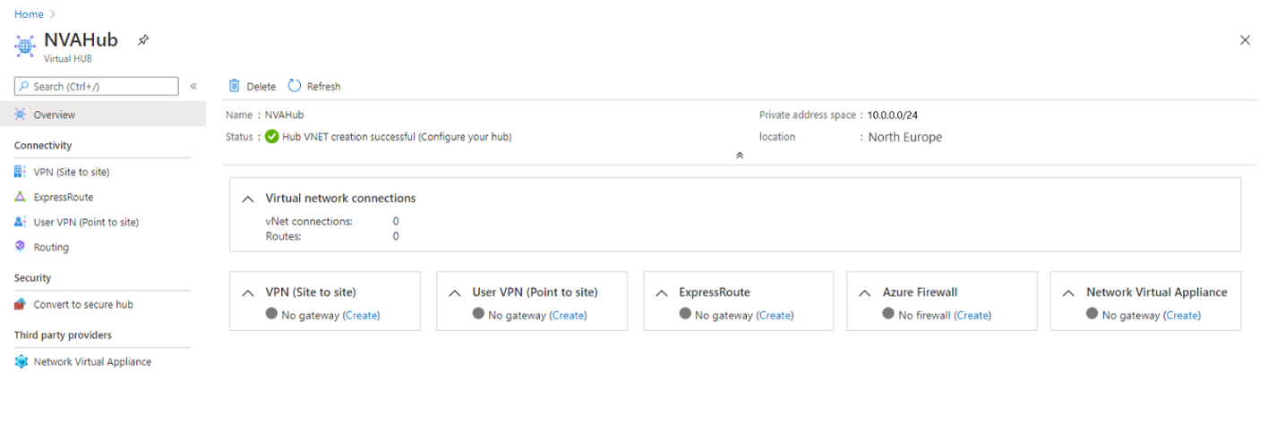

1. Find the Network Virtual Appliances tile and select the Create link.
2. On the Network Virtual Appliance blade, select Barracuda CloudGen WAN, then select the Create button.

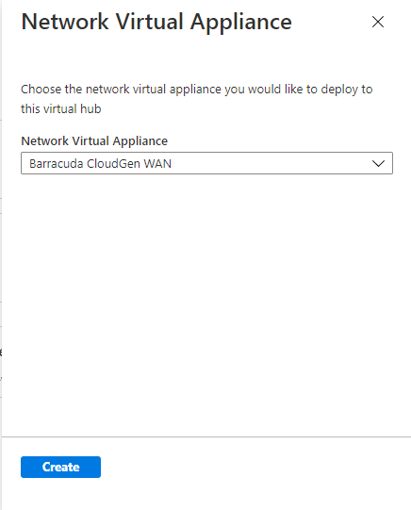

1. This will take you to the Azure Marketplace offer for the Barracuda CloudGen WAN gateway. Read the terms, then select the **Create** button when you're ready.

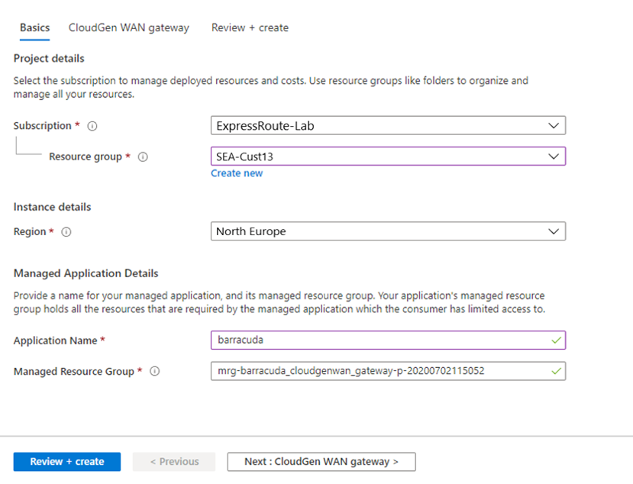

1. On the Basics page you will need to provide the following information:
   1. **Subscription -** Choose the subscription you used to deploy the Virtual WAN and hub.
   2. **Resource Group** - Choose the same Resource Group you used to deploy the Virtual WAN and hub.
   3. **Region** - Choose the same Region in which your Virtual hub resource is located.
   4. **Application Name** - The Barracuda NextGen WAN is a Managed Application. Choose a name that makes it easy to identify this resource, as this is what it will be called when it appears in your subscription.
   5. **Managed Resource Group** - This is the name of the Managed Resource Group in which Barracuda will deploy resources that are managed by them. The name should be pre-populated.
2. Select the Next: CloudGen WAN gateway button.

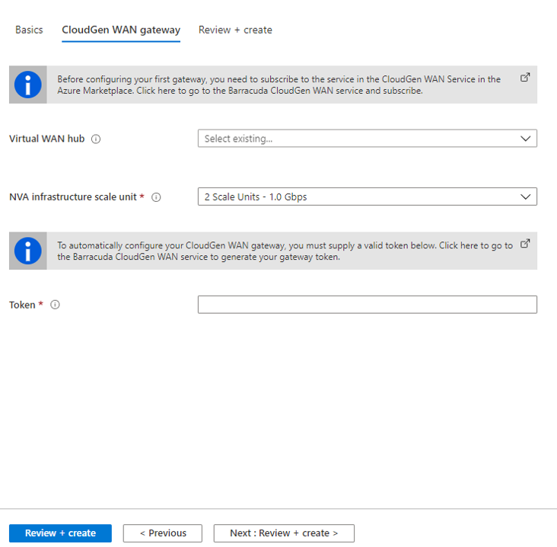

1. Provide the following information here:
   * **Virtual WAN Hub** - The Virtual WAN hub you want to deploy this NVA into.
   * **NVA Infrastructure Units** - Indicate the number of NVA Infrastructure Units you want to deploy this NVA with. Choose the amount of aggregate bandwidth capacity you want to provide across all of the branch sites that will be connecting to this hub through this NVA.
   * **Token** - Barracuda requires that you provide an authentication token here in order to identify yourself as a registered user of this product.

## NVA Infrastructure Units

When you create an NVA in the Virtual WAN hub, you must choose the number of NVA Infrastructure Units you want to deploy it with. An NVA Infrastructure Unit is a unit of aggregate bandwidth capacity for an NVA in the Virtual WAN hub. An NVA Infrastructure Unit is similar to a VPN Scale Unit in terms of the way you think about capacity and sizing.

* One NVA Infrastructure Unit represents 500 Mbps of aggregate bandwidth for all branch site connections coming into this NVA.
* Azure supports from 1-80 NVA Infrastructure Units for a given NVA virtual hub deployment.
* Each partner may offer different NVA Infrastructure Unit bundles that are a subset of all supported NVA Infrastructure Unit configurations.

# Module 3: Design and implement Azure ExpressRoute

Azure ExpressRoute is a service that allows you to extend your on-premises networks into the Microsoft Cloud over a private connection with the help of a connectivity provider. Here are some key points about Azure ExpressRoute:

1. **Private Cloud Connections:** ExpressRoute provides a fast, reliable, and private connection to Azure. Unlike typical internet connections, ExpressRoute connections don’t route through the public internet. This results in more reliability, faster speeds, and lower latency. It’s an excellent option for scenarios like periodic data migration, replication for business continuity, disaster recovery, and other high-availability strategies.
2. **Bandwidth Options:** ExpressRoute offers bandwidths up to 100 Gbps, making it suitable for various use cases. Whether you need to connect to Azure datacenters, extend and connect your datacenters, or build hybrid applications, ExpressRoute provides the necessary scale and performance without compromising network reliability.
3. **Security and Reliability:**
   * **Consistent Latency**: ExpressRoute ensures consistent latency, which is crucial for applications requiring predictable performance.
   * **Direct Connection to Your WAN**: By avoiding the public internet, ExpressRoute enhances security and privacy.
   * **IPv6 Workloads Support**: ExpressRoute supports both IPv4 and IPv6 workloads.
   * **Redundancy**: Each ExpressRoute circuit consists of dual connections to Microsoft Enterprise edge routers (MSEEs) for higher reliability.
   * **Physical Link Encryption**: ExpressRoute provides physical link encryption with MACsec, ensuring data privacy during transmission.
4. **Global Reach:** You can link circuits together for a private connection between your on-premises networks. If you have multiple circuits linking branch offices to Microsoft, establish Global Reach connections that allow direct data exchange.

## ExpressRoute capabilities

Some key benefits of ExpressRoute are:

* Layer 3 connectivity between your on-premises network and the Microsoft Cloud through a connectivity provider
* Connectivity can be from an any-to-any (IPVPN) network, a point-to-point Ethernet connection, or through a virtual cross-connection via an Ethernet exchange
* Connectivity to Microsoft cloud services across all regions in the geopolitical region
* Global connectivity to Microsoft services across all regions with the ExpressRoute premium add-on
* Built-in redundancy in every peering location for higher reliability.

## Understand use cases for Azure ExpressRoute

**Faster and Reliable connection to Azure services** - Organizations leveraging Azure services look for reliable connections to Azure services and data centers. Public internet is dependent upon many factors and may not be suitable for a business. Azure ExpressRoute is used to create private connections between Azure data centers and infrastructure on your premises or in a colocation environment. Using ExpressRoute connections to transfer data between on-premises systems and Azure can also give significant cost benefits.

**Storage, backup, and Recovery** - Backup and Recovery are important for an organization for business continuity and recovering from outages. ExpressRoute gives you a fast and reliable connection to Azure with bandwidths up to 100 Gbps, which makes it excellent for scenarios such as periodic data migration, replication for business continuity, disaster recovery and other high-availability strategies.

**Extends Data center capabilities** - ExpressRoute can be used to connect and add compute and storage capacity to your existing data centers. With high throughput and fast latencies, Azure will feel like a natural extension to or between your data centers, so you enjoy the scale and economics of the public cloud without having to compromise on network performance.

**Predictable, reliable, and high-throughput connections -** With predictable, reliable, and high-throughput connections offered by ExpressRoute, enterprises can build applications that span on-premises infrastructure and Azure without compromising privacy or performance. For example, run a corporate intranet application in Azure that authenticates your customers with an on-premises Active Directory service, and serve all your corporate customers without traffic ever routing through the public Internet.

## ExpressRoute connectivity models

You can create a connection between your on-premises network and the Microsoft cloud in four different ways, CloudExchange Co-location, Point-to-point Ethernet Connection, Any-to-any (IPVPN) Connection, and ExpressRoute Direct. Connectivity providers may offer one or more connectivity models.

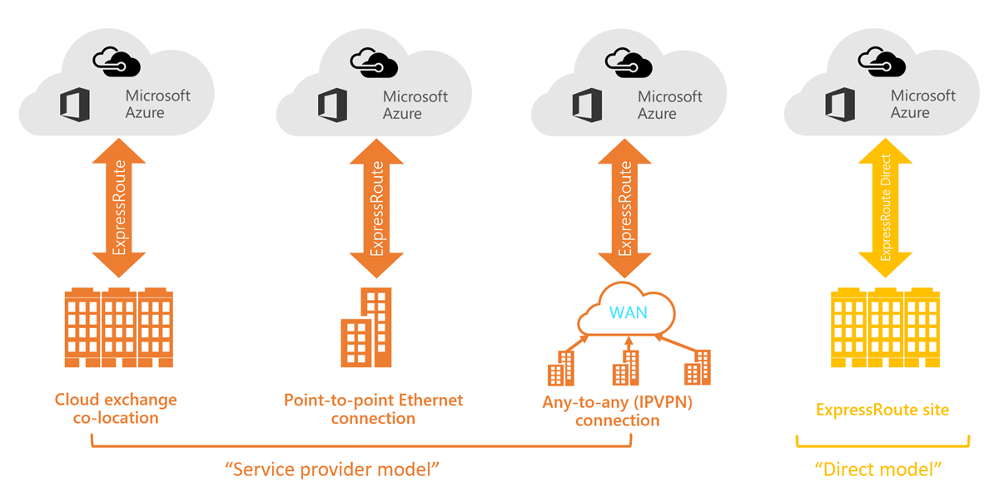

1. **Co-located at a cloud exchange**

If you are co-located in a facility with a cloud exchange, you can order virtual cross-connections to the Microsoft cloud through the co-location provider’s Ethernet exchange. Co-location providers can offer either Layer 2 cross-connections, or managed Layer 3 cross-connections between your infrastructure in the co-location facility and the Microsoft cloud.

1. **Point-to-point Ethernet connections**

You can connect your on-premises datacenters/offices to the Microsoft cloud through point-to-point Ethernet links. Point-to-point Ethernet providers can offer Layer 2 connections, or managed Layer 3 connections between your site and the Microsoft cloud.

1. **Any-to-any (IPVPN) networks**

You can integrate your WAN with the Microsoft cloud. IPVPN providers (typically MPLS VPN) offer any-to-any connectivity between your branch offices and datacenters. The Microsoft cloud can be interconnected to your WAN to make it look just like any other branch office. WAN providers typically offer managed Layer 3 connectivity.

1. **Direct from ExpressRoute sites**

You can connect directly into the Microsoft's global network at a peering location strategically distributed across the world. ExpressRoute Direct provides dual 100 Gbps or 10-Gbps connectivity, which supports Active/Active connectivity at scale.

# Design considerations for ExpressRoute deployment

## Choose between provider and direct model (ExpressRoute Direct)

**ExpressRoute Direct**

ExpressRoute Direct gives you the ability to connect directly into Microsoft’s global network at peering locations strategically distributed around the world. ExpressRoute Direct provides dual 100 Gbps or 10-Gbps connectivity, which supports Active/Active connectivity at scale. You can work with any service provider for ExpressRoute Direct.

Key features that ExpressRoute Direct provides includes:

* Massive Data Ingestion into services like Storage and Cosmos DB
* Physical isolation for industries that are regulated and require dedicated and isolated connectivity like: Banking, Government, and Retail
* Granular control of circuit distribution based on business unit

**Using ExpressRoute direct vs using a Service Provider**

|  |  |
| --- | --- |
| **ExpressRoute using a Service Provider** | **ExpressRoute Direct** |
| Uses service providers to enable fast onboarding and connectivity into existing infrastructure | Requires 100 Gbps/10 Gbps infrastructure and full management of all layers |
| Integrates with hundreds of providers including Ethernet and MPLS | Direct/Dedicated capacity for regulated industries and massive data ingestion |
| Circuits SKUs from 50 Mbps to 10 Gbps | Customer may select a combination of the following circuit SKUs on 100-Gbps ExpressRoute Direct: 5 Gbps 10 Gbps 40 Gbps 100 Gbps Customer may select a combination of the following circuit SKUs on 10-Gbps ExpressRoute Direct: 1 Gbps 2 Gbps 5 Gbps 10 Gbps |
| Optimized for single tenant | Optimized for single tenant with multiple business units and multiple work environments |

# Bidirectional Forwarding Detection

ExpressRoute supports Bidirectional Forwarding Detection (BFD) both over private and Microsoft peering. When you enable BFD over ExpressRoute, you can speed up the link failure detection between Microsoft Enterprise edge (MSEE) devices and the routers that your ExpressRoute circuit gets configured (CE/PE).

You can enable ExpressRoute circuit either by Layer 2 connections or managed Layer 3 connections. In both cases, if there are more than one Layer-2 devices in the ExpressRoute connection path, the responsibility of detecting any link failures in the path lies with the overlying BGP session.

You can control the BGP timers by configuring a lower BGP keep-alive and hold-time on your edge peering device. If the BGP timers are not the same between the two peering devices, the BGP session will establish using the lower time value.

The following diagram shows the benefit of enabling BFD over an ExpressRoute circuit:

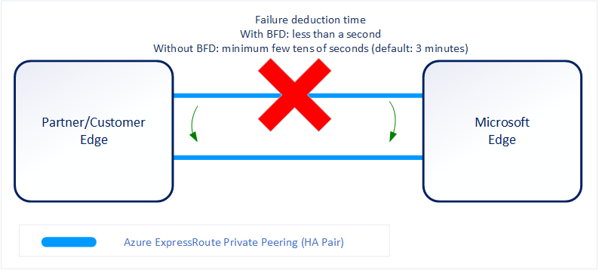

## Enabling BFD

BFD is configured by default under all the newly created ExpressRoute private peering interfaces on the MSEEs. As such, to enable BFD, you only need to configure BFD on both your primary and secondary devices. Configuring BFD is two-step process. You configure the BFD on the interface and then link it to the BGP session.

When you disable a peering, the Border Gateway Protocol (BGP) session for both the primary and the secondary connection of your ExpressRoute circuit is shut down. When you enable a peering, the BGP session on both the primary and the secondary connection of your ExpressRoute circuit is restored.

# Configure encryption over ExpressRoute

## Topology and routing

The following diagram shows an example of VPN connectivity over ExpressRoute private peering:

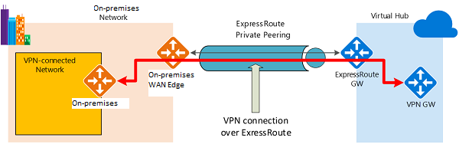

The diagram shows a network within the on-premises network connected to the Azure hub VPN gateway over ExpressRoute private peering. The connectivity establishment is straightforward:

* Establish ExpressRoute connectivity with an ExpressRoute circuit and private peering.
* Establish the VPN connectivity.

## Traffic from on-premises networks to Azure

For traffic from on-premises networks to Azure, the Azure prefixes are advertised via both the ExpressRoute private peering BGP and the VPN BGP. This results in two network routes (paths) toward Azure from the on-premises networks:

* One over the IPsec-protected path.
* One directly over ExpressRoute without IPsec protection.

To apply encryption to the communication, you must make sure that for the VPN-connected network in the diagram, the Azure routes via on-premises VPN gateway are preferred over the direct ExpressRoute path.

## Traffic from Azure to on-premises networks

The same requirement applies to the traffic from Azure to on-premises networks. To ensure that the IPsec path is preferred over the direct ExpressRoute path (without IPsec), you have two options:

* Advertise more specific prefixes on the VPN BGP session for the VPN-connected network. You can advertise a larger range that encompasses the VPN-connected network over ExpressRoute private peering, then more specific ranges in the VPN BGP session. For example, advertise 10.0.0.0/16 over ExpressRoute, and 10.0.1.0/24 over VPN.
* Advertise disjoint prefixes for VPN and ExpressRoute. If the VPN-connected network ranges are disjoint from other ExpressRoute connected networks, you can advertise the prefixes in the VPN and ExpressRoute BGP sessions, respectively. For example, advertise 10.0.0.0/24 over ExpressRoute, and 10.0.1.0/24 over VPN.

In both examples, Azure will send traffic to 10.0.1.0/24 over the VPN connection rather than directly over ExpressRoute without VPN protection.

# Design redundancy for an ExpressRoute deployment

There are 2 ways in which redundancy can be planned for an ExpressRoute deployment.

* Configure ExpressRoute and site to site coexisting connections
* Create a zone redundant VNET gateway in Azure Availability zones

## Configure ExpressRoute and site to site coexisting connections

You can configure Site-to-Site VPN as a secure failover path for ExpressRoute or use Site-to-Site VPNs to connect to sites that are not connected through ExpressRoute.

Configuring Site-to-Site VPN and ExpressRoute coexisting connections has several advantages:

* You can configure a Site-to-Site VPN as a secure failover path for ExpressRoute.
* Alternatively, you can use Site-to-Site VPNs to connect to sites that are not connected through ExpressRoute.

You can configure either gateway first. Typically, you will incur no downtime when adding a new gateway or gateway connection.

**Network Limits and limitations**

* **Only route-based VPN gateway is supported.** You must use a route-based VPN gateway. You also can use a route-based VPN gateway with a VPN connection configured for 'policy-based traffic selectors'.
* **The ASN of Azure VPN Gateway must be set to 65515.** Azure VPN Gateway supports the BGP routing protocol. For ExpressRoute and Azure VPN to work together, you must keep the Autonomous System Number of your Azure VPN gateway at its default value, 65515. If you previously selected an ASN other than 65515 and you change the setting to 65515, you must reset the VPN gateway for the setting to take effect.
* **The gateway subnet must be /27 or a shorter prefix**, (such as /26, /25), or you will receive an error message when you add the ExpressRoute virtual network gateway.
* **Coexistence in a dual stack VNet is not supported.** If you are using ExpressRoute IPv6 support and a dual-stack ExpressRoute gateway, coexistence with VPN Gateway will not be possible.

## Create a zone redundant VNet gateway in Azure availability zones

You can deploy VPN and ExpressRoute gateways in [Azure Availability Zones](https://learn.microsoft.com/en-us/azure/availability-zones/az-overview). This brings resiliency, scalability, and higher availability to virtual network gateways. Deploying gateways in Azure Availability Zones physically and logically separates gateways within a region, while protecting your on-premises network connectivity to Azure from zone-level failures.

### Zone-redundant gateways

To automatically deploy your virtual network gateways across availability zones, you can use zone-redundant virtual network gateways. With zone-redundant gateways, you can benefit from zone-resiliency to access your mission-critical, scalable services on Azure.

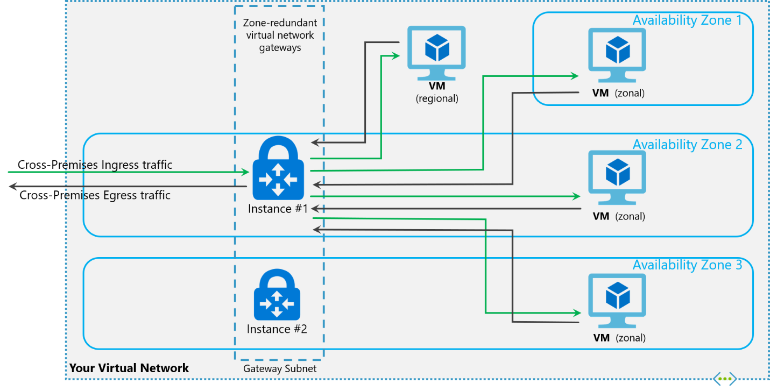

### Zonal gateways

To deploy gateways in a specific zone, you can use zonal gateways. When you deploy a zonal gateway, all instances of the gateway are deployed in the same Availability Zone.

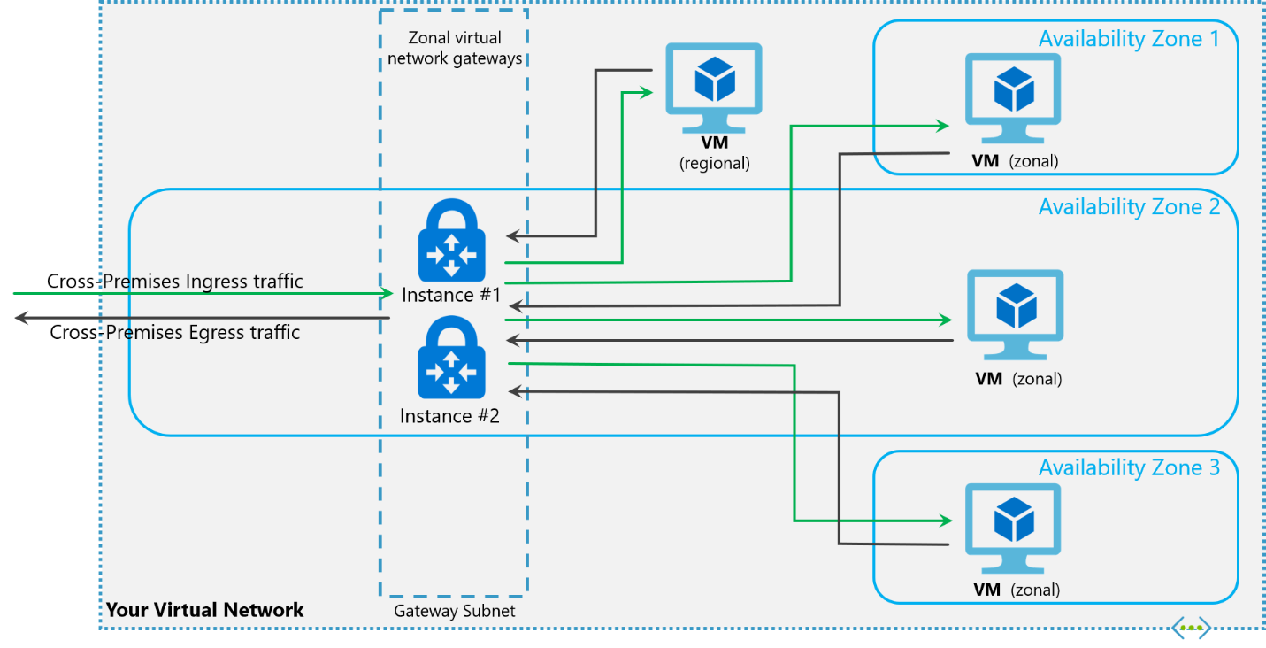

### Gateway SKUs

Zone-redundant and zonal gateways are available as gateway SKUs. There is a new virtual network gateway SKUs in Azure AZ regions. These SKUs are like the corresponding existing SKUs for ExpressRoute and VPN Gateway, except that they are specific to zone-redundant and zonal gateways. You can identify these SKUs by the "AZ" in the SKU name.

### Public IP SKUs

Zone-redundant gateways and zonal gateways both rely on the Azure public IP resource Standard SKU. The configuration of the Azure public IP resource determines whether the gateway that you deploy is zone-redundant, or zonal. If you create a public IP resource with a Basic SKU, the gateway will not have any zone redundancy, and the gateway resources will be regional.

1. **Zone-redundant gateways**
   * When you create a public IP address using the **Standard** public IP SKU without specifying a zone, the behavior differs depending on whether the gateway is a VPN gateway, or an ExpressRoute gateway.
   * For a VPN gateway, the two gateway instances will be deployed in any 2 out of these three zones to provide zone-redundancy.
   * For an ExpressRoute gateway, since there can be more than two instances, the gateway can span across all the three zones.
2. **Zonal gateways**
   * When you create a public IP address using the **Standard** public IP SKU and specify the Zone (1, 2, or 3), all the gateway instances will be deployed in the same zone.
3. **Regional gateways**
   * When you create a public IP address using the **Basic** public IP SKU, the gateway is deployed as a regional gateway and does not have any zone-redundancy built into the gateway.

# Configure a Site-to-Site VPN as a failover path for ExpressRoute

You can configure a Site-to-Site VPN connection as a backup for ExpressRoute. This connection applies only to virtual networks linked to the Azure private peering path. There is no VPN-based failover solution for services accessible through Azure Microsoft peering. The ExpressRoute circuit is always the primary link. Data flows through the Site-to-Site VPN path only if the ExpressRoute circuit fails. To avoid asymmetrical routing, your local network configuration should also prefer the ExpressRoute circuit over the Site-to-Site VPN. You can prefer the ExpressRoute path by setting higher local preference for the routes received the ExpressRoute.

**Note**

If you have ExpressRoute Microsoft Peering enabled, you can receive the public IP address of your Azure VPN gateway on the ExpressRoute connection. To set up your site-to-site VPN connection as a backup, you must configure your on-premises network so that the VPN connection is routed to the Internet.

**Note**

While ExpressRoute circuit is preferred over Site-to-Site VPN when both routes are the same, Azure will use the longest prefix match to choose the route towards the packet's destination.

# Design an ExpressRoute deployment

ExpressRoute enables us to connect on Premises to Azure services seamlessly.

## ExpressRoute circuit SKUs

Azure ExpressRoute has three different circuit SKUs: [Local](https://learn.microsoft.com/en-us/azure/expressroute/expressroute-faqs), Standard, and [Premium](https://learn.microsoft.com/en-us/azure/expressroute/expressroute-faqs). The way you are charged for your ExpressRoute usage varies between these three SKU types.

* **Local SKU** - With Local SKU, you are automatically charged with an Unlimited data plan.
* **Standard and Premium SKU** - You can select between a Metered or an Unlimited data plan. All ingress data are free of charge except when using the Global Reach add-on.

### Explore pricing based on ExpressRoute SKU

SKU models have been discussed previously as Local, Standard and Premium. It is a good practice to estimate costs before using Azure ExpressRoute as the price might affect your design decisions.

Use the Azure pricing calculator to estimate costs before you create an Azure ExpressRoute circuit.

1. On the left, select **Networking**, then select **Azure ExpressRoute** to begin.
2. Select the appropriate Zone depending on your peering location.
3. Then select the SKU, Circuit Speed, and the Data Plan you would like an estimate for.
4. In the Additional outbound data transfer, enter an estimate in GB of how much outbound data you might use over the course of a month.
5. Lastly, you can add the Global Reach Add-on to the estimate.

## Choose a peering location

### Azure regions

Azure regions are global datacenters where Azure compute, networking and storage resources are located. When creating an Azure resource, a customer needs to select a resource location. The resource location determines which Azure datacenter (or availability zone) the resource is created in.

### ExpressRoute locations (Peering locations)

ExpressRoute locations (sometimes referred to as peering locations or meet-me-locations) are co-location facilities where Microsoft Enterprise Edge (MSEE) devices are located. ExpressRoute locations are the entry point to Microsoft's network – and are globally distributed, providing customers the opportunity to connect to Microsoft's network around the world. These locations are where ExpressRoute partners and ExpressRoute Direct customers issue cross connections to Microsoft's network.

### Azure regions to ExpressRoute locations within a geopolitical region.

The following link provides a list of [Azure regions to ExpressRoute locations](https://learn.microsoft.com/en-us/azure/expressroute/expressroute-locations) within a geopolitical region. This page is kept up to date with the latest ExpressRoute locations and providers.

### ExpressRoute connectivity providers

The following link list's locations by service provider. This page is kept up to date with the latest available providers by location, see [Service providers by location](https://learn.microsoft.com/en-us/azure/expressroute/expressroute-locations-providers).

### Connectivity through Exchange providers

If your connectivity provider is not listed in previous sections, you can still create a connection. Several connectivity providers are already connected to Ethernet exchanges.

### Connectivity through satellite operators

If you are remote and do not have fiber connectivity or want to explore other connectivity options, you can check the following satellite operators.

**Additional Connectivity options:**

* Through additional service providers
* Datacenter providers
* National Research and Education networks (NERN)
* System integrators

# Choose the right ExpressRoute circuit and billing model

## Choose a billing model

You can pick a billing model that works best for you. Choose between the billing models listed as followed.

* **Unlimited data**. Billing is based on a monthly fee; all inbound and outbound data transfer is included free of charge.
* **Metered data**. Billing is based on a monthly fee; all inbound data transfer is free of charge. Outbound data transfer is charged per GB of data transfer. Data transfer rates vary by region.
* **ExpressRoute premium add-on**. ExpressRoute premium is an add-on to the ExpressRoute circuit. The ExpressRoute premium add-on provides the following capabilities:
  + - Increased route limits for Azure public and Azure private peering from 4,000 routes to 10,000 routes.
    - Global connectivity for services. An ExpressRoute circuit created in any region (excluding national clouds) will have access to resources across every other region in the world. For example, a virtual network created in West Europe can be accessed through an ExpressRoute circuit provisioned in Silicon Valley.
    - Increased number of VNet links per ExpressRoute circuit from 10 to a larger limit, depending on the bandwidth of the circuit.

# Configure peering for an ExpressRoute deployment

An ExpressRoute circuit has two peering options associated with it: Azure private, and Microsoft. Each peering is configured identically on a pair of routers (in active-active or load sharing configuration) for high availability. Azure services are categorized as Azure public and Azure private to represent the IP addressing schemes.

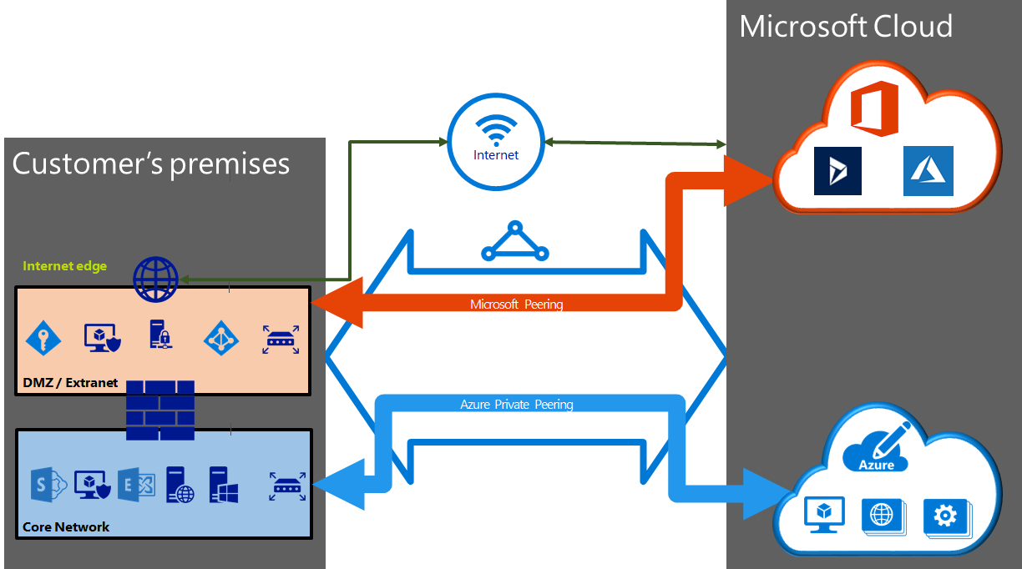

## Create Peering configuration

* You can configure private peering and Microsoft peering for an ExpressRoute circuit. Peering's can be configured in any order you choose. However, you must make sure that you complete the configuration of each peering one at a time.
* You must have an active ExpressRoute circuit. Have the circuit enabled by your connectivity provider before you continue. To configure peering(s), the ExpressRoute circuit must be in a provisioned and enabled state.
* If you plan to use a shared key/MD5 hash, be sure to use the key on both sides of the tunnel. The limit is a maximum of 25 alphanumeric characters. Special characters are not supported.
* This only applies to circuits created with service providers offering Layer 2 connectivity services. If you are using a service provider that offers managed Layer 3 services (typically an IPVPN, like MPLS), your connectivity provider configures and manages the routing for you.

## Choose between private peering only, Microsoft peering only, or both

The following table compares the two peering. Public peering is deprecated for new peering.

|  |  |  |
| --- | --- | --- |
| **Features** | **Private Peering** | **Microsoft Peering** |
| Max. # prefixes supported per peering | 4000 by default, 10,000 with ExpressRoute Premium | 200 |
| IP address ranges supported | Any valid IP address within your WAN. | Public IP addresses owned by you or your connectivity provider. |
| AS Number requirements | Private and public AS numbers. You must own the public AS number if you choose to use one. | Private and public AS numbers. However, you must prove ownership of public IP addresses. |
| IP protocols supported | IPv4, IPv6 (preview) | IPv4, IPv6 |
| Routing Interface IP addresses | RFC1918 and public IP addresses | Public IP addresses registered to you in routing registries. |
| MD5 Hash support | Yes | Yes |

Each peering requires separate BGP sessions (one pair for each peering type). The BGP session pairs provide a highly available link. If you are connecting through layer 2 connectivity providers, you are responsible for configuring and managing routing.

## Configure private peering

Azure compute services, namely virtual machines (IaaS) and cloud services (PaaS), that are deployed within a virtual network can be connected through the private peering domain. The private peering domain is a trusted extension of your core network into Microsoft Azure. You can set up bi-directional connectivity between your core network and Azure virtual networks (VNets). This peering lets you connect to virtual machines and cloud services directly on their private IP addresses.

## Configure Microsoft peering

Microsoft 365 was created to be accessed securely and reliably via the Internet. Because of this, it is recommended to use ExpressRoute for specific scenarios.

Connectivity to Microsoft online services (Microsoft 365 and Azure PaaS services) occurs through Microsoft peering. You can enable bidirectional connectivity between your WAN and Microsoft cloud services through the Microsoft peering routing domain. You must connect to Microsoft cloud services only over public IP addresses that are owned by you or your connectivity provider and you must adhere to all the defined rules.

# Configure route filters for Microsoft Peering

Route filters are a way to consume a subset of supported services through Microsoft peering.

Connectivity to all Azure and Microsoft 365 services causes many prefixes to get advertised through BGP. The large number of prefixes significantly increases the size of the route tables maintained by routers within your network. If you plan to consume only a subset of services offered through Microsoft peering, you can reduce the size of your route tables in two ways. You can:

* Filter out unwanted prefixes by applying route filters on BGP communities. Route filtering is a standard networking practice and is used commonly within many networks.
* Define route filters and apply them to your ExpressRoute circuit. A route filter is a new resource that lets you select the list of services you plan to consume through Microsoft peering. ExpressRoute routers only send the list of prefixes that belong to the services identified in the route filter.

## About route filters

When Microsoft peering gets configured on your ExpressRoute circuit, the Microsoft Edge routers establish a pair of BGP sessions with your edge routers through your connectivity provider. No routes are advertised to your network. To enable route advertisements to your network, you must associate a route filter.

A route filter lets you identify services you want to consume through your ExpressRoute circuit's Microsoft peering. It is essentially an allowed list of all the BGP community values. Once a route filter resource gets defined and attached to an ExpressRoute circuit, all prefixes that map to the BGP community values gets advertised to your network.

To attach route filters with Microsoft 365 services, you must have authorization to consume Microsoft 365 services through ExpressRoute. If you are not authorized to consume Microsoft 365 services through ExpressRoute, the operation to attach route filters fails.

# Create a route filter and a filter rule

A route filter can have only one rule, and the rule must be of type 'Allow'. This rule can have a list of BGP community values associated with it.

* Select **Create a resource** then search for Route filter as shown in the following image:

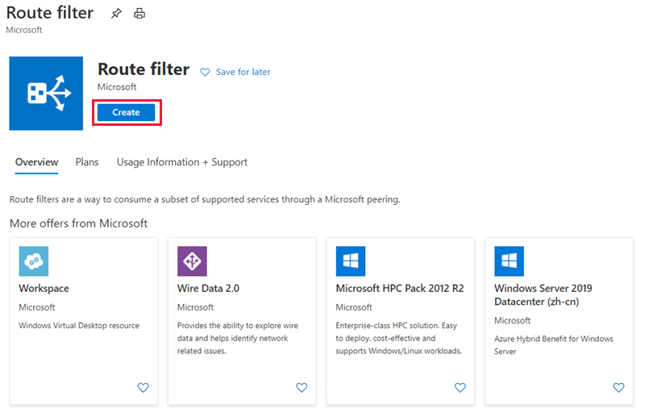

* Place the route filter in a resource group. Ensure the location is the same as the ExpressRoute circuit. Select **Review + create** and then **Create**.

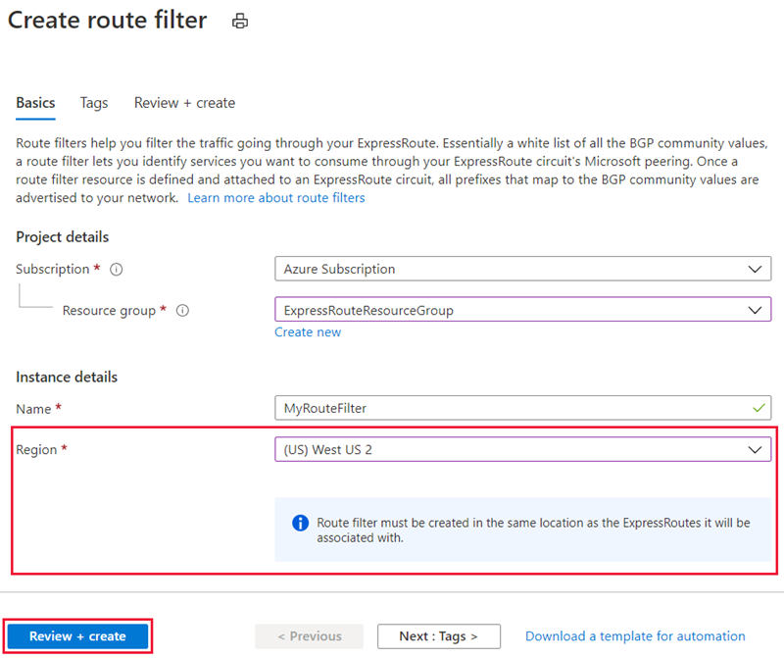

## Create a filter rule

To add and update rules, select the manage rule tab for your route filter.

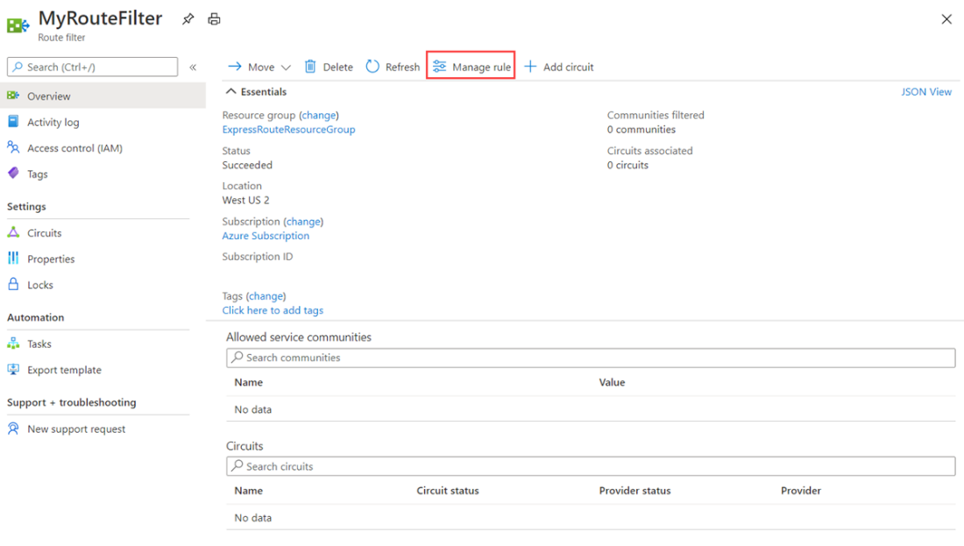

* Select the services you want to connect to from the drop-down list and save the rule when done.

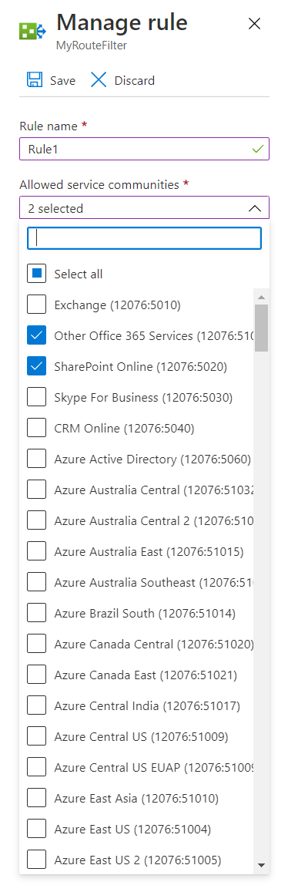

## Attach the route filter to an ExpressRoute circuit

* Attach the route filter to a circuit by selecting the **+ Add Circuit** button and selecting the ExpressRoute circuit from the drop-down list.

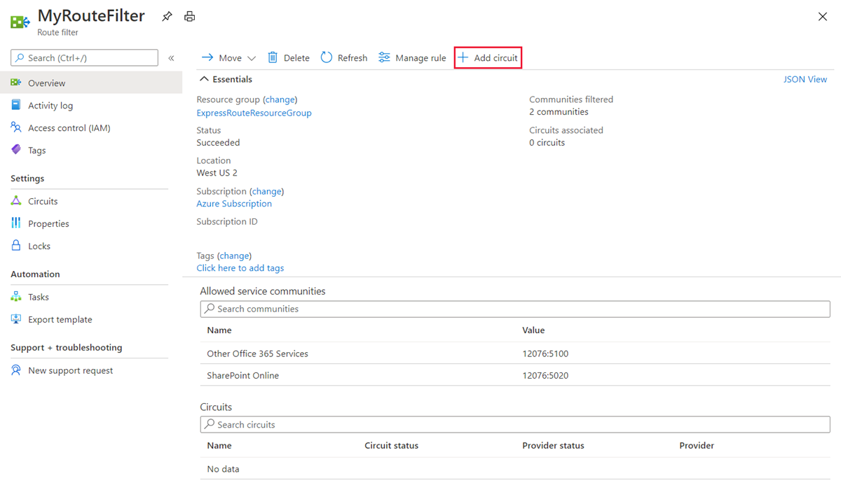

* If the connectivity provider configures peering for your ExpressRoute circuit, refresh the circuit from the ExpressRoute circuit page before you select the **+ Add Circuit** button.

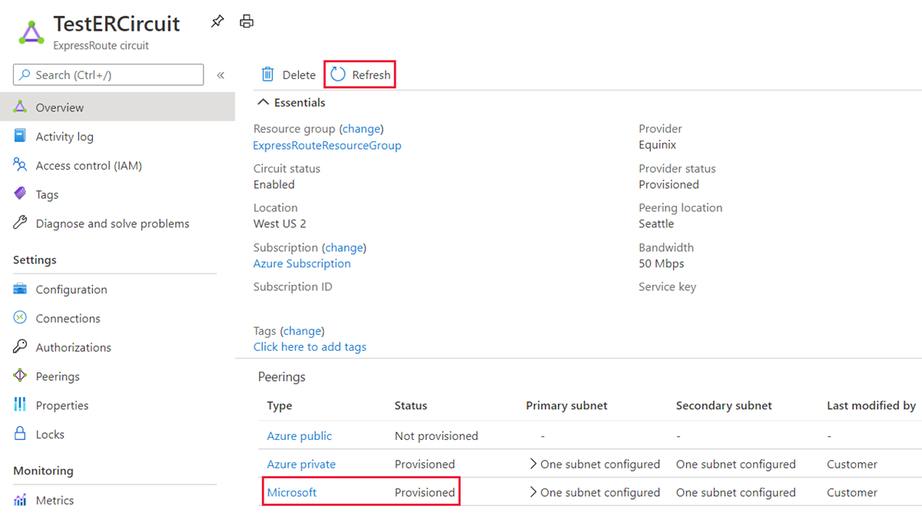

**Common tasks**

**To get the properties of a route filter**

* You can view properties of a route filter when you open the resource in the portal.

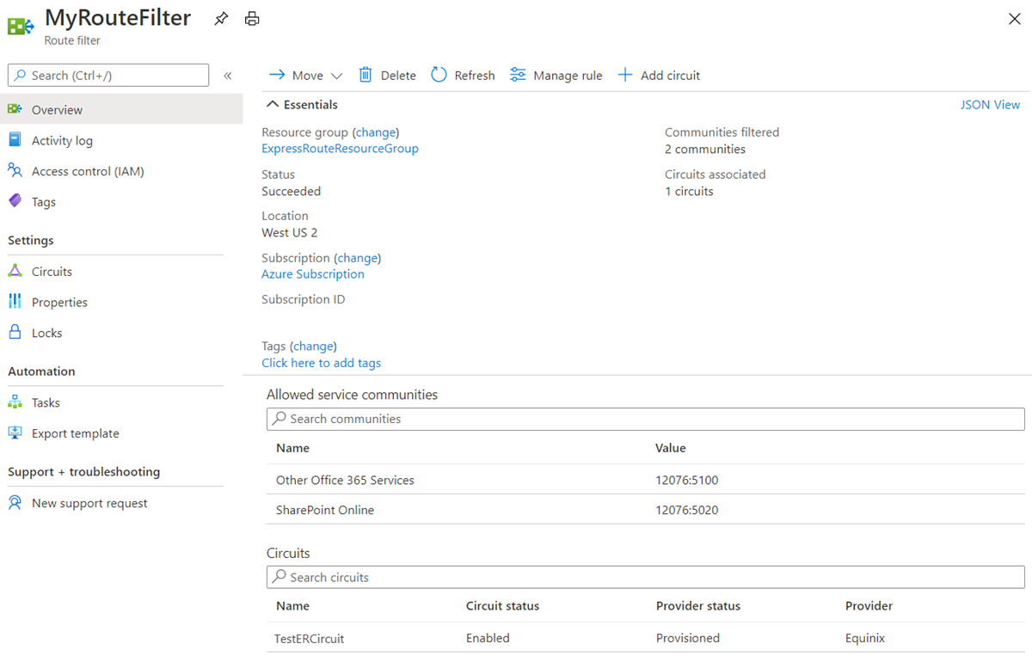

## To update the properties of a route filter

You can update the list of BGP community values attached to a circuit by selecting the **Manage rule** button.

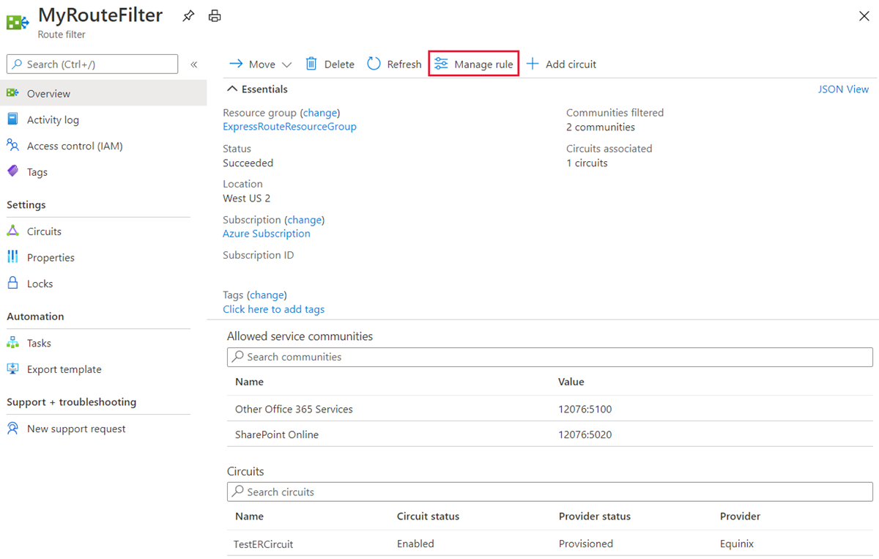

* Select the service communities you want and then select **Save**.

## To detach a route filter from an ExpressRoute circuit

* To detach a circuit from the route filter, right-click on the circuit and select **Disassociate**.

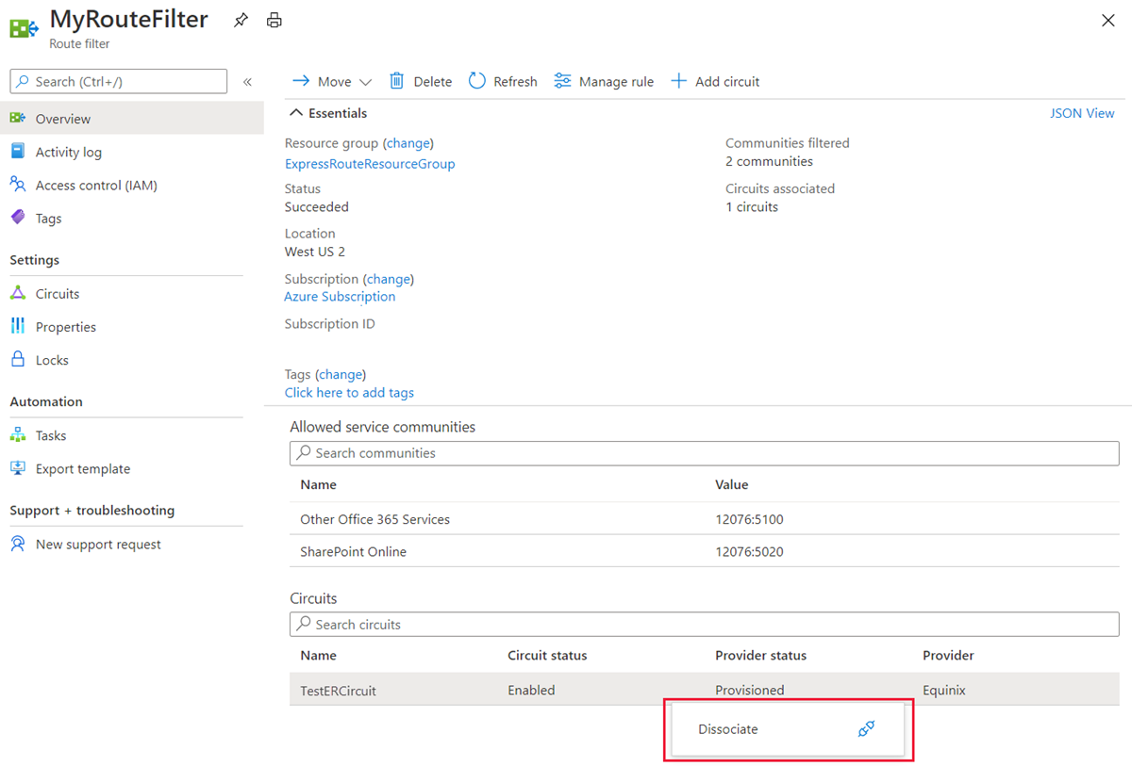

## Clean up resources

* You can delete a route filter by selecting the **Delete** button. Ensure the Route filter is not associate to any circuits before doing so.

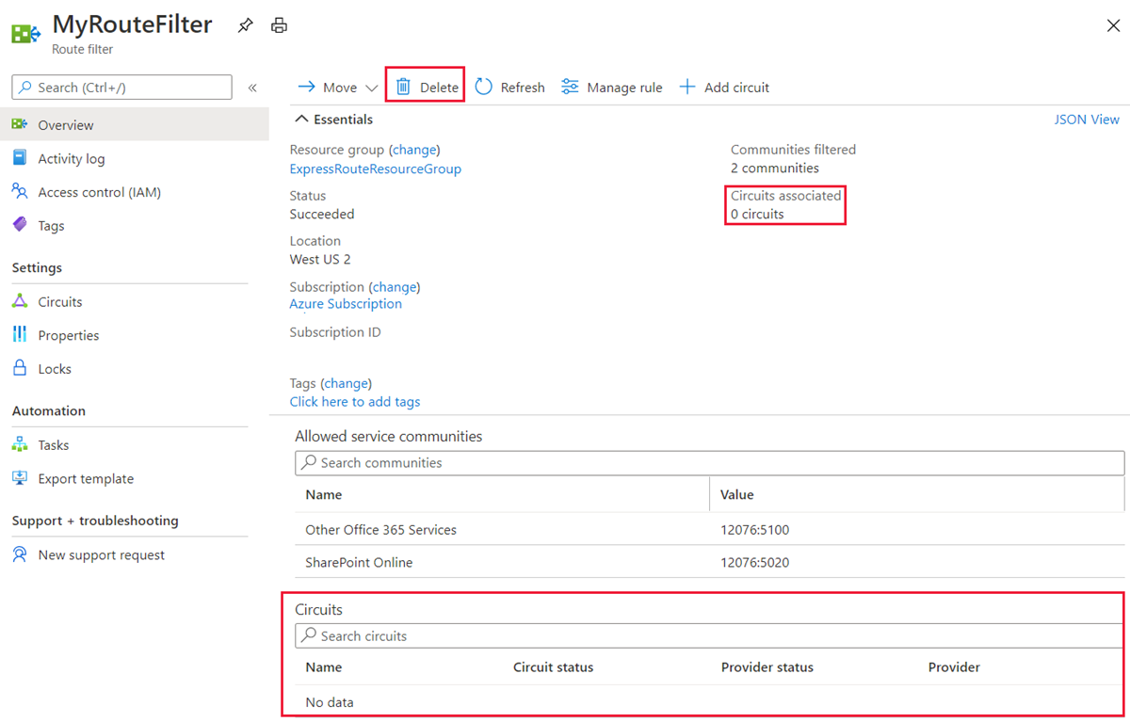

# Reset peering

**Sign into the Azure portal**

From a browser, go to the [Azure portal](https://portal.azure.com/), and then sign in with your Azure account.

**Reset a peering**

You can reset the Microsoft peering and the Azure private peering on an ExpressRoute circuit independently.

* Choose the circuit that you want to change.

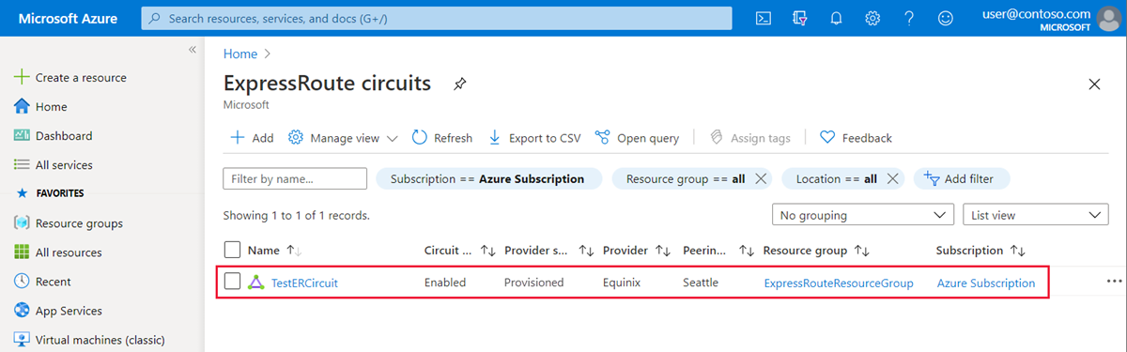

* Choose the peering configuration that you want to reset.

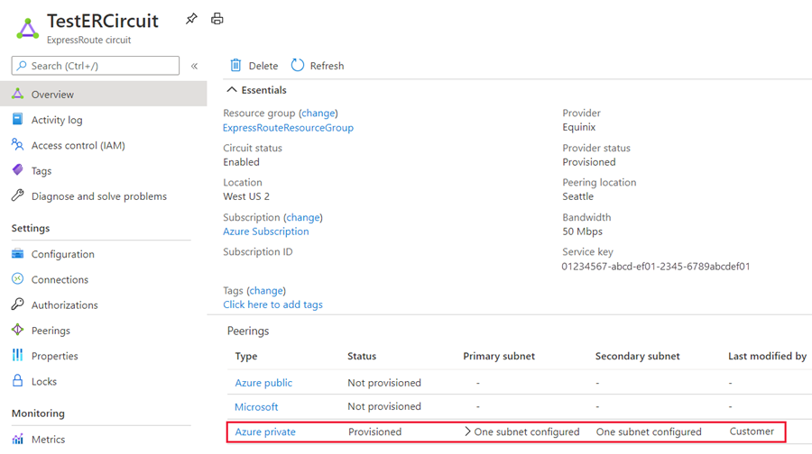

* Clear the **Enable Peering** check box, and then select **Save** to disable the peering configuration.

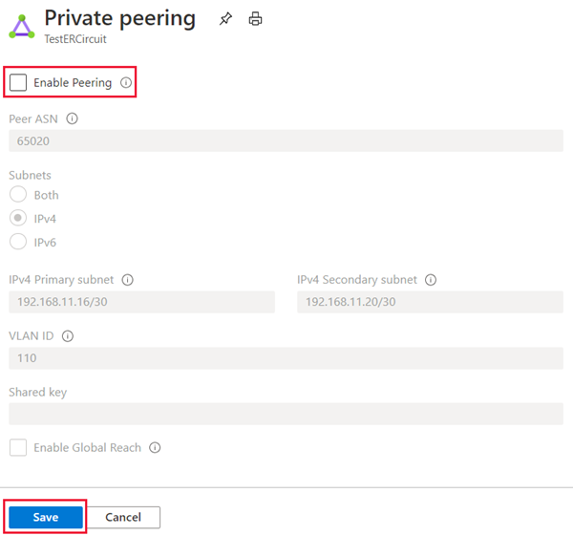

* Select the **Enable Peering** check box, and then select **Save** to re-enable the peering configuration.

# Connect an ExpressRoute circuit to a virtual network

An ExpressRoute circuit represents a logical connection between your on-premises infrastructure and Microsoft cloud services through a connectivity provider. You can order multiple ExpressRoute circuits. Each circuit can be in the same or different regions and can be connected to your premises through different connectivity providers. ExpressRoute circuits do not map to any physical entities. A circuit is uniquely identified by a standard GUID called as a service key (s-key).

## Connect a virtual network to an ExpressRoute circuit

* You must have an active ExpressRoute circuit.
* Ensure that you have Azure private peering configured for your circuit.
* Ensure that Azure private peering gets configured and establishes BGP peering between your network and Microsoft for end-to-end connectivity.
* Ensure that you have a virtual network and a virtual network gateway created and fully provisioned. A virtual network gateway for ExpressRoute uses the GatewayType 'ExpressRoute', not VPN.
* You can link up to 10 virtual networks to a standard ExpressRoute circuit. All virtual networks must be in the same geopolitical region when using a standard ExpressRoute circuit.
* A single VNet can be linked to up to 16 ExpressRoute circuits. Use the following process to create a new connection object for each ExpressRoute circuit you are connecting to. The ExpressRoute circuits can be in the same subscription, different subscriptions, or a mix of both.
* If you enable the ExpressRoute premium add-on, you can link virtual networks outside of the geopolitical region of the ExpressRoute circuit. The premium add-on will also allow you to connect more than 10 virtual networks to your ExpressRoute circuit depending on the bandwidth chosen.
* To create the connection from the ExpressRoute circuit to the target ExpressRoute virtual network gateway, the number of address spaces advertised from the local or peered virtual networks needs to be equal to or less than **200**. Once the connection has been successfully created, you can add additional address spaces, up to 1,000, to the local or peered virtual networks.

# Add a VPN to an ExpressRoute deployment

Configure secure encrypted connectivity between your on-premises network and your Azure virtual networks (VNets) over an ExpressRoute private connection. You can use Microsoft peering to establish a site-to-site IPsec/IKE VPN tunnel between your selected on-premises networks and Azure VNets. Configuring a secure tunnel over ExpressRoute allows for data exchange with confidentiality, anti-replay, authenticity, and integrity.

For high availability and redundancy, you can configure multiple tunnels over the two MSEE-PE pairs of an ExpressRoute circuit and enable load balancing between the tunnels.

VPN tunnels over Microsoft peering can be terminated either using VPN gateway or using an appropriate Network Virtual Appliance (NVA) available through Azure Marketplace. You can exchange routes statically or dynamically over the encrypted tunnels without exposing the route exchange to the underlying Microsoft peering. In this section, BGP (different from the BGP session used to create the Microsoft peering) is used to dynamically exchange prefixes over the encrypted tunnels.

**Important**

For the on-premises side, typically Microsoft peering is terminated on the DMZ and private peering is terminated on the core network zone. The two zones would be segregated using firewalls. If you are configuring Microsoft peering exclusively for enabling secure tunneling over ExpressRoute, remember to filter through only the public IPs of interest that are getting advertised via Microsoft peering.

**Steps**

* Configure Microsoft peering for your ExpressRoute circuit.
* Advertise selected Azure regional public prefixes to your on-premises network via Microsoft peering.
* Configure a VPN gateway and establish IPsec tunnels
* Configure the on-premises VPN device.
* Create the site-to-site IPsec/IKE connection.
* (Optional) Configure firewalls/filtering on the on-premises VPN device.
* Test and validate the IPsec communication over the ExpressRoute circuit.

# Connect geographically dispersed networks with ExpressRoute global reach

## Use cross-region connectivity to link multiple ExpressRoute locations

There are various ways of designing and implementing ExpressRoute based on specific organizational requirements.

ExpressRoute connections enable access to the following services:

* Microsoft Azure services
* Microsoft 365 services

### Connectivity to all regions within a geopolitical region

You can connect to Microsoft in one of the peering locations and access regions within the geopolitical region.

For example, if you connect to Microsoft in Amsterdam through ExpressRoute, you will have access to all Microsoft cloud services hosted in Northern and Western Europe.

### Global connectivity with ExpressRoute Premium

You can enable ExpressRoute Premium to extend connectivity across geopolitical boundaries. For example, if you connect to Microsoft in Amsterdam through ExpressRoute, you will have access to all Microsoft cloud services hosted in all regions across the world. You can also access services deployed in South America or Australia the same way you access North and West Europe regions. National clouds are excluded.

### Local connectivity with ExpressRoute Local

You can transfer data cost-effectively by enabling the Local SKU. With Local SKU, you can bring your data to an ExpressRoute location near the Azure region you want. With Local, Data transfer is included in the ExpressRoute port charge.

### Across on-premises connectivity with ExpressRoute Global Reach

You can enable ExpressRoute Global Reach to exchange data across your on-premises sites by connecting your ExpressRoute circuits. For example, if you have a private data center in California connected to an ExpressRoute circuit in Silicon Valley and another private data center in Texas connected to an ExpressRoute circuit in Dallas. With ExpressRoute Global Reach, you can connect your private data centers together through these two ExpressRoute circuits. Your cross-data-center traffic will traverse through Microsoft's network.

### ExpressRoute Direct

ExpressRoute is a private and resilient way to connect your on-premises networks to the Microsoft Cloud. You can access many Microsoft cloud services such as Azure and Microsoft 365 from your private data center or your corporate network. For example, you might have a branch office in San Francisco with an ExpressRoute circuit in Silicon Valley and another branch office in London with an ExpressRoute circuit in the same city. Both branch offices have high-speed connectivity to Azure resources in US West and UK South. However, the branch offices cannot connect and send data directly with one another. In other words, 10.0.1.0/24 can send data to 10.0.3.0/24 and 10.0.4.0/24 network, but NOT to 10.0.2.0/24 network.

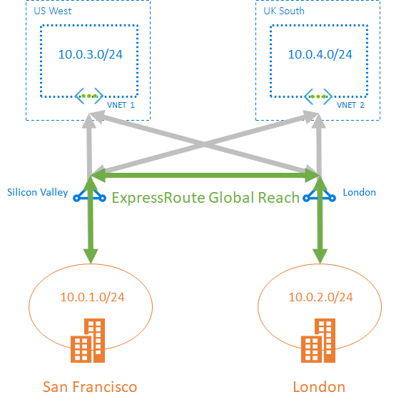

# Choose when to use ExpressRoute global reach

ExpressRoute Global Reach is designed to complement your service provider’s WAN implementation and connect your branch offices across the world. For example, if your service provider primarily operates in the United States and has linked all your branches in the U.S., but the service provider does not operate in Japan and Hong Kong SAR, with ExpressRoute Global Reach you can work with a local service provider and Microsoft will connect your branches there to the ones in the U.S. using ExpressRoute and the Microsoft global network.

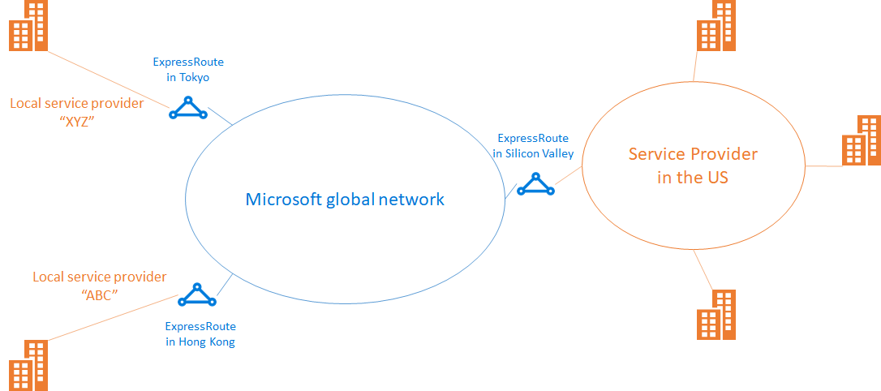

## Configure ExpressRoute global reach

These steps show you how to configure ExpressRoute Global Reach using Azure portal.

### Before you begin

Before you start configuration, confirm the following criteria:

* You understand ExpressRoute circuit provisioning workflows.
* Your ExpressRoute circuits are in a provisioned state.
* Azure private peering is configured on your ExpressRoute circuits.
* If you want to run PowerShell locally, verify that the latest version of Azure PowerShell is installed on your computer.

### Identify circuits

Identify the ExpressRoute circuits that you want use. You can enable ExpressRoute Global Reach between the private peering of any two ExpressRoute circuits, if they are in the supported countries/regions. The circuits are required to be created at different peering locations.

* If your subscription owns both circuits, you can choose either circuit to run the configuration in the following sections.
* If the two circuits are in different Azure subscriptions, you need authorization from one Azure subscription. Then you pass in the authorization key when you run the configuration command in the other Azure subscription.



### Enable connectivity

Enable connectivity between your on-premises networks. There are separate sets of instructions for circuits that are in the same Azure subscription, and circuits that are different subscriptions.

### ExpressRoute circuits in the same Azure subscription

1. Select the Azure private peering configuration.



1. Select **Add Global Reach** to open the Add Global Reach configuration page.

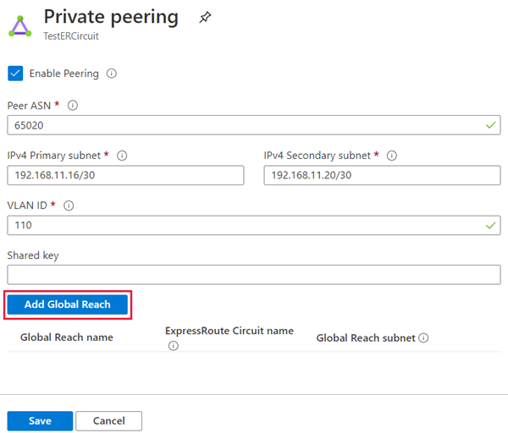

1. On the Add Global Reach configuration page, give a name to this configuration. Select the ExpressRoute circuit you want to connect this circuit to and enter in a **/29 IPv4** for the Global Reach subnet. Azure uses IP addresses in this subnet to establish connectivity between the two ExpressRoute circuits. Do not use the addresses in this subnet in your Azure virtual networks, or in your on-premises network. Select **Add** to add the circuit to the private peering configuration.

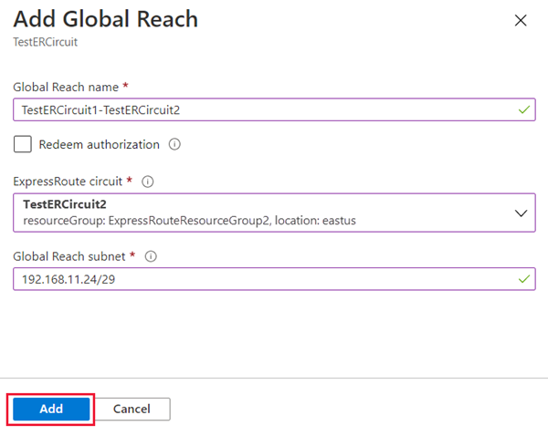

1. Select **Save** to complete the Global Reach configuration. When the operation completes, you will have connectivity between your two on-premises networks through both ExpressRoute circuits.

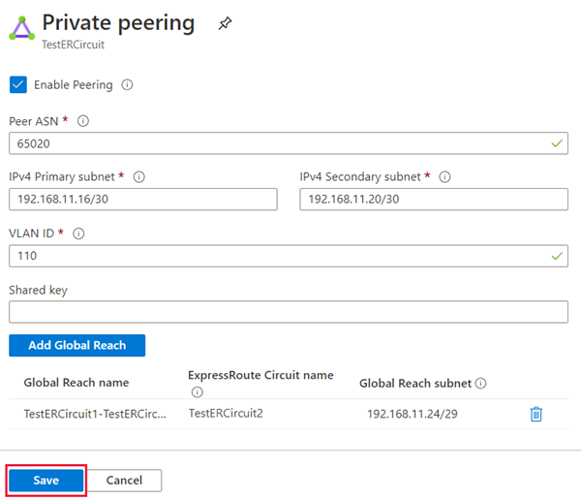

### Verify the configuration

Verify the Global Reach configuration by selecting Private peering under the ExpressRoute circuit configuration. When configured correctly your configuration should look as follows:

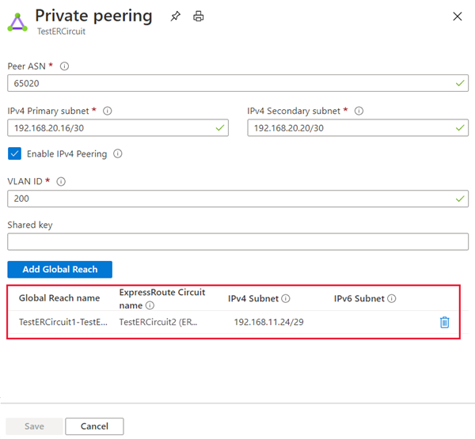

### Disable connectivity

To disable connectivity between an individual circuit, select the delete button next to the Global Reach name to remove connectivity between them. Then select **Save** to complete the operation.

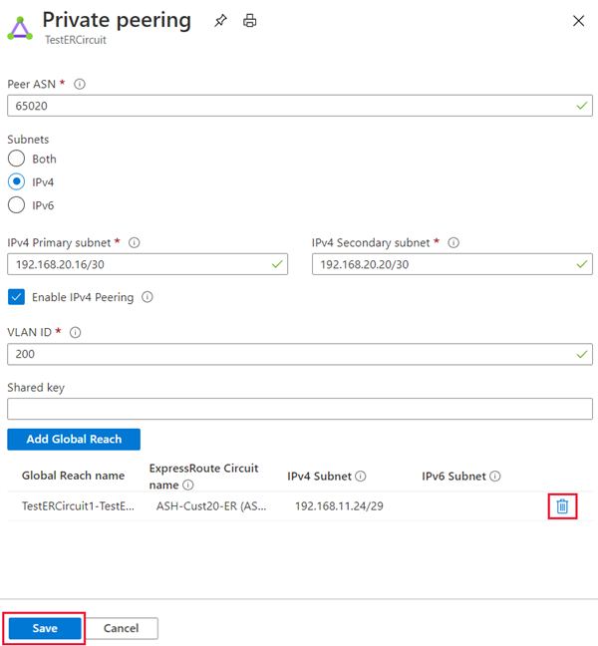

# Improve data path performance between networks with ExpressRoute FastPath

ExpressRoute virtual network gateway is designed to exchange network routes and route network traffic. FastPath is designed to improve the data path performance between your on-premises network and your virtual network. When enabled, FastPath sends network traffic directly to virtual machines in the virtual network, bypassing the gateway.

**Circuits:** FastPath is available on all ExpressRoute circuits.

**Gateways:** FastPath still requires a virtual network gateway to be created to exchange routes between virtual network and on-premises network.

## Gateway requirements for ExpressRoute FastPath

To configure FastPath, the virtual network gateway must be either:

* Ultra-Performance
* ErGw3AZ

## Limitations

While FastPath supports most configurations, it does not support the following features:

* UDR on the gateway subnet: This UDR has no impact on the network traffic that FastPath sends directly from your on-premises network to the virtual machines in Azure virtual network.
* VNet Peering: If you have other virtual networks peered with the one that is connected to ExpressRoute, the network traffic from your on-premises network to the other virtual networks (i.e., the so-called "Spoke" VNets) will continue to be sent to the virtual network gateway. The workaround is to connect all the virtual networks to the ExpressRoute circuit directly.
* Basic Load Balancer: If you deploy a Basic internal load balancer in your virtual network or the Azure PaaS service you deploy in your virtual network uses a Basic internal load balancer, the network traffic from your on-premises network to the virtual IPs hosted on the Basic load balancer will be sent to the virtual network gateway. The solution is to upgrade the Basic load balancer to a Standard load balancer.
* Private Link: If you connect to a private endpoint in your virtual network from your on-premises network, the connection will go through the virtual network gateway.

### Configure ExpressRoute FastPath

To enable FastPath, connect a virtual network to an ExpressRoute circuit using the Azure portal.

This section shows you how to create a connection to link a virtual network to an Azure ExpressRoute circuit using the Azure portal. The virtual networks that you connect to your Azure ExpressRoute circuit can either be in the same subscription or be part of another subscription.

### Prerequisites

* Review the routing requirements, and workflows before you begin configuration.
* You must have an active ExpressRoute circuit.
* Follow the instructions to create an ExpressRoute circuit and have the circuit enabled by your connectivity provider.
* Ensure that you have Azure private peering configured for your circuit.
* Ensure that Azure private peering gets configured and establishes BGP peering between your network and Microsoft for end-to-end connectivity.
* Ensure that you have a virtual network and a virtual network gateway created and fully provisioned. A virtual network gateway for ExpressRoute uses the GatewayType 'ExpressRoute', not VPN.
* You can link up to 10 virtual networks to a standard ExpressRoute circuit. All virtual networks must be in the same geopolitical region when using a standard ExpressRoute circuit.
* A single VNet can be linked to up to 16 ExpressRoute circuits. Use the following process to create a new connection object for each ExpressRoute circuit you are connecting to. The ExpressRoute circuits can be in the same subscription, different subscriptions, or a mix of both.
* If you enable the ExpressRoute premium add-on, you can link virtual networks outside of the geopolitical region of the ExpressRoute circuit. The premium add-on will also allow you to connect more than 10 virtual networks to your ExpressRoute circuit depending on the bandwidth chosen.
* To create the connection from the ExpressRoute circuit to the target ExpressRoute virtual network gateway, the number of address spaces advertised from the local or peered virtual networks needs to be equal to or less than **200**. Once the connection has been successfully created, you can add additional address spaces, up to 1,000, to the local or peered virtual networks.

# Connect a VNet to a circuit - same subscription

1. To create a connection Ensure that your ExpressRoute circuit and Azure private peering have been configured successfully. Your ExpressRoute circuit should look like the following image:

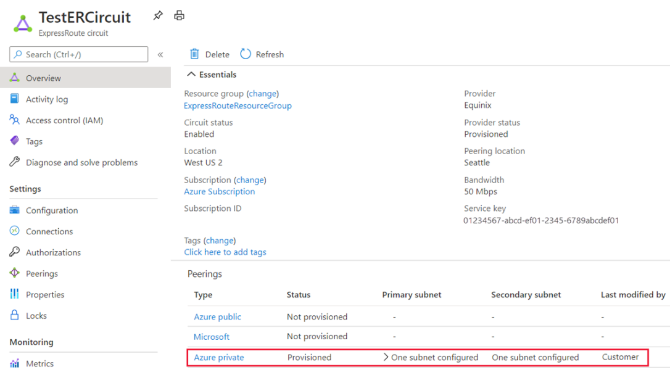

1. You can now start provisioning a connection to link your virtual network gateway to your ExpressRoute circuit. Select **Connection** > **Add** to open the **Add connection** page.

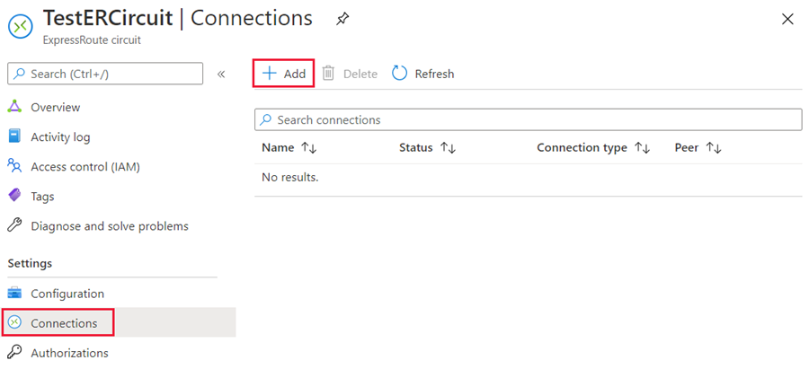

1. Enter a name for the connection and then select **Next: Settings >**.

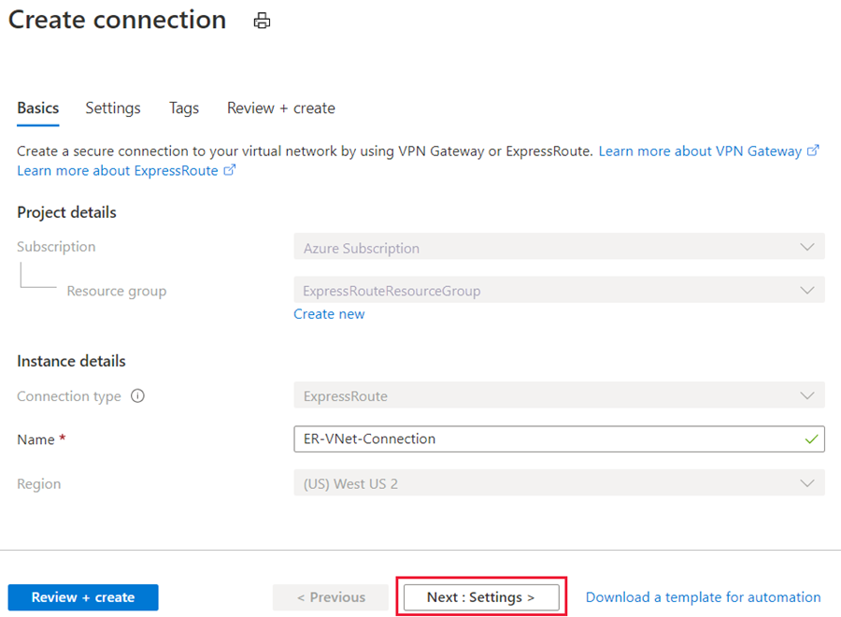

1. Select the gateway that belongs to the virtual network that you want to link to the circuit and select **Review + create**. Then select **Create** after validation completes.

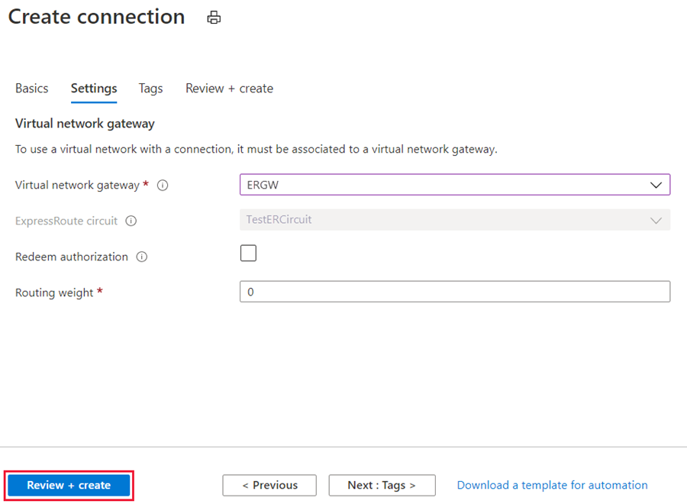

1. After your connection has been successfully configured, your connection object will show the information for the connection.

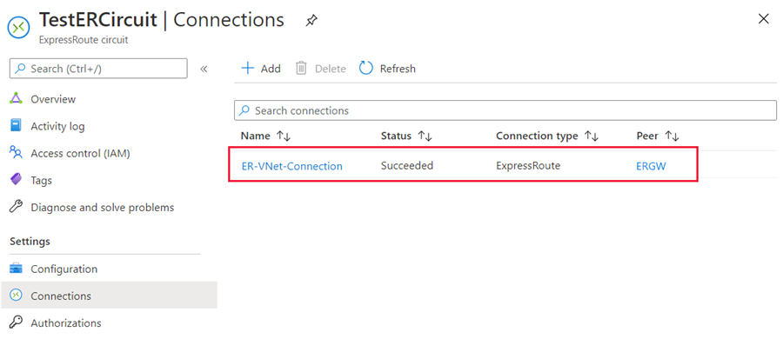

# Administration - About circuit owners and circuit users

The 'circuit owner' is an authorized Power User of the ExpressRoute circuit resource. The circuit owner can create authorizations that can be redeemed by 'circuit users'. Circuit users are owners of virtual network gateways that are not within the same subscription as the ExpressRoute circuit. Circuit users can redeem authorizations (one authorization per virtual network).

The circuit owner has the power to modify and revoke authorizations at any time. Revoking an authorization results in all link connections being deleted from the subscription whose access was revoked.

## Circuit owner operations

### To create a connection authorization

The circuit owner creates an authorization, which creates an authorization key to be used by a circuit user to connect their virtual network gateways to the ExpressRoute circuit. An authorization is valid for only one connection.

1. In the ExpressRoute page, select **Authorizations** and then type a **name** for the authorization and select **Save**.

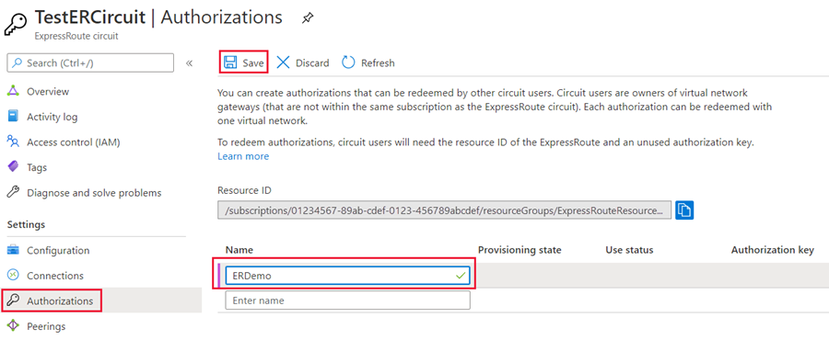

1. Once the configuration is saved, copy the **Resource ID** and the **Authorization Key**.

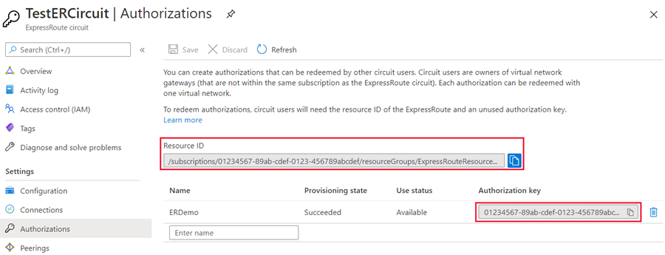

1. To delete a connection authorization

You can delete a connection by selecting the Delete icon for the authorization key for your connection.

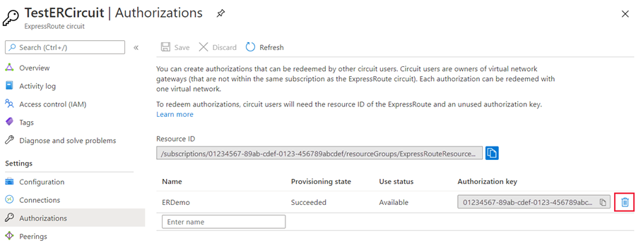

If you want to delete the connection but retain the authorization key, you can delete the connection from the connection page of the circuit.

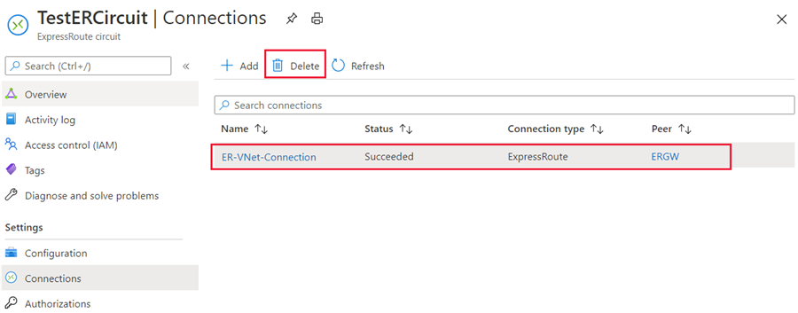

### To redeem a connection authorization

1.Select the + Create a resource button. Search for Connection and select Create.

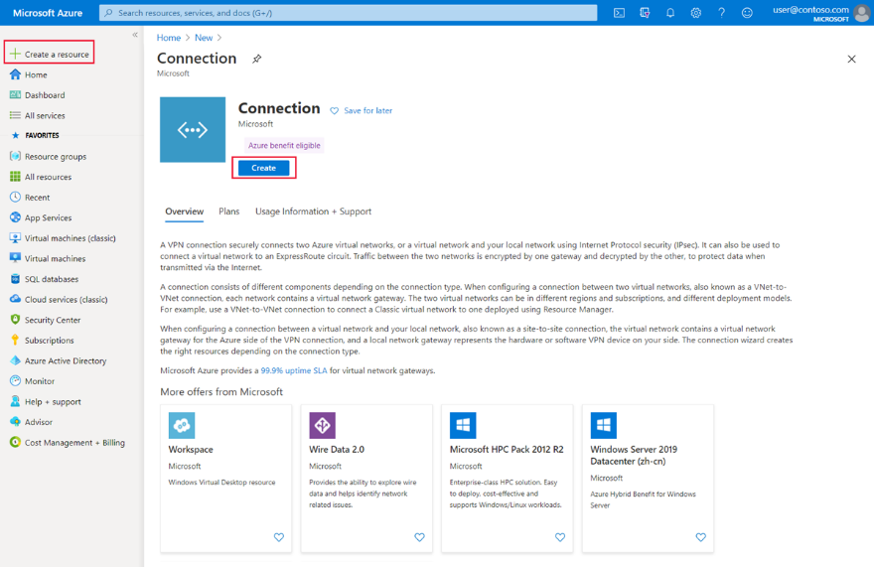

2. Make sure the Connection type is set to **ExpressRoute**. Select the Resource group and Location, then select **OK** in the Basics page.

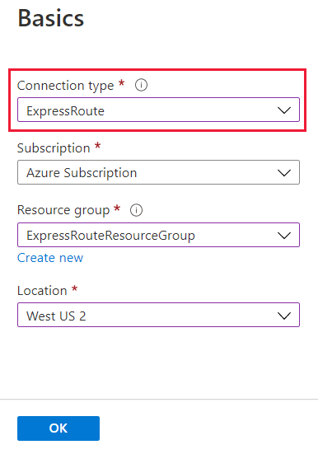

3. In the **Settings** page, Select the Virtual network gateway and check the **Redeem authorization** check box. Enter the Authorization key and the Peer circuit URI and give the connection a name. Select **OK**.

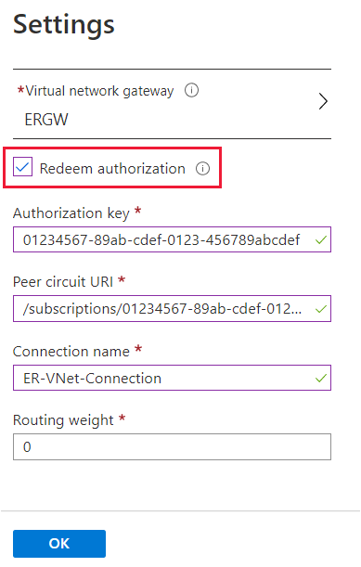

4. Review the information in the **Summary** page and select **OK**.

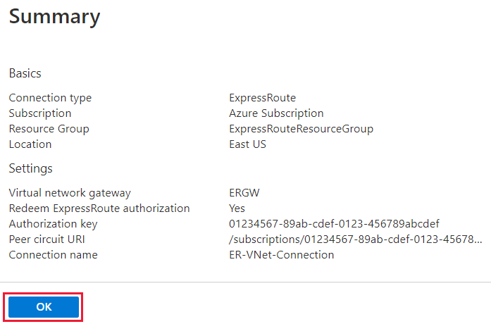

### Clean up resources:

You can delete a connection and unlink your VNet to an ExpressRoute circuit by selecting the Delete icon on the page for your connection.

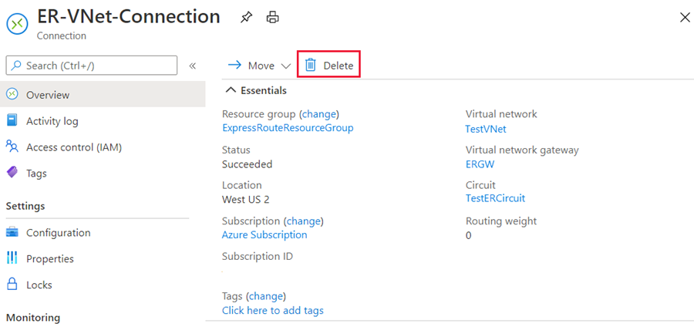

# Troubleshoot ExpressRoute connection issues

ExpressRoute connectivity traditionally involves three distinct network zones, as follows:

* Customer Network
* Provider Network
* Microsoft Datacenter

**Note**

In the ExpressRoute direct connectivity model (offered at 10/100 Gbps bandwidth), customers can directly connect to Microsoft Enterprise Edge (MSEE) routers' port. Therefore, in the direct connectivity model, there are only customer and Microsoft network zones.

## **Verify circuit provisioning and state through the Azure portal**

Provisioning an ExpressRoute circuit establishes a redundant Layer 2 connections between CEs/PE-MSEEs (2)/(4) and MSEEs (5).

In the Azure portal, open the ExpressRoute circuit blade. In the section of the blade, the ExpressRoute essentials are listed as shown in the following screenshot:

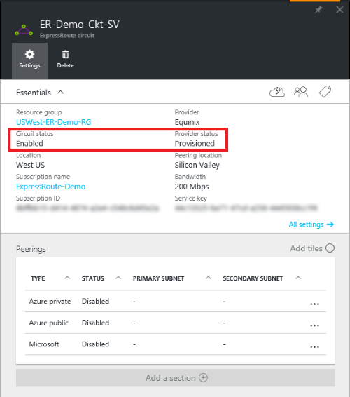

In the ExpressRoute Essentials, Circuit status indicates the status of the circuit on the Microsoft side. Provider status indicates if the circuit has been Provisioned/Not provisioned on the service-provider side.

For an ExpressRoute circuit to be operational, the Circuit status must be Enabled, and the Provider status must be Provisioned.

## **Validate peering configuration**

After the service provider has completed the provisioning the ExpressRoute circuit, multiple eBGP based routing configurations can be created over the ExpressRoute circuit between CEs/MSEE-PEs (2)/ (4) and MSEEs (5). Each ExpressRoute circuit can have: Azure private peering, and/or Microsoft peering.

In the Azure portal, status of an ExpressRoute circuit peering can be checked under the ExpressRoute circuit blade. In the overview section of the blade, the ExpressRoute peering would be listed as shown in the following screenshot:

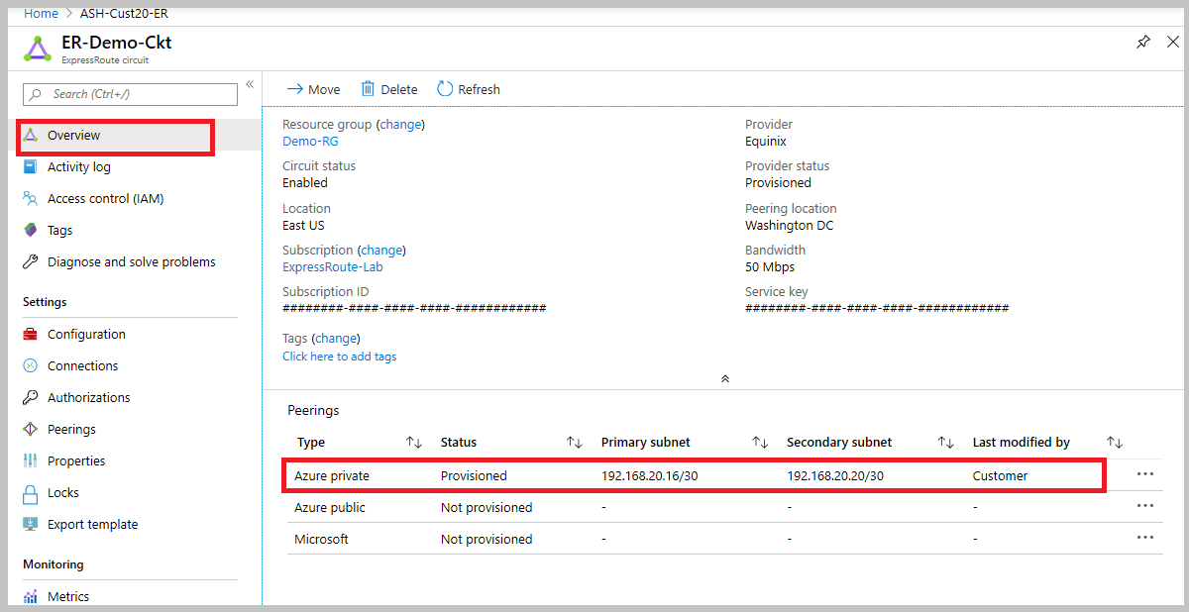

In the preceding example, as noted Azure private peering is provisioned, whereas Azure public and Microsoft peering are not provisioned. A successfully provisioned peering context would also have the primary and secondary point-to-point subnets listed. The /30 subnets are used for the interface IP address of the MSEEs and CEs/PE-MSEEs. For the peering that are provisioned, the listing also indicates who last modified the configuration.

**Note**

On a /30 subnet assigned for interface, Microsoft will pick the second usable IP address of the subnet for the MSEE interface. Therefore, ensure that the first usable IP address of the subnet has been assigned on the peered CE/PE-MSEE.

## **Validate Address Resolution Protocol (ARP)**

Address Resolution Protocol (ARP) is a layer 2 protocol defined in RFC 826. ARP is used to map the Ethernet address (MAC address) with an ip address. ARP tables can help validate layer 2 configuration and troubleshooting basic layer 2 connectivity issues.

The ARP table provides a mapping of the IP address and MAC address for a particular peering. The ARP table for an ExpressRoute circuit peering provides the following information for each interface (primary and secondary):

* Mapping of on-premises router interface ip address to the MAC address
* Mapping of ExpressRoute router interface ip address to the MAC address
* Age of the mapping ARP tables can help validate layer 2 configuration and troubleshooting basic layer 2 connectivity issues.

**ARP table when Microsoft side has problems**

* You won't see an ARP table shown for a peering if there are issues on the Microsoft side.
* Open a support ticket with Microsoft support. Specify that you have an issue with layer 2 connectivity.

**Next Steps**

* Validate Layer 3 configurations for your ExpressRoute circuit.
* Get route summary to determine the state of BGP sessions.
* Get route table to determine which prefixes are advertised across ExpressRoute.
* Validate data transfer by reviewing bytes in / out.
* Open a support ticket with Microsoft support if you're still experiencing issues.

## **ExpressRoute monitoring tools**

ExpressRoute uses Network insights to provide a detailed topology mapping of all ExpressRoute components (peerings, connections, gateways) in relation with one another. Network insights for ExpressRoute also have preloaded metrics dashboard for availability, throughput, packet drops, and gateway metrics.

You can analyze metrics for Azure ExpressRoute with metrics from other Azure services using metrics explorer by opening Metrics from the Azure Monitor menu.

* To view ExpressRoute metrics, filter by Resource Type ExpressRoute circuits.
* To view Global Reach metrics, filter by Resource Type ExpressRoute circuits and select an ExpressRoute circuit resource that has Global Reach enabled.
* To view ExpressRoute Direct metrics, filter Resource Type by ExpressRoute Ports.

# Module 4 : Explore load balancing

The term load balancing refers to the even distribution of workloads (that is, incoming network traffic), across a group of backend computing resources or servers. Load balancing aims to optimize resource use, maximize throughput, minimize response time, and avoid overloading any single resource. It can also improve availability by sharing a workload across redundant computing resources.

## **Load Balancing options for Azure**

Azure provides various load balancing services that you can use to distribute your workloads across multiple computing resources, but the following are the main services:

* **Azure Load Balancer** - high-performance, ultra-low-latency Layer 4 load-balancing service (inbound and outbound) for all UDP and TCP protocols. It's built to handle millions of requests per second while ensuring your solution is highly available. Azure Load Balancer is zone-redundant, ensuring high availability across Availability Zones.
* **Traffic Manager** - DNS-based traffic load balancer that enables you to distribute traffic optimally to services across global Azure regions, while providing high availability and responsiveness. Because Traffic Manager is a DNS-based load-balancing service, it load-balances only at the domain level. For that reason, it can't fail over as quickly as Front Door, because of common challenges around DNS caching and systems not honoring DNS time-to-live values (TTLs).
* **Azure Application Gateway** - provides application delivery controller (ADC) as a service, offering various Layer 7 load-balancing capabilities. Use it to optimize web farm productivity by offloading CPU-intensive SSL termination to the gateway.
* **Azure Front Door** - application delivery network that provides global load balancing and site acceleration service for web applications. It offers Layer 7 capabilities for your application like SSL offload, path-based routing, fast failover, caching, etc. to improve performance and high-availability of your applications.

# Categorizing load balancing services

The above load balancing services can be categorized in two ways: global versus regional, and HTTP(S) versus non-HTTP(S).

## Global versus regional

**Global** load-balancing services distribute traffic across regional backends, clouds, or hybrid on-premises services. These services route end-user traffic to the closest available backend. They also react to changes in service reliability or performance to maximize availability and performance. You can think of them as systems that load balance between application stamps, endpoints, or scale-units hosted across different regions/geographies.

In contrast, **Regional** load-balancing services distribute traffic within virtual networks across virtual machines (VMs) or zonal and zone-redundant service endpoints within a region. You can think of them as systems that load balance between VMs, containers, or clusters within a region in a virtual network.

## HTTP(S) versus non-HTTP(S)

**HTTP(S)** load-balancing services are Layer 7 load balancers that only accept HTTP(S) traffic. They're intended for web applications or other HTTP(S) endpoints. They include features such as SSL offload, web application firewall, path-based load balancing, and session affinity.

In contrast, **non-HTTP(S)** load-balancing services can handle non-HTTP(S) traffic and are recommended for non-web workloads.

The table below summarizes these categorizations for each Azure load balancing service.

|  |  |  |
| --- | --- | --- |
| **Service** | **Global/regional** | **Recommended traffic** |
| Azure Front Door | Global | HTTP(S) |
| Traffic Manager | Global | non-HTTP(S) |
| Application Gateway | Regional | HTTP(S) |
| Azure Load Balancer | Regional or Global | non-HTTP(S) |

# Choosing a load balancing option for Azure

When choosing an appropriate load balancing option, there are some key factors to consider:

* **Type of traffic** - is it for a web application? Is it a public-facing or private application?
* **Scope** - do you need to load balance virtual machines and containers within a virtual network, or load balance across regions, or both? (see 'Global versus regional' above)
* **Availability** - what is the Service Level Agreement (SLA) for the service?
* **Cost** - In addition to the cost of the actual service itself, consider the operational cost to manage and maintain a solution built on that service. See [Load balancing pricing](https://azure.microsoft.com/pricing/details/load-balancer/).
* **Features and limitations** - what features and benefits does each service provide, and what are its limitations? See [Load balancer limits](https://learn.microsoft.com/en-us/azure/azure-resource-manager/management/azure-subscription-service-limits).

The flowchart below will help you select the most appropriate load-balancing solution for your application, by guiding you through a set of key decision criteria to reach a recommendation.

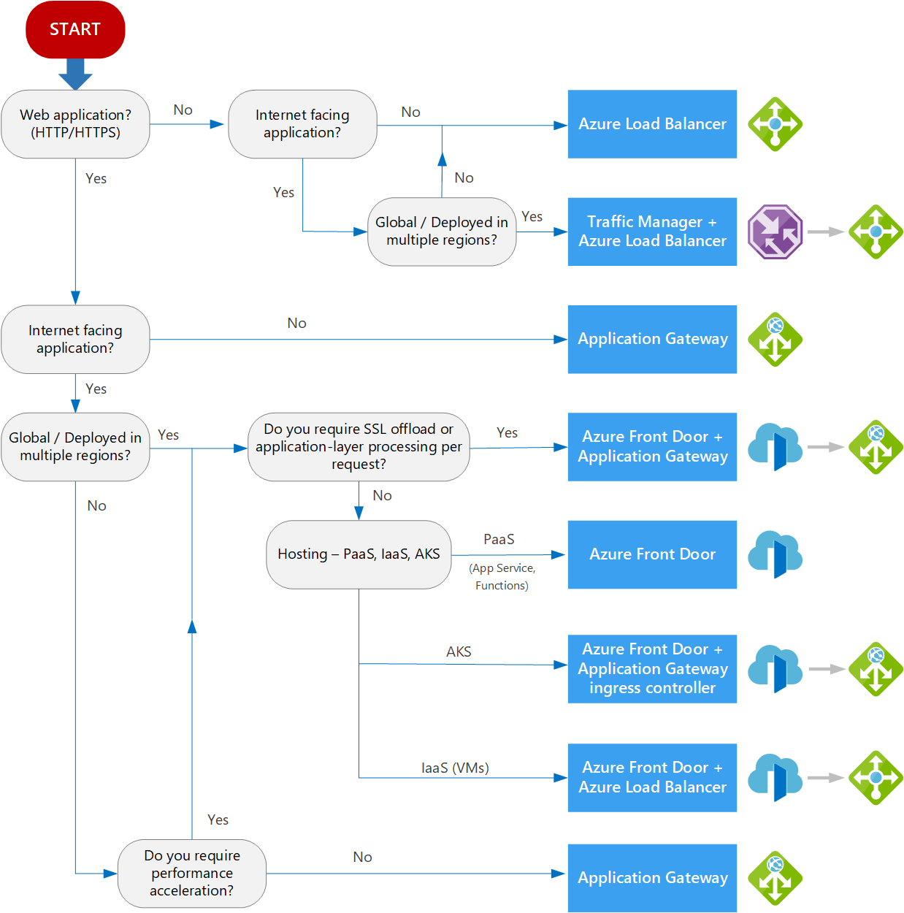

# Selecting a load balancing solution by using the Azure portal

You can use the **Azure Load Balancing** page in the Azure portal to help you guide to the right load-balancing solution for your business need. Azure Load Balancing includes the decision-making queries described in the workflow diagram above.

* Sign into the Azure portal at [https://portal.azure.com](https://portal.azure.com/).
* In the search box at the top of the page, type load balancing. When **Load balancing - help me choose (Preview)** appears in the search results, select it.

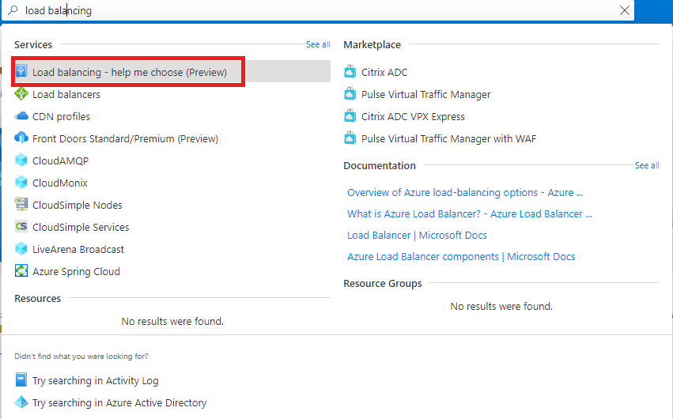

* Answer the Yes or No questions on this page to get a recommended solution. Note that the final recommended solution may be a combination of multiple load balancing services.

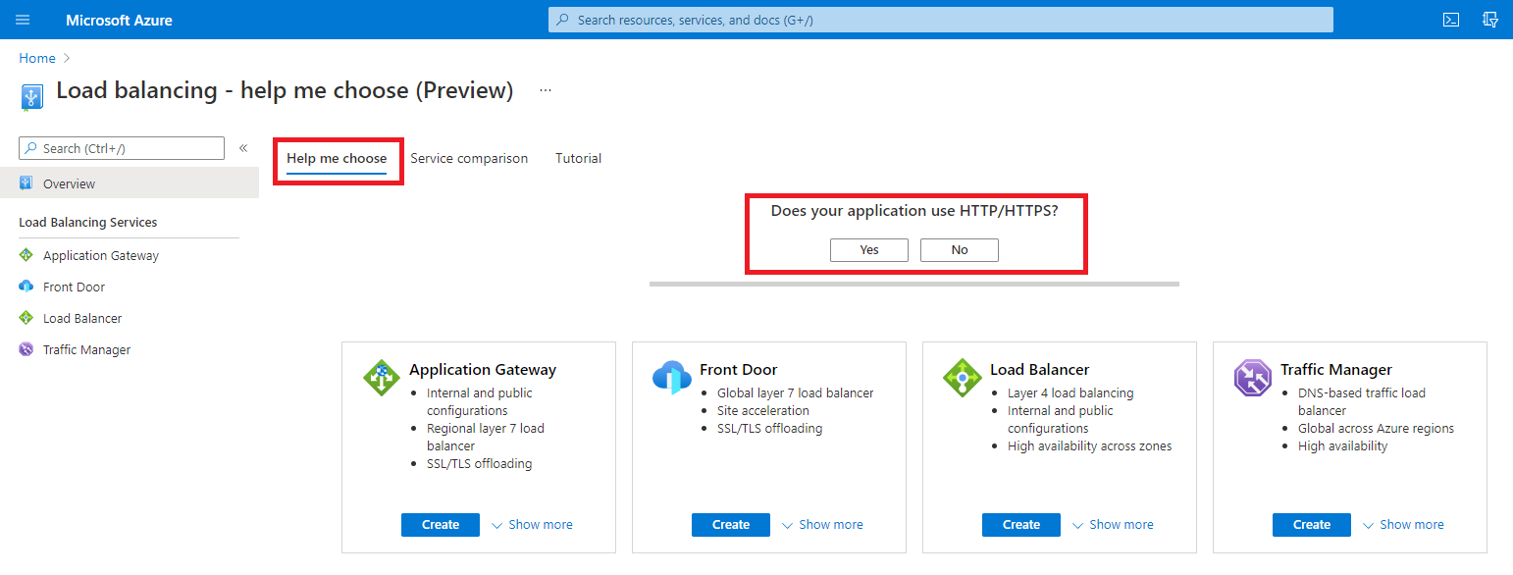

* Depending on what answers you give, the list of potential load balancing services change.

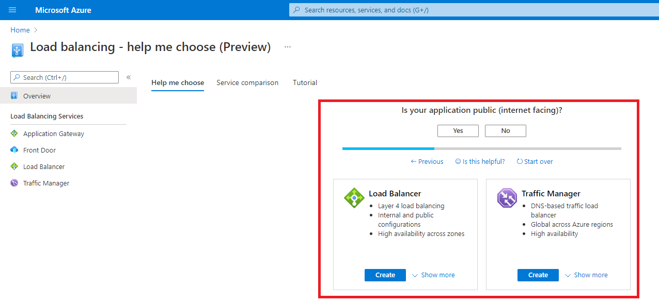

* Optionally, you can also select the **Service comparison** or **Tutorial** tabs for more information and training on the different load balancing services.

# Design and implement Azure load balancer using the Azure portal

**Azure Load Balancer** operates at layer 4 of the Open Systems Interconnection (OSI) model. It's the single point of contact for clients. Azure Load Balancer distributes inbound flows that arrive at the load balancer's front end to backend pool instances. These flows are according to configured load-balancing rules and health probes. The backend pool instances can be Azure Virtual Machines or instances in a virtual machine scale set.

## Load balancer type

Load balancers can be public (also known as external) or internal (also known as private).

A **public load balancer** can provide outbound connections for virtual machines (VMs) inside your virtual network. These connections are accomplished by translating their private IP addresses to public IP addresses. External load balancers are used to distribute client traffic from the internet across your VMs. That internet traffic might come from web browsers, module apps, or other sources.

An **internal load balancer** is used where private IPs are needed at the frontend only. Internal load balancers are used to load balance traffic from internal Azure resources to other Azure resources inside a virtual network. A load balancer frontend can also be accessed from an on-premises network in a hybrid scenario.

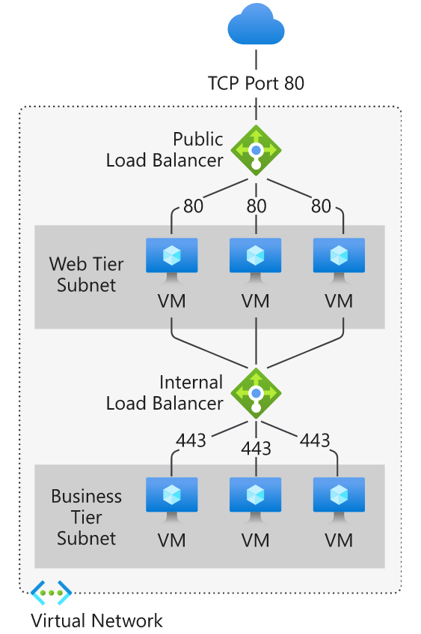

## Azure load balancer and availability zones

Azure services that support availability zones fall into three categories:

* Zonal services: Resources can be pinned to a specific zone. For example, virtual machines, managed disks, or standard IP addresses can be pinned to a specific zone, which allows for increased resilience by having one or more instances of resources spread across zones.
* Zone-redundant services: Resources are replicated or distributed across zones automatically. Azure replicates the data across three zones so that a zone failure doesn't impact its availability.
* Non-regional services: Services are always available from Azure geographies and are resilient to zone-wide outages and region-wide outages.

Azure Load Balancer supports availability zones scenarios. You can use Standard Load Balancer to increase availability throughout your scenario by aligning resources with, and distribution across zones. Review this document to understand these concepts and fundamental scenario design guidance.

A Load Balancer can either be zone redundant, zonal, or non-zonal. To configure the zone related properties (mentioned above) for your load balancer, select the appropriate type of frontend needed.

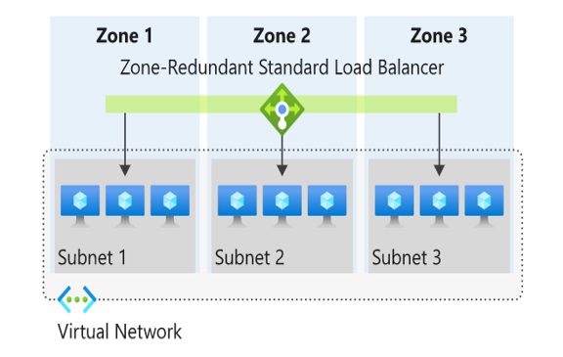

In a region with Availability Zones, a Standard Load Balancer can be zone-redundant. This traffic is served by a single IP address.

A single frontend IP address survives zone failure. The frontend IP may be used to reach all (non-impacted) backend pool members no matter the zone. One or more availability zones can fail and the data path survives as long as one zone in the region remains healthy.

The frontend's IP address is served simultaneously by multiple independent infrastructure deployments in multiple availability zones. Any retries or reestablishment succeed in other zones not affected by the zone failure.

### Zonal

You can choose to have a frontend guaranteed to a single zone, which is known as a zonal. This scenario means any inbound or outbound flow is served by a single zone in a region. Your frontend shares fate with the health of the zone. The data path is unaffected by failures in zones other than where it was guaranteed. You can use zonal frontends to expose an IP address per Availability Zone.

Additionally, the use of zonal frontends directly for load balanced endpoints within each zone is supported. You can use this configuration to expose per zone load-balanced endpoints to individually monitor each zone. For public endpoints, you can integrate them with a DNS load-balancing product like Traffic Manager and use a single DNS name.

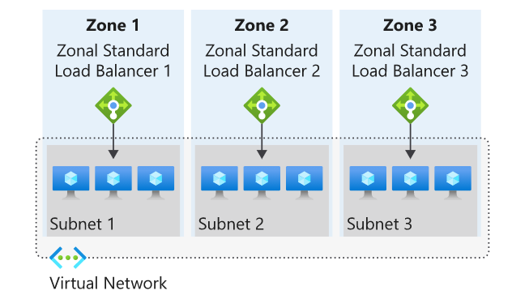

For a public load balancer frontend, you add a zones parameter to the public IP. This public IP is referenced by the frontend IP configuration used by the respective rule.

For an internal load balancer frontend, add a zones parameter to the internal load balancer frontend IP configuration. A zonal frontend guarantees an IP address in a subnet to a specific zone.

## Selecting an Azure load balancer SKU

Two SKUs are available when you create a load balancer in Azure: Basic load balancers and Standard load balancers. These SKUs differ in terms of their scenario scope and scale, features, and cost. Any scenario that is possible with the Basic load balancer can also be created with the Standard load balancer.

**Microsoft recommends Standard load balancer. Standalone VMs, availability sets, and virtual machine scale sets can be connected to only one SKU, never both. Load balancer and the public IP address SKU must match when you use them with public IP addresses.**

**SKUs aren't mutable; therefore, you cannot change the SKU of an existing resource.**

## Creating and configuring an Azure load balancer

There are several tasks you need to perform to successfully create and configure an Azure Load Balancer.

### **Create the load balancer**

In this example, we're looking at the tasks required to create and configure a **Public** (external) **load balancer** in a **Standard SKU**. The first task is to create the load balancer itself. During the creation process, a frontend IP configuration is created and a public IP address is assigned. You can also add a backend pool, create a health probe, and add load balancing rules during the creation process, but we add these components later in the process.

From the Azure portal home page, navigate to the Global Search bar and search **Load Balancer** then select **Load balancers**.

Choose **+ Create** or **Create load balancer** to start the process.

On the **Create load balancer** page, you must supply the following required information on the **Basics** tab:

|  |  |
| --- | --- |
| **Setting** | **Value** |
| Subscription | Select the Azure subscription that you want to create your new load balancer resource in. |
| Resource group | Here you can select an existing resource group or create a new one. |
| Name | Provide a unique name for the instance. |
| Region | Select the region where the virtual machines were created. |
| Type | This is where you select whether your load balancer is going to be **Internal** (private) or **Public** (external). If you choose **Internal**, you need to specify a virtual network and IP address assignment, but if you choose **Public**, you need to specify several Public IP address details. |
| SKU | Here you can select either the **Standard** SKU or the **Basic** SKU (for production workloads you should choose **Standard**, but for testing and evaluation and training purposes, you could choose **Basic**, but you won't get all the possible load balancer features). Depending on which SKU you select here, the remaining configuration options differ slightly. |
| Tier | This is where you select whether your load balancer is balancing within a region (**Regional**) or across regions (**Global**) - If you select the **Basic** SKU above, this setting is greyed out. |

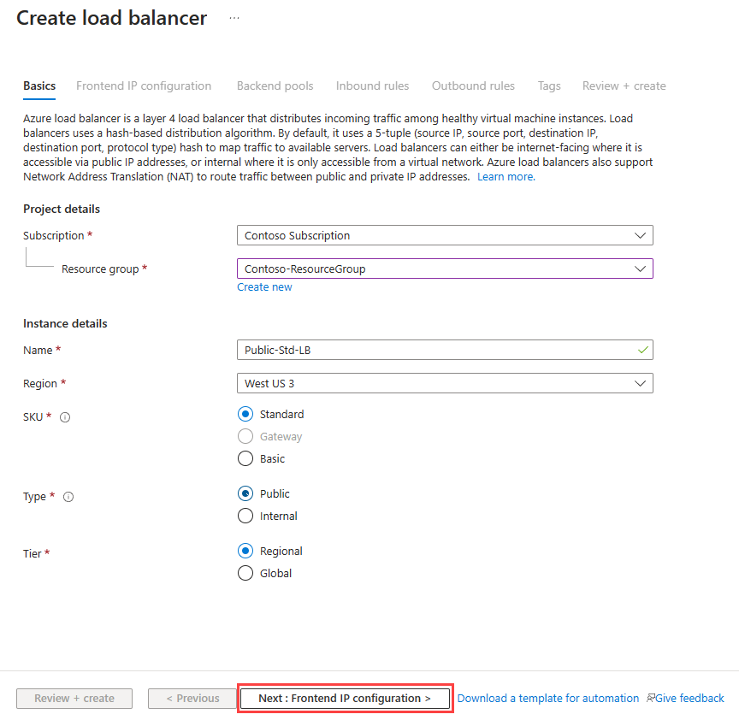

After you select **Next: Frontend IP configuration**, select **+ Add frontend IP address** to add a public IP address for your public-facing front-end. You add a name for the frontend IP configuration, choose IP version and IP type, then add a Public IP Address. You can create a new public IP address for your public-facing front-end, or use an existing one. When creating a new public IP address, you specify the name and you also specify a name for your public IP address, and whether to use a dynamic or statically assigned IP address. You can optionally also assign an IPv6 address to your load balancer in addition to the default IPv4 one.

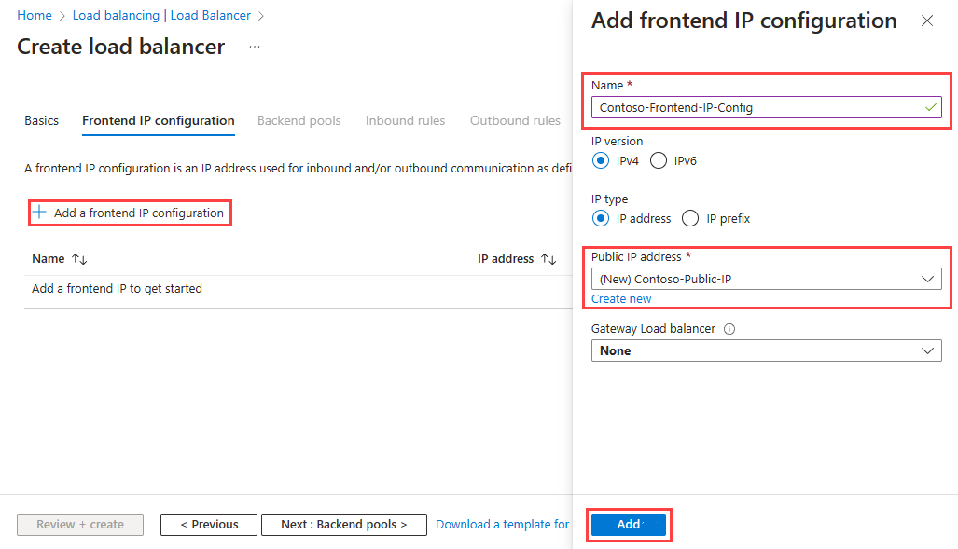

Once completed with the frontend IP configuration, select **Review + Create**, where the configuration settings for the new load balancer resource will be validated, and then you can select **Create** to deploy the resource.

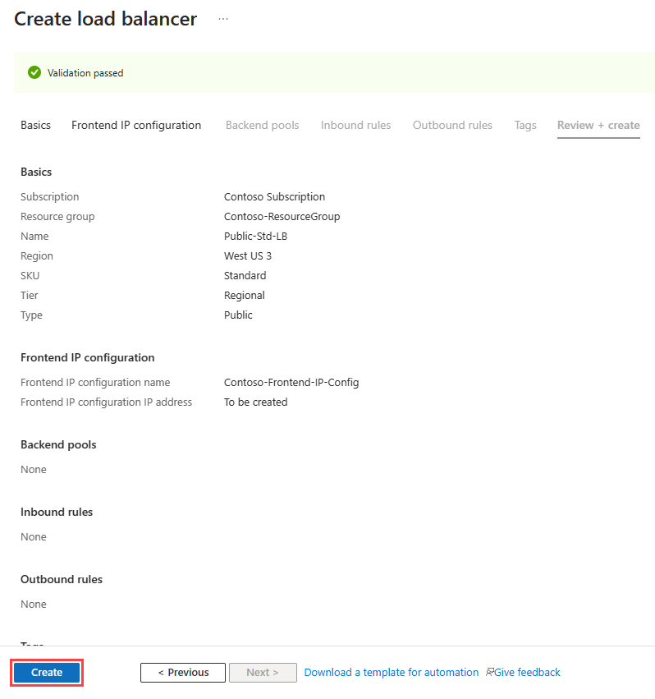

The resource starts to be deployed.

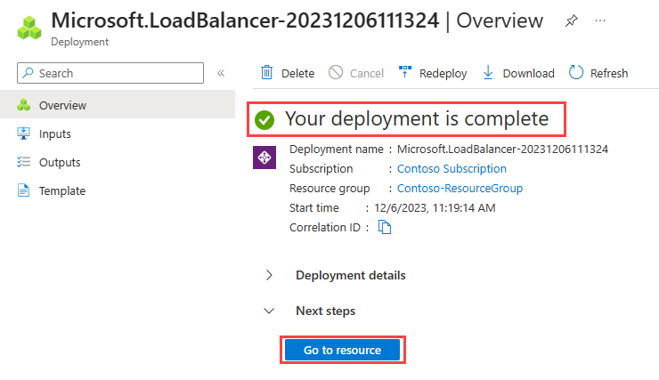

When it completes, you can select **Go to resource** to view the new load balancer resource in the portal

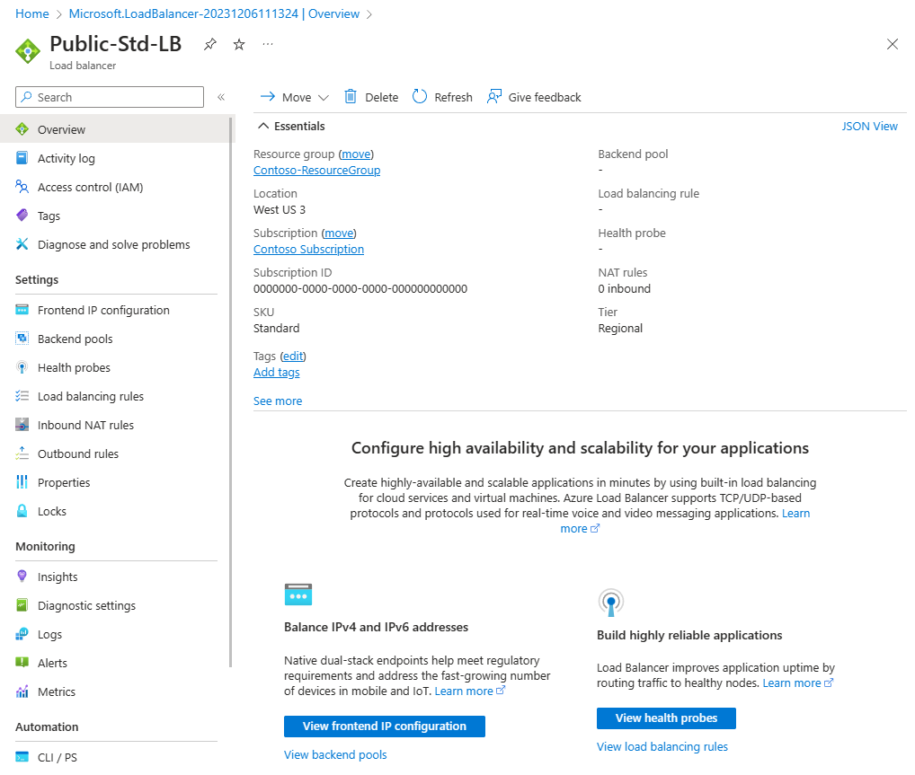

### **Add a backend pool**

The next task is to create a backend pool in the load balancer and then adds your virtual machines to it.

From the Load balancer Overview page for your load balancer, select **Backend pools** under Settings and select **+ Add**.

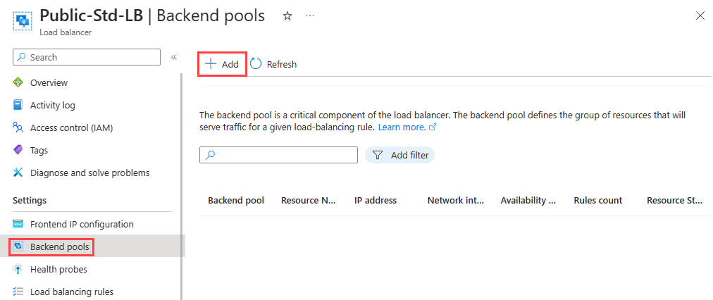

You need to enter the following information on the **Add backend pool** page:

|  |  |
| --- | --- |
| **Setting** | **Value** |
| Name | Enter a unique name for the backend pool. |
| Virtual network | Select the name of the virtual network where the resources are located that you're adding to the backend pool. |
| Backend Pool Configuration | Select whether you want to associate the backend pool using the NIC or IP address of a resource. |

You could add existing virtual machines to the backend pool at this point, or you can create and add them later. You then select **Save** to add the backend pool.

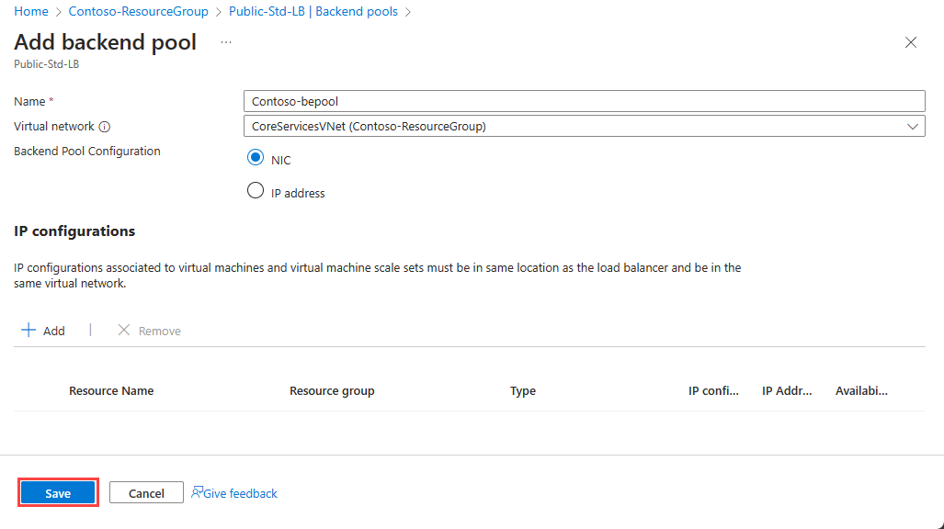

### **Add virtual machines to the backend pool**

The next task is to add the virtual machines to the existing back-end pool.

On the **Backend pools** page, select the backend pool from the list.

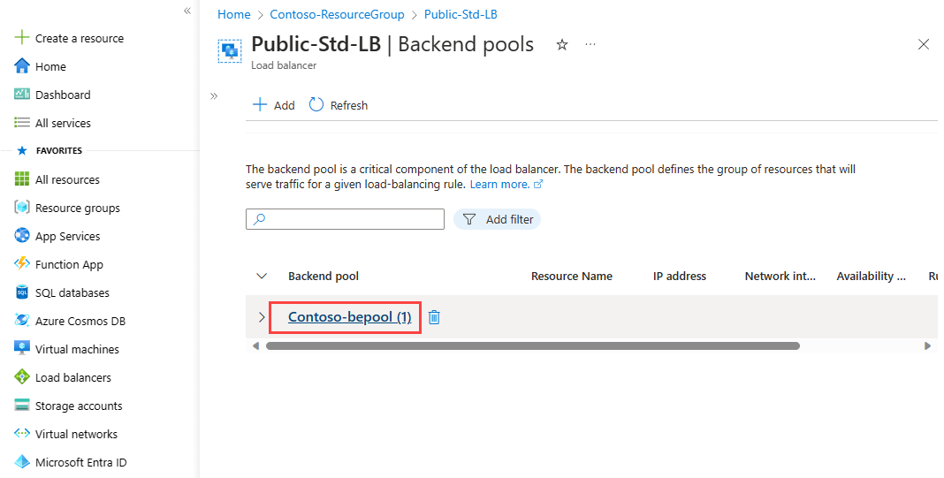

You need to enter the following information to add the virtual machines to the backend pool:

|  |  |
| --- | --- |
| **Setting** | **Value** |
| Virtual network | Specify the name of the virtual network where the resources are located that you're adding to the backend pool. |
| Backend Pool Configuration | Select whether you want to associate the backend pool using the NIC or IP address of a resource. |

Then under the **IP configurations** section, select **+ Add**.

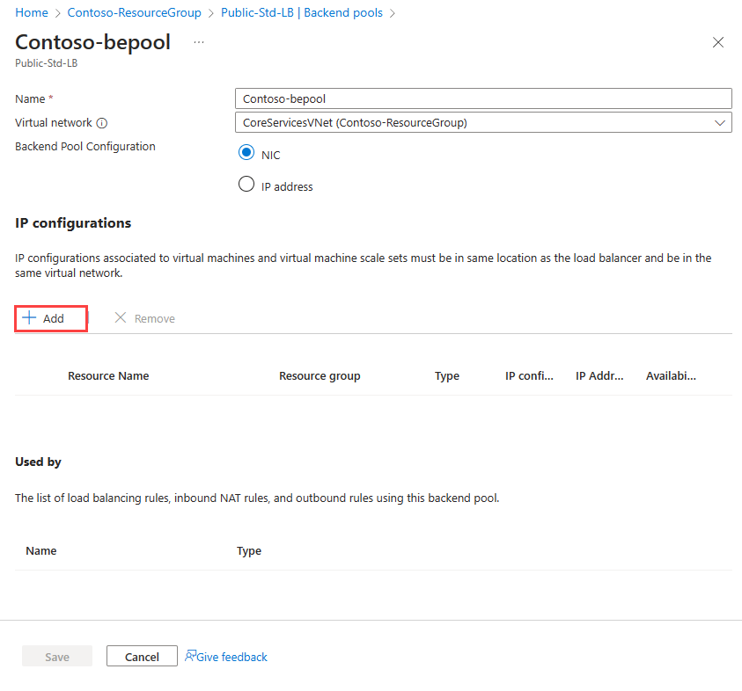

Select the virtual machines you want to add to the backend pool and select **Add**.

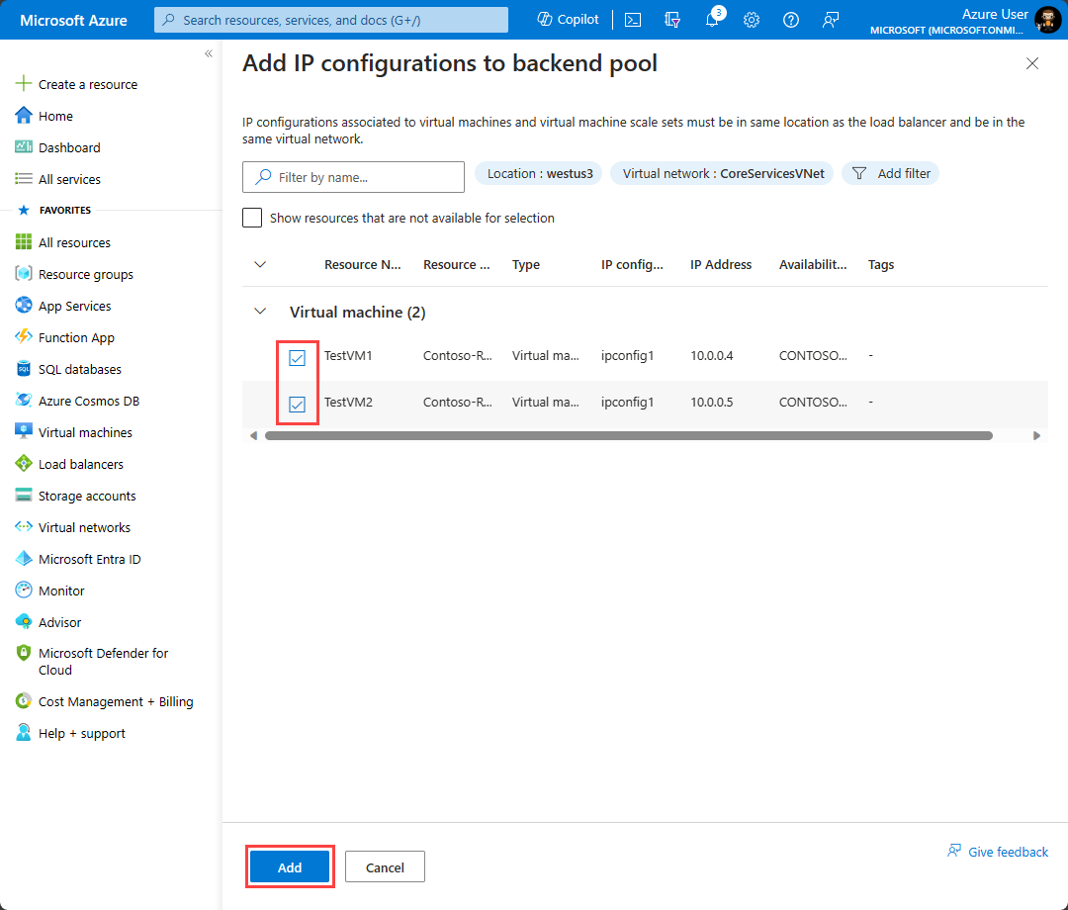

Then select **Save** to add them to the backend pool.

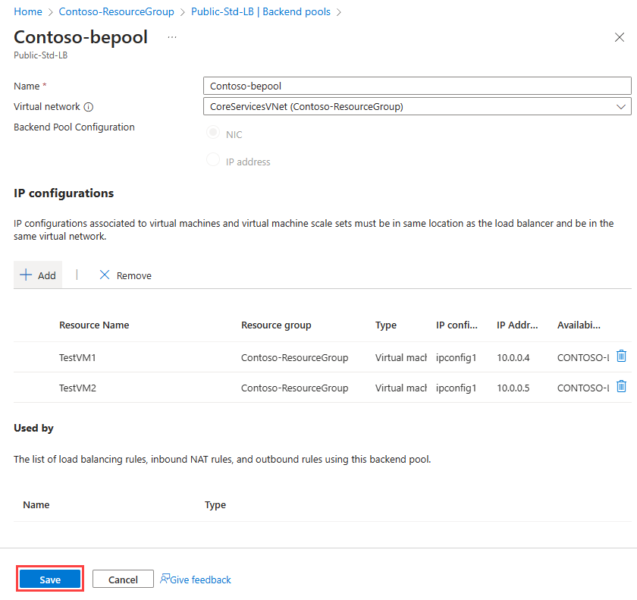

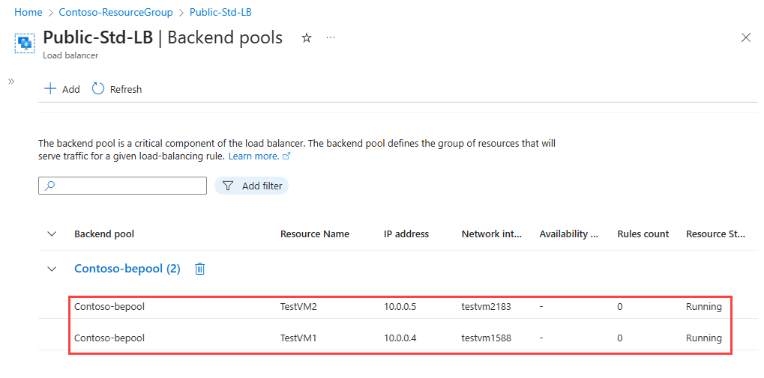

### **Add health probes**

The next task is to create a health probe to monitor the virtual machines in the back-end pool.

On the **Backend pools** page of the load balancer, select **Health probes** under **Settings**, and then select **+ Add**.

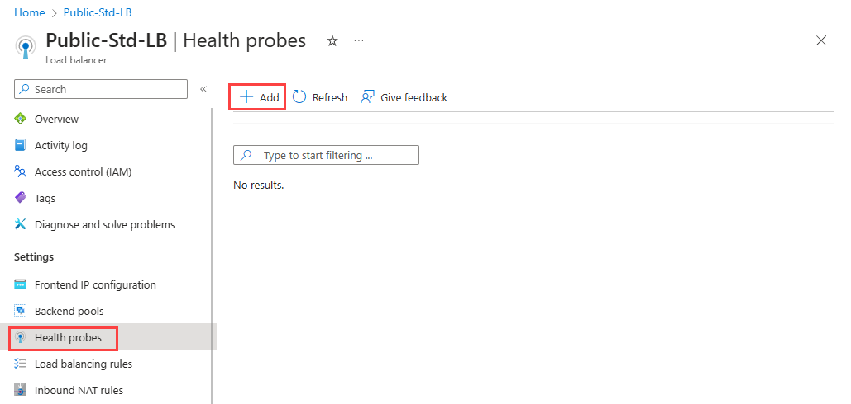

You need to enter the following information on the **Add health probe** page:

|  |  |
| --- | --- |
| **Setting** | **Value** |
| Name | Enter a unique name for the health probe. |
| Protocol | Select either **TCP**, **HTTP**, or **HTTPS**. |
| Port | Specify the destination port number for the health signal. The default is port **80**. |
| Interval (seconds) | Specify the interval time in seconds between probe attempts. The default is **5** seconds. |

You then select **Save** to add the health probe.

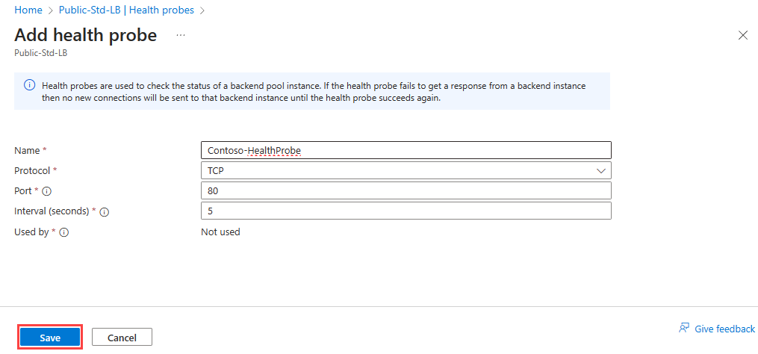

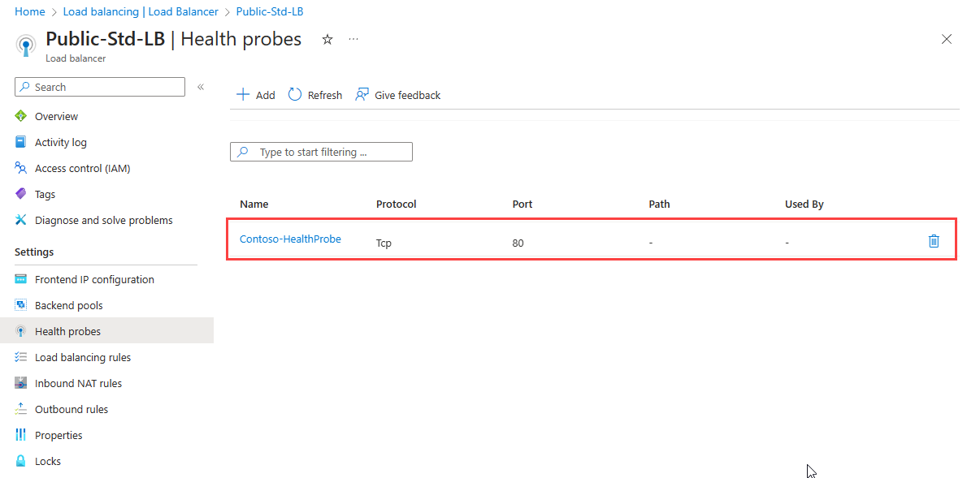

### **Add a load balancer rule**

The last task is to create a load balancing rule for the load balancer. A load balancing rule distributes incoming traffic that is sent to a selected IP address and port combination across a group of backend pool instances. Only backend instances that the health probe considers healthy receive new traffic.

On the **Health probes** page of the load balancer, select **Load balancing rules** under **Settings**, and then select **+ Add**.

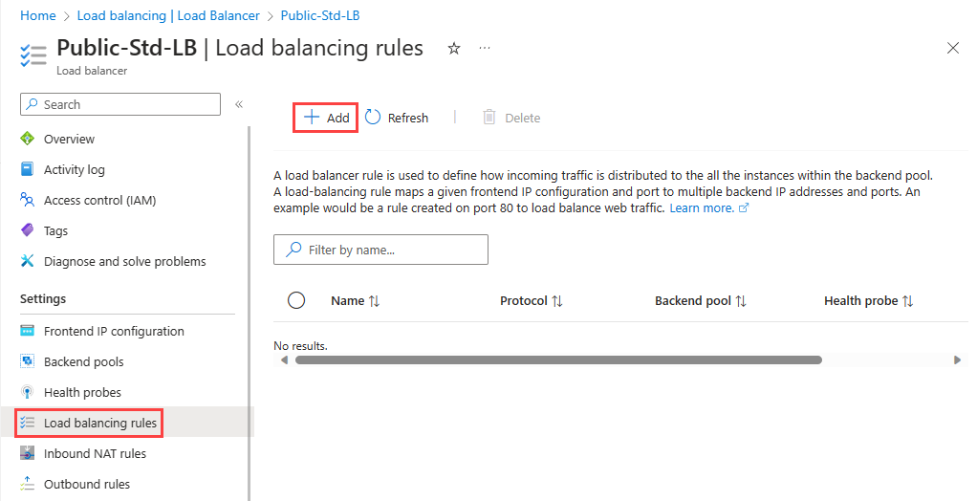

You need to enter the following information on the **Add load balancing rule** page:

|  |  |
| --- | --- |
| **Setting** | **Value** |
| **Name** | Enter a unique name for the load balancing rule. |
| **IP Version** | Select either **IPv4** or **IPv6**. |
| **Frontend IP address** | Select the existing public-facing IP address of the load balancer. |
| **Backend pool** | Select an existing backend pool. The virtual machines in this backend pool are the target for the load balanced traffic of this rule. |
| **Protocol** | Select either the **TCP** or **UDP** protocol. |
| **Port** | Specify the port number for the load balancing rule. The default is port **80**. |
| **Backend port** | You can choose to route traffic to the virtual machine in the backend pool using a different port than the one that clients use by default to communicate with the load balancer (port 80). |
| **Health probe** | Select an existing health probe or create a new one. The load balancing rule uses the health probe to determine which virtual machines in the backend pool are healthy and therefore can receive load balanced traffic. |
| **Session persistence** | You can choose **None**, or **Client IP**, or **Client IP and protocol**. Session persistence specifies that traffic from a client should be handled by the same virtual machine in the backend pool for the duration of a session. **None** specifies that successive requests from the same client may be handled by any virtual machine. **Client IP** specifies that successive requests from the same client IP address will be handled by the same virtual machine. **Client IP and protocol** specifies that successive requests from the same client IP address and protocol combination will be handled by the same virtual machine. |
| **Idle timeout (minutes)** | Specify the time to keep a TCP or HTTP connection open without relying on clients to send *keep-alive* messages. The default idle timeout is **4** minutes, which is also the minimum setting. The maximum setting is 30 minutes. |
| **Enable TCP Reset** | Choose between **Disabled** or **Enabled**. With TCP Reset on Idle set to **Disabled**, Azure doesn't send a TCP reset packet when the idle timeout period is reached. With TCP Reset on Idle set to **Enabled**, Azure sends a TCP reset packet when the idle timeout period is reached. |
| **Enable Floating IP** | Choose between **Disabled** or **Enabled**. With Floating IP set to **Disabled**, Azure exposes a traditional load balancing IP address mapping scheme for ease of use (the VM instances' IP). With Floating IP set to **Enabled**, it changes the IP address mapping to the Frontend IP of the load balancer to allow for more flexibility. |
| **Outbound source network address translation (SNAT)** | Choose between **Disabled** or **Enabled**. With Outbound SNAT set to **Disabled**, Azure doesn't translate the source IP address of outbound flows to public IP addresses. With Outbound SNAT set to **Enabled**, Azure translates the source IP address of outbound flows to public IP addresses. |

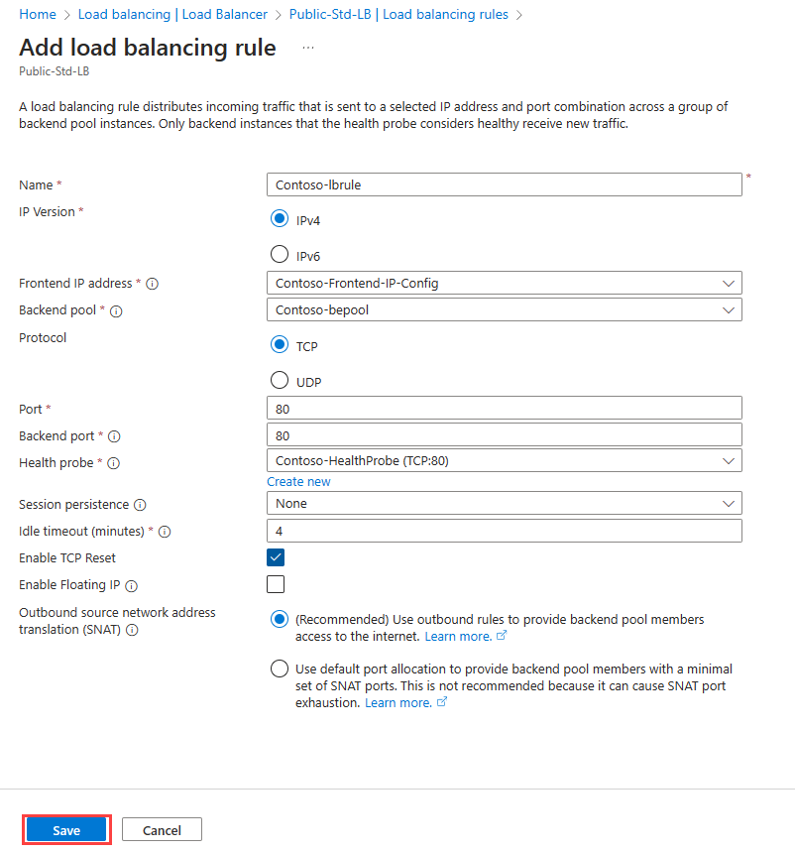

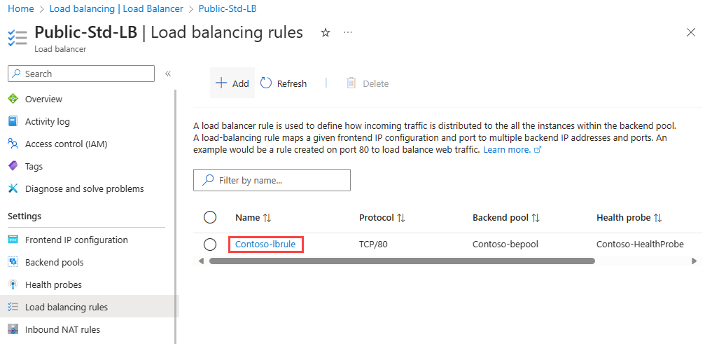

### **Test the load balancer**

Having completed the various tasks to create and configure your public load balancer and its components, you should then test your configuration to ensure it works successfully. The simplest way to do this is to copy the **Public IP Address** from the public load balancer resource you created and paste it into a web browser. You should receive a response from one of the VMs in your load balancer. You could then stop whichever VM randomly responds, and once that VM has stopped, refresh the browser page to verify that you receive a response from the other VM in the load balancer instead.

# Azure Traffic Manager

Azure Traffic Manager is a DNS-based traffic load balancer. This service allows you to distribute traffic to your public facing applications across the global Azure regions. Traffic Manager also provides your public endpoints with high availability and quick responsiveness.

## Key features of Traffic Manager

|  |  |
| --- | --- |
| **Feature** | **Description** |
| Increase application availability | Traffic Manager delivers high availability for your critical applications by monitoring your endpoints and providing automatic failover when an endpoint goes down. |
| Improve application performance | Azure allows you to run cloud services and websites in datacenters located around the world. Traffic Manager can improve the responsiveness of your website by directing traffic to the endpoint with the lowest latency. |
| Service maintenance without downtime | You can have planned maintenance done on your applications without downtime. Traffic Manager can direct traffic to alternative endpoints while the maintenance is in progress. |
| Combine hybrid applications | Traffic Manager supports external, non-Azure endpoints enabling it to be used with hybrid cloud and on-premises deployments, including the burst-to-cloud, migrate-to-cloud, and failover-to-cloud scenarios. |
| Distribute traffic for complex deployments | Using nested Traffic Manager profiles, multiple traffic-routing methods can be combined to create sophisticated and flexible rules to scale to the needs of larger, more complex deployments. |

## How Traffic Manager works

Azure Traffic Manager enables you to control the distribution of traffic across your application endpoints. An endpoint is any Internet-facing service hosted inside or outside of Azure.

Traffic Manager provides two key benefits:

* Distribution of traffic according to one of several **traffic-routing methods**
* Continuous **monitoring of endpoint** health and automatic failover when endpoints fail

When a client attempts to connect to a service, it must first resolve the DNS name of the service to an IP address. The client then connects to that IP address to access the service.

Traffic Manager uses DNS to direct clients to specific service endpoints based on the rules of the traffic-routing method. Clients connect to the selected endpoint directly. Traffic Manager isn't a proxy or a gateway. Traffic Manager doesn't see the traffic passing between the client and the service.

**Traffic Manager works at the DNS level which is at the Application layer (Layer-7).**

### Traffic Manager deployment

Contoso Corp have developed a new partner portal. The URL for this portal is <https://partners.contoso.com/login.aspx>.

The application is hosted in three regions of Azure. To improve availability and maximize global performance, they use Traffic Manager to distribute client traffic to the closest available endpoint.

To achieve this configuration, they complete the following steps:

1. Deploy three instances of their service. The DNS names of these deployments are contoso-us.cloudapp.net, contoso-eu.cloudapp.net, and contoso-asia.cloudapp.net.
2. Create a Traffic Manager profile, named contoso.trafficmanager.net, and configure it to use the 'Performance' traffic-routing method across the three endpoints.
3. Configure their vanity domain name, partners.contoso.com, to point to contoso.trafficmanager.net, using a DNS CNAME record.

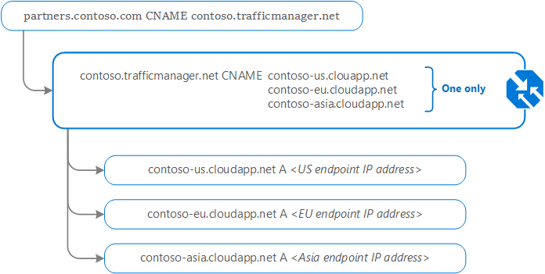

### Traffic Manager client usage

Following on from the deployment example above; when a client requests the page <https://partners.contoso.com/login.aspx>, the client performs the following steps to resolve the DNS name and establish a connection:

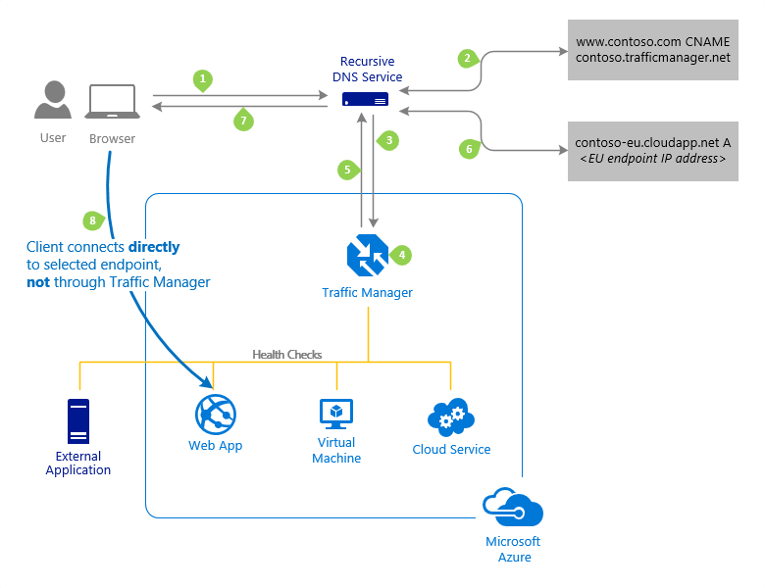

1. The client sends a DNS query to its configured recursive DNS service to resolve the name 'partners.contoso.com'. A recursive DNS service, sometimes called a 'local DNS' service, doesn't host DNS domains directly. Rather, the client off-loads the work of contacting the various authoritative DNS services across the Internet needed to resolve a DNS name.
2. To resolve the DNS name, the recursive DNS service finds the name servers for the 'contoso.com' domain. It then contacts those name servers to request the 'partners.contoso.com' DNS record. The contoso.com DNS servers return the CNAME record that points to contoso.trafficmanager.net.
3. Next, the recursive DNS service finds the name servers for the 'trafficmanager.net' domain, which are provided by the Azure Traffic Manager service. It then sends a request for the 'contoso.trafficmanager.net' DNS record to those DNS servers.
4. The Traffic Manager name servers receive the request. They choose an endpoint based on:
   1. The configured state of each endpoint (disabled endpoints aren't returned)
   2. The current health of each endpoint, as determined by the Traffic Manager health checks.
   3. The chosen traffic-routing method.
5. The chosen endpoint is returned as another DNS CNAME record. In this case, let us suppose contoso-eu.cloudapp.net is returned.
6. Next, the recursive DNS service finds the name servers for the 'cloudapp.net' domain. It contacts those name servers to request the 'contoso-eu.cloudapp.net' DNS record. A DNS 'A' record containing the IP address of the EU-based service endpoint is returned.
7. The recursive DNS service consolidates the results and returns a single DNS response to the client.
8. The client receives the DNS results and connects to the given IP address. The client connects to the application service endpoint directly, not through Traffic Manager. Since it's an HTTPS endpoint, the client performs the necessary SSL/TLS handshake, and then makes an HTTP GET request for the '/login.aspx' page.

## Traffic routing methods

Azure Traffic Manager supports six traffic-routing methods to determine how to route network traffic to the various service endpoints. For any profile, Traffic Manager applies the traffic-routing method associated to it to each DNS query it receives. The traffic-routing method determines which endpoint is returned in the DNS response.

The following traffic routing methods are available in Traffic Manager:

|  |  |
| --- | --- |
| **Routing method** | **When to use** |
| Priority | Select this routing method when you want to have a primary service endpoint for all traffic. You can provide multiple backup endpoints in case the primary or one of the backup endpoints is unavailable. |
| Subnet | Select this routing method to map sets of end-user IP address ranges to a specific endpoint. When a request is received, the endpoint returned will be the one mapped for that request’s source IP address. |
| MultiValue | Select this routing method for Traffic Manager profiles that can only have IPv4/IPv6 addresses as endpoints. When a query is received for this profile, all healthy endpoints are returned. |
| Geographic | Select this routing method to direct users to specific endpoints (Azure, External, or Nested) based on where their DNS queries originate from geographically. With this routing method, it enables you to be compliant with scenarios such as data sovereignty mandates, localization of content & user experience and measuring traffic from different regions. |
| Performance | Select the routing method when you have endpoints in different geographic locations, and you want end users to use the "closest" endpoint for the lowest network latency. |
| Weighted | Select this routing method when you want to distribute traffic across a set of endpoints based on their weight. Set the weight the same to distribute evenly across all endpoints. |

### Routing method

This is an example of the **Priority** routing method.

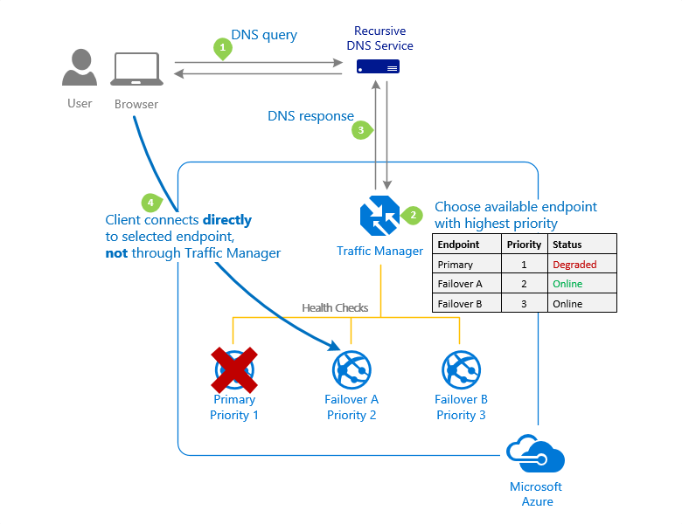

This is an example of the **Weighted** routing method.

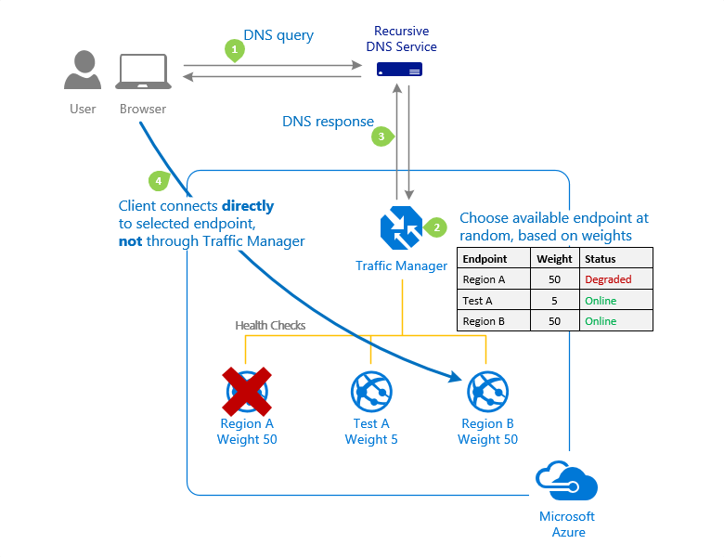

This is an example of the **Performance** routing method.

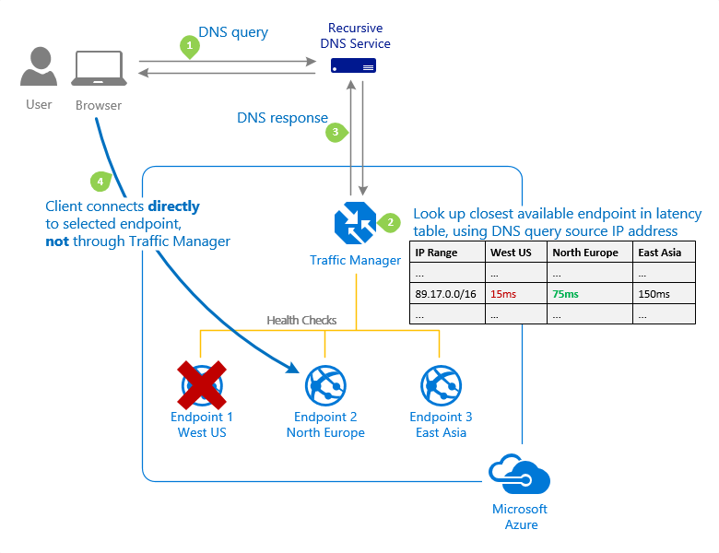

This is an example of the **Geographic** routing method.

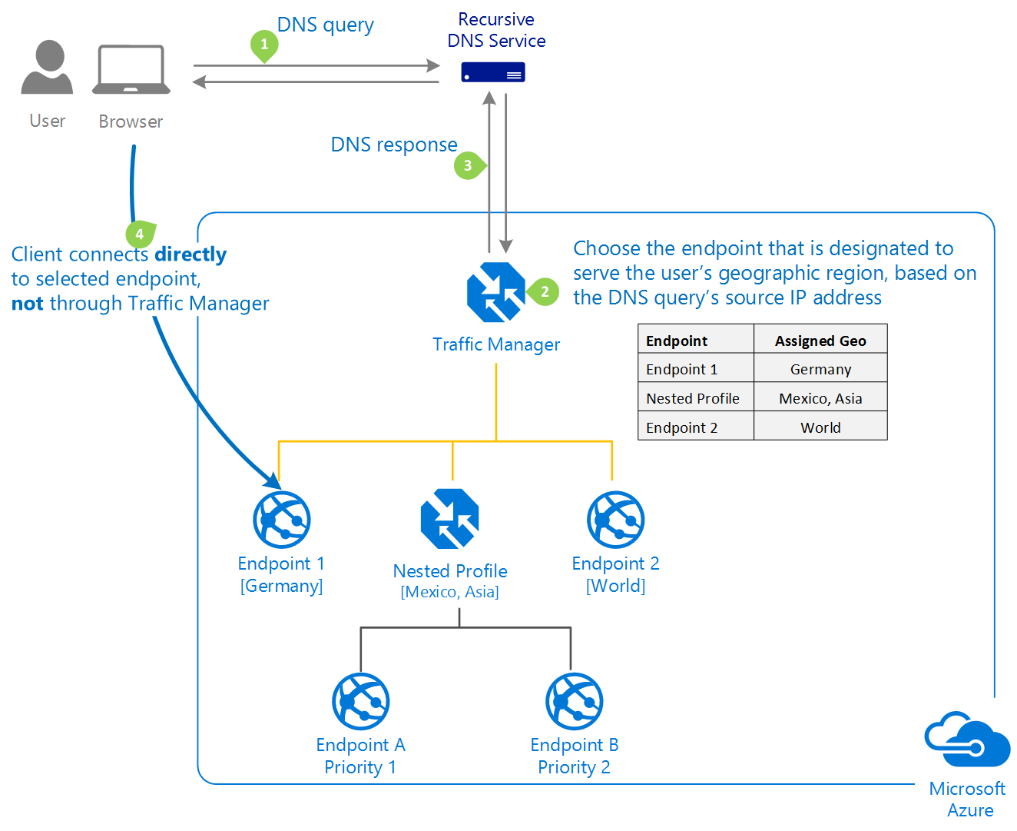

### Traffic Manager profiles

Within a Traffic Manager profile, you can only configure one traffic routing method at a time. You can select a different traffic routing method for your profile at any time. Your changes are applied within a minute without any downtime.

**All Traffic Manager profiles have health monitoring and automatic failover of endpoints.**

### Nested Traffic Manager profiles

As mentioned earlier, each Traffic Manager profile can only specify one traffic-routing method. However, you may have scenarios that require more complicated traffic routing than the routing that can be provided by a single Traffic Manager profile. In these situations, you can combine traffic routing methods by using nested Traffic Manager profiles to gain the benefits of multiple traffic-routing methods. Nested profiles enable you to override the default Traffic Manager behavior to support larger and more complex traffic-routing configurations for your application deployments.

## Combining 'performance' and 'weighted' traffic routing methods using nested profiles

Suppose that you deployed an application in the following Azure regions: West US, West Europe, and East Asia. You use the **Performance** traffic-routing method to distribute traffic to the region closest to the user.

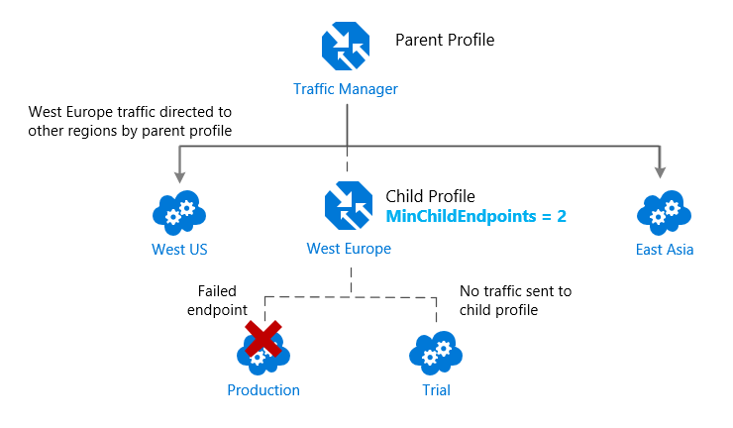

But what if you wanted to test an update to your service before rolling it out more widely, and you wanted to use the **Weighted** traffic-routing method to direct a small percentage of traffic to your test deployment?

You would set up the test deployment alongside the existing production deployment in West Europe.

You can't combine both the **Weighted** and **Performance** traffic-routing methods in a single profile. Therefore, to support this scenario, you would create a Traffic Manager profile using the two West Europe endpoints and the **Weighted** traffic-routing method. Then you would add this child profile as an endpoint to the parent profile. The parent profile would still use the **Performance** traffic-routing method and would contain the other global deployments as endpoints.

The diagram below illustrates this example scenario:

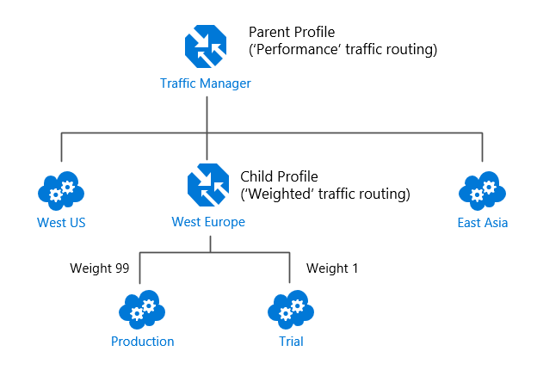

With the above configuration, traffic directed via the parent profile (using the **Performance** routing method) distributes traffic across regions normally. While, within West Europe, the nested child profile (using the **Weighted** routing method) distributes traffic to the production and test endpoints according to the weights assigned.

When the parent profile uses the **Performance** traffic-routing method, each endpoint must be assigned a location, which is done when you configure the endpoint. Choose the Azure region closest to your deployment.

# Traffic Manager endpoints

Azure Traffic Manager enables you to control how network traffic is distributed to application deployments running in your different datacenters. You configure each application deployment as an endpoint in Traffic Manager. When Traffic Manager receives a DNS request, it chooses an available endpoint to return in the DNS response. Traffic manager bases the choice on the current endpoint status and the traffic-routing method.

Traffic Manager supports three types of endpoints:

* **Azure endpoints** - Use this type of endpoint to load-balance traffic to a cloud service, web app, or public IP address in the same subscription within Azure.
* **External endpoints** - Use this type of endpoint to load balance traffic for IPv4/IPv6 addresses, FQDNs, or for services hosted outside Azure. These services can either be on-premises or with a different hosting provider.
* **Nested endpoints** - Use this type of endpoint to combine Traffic Manager profiles to create more flexible traffic-routing schemes to support the needs of larger, more complex deployments. With Nested endpoints, a child profile is added as an endpoint to a parent profile. Both the child and parent profiles can contain other endpoints of any type, including other nested profiles.

There are no restrictions on how different endpoints types can be combined in a single Traffic Manager profile; each profile can contain any mix of endpoint types.

You add endpoints to existing Traffic Manager profiles from the **Endpoints** page of a Traffic Manager profile in the Azure portal.

## Configuring Traffic Manager profiles

This example shows how to create and configure a new Traffic Manager profile to direct client traffic based on endpoint priority.

From the Azure portal home page, From the Azure portal home page, navigate to the Global Search bar and search **Traffic Manager profile**. Then select **Traffic Manager profiles**.

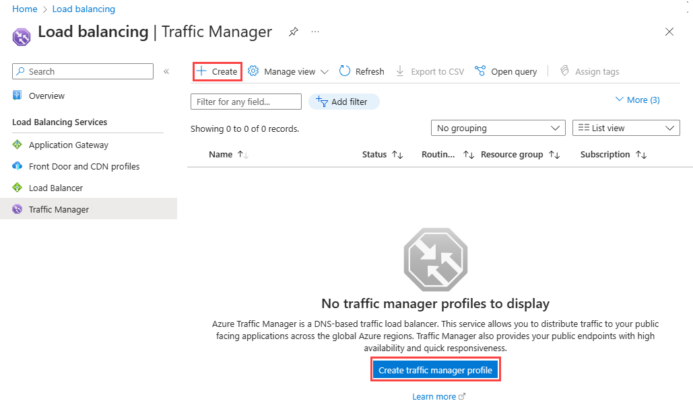

Select **+ Create** or the **Create traffic manager profile** button.

You need to enter the following information on the **Create Traffic Manager profile** page:

|  |  |
| --- | --- |
| **Field** | **Information** |
| Name | Enter a unique name for the Traffic Manager profile. |
| Routing method | Select the routing method to use in this profile. |
| Subscription | Select the subscription from the list that you want this profile to be applied to. |
| Resource group | Select the appropriate resource group from the list or create a new one. |

Select **Create** to create the profile.

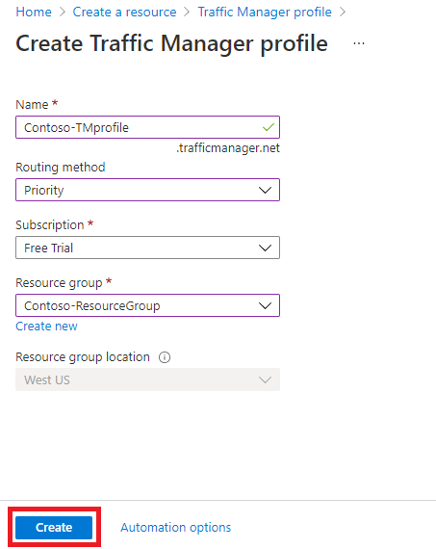

The next step is to add endpoints to the Traffic Manager profile.

From the Azure portal home page, select **All resources**, then select the Traffic Manager profile from the list.

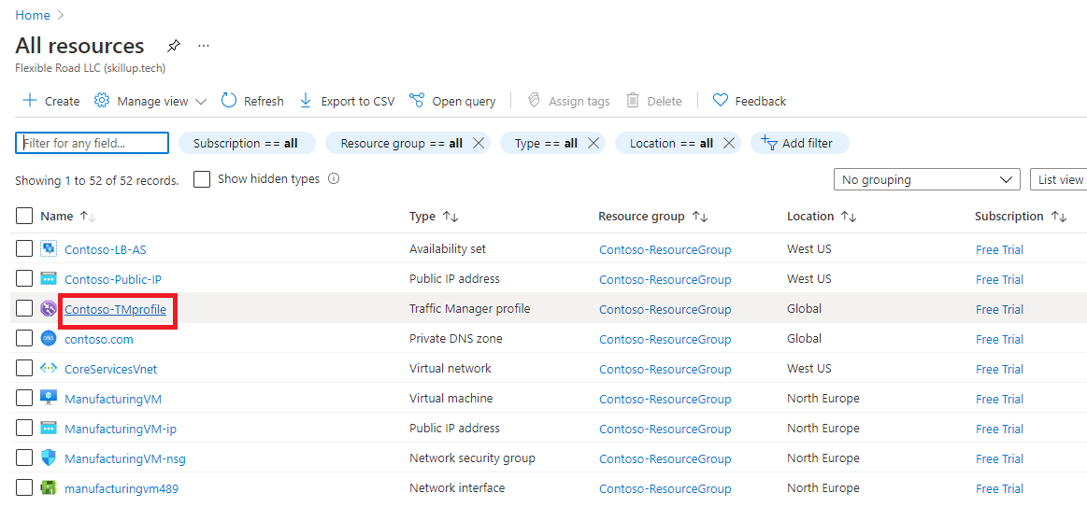

On the Traffic manager profile page, under **Settings**, select **Endpoints**, then select **Add**.

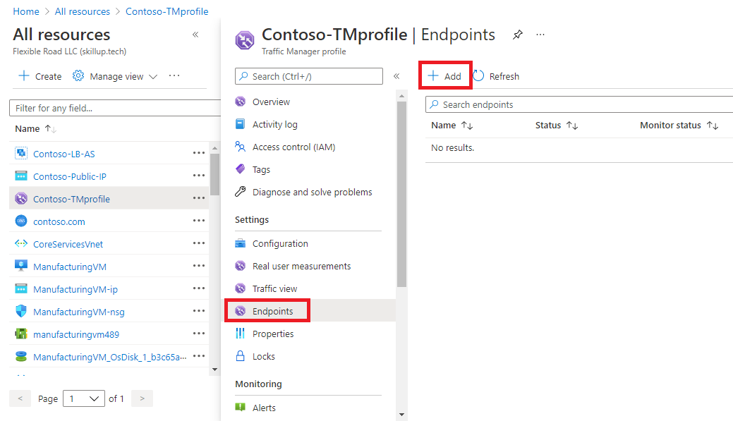

You then enter the required information on the **Add endpoint** page:

|  |  |
| --- | --- |
| **Field** | **Information** |
| Type | Select the type of endpoint to add. You can select from the following endpoint ttypes: **Azure endpoints** **External endpoints** **Nested endpoints** Depending on which endpoint type you select here, the remaining options differ. |
| Name | Enter a unique name for the endpoint. |
| Target resource type **(for Azure endpoints only)** | If you select the **Azure endpoint** type, you can select from the following resource types: **Cloud service** **App Service** **App Service slot** **Public IP address** |
| Target resource **(for Azure and Nested endpoints only)** | Select the appropriate target service, IP address, or profile from the list. The available options differ depending on which endpoint type and target resource type are selected above. |
| fully qualified domain name (FQDN) or IP **(for External endpoints only)** | Specify the FQDN or IP address for the external endpoint. |
| Priority | Specify the priority for this endpoint. If you enter **1**, then all traffic goes to this endpoint when it's healthy. |
| Minimum child endpoints **(for Nested endpoints only)** | Specify the minimum number of endpoints that must be available in the *child* Traffic Manager profile for it to receive traffic. If the available-endpoints number in the child profile falls below this threshold, this endpoint is considered as degraded. |

Select **Add** to add the endpoint to the Traffic Manager profile.

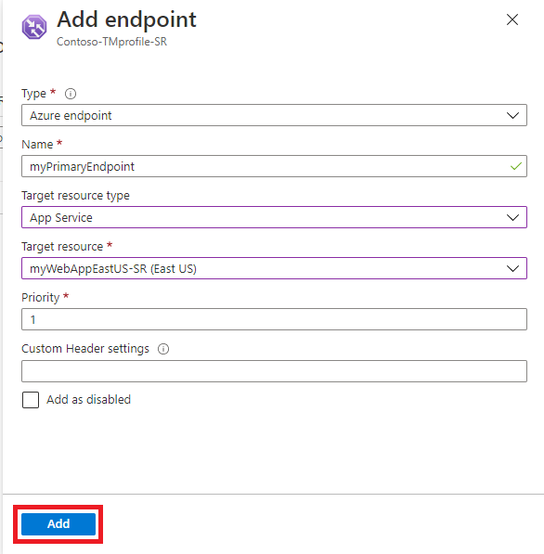

If you're adding a failover endpoint for another Azure region, then you would add another endpoint for that region. This would point to the application target resource in the other region and would have a priority setting of **2**.

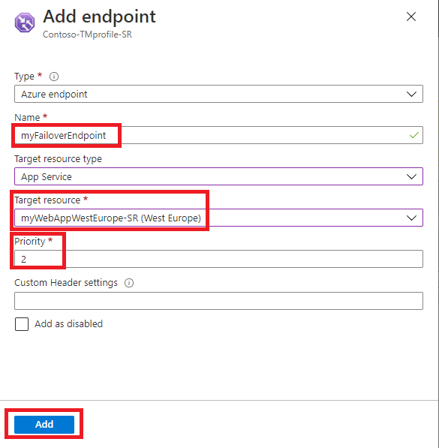

When you add endpoints to a Traffic Manager profile, their status is checked.

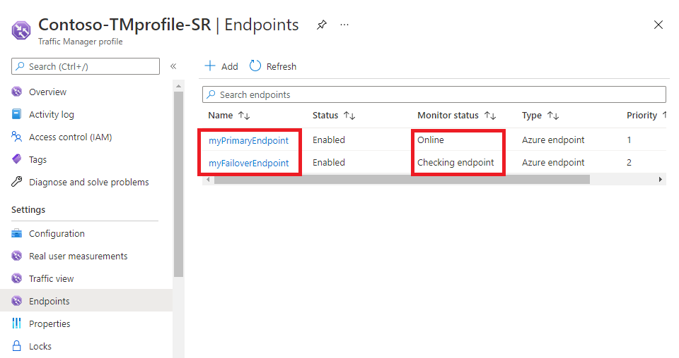

Once they have been checked their **Monitor status** changes to Online.

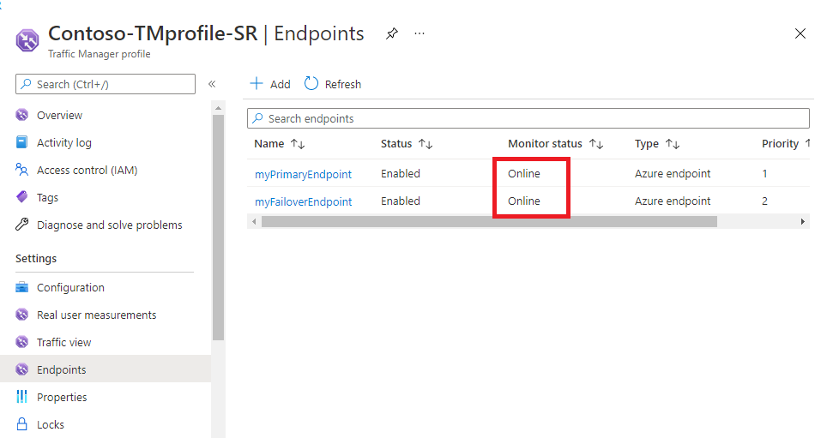

## Configuring endpoint monitoring

Azure Traffic Manager includes built-in endpoint monitoring and automatic endpoint failover. This feature helps you deliver high-availability applications that are resilient to endpoint failure, including Azure region failures.

To configure endpoint monitoring, you open the **Configuration** page for the Traffic Manager profile.

Then, under the **Endpoint monitor settings** section, you specify the following settings for the Traffic Manager profile:

|  |  |
| --- | --- |
| **Setting** | **Description** |
| Protocol | Choose HTTP, HTTPS, or TCP as the protocol that Traffic Manager uses when probing your endpoint to check its health. HTTPS monitoring doesn't verify whether your TLS/SSL certificate is valid; it only checks that the certificate is present. |
| Port | Choose the port used for the request. |
| Path | This configuration setting is valid only for the HTTP and HTTPS protocols, for which specifying the path setting is required. Providing this setting for the TCP monitoring protocol results in an error. For HTTP and HTTPS protocol, give the relative path and the name of the webpage or the file that the monitoring accesses. A forward slash (/) is a valid entry for the relative path. This value implies that the file is in the root directory (default). |
| Custom Header Settings | You can use custom headers for health checks of endpoints in a multitenant environment. That way it can be routed correctly to their destination by specifying a host header. You can also use this setting by adding unique headers that can be used to identify Traffic Manager originated HTTP(S) requests and processes them differently. You can specify up to eight *header:value* pairs separated by a comma. Example - header1:value1, header2:value2 |
| Expected Status Code ranges | This setting allows you to specify multiple success code ranges in the format 200-299, 301-301. If these status codes are  received as response from an endpoint when a health check is done, Traffic Manager marks those endpoints as healthy. You can specify a maximum of eight status code ranges. This setting is applicable only to HTTP and HTTPS protocol and to all endpoints. |
| Probing Interval | This value specifies how often an endpoint is checked for its health from a Traffic Manager probing agent. You can specify two values here: 30 seconds (normal probing) and 10 seconds (fast probing). If no values are provided, the profile sets to a default value of 30 seconds. |
| Tolerated number of failures | This value specifies how many failures a Traffic Manager probing agent tolerates before marking that endpoint as unhealthy. Its value can range between 0 and 9. A value of 0 means a single monitoring failure can cause that endpoint to be marked as unhealthy. If no value is specified, it uses the default value of 3. |
| Probe Timeout | This property specifies the amount of time the Traffic Manager probing agent should wait before considering a health probe check to an endpoint a failure. If the Probing Interval is set to 30 seconds, then you can set the Timeout value between 5 and 10 seconds. If no value is specified, it uses a default value of 10 seconds. If the Probing Interval is set to 10 seconds, then you can set the Timeout value between 5 and 9 seconds. If no Timeout value is specified, it uses a default value of 9 seconds |

Select **Save** when you have finished endpoint monitor configuration.

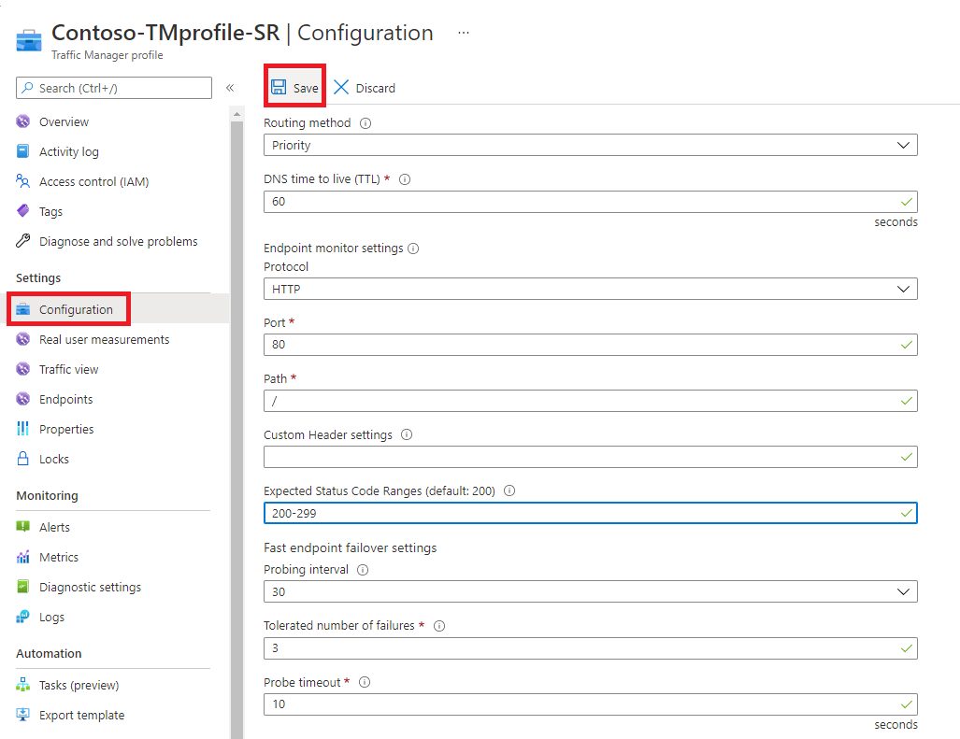

## How endpoint monitoring works

When the monitoring protocol is set as HTTP or HTTPS, the Traffic Manager probing agent makes a GET request to the endpoint using the protocol, port, and relative path given. An endpoint is considered healthy if probing agent receives a 200-OK response, or any of the responses configured in the Expected status code *ranges. If the response is a different value or no response get received within the timeout period, the Traffic Manager probing agent reattempts according to the Tolerated Number of Failures setting. No reattempts are done if this setting is 0. The endpoint is marked unhealthy if the number of consecutive failures is higher than the Tolerated Number of Failures setting.

When the monitoring protocol is TCP, the Traffic Manager probing agent creates a TCP connection request using the port specified. If the endpoint responds to the request with a response to establish the connection, that health check is marked as a success. The Traffic Manager probing agent resets the TCP connection. In cases where the response is a different value or no response get received within the timeout period, the Traffic Manager probing agent reattempts according to the Tolerated Number of Failures setting. No reattempts are made if this setting is 0. If the number of consecutive failures is higher than the Tolerated Number of Failures setting, then that endpoint is marked unhealthy.

In all cases, Traffic Manager probes from multiple locations. The consecutive failure determines what happen within each region. That's why endpoints are receiving health probes from Traffic Manager with a higher frequency than the setting used for Probing Interval.

**For HTTP or HTTPS monitoring protocol, a common practice on the endpoint side is to implement a custom page within your application - for example, /health.aspx. Using this path for monitoring, you can perform application-specific checks, such as checking performance counters or verifying database availability. Based on these custom checks, the page returns an appropriate HTTP status code.**

# Module 5: Load balance HTTP(S) traffic in Azure

# Design Azure Application Gateway

Azure Application Gateway is a web traffic load balancer that enables you to manage traffic to your web applications. Traditional load balancers operate at the transport layer (OSI layer 4 - TCP and UDP) and route traffic based on source IP address and port, to a destination IP address and port.

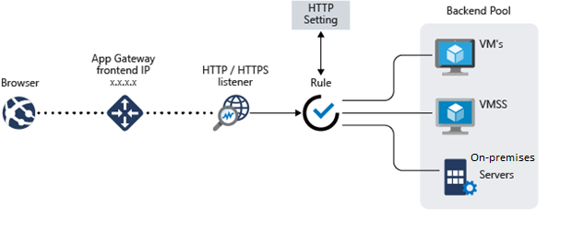

Application Gateway can make routing decisions based on additional attributes of an HTTP request, for example URI path or host headers. For example, you can route traffic based on the incoming URL. So, if /images is in the incoming URL, you can route traffic to a specific set of servers (known as a pool) configured for images. If /video is in the URL, that traffic is routed to another pool that's optimized for videos.

This type of routing is known as application layer (OSI layer 7) load balancing. Azure Application Gateway can do URL-based routing and more.

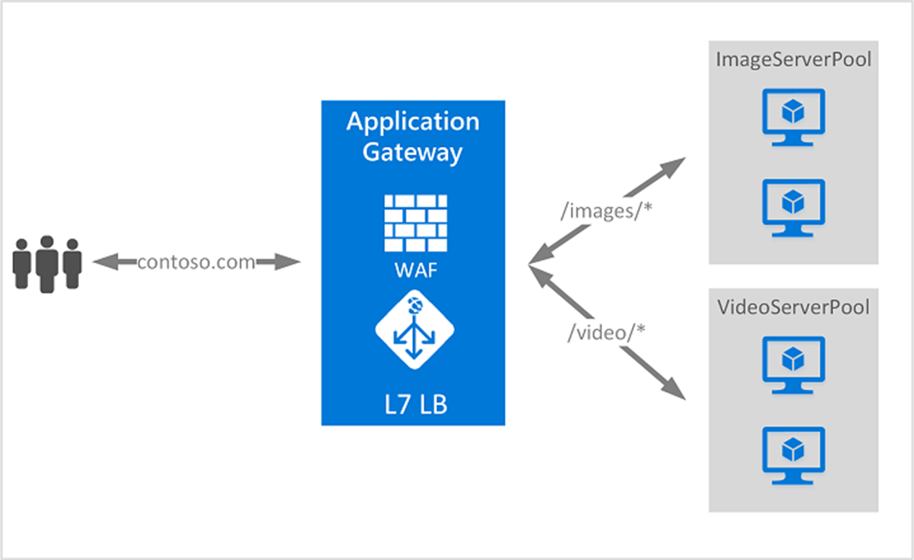

## Application Gateway features

* Support for the HTTP, HTTPS, HTTP/2 and WebSocket protocols.
* A web application firewall to protect against web application vulnerabilities.
* End-to-end request encryption.
* Autoscaling, to dynamically adjust capacity as your web traffic load change.
* **Redirection**: Redirection can be used to another site, or from HTTP to HTTPS.
* **Rewrite HTTP headers**: HTTP headers allow the client and server to pass parameter information with the request or the response.
* **Custom error pages:** Application Gateway allows you to create custom error pages instead of displaying default error pages. You can use your own branding and layout using a custom error page.

## Determine Application Gateway routing

Clients send requests to your web apps to the IP address or DNS name of the gateway. The gateway routes requests to a selected web server in the back-end pool, using a set of rules configured for the gateway to determine where the request should go.

There are two primary methods of routing traffic, path-based routing, and multiple site routing.

### Path-based routing

Path-based routing sends requests with different URL paths different pools of back-end servers. For example, you could direct requests with the path /video/* to a back-end pool containing servers that are optimized to handle video streaming, and direct /images/* requests to a pool of servers that handle image retrieval.

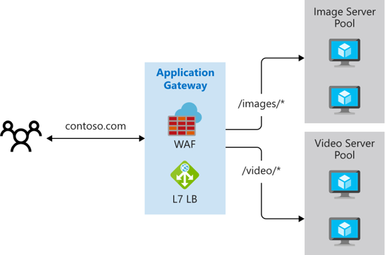

### Multiple site routing

Multiple site routing configures more than one web application on the same application gateway instance. In a multi-site configuration, you register multiple DNS names (CNAMEs) for the IP address of the Application Gateway, specifying the name of each site. Application Gateway uses separate listeners to wait for requests for each site. Each listener passes the request to a different rule, which can route the requests to servers in a different back-end pool.

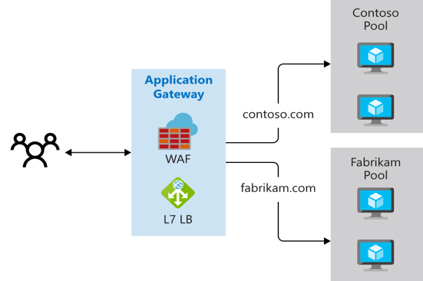

Multi-site configurations are useful for supporting multi-tenant applications, where each tenant has its own set of virtual machines or other resources hosting a web application.

## Azure Application Gateway SKU

Application Gateway is available under a Standard_v2 SKU. Web Application Firewall (WAF) is available under a WAF_v2 SKU. The v2 SKU offers performance enhancements and adds support for critical new features like autoscaling, zone redundancy, and support for static VIPs. Existing features under the Standard and WAF SKU continue to be supported in the new v2 SKU.

## Scaling Application Gateway and WAF v2

Application Gateway and WAF can be configured to scale in two modes:

**Autoscaling:** With autoscaling enabled, the Application Gateway and WAF v2 SKUs scale up or down based on application traffic requirements. This mode offers better elasticity to your application and eliminates the need to guess the application gateway size or instance count. This mode also allows you to save cost by not requiring the gateway to run at peak provisioned capacity for anticipated maximum traffic load. You must specify a minimum and optionally maximum instance count. Minimum capacity ensures that Application Gateway and WAF v2 don't fall below the minimum instance count specified, even in the absence of traffic. Each instance is roughly equivalent to 10 additional reserved Capacity Units. Zero signifies no reserved capacity and is purely autoscaling in nature. You can also optionally specify a maximum instance count, which ensures that the Application Gateway doesn't scale beyond the specified number of instances. You will only be billed for traffic served by the Gateway. The instance counts can range from 0 to 125. The default value for maximum instance count is 20 if not specified.

**Manual:** You can alternatively choose Manual mode where the gateway doesn't autoscale. In this mode, if there is more traffic than the Application Gateway or WAF can handle, it could result in traffic loss. With manual mode, specifying instance count is mandatory. Instance count can vary from 1 to 125 instances.

# Configure Azure Application Gateway

Application Gateway has a series of components that combine to route requests to a pool of web servers and to check the health of these web servers.

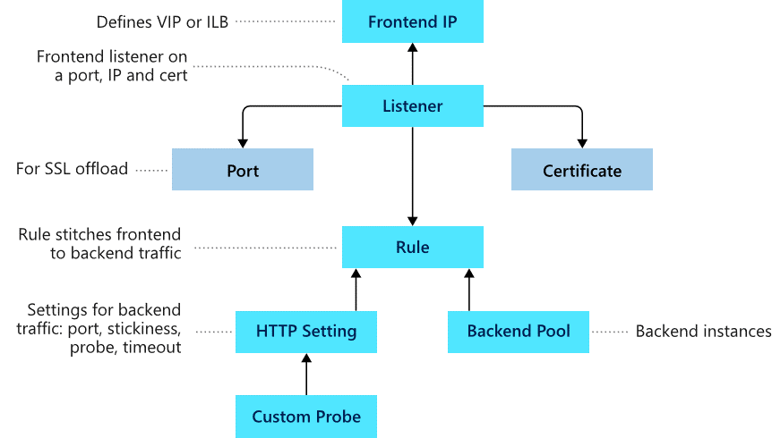

## Frontend configuration

You can configure the application gateway to have a public IP address, a private IP address, or both. A public IP address is required when you host a back end that clients must access over the Internet via an Internet-facing virtual IP.

## Backend configuration

The backend pool is used to route requests to the backend servers that serve the request. Backend pools can be composed of NICs, virtual machine scale sets, public IP addresses, internal IP addresses, fully qualified domain names (FQDN), and multi-tenant back-ends like Azure App Service. You can create an empty backend pool with your application gateway and then add backend targets to the backend pool.

## Configure health probes

Azure Application Gateway by default monitors the health of all resources in its back-end pool and automatically removes any resource considered unhealthy from the pool. Application Gateway continues to monitor the unhealthy instances and adds them back to the healthy back-end pool once they become available and respond to health probes. By default, Application gateway sends the health probes with the same port that is defined in the back-end HTTP settings. A custom probe port can be configured using a custom health probe.

The source IP address that the Application Gateway uses for health probes depends on the backend pool:

* If the server address in the backend pool is a public endpoint, then the source address is the application gateway's frontend public IP address.
* If the server address in the backend pool is a private endpoint, then the source IP address is from the application gateway subnet's private IP address space.

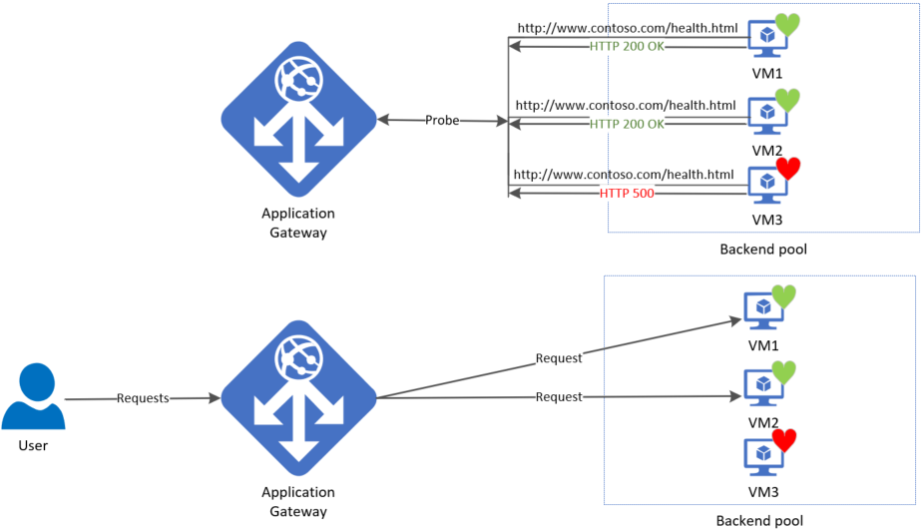

### Default health probe

An application gateway automatically configures a default health probe when you don't set up any custom probe configurations. The monitoring behavior works by making an HTTP GET request to the IP addresses or FQDN configured in the back-end pool. For default probes if the backend http settings are configured for HTTPS, the probe uses HTTPS to test health of the backend servers.

**Default health probe settings**

The following table lists the default health probe settings:

|  |  |  |
| --- | --- | --- |
| **Probe property** | **Value** | **Description** |
| Probe URL | <protocol>://127.0.0.1:<port>/ | The protocol and port are inherited from the backend HTTP settings to which the probe is associated |
| Interval | 30 | The amount of time in seconds to wait before the next health probe is sent. |
| Time-out | 30 | The amount of time in seconds the application gateway waits for a probe response before marking the probe as unhealthy. If a probe returns as healthy, the corresponding backend is immediately marked as healthy. |
| Unhealthy threshold | 3 | Governs how many probes to send in case there's a failure of the regular health probe. In v1 SKU, these additional health probes are sent in quick succession to determine the health of the backend quickly and don't wait for the probe interval. In the case of v2 SKU, the health probes wait the interval. The back-end server is marked down after the consecutive probe failure count reaches the unhealthy threshold. |

### Probe matching

By default, an HTTP(S) response with status code between 200 and 399 is considered healthy. Custom health probes additionally support two matching criteria. Matching criteria can be used to optionally modify the default interpretation of what makes a healthy response.

The following are matching criteria:

* HTTP response status code match - Probe matching criterion for accepting user specified http response code or response code ranges. Individual comma-separated response status codes or a range of status code is supported.
* HTTP response body match - Probe matching criterion that looks at HTTP response body and matches with a user specified string. The match only looks for presence of user specified string in response body and isn't a full regular expression match.

Match criteria can be specified using the New-AzApplicationGatewayProbeHealthResponseMatch cmdlet.

## Configure listeners

A listener is a logical entity that checks for incoming connection requests by using the port, protocol, host, and IP address. When you configure a listener, you must enter values that match the corresponding values in the incoming request on the gateway.

When you create an application gateway by using the Azure portal, you also create a default listener by choosing the protocol and port for the listener. You can choose whether to enable HTTP2 support on the listener. After you create the application gateway, you can edit the settings of that default listener (appGatewayHttpListener) or create new listeners.

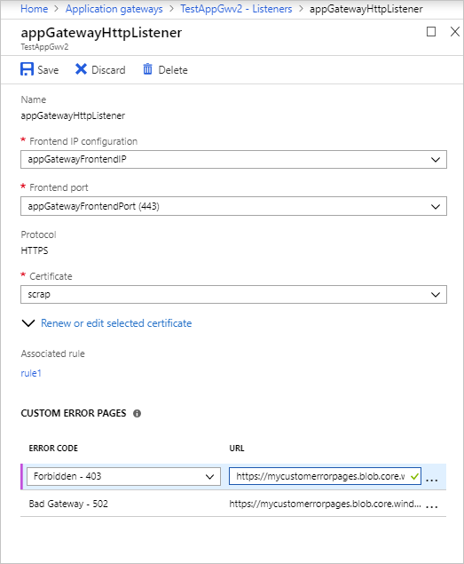

### Listener type

When you create a new listener, you must choose between basic and multi-site.

* **Basic:** All requests for any domain will be accepted and forwarded to backend pools.
* **Multi-site:** Forward requests to different backend pools based on the host header or host names. You must specify a host name that matches with the incoming request. This is because Application Gateway relies on HTTP 1.1 host headers to host more than one website on the same public IP address and port.

### Order of processing listeners

For the v1 SKU, requests are matched according to the order of the rules and the type of listener. If a rule with basic listener comes first in the order, it's processed first and accepts any request for that port and IP combination. To avoid this, configure the rules with multi-site listeners first and push the rule with the basic listener to the last in the list.

For the v2 SKU, multi-site listeners are processed before basic listeners.

### Front-end IP address

Choose the front-end IP address that you plan to associate with this listener. The listener will listen to incoming requests on this IP.

### Front-end port

Choose the front-end port. Select an existing port or create a new one. Choose any value from the allowed range of ports. You can use not only well-known ports, such as 80 and 443, but any allowed custom port that's suitable. A port can be used for public-facing listeners or private-facing listeners.

### Protocol

Choose HTTP or HTTPS:

* **HTTP:** traffic between the client and the application gateway is unencrypted.
* **HTTPS:** enables TLS termination or end-to-end TLS encryption. The TLS connection terminates at the application gateway. Traffic between the client and the application gateway is encrypted. If you want end-to-end TLS encryption, you must choose HTTPS and configure the back-end HTTP setting. This ensures that traffic is re-encrypted when it travels from the application gateway to the back end.

To configure TLS termination and end-to-end TLS encryption, you must add a certificate to the listener to enable the application gateway to derive a symmetric key. The symmetric key is used to encrypt and decrypt the traffic that's sent to the gateway. The gateway certificate must be in Personal Information Exchange (PFX) format. This format lets you export the private key that the gateway uses to encrypt and decrypt traffic.

## **Redirection overview**

You can use application gateway to redirect traffic. It has a generic redirection mechanism which allows for redirecting traffic received at one listener to another listener or to an external site. This simplifies application configuration, optimizes the resource usage, and supports new redirection scenarios including global and path-based redirection.

A common redirection scenario for many web applications is to support automatic HTTP to HTTPS redirection to ensure all communication between application and its users occurs over an encrypted path. In the past, customers have used techniques such as creating a dedicated backend pool whose sole purpose is to redirect requests it receives on HTTP to HTTPS. With redirection support in Application Gateway, you can accomplish this simply by adding a new redirect configuration to a routing rule and specifying another listener with HTTPS protocol as the target listener.

The following types of redirection are supported:

* 301 Permanent Redirect
* 302 Found
* 303 See Other
* 307 Temporary Redirect

Application Gateway redirection support offers the following capabilities:

* **Global redirection:** Redirects from one listener to another listener on the gateway. This enables HTTP to HTTPS redirection on a site.
* **Path-based redirection:** Enables HTTP to HTTPS redirection only on a specific site area, for example a shopping cart area denoted by /cart/*.
* **Redirect to external site:** Requires a new redirect configuration object, which specifies the target listener or external site to which redirection is desired. The configuration element also supports options to enable appending the URI path and query string to the redirected URL. The redirect configuration is attached to the source listener via a new rule.

## Application Gateway request routing rules

When you create an application gateway using the Azure portal, you create a default rule (rule1). This rule binds the default listener (appGatewayHttpListener) with the default back-end pool (appGatewayBackendPool) and the default back-end HTTP settings (appGatewayBackendHttpSettings). After you create the gateway, you can edit the settings of the default rule or create new rules.

Rule types:

* Basic forwards all requests on the associated listener (for example, blog.contoso.com/*) to a single back-end pool.
* Path-based routes requests from specific URL paths to specific back-end pools.

### Order of processing rules

For the v1 and v2 SKU, pattern matching of incoming requests is processed in the order that the paths are listed in the URL path map of the path-based rule. If a request matches the pattern in two or more paths in the path map, the path that's listed first is matched. And the request is forwarded to the back end that's associated with that path.

**Associated listener:**

Associate a listener to the rule so that the request-routing rule that's associated with the listener is evaluated to determine the back-end pool to route the request to.

**Associated back-end pool:**

Associate to the rule the back-end pool that contains the back-end targets that serve requests that the listener receives.

For a basic rule, only one back-end pool is allowed. All requests on the associated listener are forwarded to that back-end pool.

For a path-based rule, add multiple back-end pools that correspond to each URL path. The requests that match the URL path that's entered are forwarded to the corresponding back-end pool. Also, add a default back-end pool. Requests that don't match any URL path in the rule are forwarded to that pool.

**Associated back-end HTTP setting:**

Add a back-end HTTP setting for each rule. Requests are routed from the application gateway to the back-end targets by using the port number, protocol, and other information that's specified in this setting.

For a basic rule, only one back-end HTTP setting is allowed. All requests on the associated listener are forwarded to the corresponding back-end targets by using this HTTP setting.

For a path-based rule, add multiple back-end HTTP settings that correspond to each URL path. Requests that match the URL path in this setting are forwarded to the corresponding back-end targets by using the HTTP settings that correspond to each URL path. Also, add a default HTTP setting. Requests that don't match any URL path in this rule are forwarded to the default back-end pool by using the default HTTP setting.

## Redirection setting

If redirection is configured for a basic rule, all requests on the associated listener are redirected to the target. This is global redirection. If redirection is configured for a path-based rule, only requests in a specific site area are redirected. An example is a shopping cart area that's denoted by /cart/*. This is path-based redirection.

**Redirection type:** Choose the type of redirection required: Permanent(301), Temporary(307), Found(302), or See other(303).

**Redirection target:** Choose another listener or an external site as the redirection target.

**Listener:** Choose listener as the redirection target to redirect traffic from one listener to another on the gateway.

**External site:** Choose external site when you want to redirect the traffic on the listener that's associated with this rule to an external site. You can choose to include the query string from the original request in the request that's forwarded to the redirection target. You can't forward the path to the external site that was in the original request.

## Rewrite HTTP headers and URL

By using rewrite rules, you can add, remove, or update HTTP(S) request and response headers as well as URL path and query string parameters as the request and response packets move between the client and backend pools via the application gateway.

The headers and URL parameters can be set to static values or to other headers and server variables. This helps with important use cases, such as extracting client IP addresses, removing sensitive information about the backend, adding more security, and so on.

## Configure URL-based routing

URL Path Based Routing allows you to route traffic to back-end server pools based on URL Paths of the request. One use case is to route requests for different content types to different backend server pools.

**For the v1 SKU, rules are processed in the order they are listed in the portal. If a basic listener is listed first and matches an incoming request, it gets processed by that listener. For the v2 SKU, exact matches have higher precedence. However, it is highly recommended to configure multi-site listeners first prior to configuring a basic listener. This ensures that traffic gets routed to the right back end**.

## UrlPathMap configuration element

The urlPathMap element is used to specify Path patterns to back-end server pool mappings.

## PathPattern

PathPattern is a list of path patterns to match. Each must start with / and the only place a "*" is allowed is at the end following a "/." The string fed to the path matcher does not include any text after the first? or #, and those chars are not allowed here. Otherwise, any characters allowed in a URL are allowed in PathPattern. The supported patterns depend on whether you deploy Application Gateway v1 or v2.

**PathBasedRouting rule**

RequestRoutingRule of type PathBasedRouting is used to bind a listener to a urlPathMap. All requests that are received for this listener are routed based on policy specified in urlPathMap.

## Configure rewrite policies in Application Gateway

Application Gateway allows you to rewrite selected content of requests and responses. With this feature, you can translate URLs, query string parameters as well as modify request and response headers. It also allows you to add conditions to ensure that the URL or the specified headers are rewritten only when certain conditions are met. These conditions are based on the request and response information.

HTTP header and URL rewrite features are only available for the Application Gateway v2 SKU.

## Supported rewrite types

Application Gateway supports multiple rewrite types.

### Request and response headers

HTTP headers allow a client and server to pass additional information with a request or response. By rewriting these headers, you can accomplish important tasks, such as adding security-related header fields like HSTS/ X-XSS-Protection, removing response header fields that might reveal sensitive information, and removing port information from X-Forwarded-For headers.

Application Gateway allows you to add, remove, or update HTTP request and response headers while the request and response packets move between the client and back-end pools.

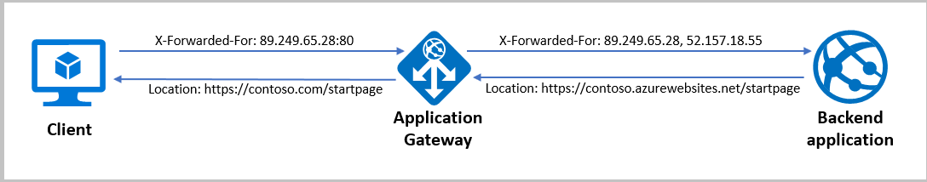

**URL path and query string**

With URL rewrite capability in Application Gateway, you can:

* Rewrite the host name, path, and query string of the request URL
* Choose to rewrite the URL of all requests on a listener or only those requests which match one or more of the conditions you set. These conditions are based on the request and response properties (request, header, response header and server variables).
* Choose to route the request (select the backend pool) based on either the original URL or the rewritten URL.

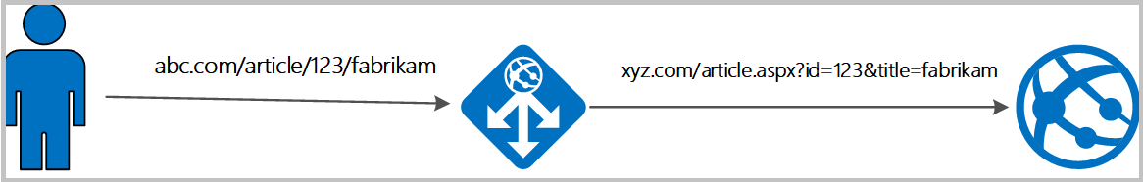

## Rewrite actions

You use rewrite actions to specify the URL, request headers or response headers that you want to rewrite and the new value to which you intend to rewrite them to. The value of a URL or a new or existing header can be set to these types of values:

* Text
* Request header. To specify a request header, you need to use the syntax {http_req_headerName}
* Response header. To specify a response header, you need to use the syntax {http_resp_headerName}
* Server variable. To specify a server variable, you need to use the syntax {var_serverVariable}. See the list of supported server variables

A combination of text, a request header, a response header, and a server variable.

## Rewrite conditions

You can use rewrite conditions, an optional configuration, to evaluate the content of HTTP(S) requests and responses and perform a rewrite only when one or more conditions are met. The application gateway uses these types of variables to evaluate the content of requests and responses:

* HTTP headers in the request
* HTTP headers in the response
* Application Gateway server variables

You can use a condition to evaluate whether a specified variable is present, whether a specified variable matches a specific value, or whether a specified variable matches a specific pattern.

## Rewrite configuration

To configure a rewrite rule, you need to create a rewrite rule set and add the rewrite rule configuration in it.

A rewrite rule set contains:

* **Request routing rule association:** The rewrite configuration is associated to the source listener via the routing rule. When you use a basic routing rule, the rewrite configuration is associated with a source listener and is a global header rewrite. When you use a path-based routing rule, the rewrite configuration is defined on the URL path map. In that case, it applies only to the specific path area of a site. You can create multiple rewrite sets and apply each rewrite set to multiple listeners. But you can apply only one rewrite set to a specific listener.
* **Rewrite Condition:** It is an optional configuration. Rewrite conditions evaluate the content of the HTTP(S) requests and responses. The rewrite action will occur if the HTTP(S) request or response matches the rewrite condition. If you associate more than one condition with an action, the action occurs only when all the conditions are met. In other words, the operation is a logical AND operation.
* **Rewrite type:** There are three types of rewrites available:
* Rewriting request headers
* Rewriting response headers
* Rewriting URL components

1. **URL path:** The value to which the path is to be rewritten to.
2. **URL Query String:** The value to which the query string is to be rewritten to.
3. **Re-evaluate path map:** Used to determine whether the URL path map is to be re-evaluated or not. If kept unchecked, the original URL path will be used to match the path-pattern in the URL path map. If set to true, the URL path map will be re-evaluated to check the match with the rewritten path. Enabling this switch helps in routing the request to a different backend pool post rewrite.

# Design and configure Azure Front Door

Azure Front Door is Microsoft’s modern cloud Content Delivery Network (CDN) that provides fast, reliable, and secure access between your users and your applications’ static and dynamic web content across the globe. Azure Front Door delivers your content using the Microsoft’s global edge network with hundreds of global and local POPs distributed around the world close to both your enterprise and consumer end users.

Many organizations have applications they want to make available to their customers, their suppliers, and almost certainly their users. The tricky part is making sure those applications are highly available. In addition, they need to be able to quickly respond while being appropriately secured. Azure Front Door provides different SKUs (pricing tiers) that meet these requirements. Let's briefly review the features and benefits of these SKUs so you can determine which option best suits your requirements.

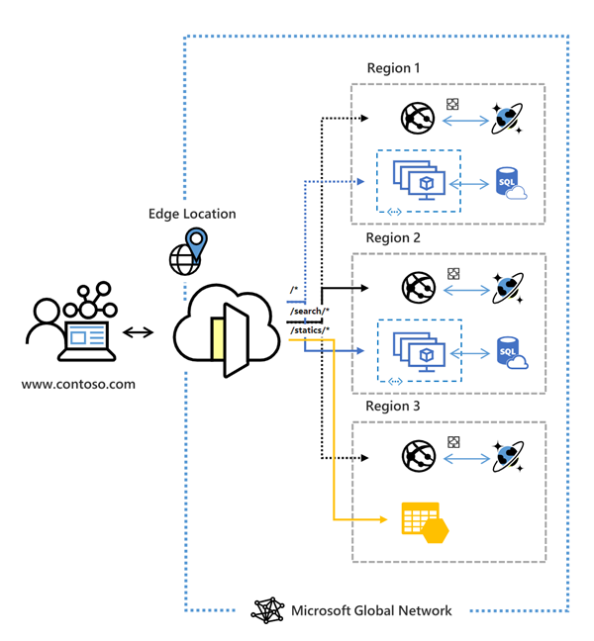

A secure, modern cloud CDN provides a distributed platform of servers. This helps minimize latency when users are accessing webpages. Historically, IT staff might have used a CDN and a web application firewall to control HTTP and HTTPS traffic flowing to and from target applications.

## Azure Front Door tier comparison

Azure Front Door is offered in 2 different tiers, Azure Front Door Standard and Azure Front Door Premium. Azure Front Door Standard and Premium tier combines capabilities of Azure Front Door (classic), Azure CDN Standard from Microsoft (classic), and Azure WAF into a single secure cloud CDN platform with intelligent threat protection. Azure Front Door resides in the edge locations and manages user requests to your hosted applications. Users connect to your application through the Microsoft global network. Azure Front Door then routes user requests to the fastest and most available application backend.

## Create a Front Door in the Azure portal

You can create an Azure Front Door profile through Quick Create with basic configurations or through the Custom create which allows a more advanced configuration.

## Routing architecture overview

Front Door traffic routing takes place over multiple stages. First, traffic is routed from the client to Front Door. Then, Front Door uses your configuration to determine the origin to send the traffic to. The Front Door web application firewall, routing rules, rules engine, and caching configuration all affect the routing process. The following diagram illustrates the routing architecture:

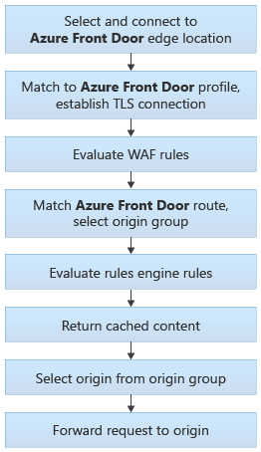

## Configure redirection rules in Front Door

After establishing a connection and completing a TLS handshake, when a request lands on a Front Door environment one of the first things that Front Door does is determine which routing rule to match the request to and then take the defined action in the configuration.

### Front Door route rules configuration structure

A Front Door routing rule configuration is composed of two major parts: a "left-hand side" and a "right-hand side". Front Door matches the incoming request to the left-hand side of the route. The right-hand side defines how Front Door processes the request.

**Incoming match**

The following properties determine whether the incoming request matches the routing rule (or left-hand side):

* HTTP Protocols (HTTP/HTTPS)
* Hosts
* Paths (for example, /*, /users/*, /file.gif)

These properties are expanded out internally so that every combination of Protocol/Host/Path is a potential match set.

**Route data**

Front Door speeds up the processing of requests by using caching. If caching is enabled for a specific route, it uses the cached response. If there is no cached response for the request, Front Door forwards the request to the appropriate backend in the configured backend pool.

**Route matching**

Front Door attempts to match to the **most-specific match first** looking only at the left-hand side of the route. It first matches based on HTTP protocol, then Frontend host, then the Path.

**Frontend host matching:**

* + Look for any routing with an exact match on the host.
  + If no exact frontend hosts match, reject the request and send a 400 Bad Request error.

**Path matching:**

* + Look for any routing rule with an exact match on the Path.
  + If no exact match Paths, look for routing rules with a wildcard Path that matches.
  + If no routing rules are found with a matching Path, then reject the request and return a 400: Bad Request error HTTP response.

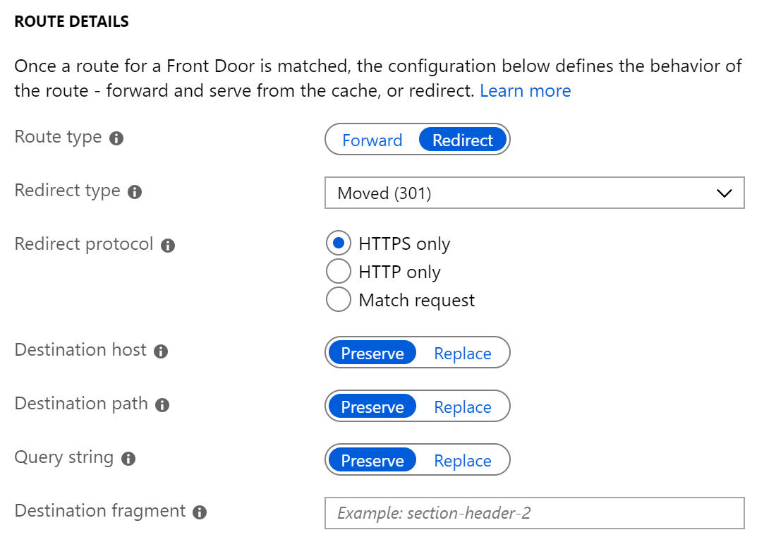

### Redirection types

A redirect type sets the response status code for the clients to understand the purpose of the redirect. The following types of redirection are supported:

|  |  |  |
| --- | --- | --- |
| **Redirection type** | **Action** | **Description** |
| 301 | Moved permanently | Indicates that the target resource has been assigned a new permanent URI. Any future references to this resource will use one of the enclosed URIs. Use 301 status code for HTTP to HTTPS redirection. |
| 302 | Found | Indicates that the target resource is temporarily under a different URI. Since the redirection can change on occasion, the client should continue to use the effective request URI for future requests. |
| 307 | Temporary redirect | Indicates that the target resource is temporarily under a different URI. The user agent MUST NOT change the request method if it does an automatic redirection to that URI. Since the redirection can change over time, the client ought to continue using the original effective request URI for future requests. |
| 308 | Permanent redirect | Indicates that the target resource has been assigned a new permanent URI. Any future references to this resource should use one of the enclosed URIs. |

### Redirection protocol

You can set the protocol that will be used for redirection. The most common use case of the redirect feature is to set HTTP to HTTPS redirection.

* **HTTPS only:** Set the protocol to HTTPS only, if you're looking to redirect the traffic from HTTP to HTTPS. Azure Front Door recommends that you should always set the redirection to HTTPS only.
* **HTTP only:** Redirects the incoming request to HTTP. Use this value only if you want to keep your traffic HTTP that is, non-encrypted.
* **Match request:** This option keeps the protocol used by the incoming request. So, an HTTP request remains HTTP and an HTTPS request remains HTTPS post redirection.

### Destination host

As part of configuring a redirect routing, you can also change the hostname or domain for the redirect request. You can set this field to change the hostname in the URL for the redirection or otherwise preserve the hostname from the incoming request.

### Destination path

For cases where you want to replace the path segment of a URL as part of redirection, you can set this field with the new path value. Otherwise, you can choose to preserve the path value as part of redirect. So, using this field, you can redirect all requests sent to <https://www.contoso.com/>* to <https://www.contoso.com/redirected-site>.

### Destination fragment

The destination fragment is the portion of URL after '#', which is used by the browser to land on a specific section of a web page. You can set this field to add a fragment to the redirect URL.

## Configure health probes, including customization of HTTP response codes

To determine the health and proximity of each backend for a given Front Door environment, each Front Door environment periodically sends a synthetic HTTP/HTTPS request to each of your configured backends. Front Door then uses these responses from the probe to determine the "best" backend resources to route your client requests.

Since Front Door has many edge environments globally, health probe volume for your backends can be quite high - ranging from 25 requests every minute to as high as 1200 requests per minute, depending on the health probe frequency configured. With the default probe frequency of 30 seconds, the probe volume on your backend should be about 200 requests per minute.

### Supported HTTP methods for health probes

Front Door supports sending probes over either HTTP or HTTPS protocols. These probes are sent over the same TCP ports configured for routing client requests and cannot be overridden.

Front Door supports the following HTTP methods for sending the health probes:

**GET:** The GET method means retrieve whatever information (in the form of an entity) is identified by the Request-URI.

**HEAD:** The HEAD method is identical to GET except that the server MUST NOT return a message-body in the response. Because it has lower load and cost on your backends, for new Front Door profiles, by default, the probe method is set as HEAD.

### Health probe responses

The following table describes responses to the health probe:

|  |  |
| --- | --- |
| **Response** | **Description** |
| Determining Health | A 200 OK status code indicates the backend is healthy. Everything else is considered a failure. If for any reason (including network failure) a valid HTTP response isn't received for a probe, the probe is counted as a failure. |
| Measuring Latency | Latency is the wall-clock time measured from the moment immediately before the probe request is sent to the moment the last byte of the response is received. A new TCP connection is used for each request, so this measurement isn't biased towards backends with existing warm connections. |

Azure Front Door uses the same three-step process below across all algorithms to determine health.

1. Exclude disabled backends.
2. Exclude backends that have health probe errors:
   1. This selection is done by looking at the last n health probe responses. If at least x are healthy, the backend is considered healthy.
   2. n is configured by changing the SampleSize property in load-balancing settings.
   3. x is configured by changing the SuccessfulSamplesRequired property in load-balancing settings.
3. For the sets of healthy backends in the backend pool, Front Door additionally measures and maintains the latency (round-trip time) for each backend.

If you have a single backend in your backend pool, you can choose to disable the health probes reducing the load on your application backend. Even if you have multiple backends in the backend pool but only one of them is in enabled state, you can disable health probes.

## Secure Front Door with SSL

Use the HTTPS protocol on your custom domain you ensure that your sensitive data is delivered securely via TLS/SSL encryption when it's sent across the internet. When your web browser is connected to a web site via HTTPS, it validates the web site's security certificate and verifies that it was issued by a legitimate certificate authority. This process provides security and protects your web applications from attacks.

Some of the key attributes of the custom HTTPS feature are:

* **No extra cost:** There are no costs for certificate acquisition or renewal and no extra cost for HTTPS traffic.
* **Simple enablement:** One-click provisioning is available from the Azure portal. You can also use REST API or other developer tools to enable the feature.
* **Complete certificate management:** All certificate procurement and management is handled for you. Certificates are automatically provisioned and renewed before expiration, which removes the risks of service interruption because of a certificate expiring.

You can enable the HTTPS protocol for a custom domain that's associated with your Front Door under the frontend hosts section.

# [Design and implement network security](https://learn.microsoft.com/en-us/training/modules/design-implement-network-security-monitoring/)

## Network Security

Network Security covers controls to secure and protect Azure networks, including securing virtual networks, establishing private connections, preventing and mitigating external attacks, and securing DNS.

### NS-1: Establish network segmentation boundaries

**Security Principle**: Ensure that your virtual network deployment aligns to your enterprise segmentation strategy defined in the GS-2 security control. Any workload that could incur higher risk for the organization should be in isolated virtual networks. Examples of high-risk workload include:

* An application storing or processing highly sensitive data.
* An external network-facing application accessible by the public or users outside of your organization.
* An application using insecure architecture or containing vulnerabilities that cannot be easily remediated.

To enhance your enterprise segmentation strategy, restrict or monitor traffic between internal resources using network controls. For specific, well-defined applications (such as a 3-tier app), this can be a highly secure "deny by default, permit by exception" approach by restricting the ports, protocols, source, and destination IPs of the network traffic. If you have many applications and endpoints interacting with each other, blocking traffic may not scale well, and you may only be able to monitor traffic.

**Azure Guidance**: Create a virtual network (VNet) as a fundamental segmentation approach in your Azure network, so resources such as VMs can be deployed into the VNet within a network boundary. To further segment the network, you can create subnets inside VNet for smaller sub-networks.

Use network security groups (NSG) as a network layer control to restrict or monitor traffic by port, protocol, source IP address, or destination IP address.

You can also use application security groups (ASGs) to simplify complex configuration. Instead of defining policy based on explicit IP addresses in network security groups, ASGs enable you to configure network security as a natural extension of an application's structure, allowing you to group virtual machines and define network security policies based on those groups.

### NS-2: Secure cloud services with network controls

**Security Principle**: Secure cloud services by establishing a private access point for the resources. You should also disable or restrict access from public network when possible.

**Azure Guidance**: Deploy private endpoints for all Azure resources that support the Private Link feature, to establish a private access point for the resources. You should also disable or restrict public network access to services where feasible.

For certain services, you also have the option to deploy VNet integration for the service where you can restrict the VNET to establish a private access point for the service.

### NS-3: Deploy firewall at the edge of enterprise network

**Security Principle**: Deploy a firewall to perform advanced filtering on network traffic to and from external networks. You can also use firewalls between internal segments to support a segmentation strategy. If required, use custom routes for your subnet to override the system route when you need to force the network traffic to go through a network appliance for security control purpose.

At a minimum, block known bad IP addresses and high-risk protocols, such as remote management (for example, RDP and SSH) and intranet protocols (for example, SMB and Kerberos).

**Azure Guidance**: Use Azure Firewall to provide fully stateful application layer traffic restriction (such as URL filtering) and/or central management over a large number of enterprise segments or spokes (in a hub/spoke topology).

If you have a complex network topology, such as a hub/spoke setup, you may need to create user-defined routes (UDR) to ensure the traffic goes through the desired route. For example, you have option to use an UDR to redirect egress internet traffic through a specific Azure Firewall or a network virtual appliance.

### NS-4: Deploy intrusion detection/intrusion prevention systems (IDS/IPS)

**Security Principle**: Use network intrusion detection and intrusion prevention systems (IDS/IPS) to inspect the network and payload traffic to or from your workload. Ensure that IDS/IPS is always tuned to provide high-quality alerts to your SIEM solution.

For more in-depth host level detection and prevention capability, use host-based IDS/IPS or a host-based endpoint detection and response (EDR) solution in conjunction with the network IDS/IPS.

**Azure Guidance**: Use Azure Firewall’s IDPS capability on your network to alert on and/or block traffic to and from known malicious IP addresses and domains.

For more in-depth host level detection and prevention capability, deploy host-based IDS/IPS or a host-based endpoint detection and response (EDR) solution, such as Microsoft Defender for Endpoint, at the VM level in conjunction with the network IDS/IPS.

### NS-5: Deploy DDOS protection

**Security Principle**: Deploy distributed denial of service (DDoS) protection to protect your network and applications from attacks.

**Azure Guidance**: Enable DDoS Network Protection plan on your VNet to protect resources that are exposed to the public networks.

### NS-6: Deploy web application firewall

**Security Principle**: Deploy a web application firewall (WAF) and configure the appropriate rules to protect your web applications and APIs from application-specific attacks.

**Azure Guidance**: Use web application firewall (WAF) capabilities in Azure Application Gateway, Azure Front Door, and Azure Content Delivery Network (CDN) to protect your applications, services and APIs against application layer attacks at the edge of your network. Set your WAF in "detection" or "prevention mode", depending on your needs and threat landscape. Choose a built-in ruleset, such as OWASP Top 10 vulnerabilities, and tune it to your application.

### NS-7: Simplify network security configuration

**Security Principle**: When managing a complex network environment, use tools to simplify, centralize and enhance the network security management.

**Azure Guidance**: Use the following features to simplify the implementation and management of the NSG and Azure Firewall rules:

* Use Microsoft Defender for Cloud Adaptive Network Hardening to recommend NSG hardening rules that further limit ports, protocols and source IPs based on threat intelligence and traffic analysis result.
* Use Azure Firewall Manager to centralize the firewall policy and route management of the virtual network. To simplify the firewall rules and network security groups implementation, you can also use the Azure Firewall Manager ARM (Azure Resource Manager) template.

### NS-8: Detect and disable insecure services and protocols

**Security Principle**: Detect and disable insecure services and protocols at the OS, application, or software package layer. Deploy compensating controls if disabling insecure services and protocols are not possible.

**Azure Guidance**: Use Azure Sentinel’s built-in Insecure Protocol Workbook to discover the use of insecure services and protocols such as SSL/TLSv1, SSHv1, SMBv1, LM/NTLMv1, wDigest, Unsigned LDAP Binds, and weak ciphers in Kerberos. Disable insecure services and protocols that do not meet the appropriate security standard.

**Note:** If disabling insecure services or protocols is not possible, use compensating controls such as blocking access to the resources through network security group, Azure Firewall, or Azure Web Application Firewall to reduce the attack surface.

### NS-9: Connect on-premises or cloud network privately

**Security Principle**: Use private connections for secure communication between different networks, such as cloud service provider datacenters and on-premises infrastructure in a colocation environment.

**Azure Guidance**: Use private connections for secure communication between different networks, such as cloud service provider datacenters and on-premises infrastructure in a colocation environment.

For lightweight connectivity between site-to-site or point-to-site, use Azure virtual private network (VPN) to create a secure connection between your on-premises site or end-user device to the Azure virtual network.

For enterprise-level high performance connection, use Azure ExpressRoute (or Virtual WAN) to connect Azure datacenters and on-premises infrastructure in a co-location environment.

When connecting two or more Azure virtual networks together, use virtual network peering. Network traffic between peered virtual networks is private and is kept on the Azure backbone network.

### NS-10: Ensure Domain Name System (DNS) security

**Security Principle**: Ensure that Domain Name System (DNS) security configuration protects against known risks:

* Use trusted authoritative and recursive DNS services across your cloud environment to ensure the client (such as operating systems and applications) receive the correct resolution result.
* Separate the public and private DNS resolution so the DNS resolution process for the private network can be isolated from the public network.
* Ensure your DNS security strategy also includes mitigations against common attacks, such as dangling DNS, DNS amplifications attacks, DNS poisoning and spoofing, and so on.

**Azure Guidance**: Use Azure recursive DNS or a trusted external DNS server in your workload recursive DNS setup, such as in VM's operating system or in the application.

Use Azure Private DNS for private DNS zone setup where the DNS resolution process does not leave the virtual network. Use a custom DNS to restrict the DNS resolution which only allows the trusted resolution to your client.

Use Azure Defender for DNS for the advanced protection against the following security threats to your workload or your DNS service:

* Data exfiltration from your Azure resources using DNS tunneling
* Malware communicating with command-and-control server
* Communication with malicious domains as phishing and crypto mining
* DNS attacks in communication with malicious DNS resolvers

You can also use Azure Defender for App Service to detect dangling DNS records if you decommission an App Service website without removing its custom domain from your DNS registrar.

## Microsoft cloud security benchmark

Microsoft has found that using security benchmarks can help you quickly secure cloud deployments. A comprehensive security best practice framework from cloud service providers can give you a starting point for selecting specific security configuration settings in your cloud environment, across multiple service providers and allow you to monitor these configurations using a single pane of glass.

The Microsoft cloud security benchmark (MCSB) includes a collection of high-impact security recommendations you can use to help secure your cloud services in a single or multicloud environment. MCSB recommendations include two key aspects:

* **Security controls:** These recommendations are generally applicable across your cloud workloads. Each recommendation identifies a list of stakeholders that are typically involved in planning, approval, or implementation of the benchmark.
* **Service baselines:** These apply the controls to individual cloud services to provide recommendations on that specific service’s security configuration. We currently have service baselines available only for Azure.

### Implement Microsoft cloud security benchmark

* **Plan** your MCSB implementation by reviewing the documentation for the enterprise controls and service-specific baselines to plan your control framework and how it maps to guidance like Center for Internet Security (CIS) Controls, National Institute of Standards and Technology (NIST), and the Payment Card Industry Data Security Standard (PCI-DSS) framework.
* **Monitor** your compliance with MCSB status (and other control sets) using the Microsoft Defender for Cloud – Regulatory Compliance Dashboard for your multicloud environment.
* **Establish** guardrails to automate secure configurations and enforce compliance with MCSB (and other requirements in your organization) using features such as Azure Blueprints, Azure Policy, or the equivalent technologies from other cloud platforms.

### Terminology

The terms **control**, and **baseline** are used often in the Microsoft cloud security benchmark documentation, and it is important to understand how Azure uses those terms.

|  |  |  |
| --- | --- | --- |
| **Term** | **Description** | **Example** |
| Control | A control is a high-level description of a feature or activity that needs to be addressed and is not specific to a technology or implementation. | Data Protection is one of the security control families. Data Protection contains specific actions that must be addressed to help ensure data is protected. |
| Baseline | A baseline is the implementation of the control on the individual Azure services. Each organization dictates a benchmark recommendation and corresponding configurations are needed in Azure. Note: Today we have service baselines available only for Azure. | The Contoso company looks to enable Azure SQL security features by following the configuration recommended in the Azure SQL security baseline. |

## Using Microsoft Defender for Cloud for regulatory compliance

Microsoft Defender for Cloud helps streamline the process for meeting regulatory compliance requirements, using the regulatory compliance dashboard.

The regulatory compliance dashboard shows the status of all the assessments within your environment for your chosen standards and regulations. As you act on the recommendations and reduce risk factors in your environment, your compliance posture improves.

### Regulatory compliance dashboard

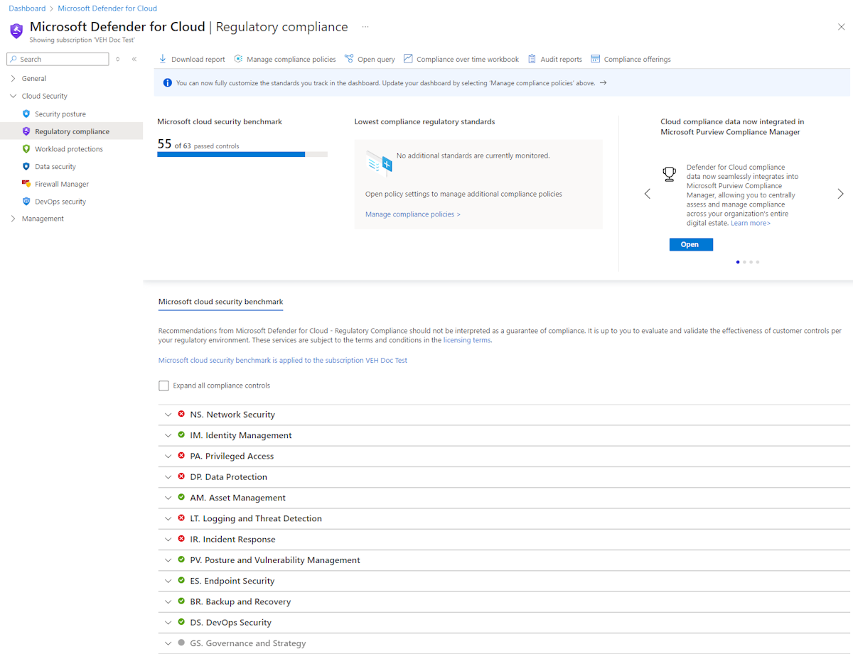

The dashboard shows an overview of your compliance status with the set of supported compliance regulations. You will see your overall compliance score, and the number of passing vs. failing assessments associated with each standard.

### Compliance controls

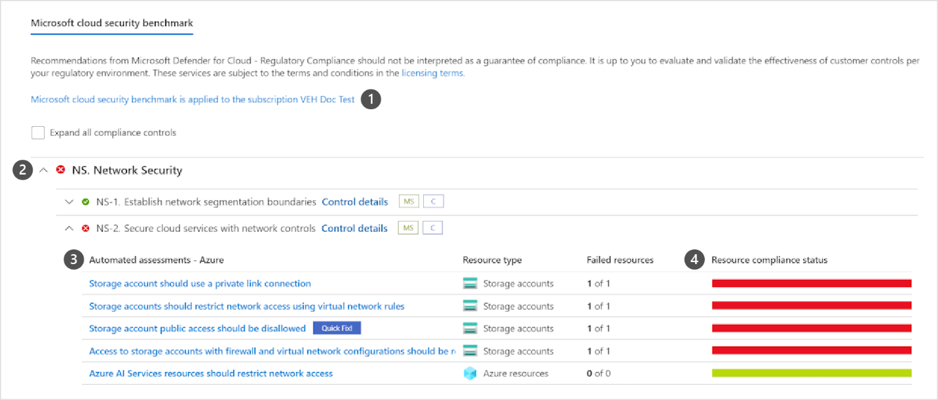

1. Subscriptions the standard is applied on.
2. List of all controls for that standard.
3. View the details of passing and failing assessments associated with that control.
4. Number of affected resources.

Some controls are grayed out. These controls do not have any Microsoft Defender for Cloud assessments associated with them. Check their requirements and assess them in your environment. Some of these might be process-related and not technical.

### Exploring the details of compliance with a specific standard

To generate a PDF report with a summary of your current compliance status for a particular standard, select Download report.

The report provides a high-level summary of your compliance status for the selected standard based on Microsoft Defender for Cloud assessments data. The report is organized according to the controls of that standard. The report can be shared with relevant stakeholders and might provide evidence to internal and external auditors.

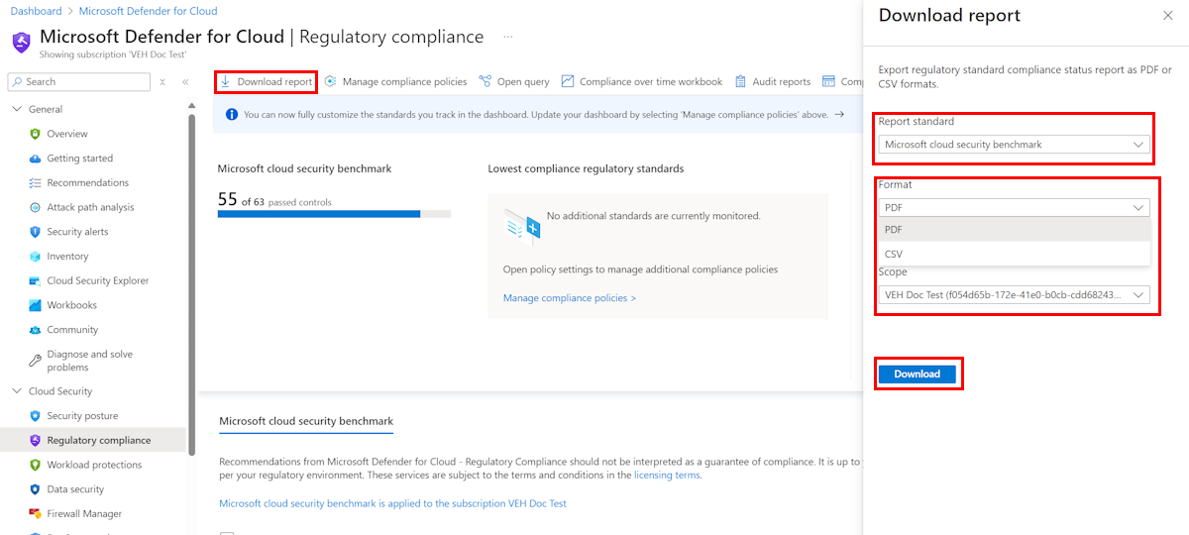

## Alerts in Microsoft Defender for Cloud

Microsoft Defender for Cloud automatically collects, analyzes, and integrates log data from your Azure resources, the network, and connected partner solutions - like firewall and endpoint protection solutions - to detect real threats and reduce false positives. A list of prioritized security alerts is shown in Microsoft Defender for Cloud along with the information you need to quickly investigate the problem and steps to take to remediate an attack.

### Manage your security alerts

The Microsoft Defender for Cloud overview page shows the Security alerts tile at the top of the page, and as a link from the sidebar.

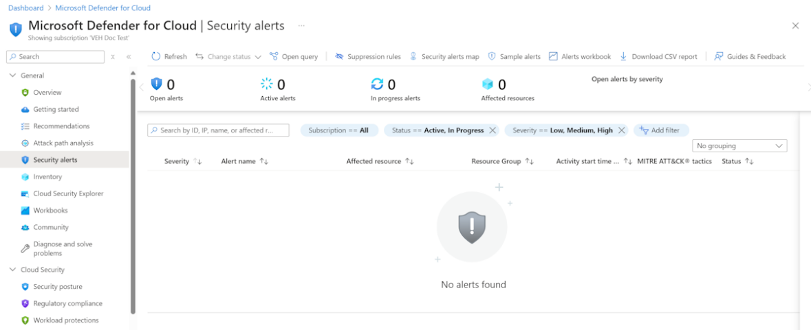

The security alerts page shows the active alerts. You can sort the list by Severity, Alert title, Affected resource, Activity start time. MITRE ATTACK tactics, and status.

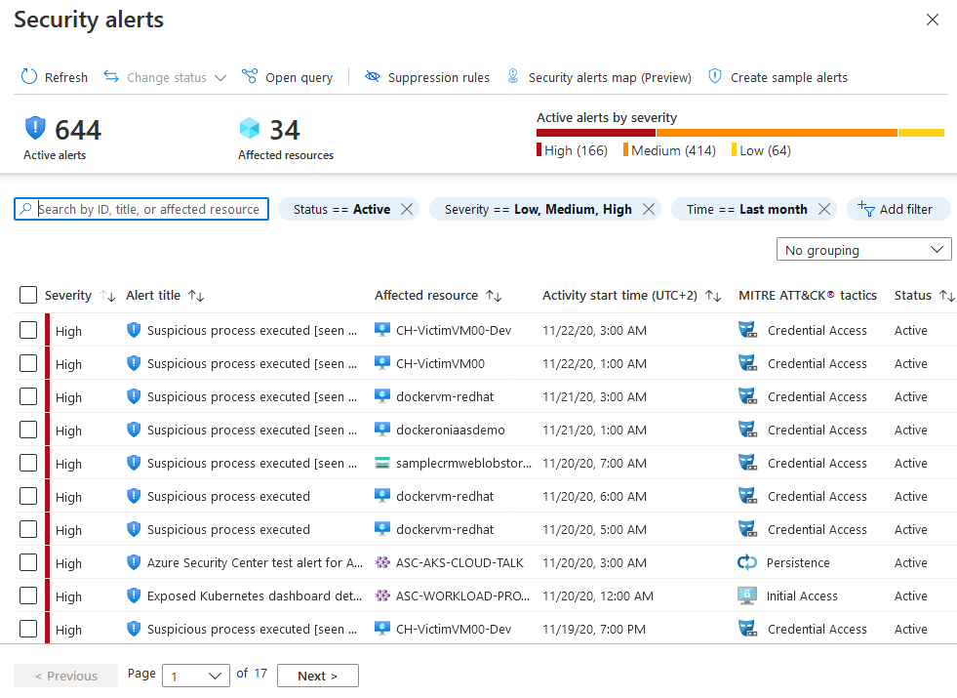

To filter the alerts list, select any of the relevant filters. You can add further filters with the Add filter option.

The list updates according to the filtering options you have selected. Filtering can be very helpful. For example, you might want to address security alerts that occurred in the last 24 hours because you are investigating a potential breach in the system.

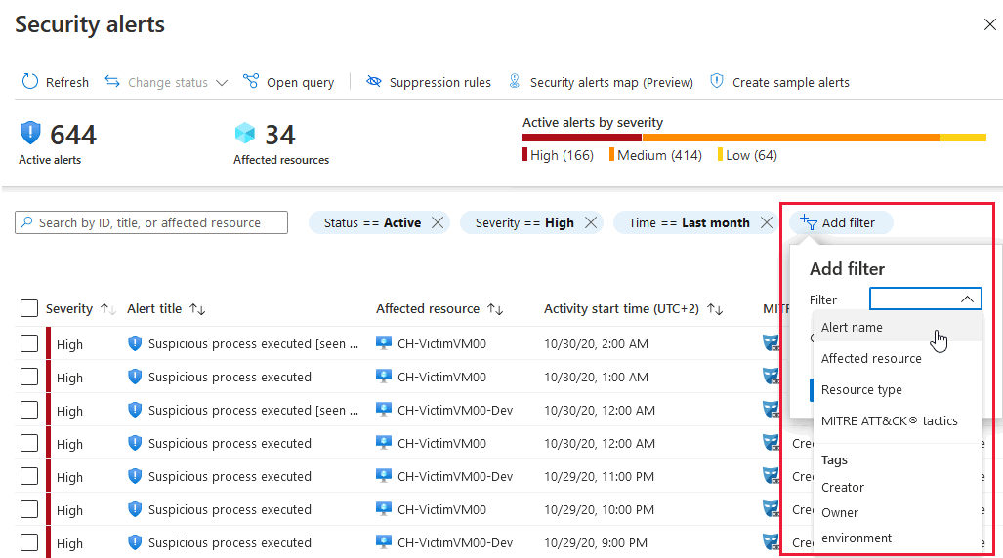

### Respond to security alerts

From the Security alerts list, select an alert. A side pane opens and shows a description of the alert and all the affected resources.

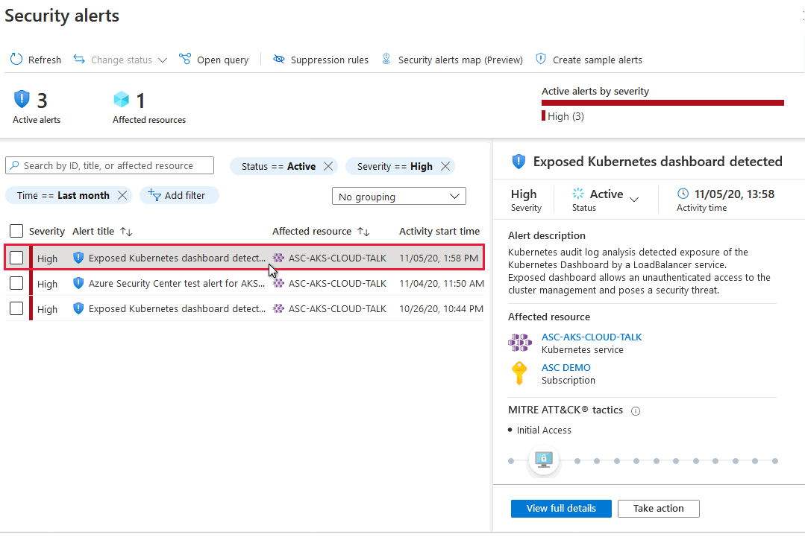

View full details displays further information, as shown in the following image:

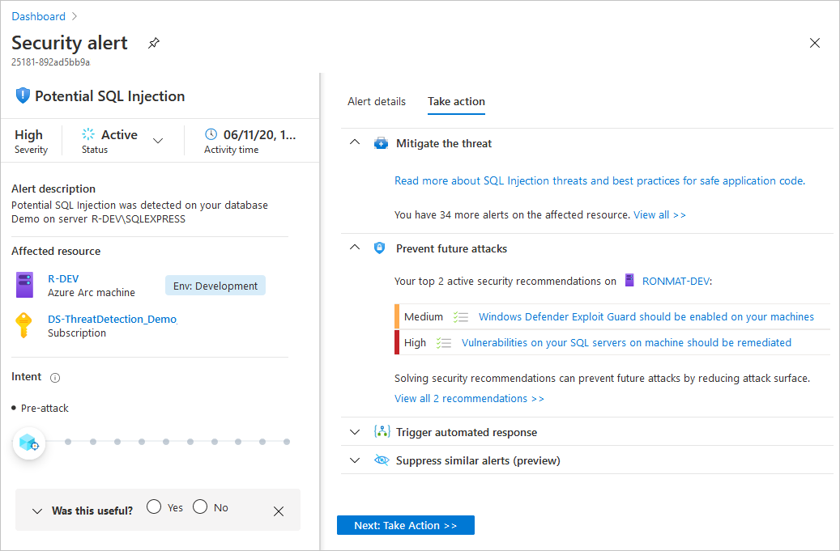

The left pane of the security alert page shows high-level information regarding the security alert: title, severity, status, activity time, description of the suspicious activity, and the affected resource. Alongside the affected resource are the Azure tags relevant to the resource. Use these to infer the organizational context of the resource when investigating the alert.

The right pane includes the Alert details tab containing further details of the alert to help you investigate the issue: IP addresses, files, processes, and more.

Also in the right pane is the Take action tab. Use this tab to take further actions regarding the security alert. Actions such as:

* **Mitigate the threat:** Provides manual remediation steps for this security alert.
* **Prevent future attacks:** Provides security recommendations to help reduce the attack surface, increase security posture, and thus prevent future attacks.
* **Trigger automated response:** Provides the option to trigger a logic app as a response to this security alert.
* **Suppress similar alerts:** Provides the option to suppress future alerts with similar characteristics if the alert isn’t relevant for your organization.

# Deploy Azure DDoS Protection by using the Azure portal

## Distributed Denial of Service (DDoS)

A denial of service attack (DoS) is an attack that has the goal of preventing access to services or systems. If the attack originates from one location, it's called a DoS. If the attack originates from multiple networks and systems, it's called distributed denial of service (DDoS).

Distributed Denial of Service (DDoS) attacks are some of the largest availability and security concerns facing customers that are moving their applications to the cloud. A DDoS attack tries to drain an API's or application's resources, making that application unavailable to legitimate users. DDoS attacks can be targeted at any endpoint that is publicly reachable through the internet.

## DDoS implementation

Azure DDoS Protection, combined with application design best practices, provide defense against DDoS attacks. Azure DDoS Protection provides the following service tiers:

* **Network Protection**

Provides additional mitigation capabilities over DDoS infrastructure Protection that are tuned specifically to Azure Virtual Network resources. Azure DDoS Protection is simple to enable, and requires no application changes. Protection policies are tuned through dedicated traffic monitoring and machine learning algorithms. Policies are applied to public IP addresses associated to resources deployed in virtual networks, such as Azure Load Balancer, Azure Application Gateway, and Azure Service Fabric instances, but this protection doesn't apply to App Service Environments. Real-time telemetry is available through Azure Monitor views during an attack, and for history. Rich attack mitigation analytics are available via diagnostic settings. Application layer protection can be added through the Azure Application Gateway Web Application Firewall or by installing a third party firewall from Azure Marketplace. Protection is provided for IPv4 and IPv6 Azure public IP addresses.

* **IP Protection**

DDoS IP Protection is a pay-per-protected IP model. DDoS IP Protection contains the same core engineering features as DDoS Network Protection, but will differ in value-added services like DDoS rapid response support, cost protection, and discounts on WAF.

DDoS Protection protects resources in a virtual network including public IP addresses associated with virtual machines, load balancers, and application gateways. When coupled with the Application Gateway web application firewall, or a third-party web application firewall deployed in a virtual network with a public IP, DDoS Protection can provide full layer 3 to layer 7 mitigation capability.

Every property in Azure is protected by Azure's DDoS infrastructure (Basic) Protection at no additional cost. Azure DDoS Protection is a paid service, designed for services that are deployed in a virtual network.

## Types of DDoS attacks

DDoS Protection can mitigate the following types of attacks:

* **Volumetric attacks**

These attacks flood the network layer with a substantial amount of seemingly legitimate traffic. They include UDP floods, amplification floods, and other spoofed-packet floods. DDoS Protection mitigates these potential multi-gigabyte attacks by absorbing and scrubbing them, with Azure's global network scale, automatically.

* **Protocol attacks**

These attacks render a target inaccessible, by exploiting a weakness in the layer 3 and layer 4 protocol stack. They include SYN flood attacks, reflection attacks, and other protocol attacks. DDoS Protection mitigates these attacks, differentiating between malicious and legitimate traffic, by interacting with the client, and blocking malicious traffic.

* **Resource (application) layer attacks**

These attacks target web application packets, to disrupt the transmission of data between hosts. They include HTTP protocol violations, SQL injection, cross-site scripting, and other layer 7 attacks. Use a Web Application Firewall, such as the Azure Application Gateway web application firewall, and DDoS Protection to provide defense against these attacks. There are also third-party web application firewall offerings available in the Azure Marketplace.

## Azure DDoS protection features

Some of Azure DDoS protection features include:

* **Native platform integration:** Natively integrated into Azure and configured through portal.
* **Turnkey protection:** Simplified configuration protecting all resources immediately.
* **Always-on traffic monitoring:** Your application traffic patterns are monitored 24 hours a day, 7 days a week, looking for indicators of DDoS attacks.
* **Adaptive tuning:** Profiling and adjusting to your service's traffic.
* **Attack analytics:** Get detailed reports in five-minute increments during an attack, and a complete summary after the attack ends.
* **Attack metrics and alerts:** Summarized metrics from each attack are accessible through Azure Monitor. Alerts can be configured at the start and stop of an attack, and over the attack's duration, using built-in attack metrics.
* **Multi-layered protection:** When deployed with a web application firewall (WAF), DDoS Protection protects both at the network layer (Layer 3 and 4, offered by Azure DDoS Protection) and at the application layer (Layer 7, offered by a WAF).

Let us have a look in a bit more detail at some of those key features.

### Always-on traffic monitoring

DDoS Protection monitors actual traffic utilization and constantly compares it against the thresholds defined in the DDoS Policy. When the traffic threshold is exceeded, DDoS mitigation is initiated automatically. When traffic returns below the thresholds, the mitigation is stopped.

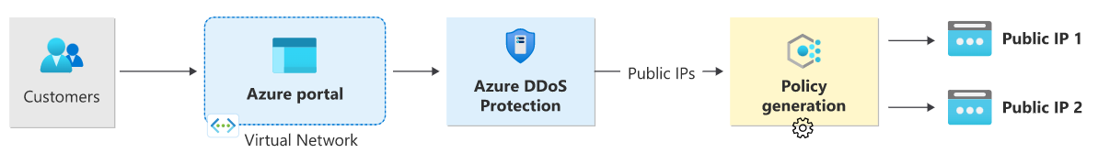During mitigation, traffic sent to the protected resource is redirected by the DDoS protection service and several checks are performed, such as:

* Ensure packets conform to internet specifications and aren't malformed.
* Interact with the client to determine if the traffic is potentially a spoofed packet (e.g: SYN Auth or SYN Cookie or by dropping a packet for the source to retransmit it).
* Rate-limit packets if no other enforcement method can be performed.

DDoS protection drops attack traffic and forwards the remaining traffic to its intended destination. Within a few minutes of attack detection, you're notified using Azure Monitor metrics. By configuring logging on DDoS Protection telemetry, you can write the logs to available options for future analysis. Metric data in Azure Monitor for DDoS Protection is retained for 30 days.

### Adaptive real-time tuning

The Azure DDoS Protection service helps protect customers and prevent impacts to other customers. For example, if a service is provisioned for a typical volume of legitimate incoming traffic that is smaller than the trigger rate of the infrastructure-wide DDoS Protection policy, a DDoS attack on that customer’s resources might go unnoticed. More generally, the complexity of recent attacks (for example, multi-vector DDoS) and the application-specific behaviors of tenants call for per-customer, tailored protection policies.

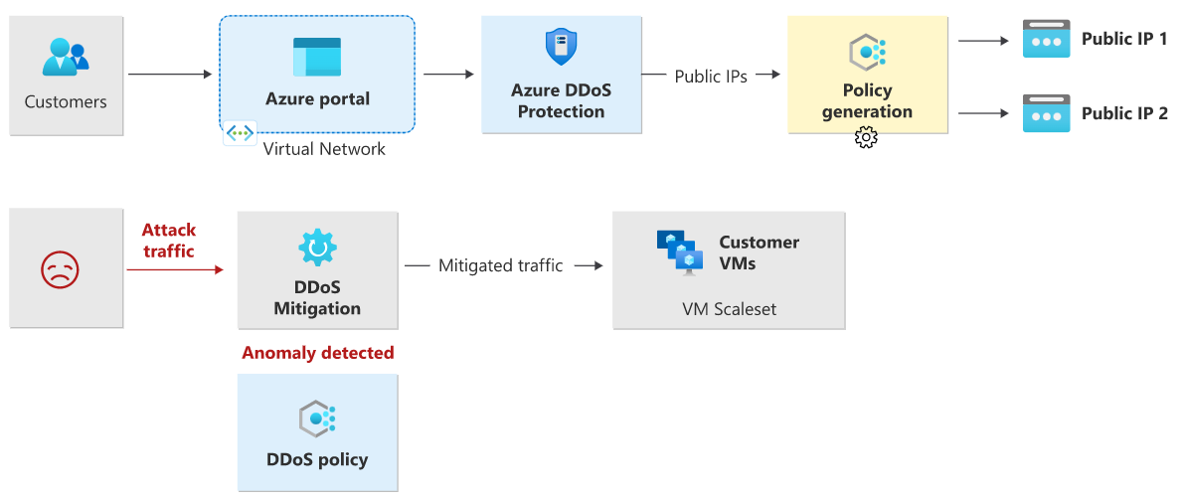

The service accomplishes this by using two insights:

* Automatic learning of per-customer (per- Public IP) traffic patterns for Layer 3 and 4.
* Minimizing false positives, considering that the scale of Azure allows it to absorb a significant amount of traffic.

### Attack metrics, alerts, and logs

DDoS Protection exposes rich telemetry via the Azure Monitor tool. You can configure alerts for any of the Azure Monitor metrics that DDoS Protection uses. You can integrate logging with Splunk (Azure Event Hubs), Azure Monitor logs, and Azure Storage for advanced analysis via the Azure Monitor Diagnostics interface.

In the Azure portal, select **Monitor > Metrics**. In the **Metrics** pane, select the resource group, select a resource type of **Public IP Address**, and select your Azure public IP address. DDoS metrics are visible in the **Available metrics** pane.

DDoS Protection applies three autotuned mitigation policies (SYN, TCP, and UDP) for each public IP of the protected resource, in the virtual network that has DDoS enabled. You can view the policy thresholds by selecting the **Inbound [SYN/TCP/UDP] packets to trigger DDoS mitigation** metrics as shown in the example screenshot below.

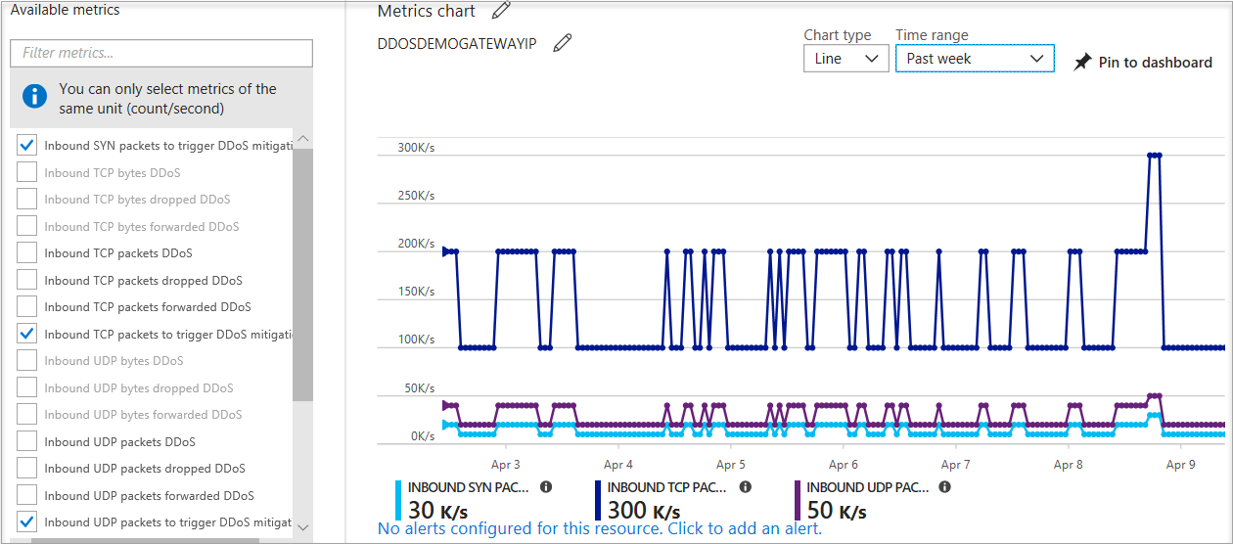

The policy thresholds are autoconfigured via machine learning-based network traffic profiling. DDoS mitigation occurs for an IP address under attack only when the policy threshold is exceeded.

If the public IP address is under attack, the value for the **Under DDoS attack or not** metric changes to **1** as DDoS Protection performs mitigation on the attack traffic.

It's recommended to configure an alert on this metric as you'll then get notified if there's an active DDoS mitigation performed on your public IP address.

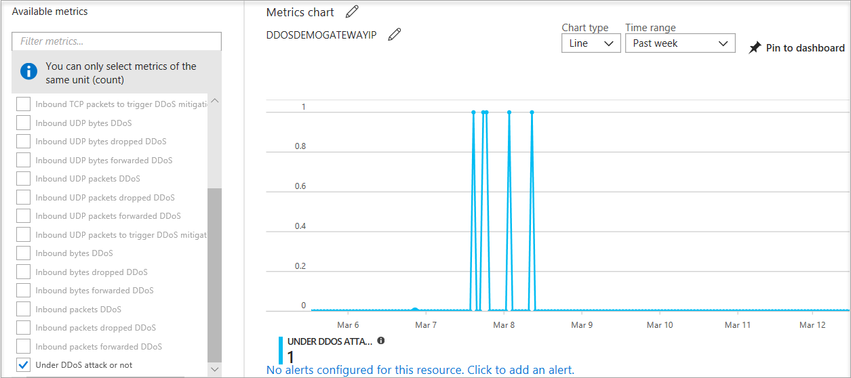

### Multi-layered protection

Specific to resource attacks at the application layer, you should configure a web application firewall (WAF) to help secure web applications. A WAF inspects inbound web traffic to block SQL injections, cross-site scripting, DDoS, and other Layer 7 attacks. Azure provides WAF as a feature of **Application Gateway** for centralized protection of your web applications from common exploits and vulnerabilities. There are other WAF offerings available from Azure partners that might be more suitable for your needs via the Azure Marketplace.

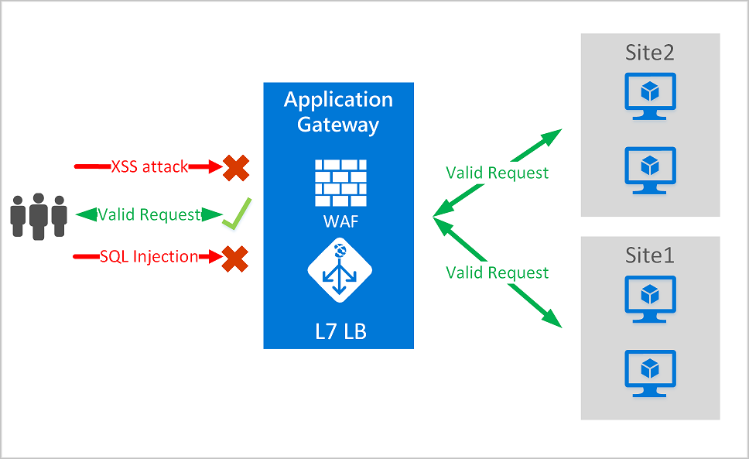

Even web application firewalls are susceptible to volumetric and state exhaustion attacks. Therefore, it's firmly recommended to enable DDoS Protection on the WAF virtual network to help protect from volumetric and protocol attacks.

## Deploying a DDoS protection plan

The key stages of deploying a DDoS Protection plan are as follows:

* Create a resource group
* Create a DDoS Protection Plan
* Enable DDoS protection on a new or existing virtual network or IP address
* Configure DDoS telemetry
* Configure DDoS diagnostic logs
* Configure DDoS alerts
* Run a test DDoS attack and monitor the results.

# Deploy Network Security Groups by using the Azure portal

A Network Security Group (NSG) in Azure allows you to filter network traffic to and from Azure resources in an Azure virtual network. A network security group contains security rules that allow or deny inbound network traffic to, or outbound network traffic from, several types of Azure resources. For each rule, you can specify source and destination, port, and protocol.

## NSG security rules

A network security group contains zero, or as many rules as desired, within Azure subscription limits. Each rule specifies the following properties:

* **Name** - Must be a unique name within the network security group.
* **Priority** - Can be any number between 100 and 4096. Rules are processed in priority order, with lower numbers processed before higher numbers, because lower numbers have higher priority. Once traffic matches a rule, processing stops. As a result, any rules that exist with lower priorities (higher numbers) that have the same attributes as rules with higher priorities aren't processed.
* **Source or destination** - Can be set to Any, or an individual IP address, or classless inter-domain routing (CIDR) block (10.0.0.0/24, for example), service tag, or application security group.
* **Protocol** - Can be TCP, UDP, ICMP, ESP, AH, or Any.
* **Direction** - Can be configured to apply to inbound, or outbound traffic.
* **Port range** - Can be specified either as an individual port or range of ports. For example, you could specify 80 or 10000-10005. Specifying ranges enables you to create fewer security rules.
* **Action** - Can be set to Allow or deny.

The firewall evaluates network security group security rules by priority, using the 5-tuple information (source, source port, destination, destination port, and protocol) to either allow or deny the traffic.

|  |  |  |  |  |  |  |  |  |
| --- | --- | --- | --- | --- | --- | --- | --- | --- |
| **Direction** | **Name** | **Priority** | **Source** | **Source Ports** | **Destination** | **Destination Ports** | **Protocol** | **Access** |
| Inbound | AllowVNetInBound | 65000 | VirtualNetwork | 0-65535 | VirtualNetwork | 0-65535 | Any | Allow |
| Inbound | AllowAzureLoadBalancerInBound | 65001 | AzureLoadBalancer | 0-65535 | 0.0.0.0/0 | 0-65535 | Any | Allow |
| Inbound | DenyAllInbound | 65500 | 0.0.0.0/0 | 0-65535 | 0.0.0.0/0 | 0-65535 | Any | Deny |
| Outbound | AllowVnetOutBound | 65000 | VirtualNetwork | 0-65535 | VirtualNetwork | 0-65535 | Any | Allow |
| Outbound | AllowInternetOutBound | 65001 | 0.0.0.0/0 | 0-65535 | Internet | 0-65535 | Any | Allow |
| Outbound | DenyAllOutBound | 65500 | 0.0.0.0/0 | 0-65535 | 0.0.0.0/0 | 0-65535 | Any | Deny |

The following diagram and bullet points illustrate different scenarios for how network security groups might be deployed to allow network traffic to and from the internet over TCP port 80:

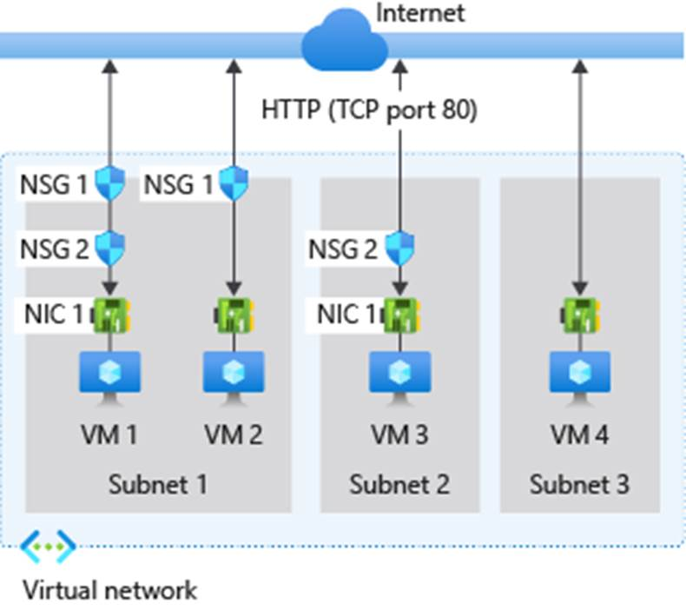

For **inbound traffic** Azure processes the rules in a network security group associated to a subnet first, if there's one, and then the rules in a network security group associated to the network interface, if there's one.

* **VM1:** Subnet1 is associated with NSG1, so the security rules are processed, and VM1 is in Subnet1. Unless you created a rule that allows port 80 inbound, the DenyAllInbound default security rule denies the traffic, and never evaluated by NSG2, since NSG2 is associated to the network interface. If NSG1 has a security rule that allows port 80, NSG2 then processes the traffic. To allow port 80 to the virtual machine, both NSG1 and NSG2 must have a rule that allows port 80 from the internet.
* **VM2:** The rules in NSG1 are processed because VM2 is also in Subnet1. Since VM2 doesn't have a network security group associated to its network interface, it receives all traffic allowed through NSG1 or is denied all traffic denied by NSG1. Traffic is either allowed or denied to all resources in the same subnet when a network security group is associated to a subnet.
* **VM3:** Since there's no network security group associated to Subnet2, traffic is allowed into the subnet and processed by NSG2, because NSG2 is associated to the network interface attached to VM3.
* **VM4:** Traffic is allowed to VM4, because a network security group isn't associated to Subnet3, or the network interface in the virtual machine. All network traffic is allowed through a subnet and network interface if they don't have a network security group associated to them.

For **outbound traffic**, Azure processes the rules in a network security group associated to a network interface first, if there's one, and then the rules in a network security group associated to the subnet, if there's one.

* **VM1:** The security rules in NSG2 are processed. Unless you create a security rule that denies port 80 outbound to the internet, the AllowInternetOutbound default security rule allows the traffic in both NSG1 and NSG2. If NSG2 has a security rule that denies port 80, the traffic is denied, and NSG1 never evaluates it. To deny port 80 from the virtual machine, either or both network security groups must have a rule denying port 80 to the internet.
* **VM2:** All traffic is sent through the network interface to the subnet, since the network interface attached to VM2 doesn't have a network security group associated to it. The rules in NSG1 are processed.
* **VM3:** If NSG2 has a security rule that denies port 80, the traffic is denied. If NSG2 has a security rule that allows port 80, then port 80 is allowed outbound to the internet, since a network security group isn't associated to Subnet2.
* **VM4:** All network traffic is allowed from VM4, because a network security group isn't associated to the network interface attached to the virtual machine, or to Subnet3.

## Application Security Groups

An Application Security Group (ASG) enables you to configure network security as a natural extension of an application's structure, allowing you to group virtual machines and define network security policies based on those groups. You can reuse your security policy at scale without manual maintenance of explicit IP addresses. The platform handles the complexity of explicit IP addresses and multiple rule sets, allowing you to focus on your business logic.

To minimize the number of security rules you need, and the need to change the rules, plan out the application security groups you need and create rules using service tags or application security groups, rather than individual IP addresses, or ranges of IP addresses, whenever possible.

## Filter network traffic with an NSG using the Azure portal

You can use a network security group to filter network traffic inbound and outbound from a virtual network subnet. Network security groups contain security rules that filter network traffic by IP address, port, and protocol. Security rules are applied to resources deployed in a subnet.

The key stages to filter network traffic with an NSG using the Azure portal are:

Create a resource group - this can either be done beforehand or as you create the virtual network in the next stage. All other resources that you create must be in the same region specified here.

**Create a virtual network -** this must be deployed in the same resource group you created previously.

**Create application security groups -** the application security groups you create here enables you to group together servers with similar functions, such as web servers or management servers. You would create two application security groups here; one for web servers and one for management servers.

**Create a network security group -** the network security group secures network traffic in your virtual network. This NSG will be associated with a subnet in the next stage.

**Associate a network security group with a subnet -** this is where you associate the network security group you create previously, with the subnet of the virtual network you created in stage 2 above.

**Create security rules -** this is where you create your inbound security rules. Here you would create a security rule to allow ports 80 and 443 to the application security group for your web servers (for example, MyAsgWebServers). Then you would create another security rule to allow RDP traffic on port 3389 to the application security group for your management servers (for example, MyAsgMgmtServers). These rules control from where you can access your VM remotely and your IIS Webserver.

**Create virtual machines -** this is where you create the web server (for example, MyVMWeb) and management server (for example, MyVMMgmt) virtual machines that will be associated with their respective application security group in the next stage.

**Associate NICs to an ASG -** this is where you associate the network interface card (NIC) attached to each virtual machine with the relevant application security group that you created in stage 3 above.

**Test traffic filters -** the final stage is where you test that your traffic filtering is working as expected.

* + To test this, you would attempt to connect to the management server virtual machine (for example, MyVMMgmt) by using an RDP connection, thereby verifying that you can connect because port 3389 is allowing inbound connections from the Internet to the management servers application security group (for example, MyAsgMgmtServers).
  + While connected to the RDP session on the management server (for example, MyVMMgmt), you would then test an RDP connection from the management server virtual machine (for example, MyVMMgmt) to the web server virtual machine (for example, MyVMWeb), which again should succeed because virtual machines in the same network can communicate with each over any port by default.
  + However, you'll not be able to create an RDP connection to the web server virtual machine (for example, MyVMWeb) from the internet, because the security rule for the web servers application security group (for example, MyAsgWebServers) prevents connections to port 3389 inbound from the Internet. Inbound traffic from the Internet is denied to all resources by default.
  + While connected to the RDP session on the web server (for example, MyVMWeb), you could then install IIS on the web server, then disconnect from the web server virtual machine RDP session, and disconnect from the management server virtual machine RDP session.

# Design and implement Azure Firewall

Azure Firewall is a managed, cloud-based network security service that protects your Azure Virtual Network resources. It is a fully stateful firewall as a service with built-in high availability and unrestricted cloud scalability.

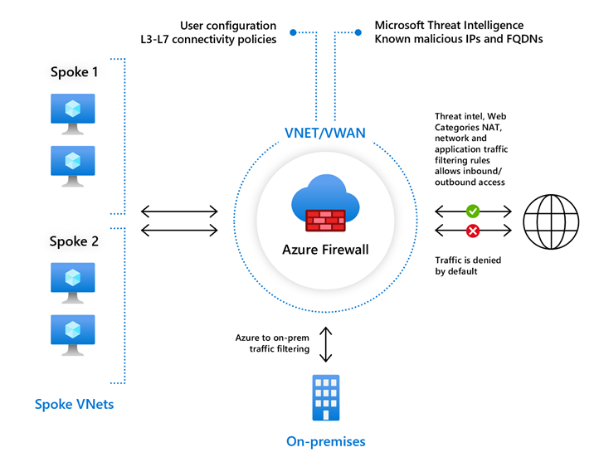

## Azure Firewall features

Azure Firewall includes the following features:

* **Built-in high availability** - High availability is built in, so no extra load balancers are required and there's nothing you need to configure.
* **Unrestricted cloud scalability** - Azure Firewall can scale out as much as you need to accommodate changing network traffic flows, so you do not need to budget for your peak traffic.
* **Application FQDN filtering rules** - You can limit outbound HTTP/S traffic or Azure SQL traffic to a specified list of fully qualified domain names (FQDN) including wild cards. This feature does not require TLS termination.
* **Network traffic filtering rules** - You can centrally create allow or deny network filtering rules by source and destination IP address, port, and protocol. Azure Firewall is fully stateful, so it can distinguish legitimate packets for different types of connections. Rules are enforced and logged across multiple subscriptions and virtual networks.
* **FQDN tags** - These tags make it easy for you to allow well-known Azure service network traffic through your firewall. For example, say you want to allow Windows Update network traffic through your firewall. You create an application rule and include the Windows Update tag. Now network traffic from Windows Update can flow through your firewall.
* **Service tags** - A service tag represents a group of IP address prefixes to help minimize complexity for security rule creation. You cannot create your own service tag, nor specify which IP addresses are included within a tag. Microsoft manages the address prefixes encompassed by the service tag, and automatically updates the service tag as addresses change.
* **Threat intelligence** - Threat intelligence-based filtering (IDPS) can be enabled for your firewall to alert and deny traffic from/to known malicious IP addresses and domains. The IP addresses and domains are sourced from the Microsoft Threat Intelligence feed.
* **TLS inspection** - The firewall can decrypt outbound traffic, processes the data, then encrypt the data and sends it to the destination.
* **Outbound SNAT support** - All outbound virtual network traffic IP addresses are translated to the Azure Firewall public IP (Source Network Address Translation (SNAT)). You can identify and allow traffic originating from your virtual network to remote Internet destinations.
* **Inbound DNAT support** - Inbound Internet network traffic to your firewall public IP address is translated (Destination Network Address Translation) and filtered to the private IP addresses on your virtual networks.
* **Multiple public IP addresses** - You can associate multiple public IP addresses (up to 250) with your firewall, to enable specific DNAT and SNAT scenarios.
* **Azure Monitor logging** - All events are integrated with Azure Monitor, allowing you to archive logs to a storage account, stream events to your Event Hubs, or send them to Azure Monitor logs.
* **Forced tunneling** - You can configure Azure Firewall to route all Internet-bound traffic to a designated next hop instead of going directly to the Internet. For example, you may have an on-premises edge firewall or other network virtual appliance (NVA) to process network traffic before it is passed to the Internet.
* **Web categories** - Web categories let administrators allow or deny user access to web site categories such as gambling websites, social media websites, and others. Web categories are included in Azure Firewall Standard, but it is more fine-tuned in Azure Firewall Premium Preview. As opposed to the Web categories capability in the Standard SKU that matches the category based on an FQDN, the Premium SKU matches the category according to the entire URL for both HTTP and HTTPS traffic.
* **Certifications** - Azure Firewall is Payment Card Industry (PCI), Service Organization Controls (SOC), International Organization for Standardization (ISO), and ICSA Labs compliant.

## Rule processing in Azure Firewall

In the Azure Firewall, you can configure NAT rules, network rules, and applications rules, and this can be done either by using classic rules or Firewall Policy. An Azure Firewall denies all traffic by default, until rules are manually configured to allow traffic.

### Rule processing with classic rules

With classic rules, rule collections are processed according to the rule type in priority order, lower numbers to higher numbers from 100 to 65,000. A rule collection name can have only letters, numbers, underscores, periods, or hyphens. It must also begin with either a letter or a number, and it must end with a letter, a number, or an underscore. The maximum name length is 80 characters. It is best practice to initially space your rule collection priority numbers in increments of 100 (i.e., 100, 200, 300, and so on) so that you give yourself space to add more rule collections when needed.

### Rule processing with Firewall Policy

With Firewall Policy, rules are organized inside Rule Collections which are contained in Rule Collection Groups. Rule Collections can be of the following types:

* DNAT (Destination Network Address Translation)
* Network
* Application

You can define multiple Rule Collection types within a single Rule Collection Group, and you can define zero or more Rules in a Rule Collection, but the rules within a Rule Collection must be of the same type (i.e., DNAT, Network, or Application).

With Firewall Policy, rules are processed based on Rule Collection Group Priority and Rule Collection priority. Priority is any number between 100 (highest priority) and 65,000 (lowest priority). Highest priority Rule Collection Groups are processed first, and inside a Rule Collection Group, Rule Collections with the highest priority (i.e., the lowest number) are processed first.

In the case of a Firewall Policy being inherited from a parent policy, Rule Collection Groups in the parent policy always takes precedence regardless of the priority of the child policy.

Application rules are always processed after network rules, which are themselves always processed after DNAT rules regardless of Rule Collection Group or Rule Collection priority and policy inheritance.

### Outbound connectivity using network rules and application rules

If you configure both network rules and application rules, then network rules are applied in priority order before application rules. Additionally, all rules are terminating, therefore, if a match is found in a network rule, no other rules are processed thereafter.

If there is no network rule match, and if the protocol is either HTTP, HTTPS, or MSSQL, then the packet is then evaluated by the application rules in priority order. For HTTP, Azure Firewall looks for an application rule match according to the Host Header, whereas for HTTPS, Azure Firewall looks for an application rule match according to Server Name Indication (SNI) only.

### Inbound connectivity using DNAT rules and network rules

Inbound Internet connectivity can be enabled by configuring DNAT. As mentioned previously, DNAT rules are applied in priority before network rules. If a match is found, an implicit corresponding network rule to allow the translated traffic is added. For security reasons, the recommended approach is to add a specific Internet source to allow DNAT access to the network and avoid using wildcards.

Application rules aren't applied for inbound connections. So, if you want to filter inbound HTTP/S traffic, you should use Web Application Firewall (WAF).

For enhanced security, if you modify a rule to deny access to traffic that had previously been allowed, any relevant existing sessions are dropped.

## Deploying and configuring Azure Firewall

Be aware of the following when deploying Azure Firewall:

* It can centrally create, enforce, and log application and network connectivity policies across subscriptions and virtual networks.
* It uses a static, public IP address for your virtual network resources. This allows outside firewalls to identify traffic originating from your virtual network.
* It is fully integrated with Azure Monitor for logging and analytics.
* When creating firewall rules, it is best to use the FQDN tags.

The key stages of deploying and configuring Azure Firewall are as follows:

* Create a resource group
* Create a virtual network and subnets
* Create a workload VM in a subnet
* Deploy the firewall and policy to the virtual network
* Create a default outbound route
* Configure an application rule
* Configure a network rule
* Configure a Destination NAT (DNAT) rule
* Test the firewall

### Deploying Azure Firewall with Availability Zones

One of the major features of Azure Firewall is Availability Zones.

When deploying Azure Firewall, you can configure it to span multiple Availability Zones for increased availability. When you configure Azure Firewall in this way your availability increases to 99.99% uptime. The 99.99% uptime SLA is offered when two or more Availability Zones are selected.

You can also associate Azure Firewall to a specific zone just for proximity reasons, using the service standard 99.95% SLA.

There is no additional cost for a firewall deployed in an Availability Zone. However, there are added costs for inbound and outbound data transfers associated with Availability Zones.

Azure Firewall Availability Zones are only available in regions that support Availability Zones.

Availability Zones can only be configured during firewall deployment. You cannot configure an existing firewall to include Availability Zones.

### Methods for deploying an Azure Firewall with Availability Zones

You can use several methods for deploying your Azure Firewall using Availability Zones.

* Azure portal
* Azure PowerShell
* Azure Resource Manager template

# Secure networks with Azure Firewall Manager

## Working with Azure Firewall Manager

Azure Firewall Manager is a security management service that provides central security policy and route management for cloud-based security perimeters.

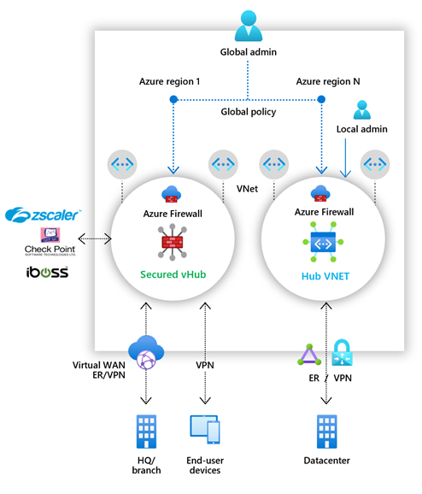

Azure Firewall Manager simplifies the process of centrally defining network and application-level rules for traffic filtering across multiple Azure Firewall instances. You can span different Azure regions and subscriptions in hub and spoke architectures for traffic governance and protection.

If you manage multiple firewalls, you know that continuously changing firewall rules make it difficult to keep them in sync. Central IT teams need a way to define base firewall policies and enforce them across multiple business units. At the same time, DevOps teams want to create their own local derived firewall policies that are implemented across organizations. Azure Firewall Manager can help solve these problems.

Firewall Manager can provide security management for two network architecture types:

* **Secured Virtual Hub** - This is the name given to any Azure Virtual WAN Hub when security and routing policies have been associated with it. An Azure Virtual WAN Hub is a Microsoft-managed resource that lets you easily create hub and spoke architectures.
* **Hub Virtual Network** - This is the name given to any standard Azure virtual network when security policies are associated with it. A standard Azure virtual network is a resource that you create and manage yourself. At this time, only Azure Firewall Policy is supported. You can peer spoke virtual networks that contain your workload servers and services. You can also manage firewalls in standalone virtual networks that are not peered to any spoke.

## Azure Firewall Manager features

The key features offered by Azure Firewall Manager are:

* **Central Azure Firewall deployment and configuration**

You can centrally deploy and configure multiple Azure Firewall instances that span different Azure regions and subscriptions.

* **Hierarchical policies (global and local)**

You can use Azure Firewall Manager to centrally manage Azure Firewall policies across multiple secured virtual hubs. Your central IT teams can author global firewall policies to enforce organization wide firewall policy across teams. Locally authored firewall policies allow a DevOps self-service model for better agility.

* **Integrated with third-party security-as-a-service for advanced security**

In addition to Azure Firewall, you can integrate third-party security-as-a-service providers to provide additional network protection for your VNet and branch Internet connections. This feature is available only with secured virtual hub deployments (see above).

* **Centralized route management**

You can easily route traffic to your secured hub for filtering and logging without the need to manually set up User Defined Routes (UDR) on spoke virtual networks. This feature is available only with secured virtual hub deployments (see above).

* **Region availability**

You can use Azure Firewall Policies across regions. For example, you can create a policy in the West US region, and still use it in the East US region.

* **DDoS protection plan**

You can associate your virtual networks with a DDoS protection plan within Azure Firewall Manager.

* **Manage Web Application Firewall policies**

You can centrally create and associate Web Application Firewall (WAF) policies for your application delivery platforms, including Azure Front Door and Azure Application Gateway.

## Azure Firewall Manager policies

A Firewall policy is an Azure resource that contains NAT, network, and application rule collections and Threat Intelligence settings. It is a global resource that can be used across multiple Azure Firewall instances in Secured Virtual Hubs and Hub Virtual Networks. New policies can be created from scratch or inherited from existing policies. Inheritance allows DevOps to create local firewall policies on top of organization mandated base policy. Policies work across regions and subscriptions.

You can create Firewall Policy and associations with Azure Firewall Manager. However, you can also create and manage a policy using REST API, templates, Azure PowerShell, and the Azure CLI. Once you create a policy, you can associate it with a firewall in a virtual WAN hub making it a Secured Virtual Hub and/or associate it with a firewall in a standard Azure virtual network making it a Hub Virtual Network.

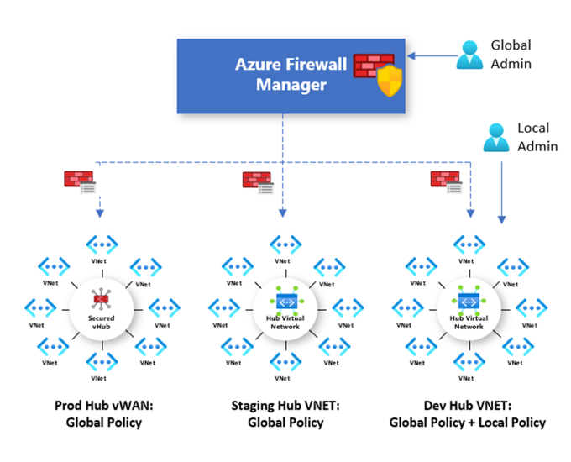

## Deploying Azure Firewall Manager for Hub Virtual Networks

The recommended process to deploy Azure Firewall Manager for Hub Virtual Networks is as follows:

1. **Create a firewall policy**

You can either create a new policy, derive a base policy, and customize a local policy, or import rules from an existing Azure Firewall. Ensure you remove NAT rules from policies that should be applied across multiple firewalls.

**2. Create your hub and spoke architecture**

Do this either by creating a Hub Virtual Network using Azure Firewall Manager and peering spoke virtual networks to it using virtual network peering, or by creating a virtual network and adding virtual network connections and peering spoke virtual networks to it using virtual network peering.

**3. Select security providers and associate firewall policy**

Currently, only Azure Firewall is a supported provider. This can be done while creating a Hub Virtual Network, or by converting an existing virtual network to a Hub Virtual Network. It is also possible to convert multiple virtual networks.

**4. Configure User Defined Routes to route traffic to your Hub Virtual Network firewall.**

## Deploying Azure Firewall Manager for Secured Virtual Hubs

The recommended process to deploy Azure Firewall Manager for Secured Virtual Hubs is as follows:

1. **Create your hub and spoke architecture**

Do this either by creating a Secured Virtual Hub using Azure Firewall Manager and adding virtual network connections, or by creating a Virtual WAN Hub and adding virtual network connections.

1. **Select security providers**

This can be done while creating a Secured Virtual Hub, or by converting an existing Virtual WAN Hub to a Secure Virtual Hub.

1. **Create a firewall policy and associate it with your hub**

This is applicable only if you are using Azure Firewall. Third-party security-as-a-service policies are configured via the partners management experience.

1. **Configure route settings to route traffic to your Secured Virtual Hub**

You can easily route traffic to your secured hub for filtering and logging without User Defined Routes (UDR) on spoke Virtual Networks by using the Secured Virtual Hub Route Setting page.

* You cannot have more than one hub per virtual WAN per region, however you can add multiple virtual WANs in the region to achieve this.
* You cannot have overlapping IP spaces for hubs in a WAN.
* Your hub VNet connections must be in the same region as the hub.

# Implement a Web Application Firewall on Azure Front Door

Web Application Firewall (WAF) provides centralized protection of your web applications from common exploits and vulnerabilities. Web applications are increasingly targeted by malicious attacks that exploit commonly known vulnerabilities. SQL injection and cross-site scripting are among the most common attacks.

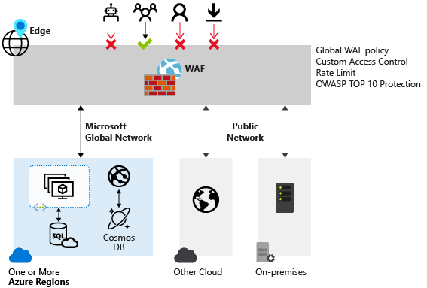

Preventing such attacks in application code is challenging. It can require rigorous maintenance, patching, and monitoring at multiple layers of the application topology. A centralized web application firewall helps make security management much simpler. A WAF also gives application administrators better assurance of protection against threats and intrusions.

A WAF solution can react to a security threat faster by centrally patching a known vulnerability, instead of securing each individual web application.

## Web Application Firewall policy modes

When you create a Web Application Firewall (WAF) policy, by default the WAF policy is in Detection mode. In Detection mode, WAF does not block any requests; instead, requests matching the WAF rules are logged at WAF logs. To see WAF in action, you can change the mode settings from Detection to Prevention. In Prevention mode, requests that match rules that are defined in Default Rule Set (DRS) are blocked and logged at WAF logs.

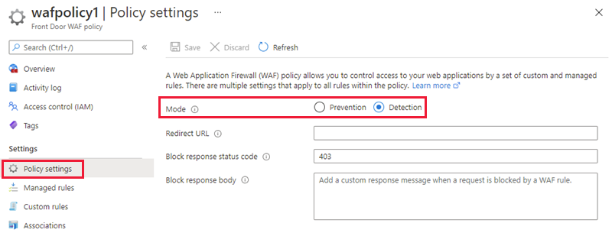

## Web Application Firewall Default Rule Set rule groups and rules

Azure Front Door web application firewall (WAF) protects web applications from common vulnerabilities and exploits. Azure-managed rule sets provide an easy way to deploy protection against a common set of security threats. Since such rule sets are managed by Azure, the rules are updated as needed to protect against new attack signatures.

### Managed rules

Azure-managed Default Rule Set includes rules against the following threat categories:

* Cross-site scripting
* Java attacks
* Local file inclusion
* PHP injection attacks
* Remote command execution
* Remote file inclusion
* Session fixation
* SQL injection protection
* Protocol attackers

Azure-managed Default Rule Set is enabled by default. The current default version is DefaultRuleSet_2.1. Other rule sets are available in the drop-down box.

To disable an individual rule, select the checkbox in front of the rule number, and select **Disable** at the top of the page. To change action types for individual rules within the rule set, select the checkbox in front of the rule number, and then select **Change action** at the top of the page.

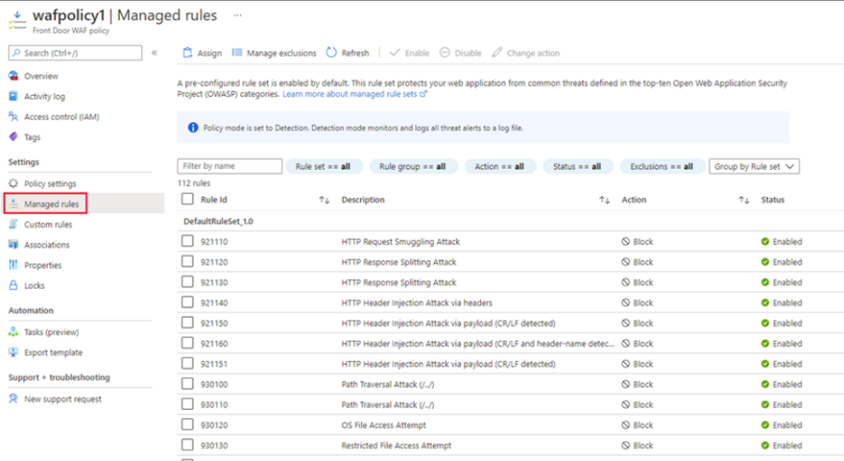

### Custom rules

Azure WAF with Front Door allows you to control access to your web applications based on the conditions you define. A custom WAF rule consists of a priority number, rule type, match conditions, and an action. There are two types of custom rules: match rules and rate limit rules. A match rule controls access based on a set of matching conditions while a rate limit rule controls access based on matching conditions and the rates of incoming requests. You may disable a custom rule to prevent it from being evaluated, but still keep the configuration.

When creating a WAF policy, you can create a custom rule by selecting **Add custom rule** under the **Custom rules** section. This launches the custom rule configuration page.

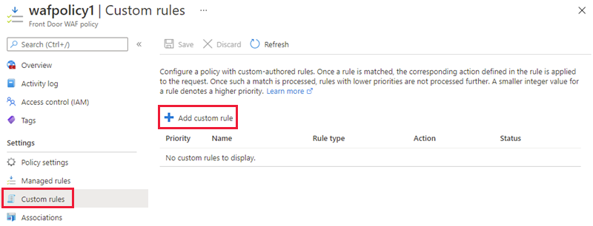

The example screenshot below shows the configuration of a custom rule to block a request if the query string contains **blockme**.

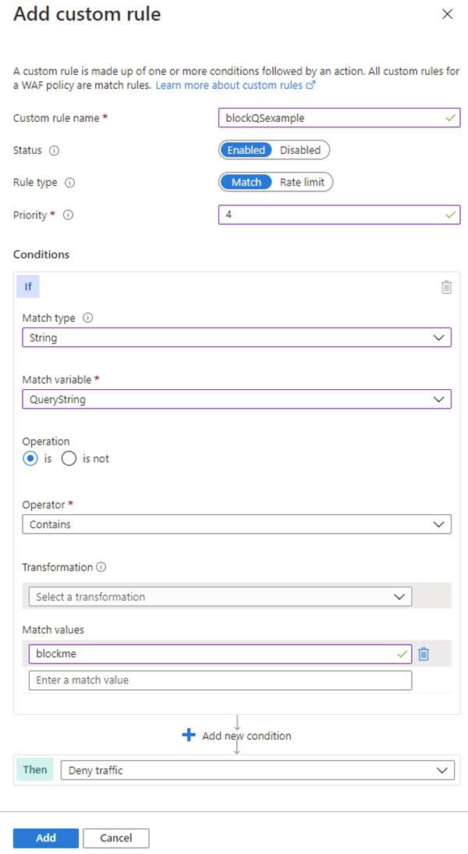

## Create a Web Application Firewall policy on Azure Front Door

This section describes how to create a basic Azure Web Application Firewall (WAF) policy and apply it to a profile in Azure Front Door.

The key stages to create a WAF policy on Azure Front Door using the Azure portal are:

1. **Create a Web Application Firewall policy**

This is where you create a basic WAF policy with managed Default Rule Set (DRS).

1. **Associate the WAF policy with a Front Door profile**

This is where you associate the WAF policy created in stage 1 with a Front Door profile. This association can be done during the creation of the WAF policy, or it can be done on a previously created WAF policy. During the association you specify the Front Door profile and the domain/s within the Front Door profile you want the WAF policy to be applied to. During this stage if the domain is associated to a WAF policy, it is shown as grayed out. You must first remove the domain from the associated policy, and then re-associate the domain to a new WAF policy.

1. **Configure WAF policy settings and rules**

This is an optional stage, where you can configure policy settings such as the **Mode** (Prevention or Detection) and configure managed rules and custom rules.

# Module 7: Design and implement private access to Azure Services

# Virtual network service endpoints

## What is a virtual network service endpoint?

Virtual Network (VNet) service endpoint provides secure and direct connectivity to Azure services over an optimized route over the Azure backbone network. Endpoints allow you to secure your critical Azure service resources to only your virtual networks. Service Endpoints enables private IP addresses in the VNet to reach the endpoint of an Azure service without needing a public IP address on the VNet.

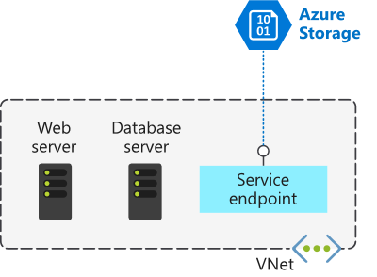

By default, Azure services are all designed for direct internet access. All Azure resources have public IP addresses, including PaaS services such as Azure SQL Database and Azure Storage. Because these services are exposed to the internet, anyone can potentially access your Azure services.

Service endpoints can connect certain PaaS services directly to your private address space in Azure, so they act like they’re on the same virtual network. Use your private address space to access the PaaS services directly. Adding service endpoints doesn't remove the public endpoint. It simply provides a redirection of traffic.

## Preparing to Implement Service Endpoints

To enable a Service Endpoint, you must do the following two things:

* Turn off public access to the service.
* Add the Service Endpoint to a virtual network.

When you enable a Service Endpoint, you restrict the flow of traffic, and enable your Azure VMs to access the service directly from your private address space. Devices cannot access the service from a public network. On a deployed VM vNIC, if you look at Effective routes, you'll notice the Service Endpoint as the Next Hop Type.

This is an example route table, before enabling a Service Endpoint:

|  |  |  |  |
| --- | --- | --- | --- |
| **SOURCE** | **STATE** | **ADDRESS PREFIXES** | **NEXT HOP TYPE** |
| Default | Active | 10.1.1.0/24 | VNet |
| Default | Active | 0.0.0.0./0 | Internet |
| Default | Active | 10.0.0.0/8 | None |
| Default | Active | 100.64.0.0./ | None |
| Default | Active | 192.168.0.0/16 | None |

And here's an example route table after you've added two Service Endpoints to the virtual network:

|  |  |  |  |
| --- | --- | --- | --- |
| **SOURCE** | **STATE** | **ADDRESS PREFIXES** | **NEXT HOP TYPE** |
| Default | Active | 10.1.1.0/24 | VNet |
| Default | Active | 0.0.0.0./0 | Internet |
| Default | Active | 10.0.0.0/8 | None |
| Default | Active | 100.64.0.0./ | None |
| Default | Active | 192.168.0.0/16 | None |
| Default | Active | 20.38.106.0/23, 10 more | VirtualNetworkServiceEndpoint |
| Default | Active | 20.150.2.0/23, 9 more | VirtualNetworkServiceEndpoint |

All traffic for the service now is routed to the Virtual Network Service Endpoint and remains internal to Azure.

## Create Service Endpoints

As the network engineer, you're planning to move sensitive engineering diagram files into Azure Storage. The files must only be accessible from computers inside the corporate network. You want to create a virtual network Service Endpoint for Azure Storage to secure the connectivity to your storage accounts.

In the [service endpoint tutorial](https://learn.microsoft.com/en-us/azure/virtual-network/tutorial-restrict-network-access-to-resources) you will learn how to:

* Enable a service endpoint on a subnet
* Use network rules to restrict access to Azure Storage
* Create a virtual network service endpoint for Azure Storage
* Verify that access is denied appropriately

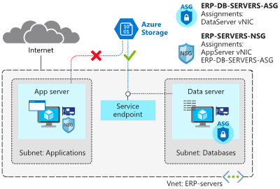

## Configure service tags

A service tag represents a group of IP address prefixes from a given Azure service. Microsoft manages the address prefixes encompassed by the service tag and automatically updates the service tag as addresses change, minimizing the complexity of frequent updates to network security rules.

You can use service tags to define network access controls on network security groups or Azure Firewall. Use service tags in place of specific IP addresses when you create security rules. By specifying the service tag name, such as API Management, in the appropriate source or destination field of a rule, you can allow or deny the traffic for the corresponding service.

As of March 2021, you can also use Service Tags in place of explicit IP ranges in user defined routes. This feature is currently in Public Preview.

You can use service tags to achieve network isolation and protect your Azure resources from the general Internet while accessing Azure services that have public endpoints. Create inbound/outbound network security group rules to deny traffic to/from Internet and allow traffic to/from AzureCloud or other available service tags of specific Azure services.

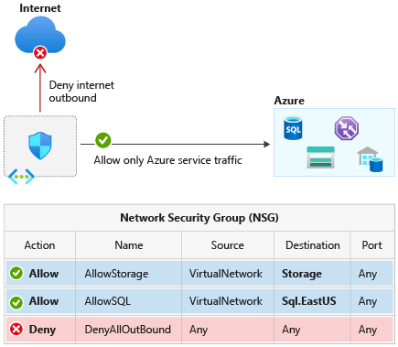

## Available service tags

The following table includes all the service tags available for use in network security group rules.

The columns indicate whether the tag:

* Is suitable for rules that cover inbound or outbound traffic.
* Supports regional scope.
* Is usable in Azure Firewall rules.

By default, service tags reflect the ranges for the entire cloud. Some service tags also allow more granular control by restricting the corresponding IP ranges to a specified region. For example, the service tag Storage represents Azure Storage for the entire cloud, but Storage. WestUS narrows the range to only the storage IP address ranges from the WestUS region. The [following table](https://learn.microsoft.com/en-us/azure/virtual-network/service-tags-overview#available-service-tags) indicates whether each service tag supports such regional scope.

Service tags of Azure services denote the address prefixes from the specific cloud being used. For example, the underlying IP ranges that correspond to the SQL tag value on the Azure Public cloud will be different from the underlying ranges on the Azure China cloud.

If you implement a virtual network Service Endpoint for a service, such as Azure Storage or Azure SQL Database, Azure adds a route to a virtual network subnet for the service. The address prefixes in the route are the same address prefixes, or CIDR ranges, as those of the corresponding service tag.

# Private Link Service and private endpoint

## What is Azure Private Link?

Azure Private Link enables you to access Azure PaaS Services (for example, Azure Storage and SQL Database) and Azure hosted customer-owned/partner services over a Private Endpoint in your virtual network.

Before you learn about Azure Private Link and its features and benefits, let's examine the problem that Private Link is designed to solve.

Contoso has an Azure virtual network, and you want to connect to a PaaS resource such as an Azure SQL database. When you create such resources, you normally specify a public endpoint as the connectivity method.

Having a public endpoint means that the resource is assigned a public IP address. So, even though both your virtual network and the Azure SQL database are located within the Azure cloud, the connection between them takes place over the internet.

The concern here is that your Azure SQL database is exposed to the internet via its public IP address. That exposure creates multiple security risks. The same security risks are present when an Azure resource is accessed via a public IP address from the following locations:

* A peered Azure virtual network
* An on-premises network that connects to Azure using ExpressRoute and Microsoft peering
* A customer's Azure virtual network that connects to an Azure service offered by your company

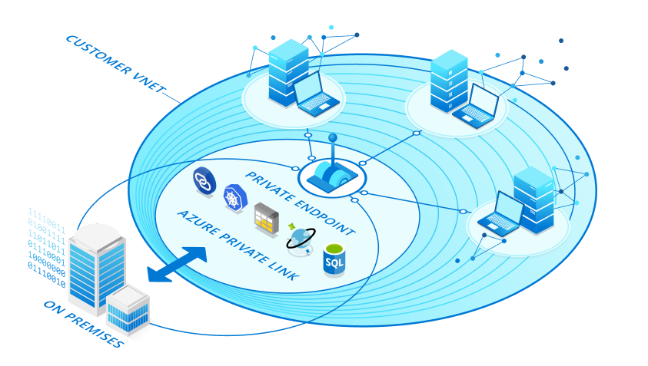

Private Link is designed to eliminate these security risks by removing the public part of the connection.

Private Link provides secure access to Azure services. Private Link achieves that security by replacing a resource's public endpoint with a private network interface. There are three key points to consider with this new architecture:

* The Azure resource becomes, in a sense, a part of your virtual network.
* The connection to the resource now uses the Microsoft Azure backbone network instead of the public internet.
* You can configure the Azure resource to no longer expose its public IP address, which eliminates that potential security risk.

## What is Azure Private Endpoint?

Private Endpoint is the key technology behind Private Link. Private Endpoint is a network interface that enables a private and secure connection between your virtual network and an Azure service. In other words, Private Endpoint is the network interface that replaces the resource's public endpoint.

Private Link provides secure access to Azure services. Private Link achieves that security by replacing a resource's public endpoint with a private network interface. Private Endpoint uses a private IP address from the VNet to bring the service into the VNet.

### How is Azure Private Endpoint different from a service endpoint?

Private Endpoints grant network access to specific resources behind a given service providing granular segmentation. Traffic can reach the service resource from on premises without using public endpoints.

A service endpoint remains a publicly routable IP address. A private endpoint is a private IP in the address space of the virtual network where the private endpoint is configured.

**Note**

Microsoft recommends use of Azure Private Link for secure and private access to services hosted on Azure platform.

## What is Azure Private Link Service?

Private Link gives you private access from your Azure virtual network to PaaS services and Microsoft Partner services in Azure. However, what if your company has created its own Azure services that are consumed by your company's customers? Is it possible to offer those customers a private connection to your company's services?

Yes, by using Azure Private Link Service. This service lets you offer Private Link connections to your custom Azure services. Consumers of your custom services can then access those services privately—that is, without using the internet—from their own Azure virtual networks.

Azure Private Link service is the reference to your own service powered by Azure Private Link. Your service that is running behind Azure standard load balancer can be enabled for Private Link access so that consumers to your service can access it privately from their own VNets. Your customers can create a private endpoint inside their VNet and map it to this service. A Private Link service receives connections from multiple private endpoints. A private endpoint connects to one Private Link service.

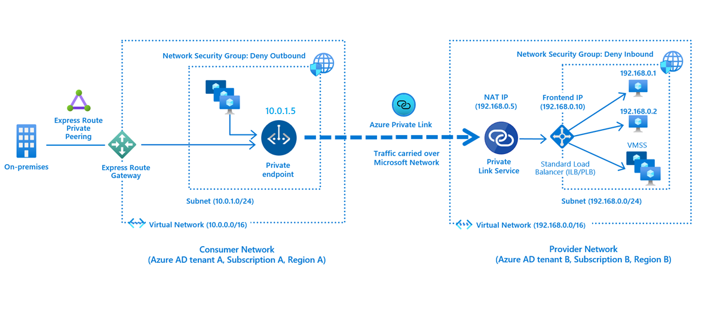

## Private Endpoint properties

Before creating a Private Endpoint, you should consider the Private Endpoint properties and collect data about specific needs to be addressed. These include:

* A unique name with a resource group
* A subnet to deploy and allocate private IP addresses from a virtual network
* The Private Link resource to connect using resource ID or alias, from the list of available types. A unique network identifier will be generated for all traffic sent to this resource.
* The subresource to connect. Each Private Link resource type has different options to select based on preference.
* An automatic or manual connection approval method. Based on Azure role-based access control (Azure RBAC) permissions, your Private Endpoint can be approved automatically. If you try to connect to a Private Link resource without Azure RBAC, use the manual method to allow the owner of the resource to approve the connection.
* A specific request message for requested connections to be approved manually. This message can be used to identify a specific request.
* Connection status, A read-only property that specifies if the Private Endpoint is active. Only Private Endpoints in an approved state can be used to send traffic.

## Private Endpoint Details:

* Private Endpoint enables connectivity between the consumers from the same VNet, regionally peered VNets, globally peered VNets and on premises using VPN or Express Route and services powered by Private Link.
* Network connections can only be initiated by clients connecting to the Private Endpoint, Service providers do not have any routing configuration to initiate connections into service consumers. Connections can only be established in a single direction.
* When creating a Private Endpoint, a read-only network interface is also created for the lifecycle of the resource. The interface is assigned dynamically private IP addresses from the subnet that maps to the Private Link resource. The value of the private IP address remains unchanged for the entire lifecycle of the Private Endpoint.
* The Private Endpoint must be deployed in the same region and subscription as the virtual network.
* The Private Link resource can be deployed in a different region than the virtual network and Private Endpoint.
* Multiple Private Endpoints can be created using the same Private Link resource. For a single network using a common DNS server configuration, the recommended practice is to use a single Private Endpoint for a given Private Link resource to avoid duplicate entries or conflicts in DNS resolution.
* Multiple Private Endpoints can be created on the same or different subnets within the same virtual network. There are limits to the number of Private Endpoints you can create in a subscription. For details, see Azure limits.
* The subscription from the Private Link resource must also be registered with Microsoft.

# Integrate private endpoint with DNS

Private DNS zones are typically hosted centrally in the same Azure subscription where the hub VNet is deployed. This central hosting practice is driven by cross-premises DNS name resolution and other needs for central DNS resolution such as Active Directory. In most cases, only networking/identity admins have permissions to manage DNS records in these zones.

## Azure Private Endpoint DNS configuration

The following diagram shows a typical high-level architecture for enterprise environments with central DNS resolution and where name resolution for Private Link resources is done via Azure Private DNS:

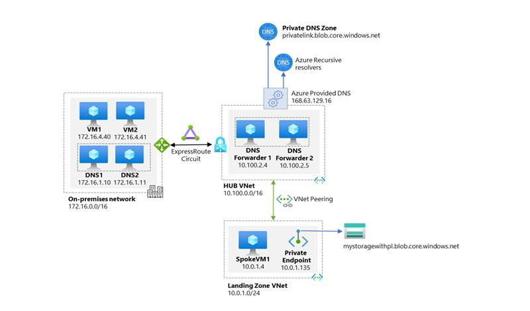

From the previous diagram, it is important to highlight that:

* On-premises DNS servers have conditional forwarders configured for each Private Endpoint public DNS zone forwarder pointing to the DNS forwarders (10.100.2.4 and 10.100.2.5) hosted in the hub VNet.
* The DNS servers 10.100.2.4 and 10.100.2.5 hosted in the hub VNet use the Azure-provided DNS resolver (168.63.129.16) as a forwarder.
* All Azure VNets have the DNS forwarders (10.100.2.4 and 10.100.2.5) configured as the primary and secondary DNS servers.
* There are two conditions that must be true to allow application teams the freedom to create any required Azure PaaS resources in their subscription:
* Central networking and/or central platform team must ensure that application teams can only deploy and access Azure PaaS services via Private Endpoints.
* Central networking and/or central platform teams must ensure that whenever Private Endpoints are created, the corresponding records are automatically created in the centralized private DNS zone that matches the service created.
* DNS record needs to follow the lifecycle of the Private Endpoint and automatically remove the DNS record when the Private Endpoint is deleted.

## Significance of IP address 168.63.129.16

IP address 168.63.129.16 is a virtual public IP address that is used to facilitate a communication channel to Azure platform resources. Customers can define any address space for their private virtual network in Azure. The Azure platform resources must be presented as a unique public IP address. This virtual public IP address facilitates the following things:

* Enables the VM Agent to communicate with the Azure platform to signal that it is in a "Ready" state
* Enables communication with the DNS virtual server to provide filtered name resolution to the resources (such as VM) that do not have a custom DNS server. This filtering makes sure that customers can resolve only the hostnames of their resources
* Enables health probes from Azure load balancer to determine the health state of VMs
* Enables the VM to obtain a dynamic IP address from the DHCP service in Azure
* Enables Guest Agent heartbeat messages for the PaaS role.

## Azure services Private DNS zone configuration examples

Azure creates a canonical name DNS record (CNAME) on the public DNS. The CNAME record redirects the resolution to the private domain name. You can override the resolution with the private IP address of your Private Endpoints.

Your applications don't need to change the connection URL. When resolving to a public DNS service, the DNS server will resolve to your Private Endpoints. The process doesn't affect your existing applications.

Private networks already using the private DNS zone for a given type, can only connect to public resources if they don't have any Private Endpoint connections, otherwise a corresponding DNS configuration is required on the private DNS zone in order to complete the DNS resolution sequence.

## DNS configuration scenarios

The FQDN of the services resolves automatically to a public IP address. To resolve to the private IP address of the Private Endpoint, change your DNS configuration.

DNS is a critical component to make the application work correctly by successfully resolving the Private Endpoint IP address.

Based on your preferences, the following scenarios are available with DNS resolution integrated:

* [Virtual network workloads without custom DNS server](https://learn.microsoft.com/en-us/azure/private-link/private-endpoint-dns#virtual-network-workloads-without-custom-dns-server)
* [On-premises workloads using a DNS forwarder](https://learn.microsoft.com/en-us/azure/private-link/private-endpoint-dns#on-premises-workloads-using-a-dns-forwarder)
* [Virtual network and on-premises workloads using a DNS forwarder](https://learn.microsoft.com/en-us/azure/private-link/private-endpoint-dns#virtual-network-and-on-premises-workloads-using-a-dns-forwarder)
* [Private DNS zone group](https://learn.microsoft.com/en-us/azure/private-link/private-endpoint-dns#private-dns-zone-group)

### On-premises workloads using a DNS forwarder

For on-premises workloads to resolve the FQDN of a Private Endpoint, use a DNS forwarder to resolve the Azure service public DNS zone in Azure. A DNS forwarder is a Virtual Machine running on the Virtual Network linked to the Private DNS Zone that can proxy DNS queries coming from other Virtual Networks or from on-premises. This is required as the query must be originated from the Virtual Network to Azure DNS. A few options for DNS proxies are: Windows running DNS services, Linux running DNS services, Azure Firewall.

The following scenario is for an on-premises network that has a DNS forwarder in Azure. This forwarder resolves DNS queries via a server-level forwarder to the Azure provided DNS 168.63.129.16.

This scenario uses the Azure SQL Database-recommended private DNS zone. For other services, you can adjust the model using the following reference: Azure services DNS zone configuration.

To configure properly, you need the following resources:

* On-premises network
* Virtual network connected to on-premises
* DNS forwarder deployed in Azure
* Private DNS zones privatelink.database.windows.net with type A record
* Private Endpoint information (FQDN record name and private IP address)

The following diagram illustrates the DNS resolution sequence from an on-premises network. The configuration uses a DNS forwarder deployed in Azure. The resolution is made by a private DNS zone linked to a virtual network:

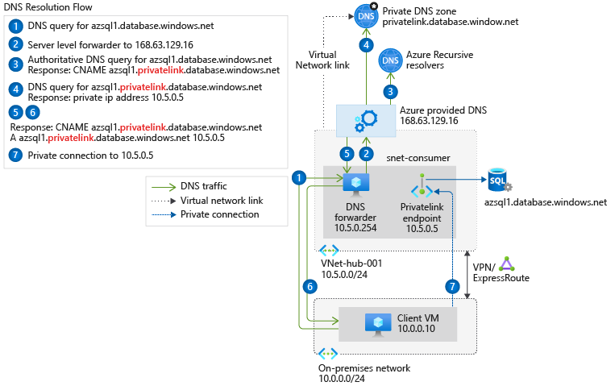

### Virtual network and on-premises workloads using Azure DNS Private Resolver

When you use DNS Private Resolver, you don't need a DNS forwarder VM, and Azure DNS is able to resolve on-premises domain names.

The following diagram uses DNS Private Resolver in a hub-spoke network topology. As a best practice, the Azure landing zone design pattern recommends using this type of topology. A hybrid network connection is established by using Azure ExpressRoute and Azure Firewall. This setup provides a secure hybrid network. DNS Private Resolver is deployed in the hub network.

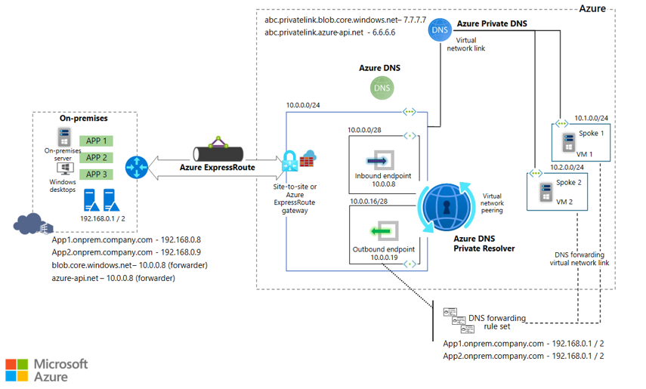

# Monitor your networks using Azure monitor

## What is Azure Monitor

Azure Monitor helps you maximize the availability and performance of your applications and services. It delivers a comprehensive solution for collecting, analyzing, and acting on telemetry from your cloud and on-premises environments. This information helps you understand how your applications are performing and proactively identify issues affecting them and the resources they depend on.

Just a few examples of what you can do with Azure Monitor include:

* Detect and diagnose issues across applications and dependencies with Application Insights.
* Correlate infrastructure issues with VM insights and Container insights.
* Drill into your monitoring data with Log Analytics for troubleshooting and deep diagnostics.
* Support operations at scale with smart alerts and automated actions.
* Create visualizations with Azure dashboards and workbooks.
* Collect data from monitored resources using Azure Monitor Metrics.

The diagram below offers a high-level view of Azure Monitor. At the center of the diagram are the data stores for metrics and logs, which are the two fundamental types of data used by Azure Monitor. On the left are the sources of monitoring data that populate these data stores. On the right are the different functions that Azure Monitor performs with this collected data. This includes such actions as analysis, alerting, and streaming to external systems.

## Monitor data types in Azure Monitor

The data collected by Azure Monitor fits into one of two fundamental types:

* **Metrics** - Metrics are numerical values that describe some aspect of a system at a particular point in time. They are lightweight and capable of supporting near real-time scenarios.
* **Logs** - Logs contain different kinds of data organized into records with different sets of properties for each type. Telemetry such as events and traces are stored as logs in addition to performance data so that it can all be combined for analysis.

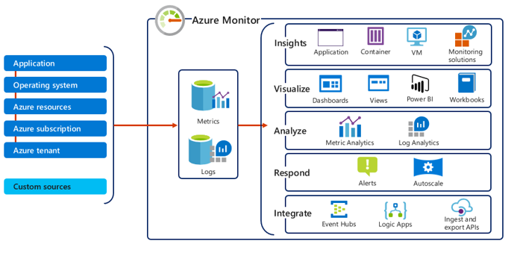

## Azure Monitor metrics

Azure Monitor Metrics is a feature of Azure Monitor that collects numeric data from monitored resources into a time series database. Metrics are numerical values collected regularly and describe some aspect of a system at a particular time. Metrics in Azure Monitor are lightweight and capable of supporting near real-time scenarios making them particularly useful for alerting and fast detection of issues. You can analyze them interactively with metrics explorer, be proactively notified with an alert when a value crosses a threshold or visualize them in a workbook or dashboard.

The table below provides a summary of the various types of tasks you can perform by utilizing metrics in Azure Monitor:

|  |  |
| --- | --- |
| **Task** | **Description** |
| Analyze | Use metrics explorer to analyze collected metrics on a chart and compare metrics from different resources. |
| Alert | Configure a metric alert rule that sends a notification or takes automated action when the metric value crosses a threshold. |
| Visualize | Pin a chart from metrics explorer to an Azure dashboard. Create a workbook to combine with multiple sets of data in an interactive report.Export the results of a query to Grafana to leverage its dashboarding and combine with other data sources. |
| Automate | Use Autoscale to increase or decrease resources based on a metric value crossing a threshold. |
| Retrieve | Access metric values from a command line using PowerShell cmdlets. Access metric values from custom application using REST API. Access metric values from a command line using CLI. |
| Export | Route Metrics to Logs to analyze data in Azure Monitor Metrics together with data in Azure Monitor Logs and to store metric values for longer than 93 days Stream Metrics to an event hub to route them to external systems. |
| Archive | Archive the performance or health history of your resource for compliance, auditing, or offline reporting purposes. |

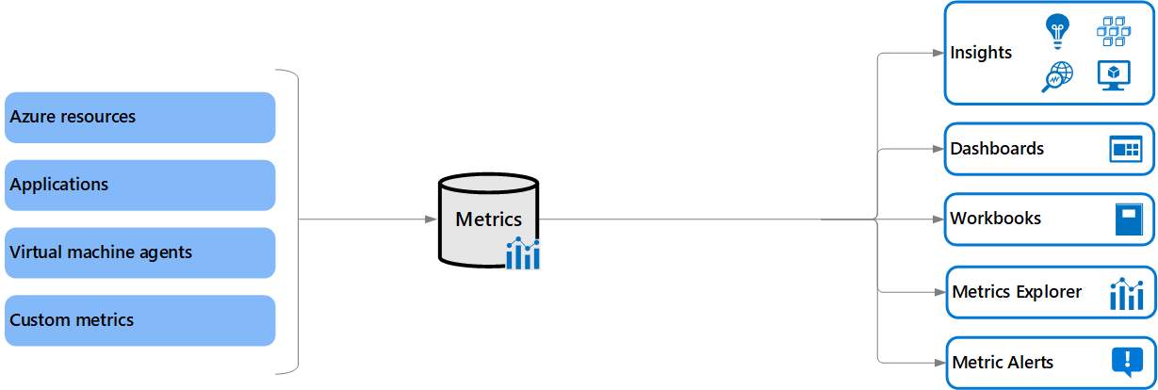

## Azure Monitor metrics sources

There are three fundamental sources of metrics collected by Azure Monitor. Once these metrics are collected in the Azure Monitor metric database, they can be evaluated together regardless of their source.

* **Azure resources** - Platform metrics are created by Azure resources and give you visibility into their health and performance. Each type of resource creates a distinct set of metrics without any configuration required. Platform metrics are collected from Azure resources at one-minute frequency unless specified otherwise in the metric's definition.
* **Applications** - Metrics are created by Application Insights for your monitored applications and help you detect performance issues and track trends in how your application is being used. This includes such values as Server response time and Browser exceptions.
* **Virtual machine agents** - Metrics are collected from the guest operating system of a virtual machine. Enable guest OS metrics for Windows virtual machines with Windows Diagnostic Extension (WAD) and for Linux virtual machines with InfluxData Telegraf Agent.
* **Custom metrics** - You can define metrics in addition to the standard metrics that are automatically available. You can define custom metrics in your application that is monitored by Application Insights or create custom metrics for an Azure service using the custom metrics API.

# Metrics Explorer

For several of your resources in Azure, you will see the data collected by Azure Monitor illustrated directly in the Azure portal on the **Monitoring** tab of a resource's **Overview** page.

In the screenshot below for example, you can see the Monitoring tab from the Overview page of a virtual machine.

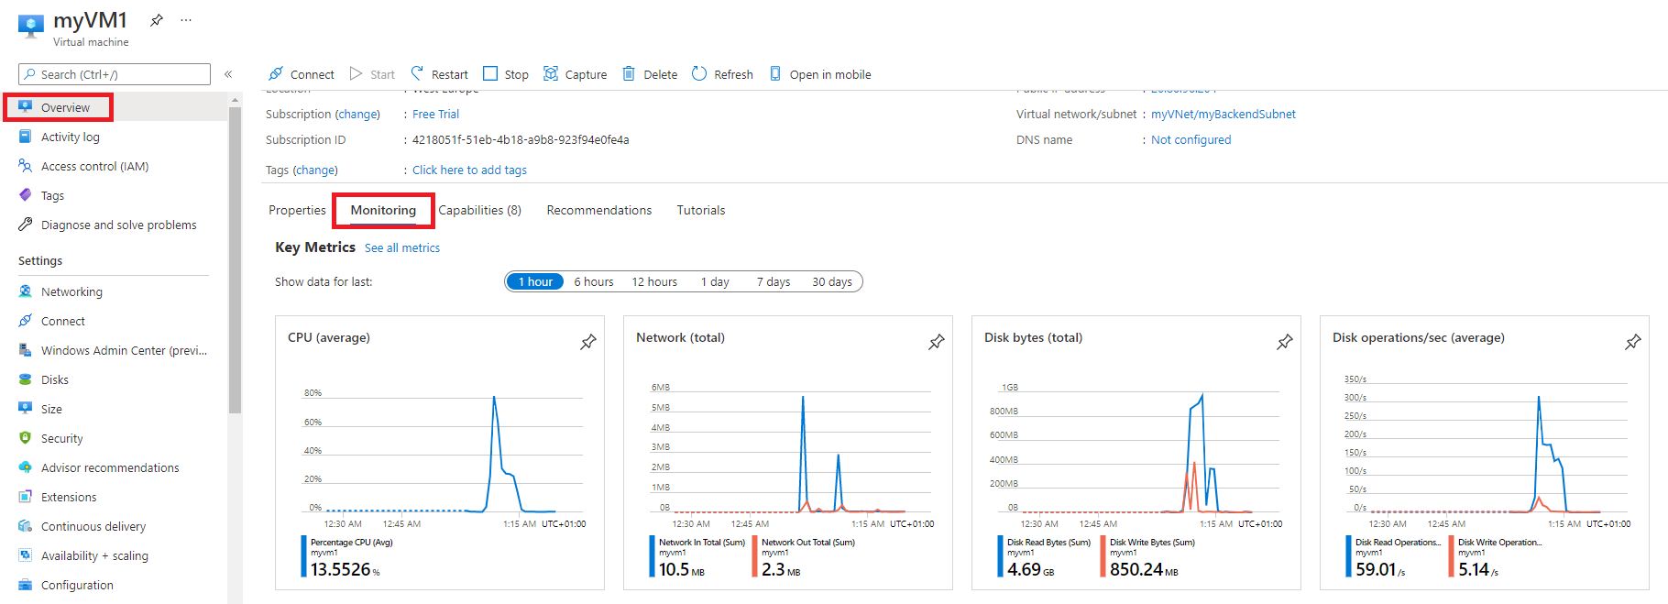

Note the various charts displaying several key performance metrics for system components such as **CPU**, **Network**, and **Disk**.

You can click on these graphs to open the data in **Metrics Explorer** in the Azure portal, which allows you to interactively analyze the data in your metric database and chart the values of multiple metrics over time. You can also pin the charts to a dashboard to view them with other visualizations later. You can also retrieve metrics by using the Azure monitoring REST API.

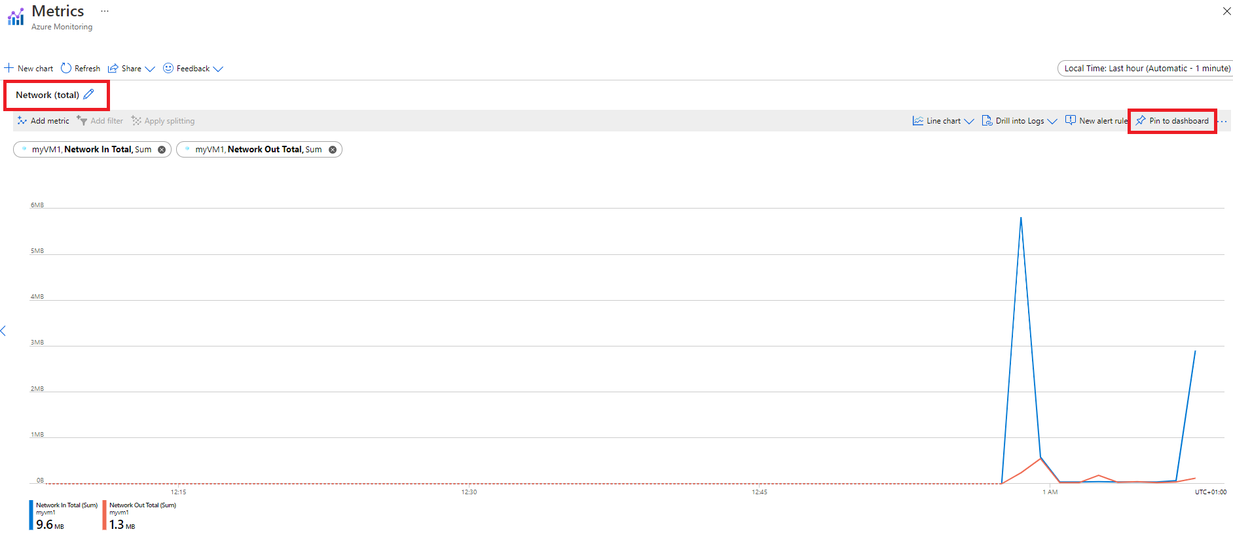

The data collected by Azure Monitor Metrics is stored in a time-series database which is optimized for analyzing time-stamped data. Each set of metric values is a time series with the following properties:

* The time the value was collected
* The resource the value is associated with
* A namespace that acts like a category for the metric
* A metric name
* The value itself

## Access Metrics in the Azure portal

You can access metrics from the **Metrics** option in the Azure Monitor menu.

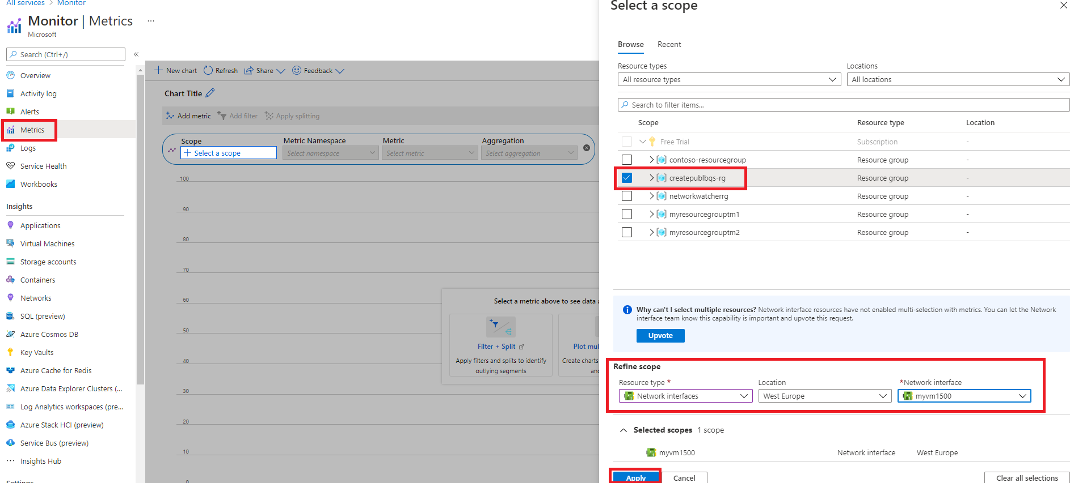

You can also access metrics from the **Metrics** menu of most other services and resources in the Azure portal. The screenshot below for example, displays the **Metrics** page for a virtual network resource.

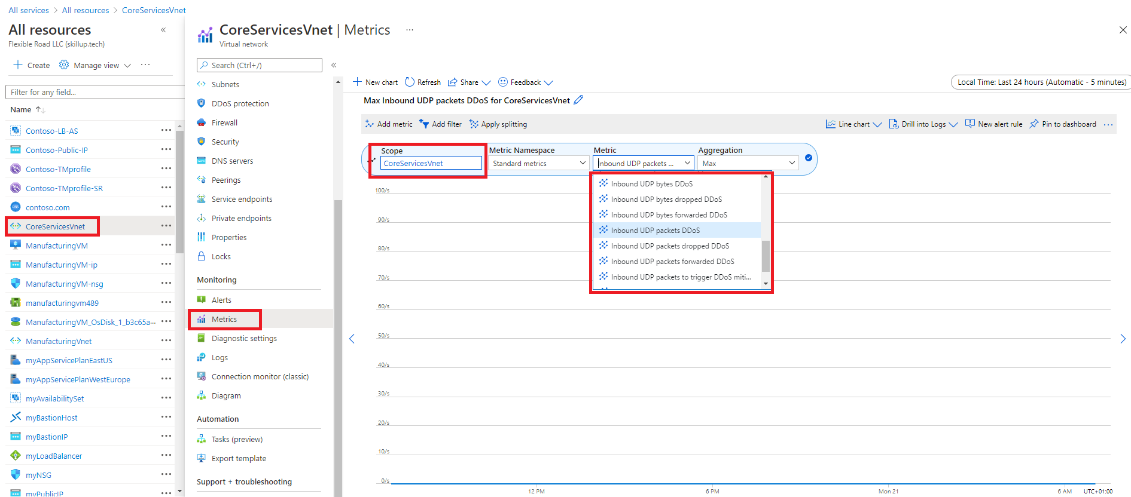

## Create metric charts with metrics explorer

Azure Monitor **Metrics Explorer** is a component of the Microsoft Azure portal that allows plotting charts, visually correlating trends, and investigating spikes and dips in metrics' values. Use the metrics explorer to investigate the health and utilization of your resources.

Start in the following order:

1. Pick a resource and a metric and you see a basic chart. Then select a time range that is relevant for your investigation.
2. Try applying dimension filters and splitting. The filters and splitting allow you to analyze which segments of the metric contribute to the overall metric value and identify possible outliers.
3. Use advanced settings to customize the chart before pinning to dashboards. Configure alerts to receive notifications when the metric value exceeds or drops below a threshold.
4. To create a metric chart, from your resource, resource group, subscription, or Azure Monitor view, open the Metrics tab and follow these steps:
5. Click on the "Select a scope" button to open the resource scope picker. This will allow you to select the resource(s) you want to see metrics for. If you opened metrics explorer from the resource's menu, the resource should already be populated.

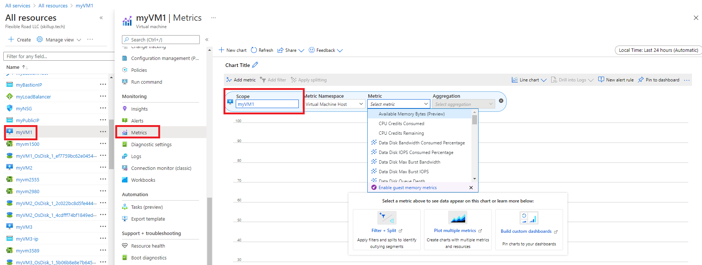

1. For some resources, you must pick a namespace. The namespace is just a way to organize metrics so that you can easily find them. For example, storage accounts have separate namespaces for storing Files, Tables, Blobs, and Queues metrics. Many resource types only have one namespace.

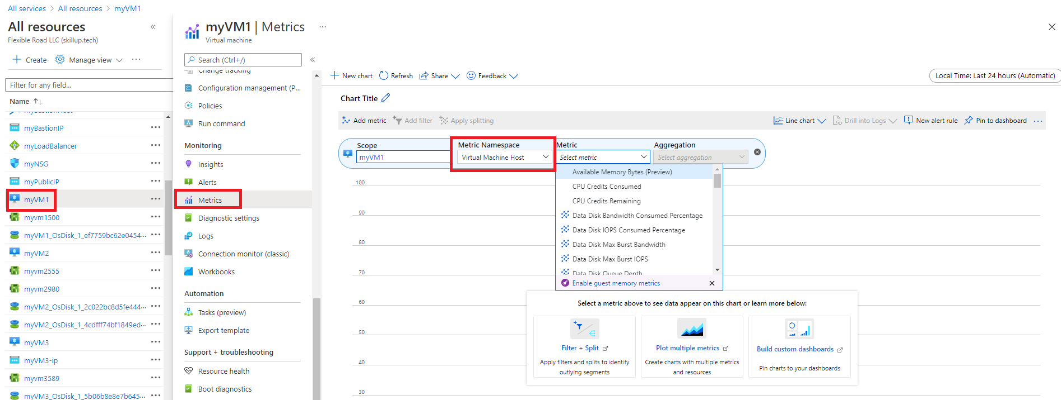

1. Select a metric from the list of available metrics. This list will vary depending on what resource and scope you select.

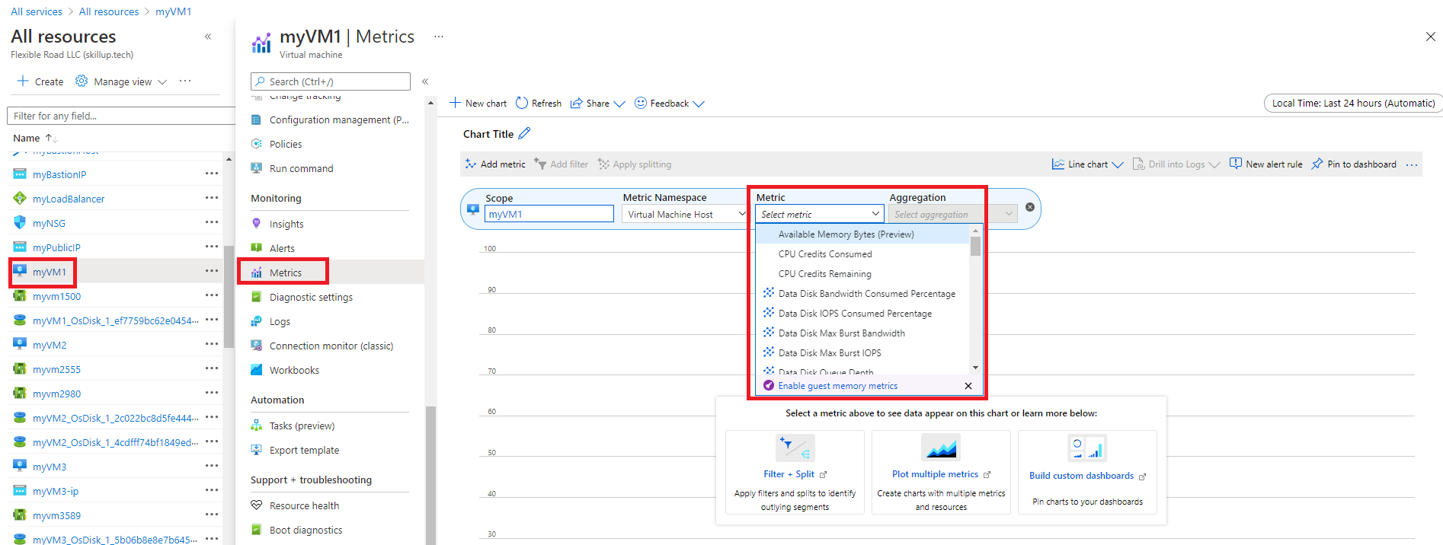

1. Optionally, you can change the metric aggregation. For example, you might want your chart to show minimum, maximum, or average values of the metric.

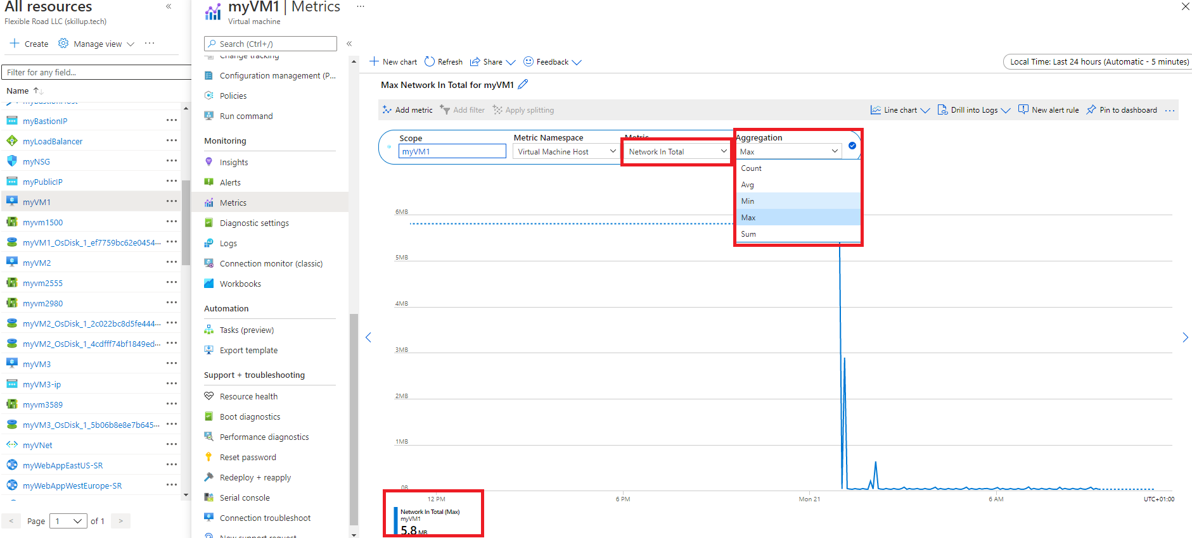

# Monitor network resources with Azure Monitor Network Insights

You can use the **Insights>Networks** section in **Azure Monitor** to obtain a broad view of health and metrics for all your deployed network resources, without requiring any configuration. It also provides access to network monitoring features such as Connection Monitor, flow logging for network security groups (NSG) flow logs, and Traffic Analytics, and it provides other network diagnostic features.

Azure Monitor Network Insights is structured around these key components of monitoring:

* Network health and metrics
* Connectivity
* Traffic
* Diagnostic Toolkit

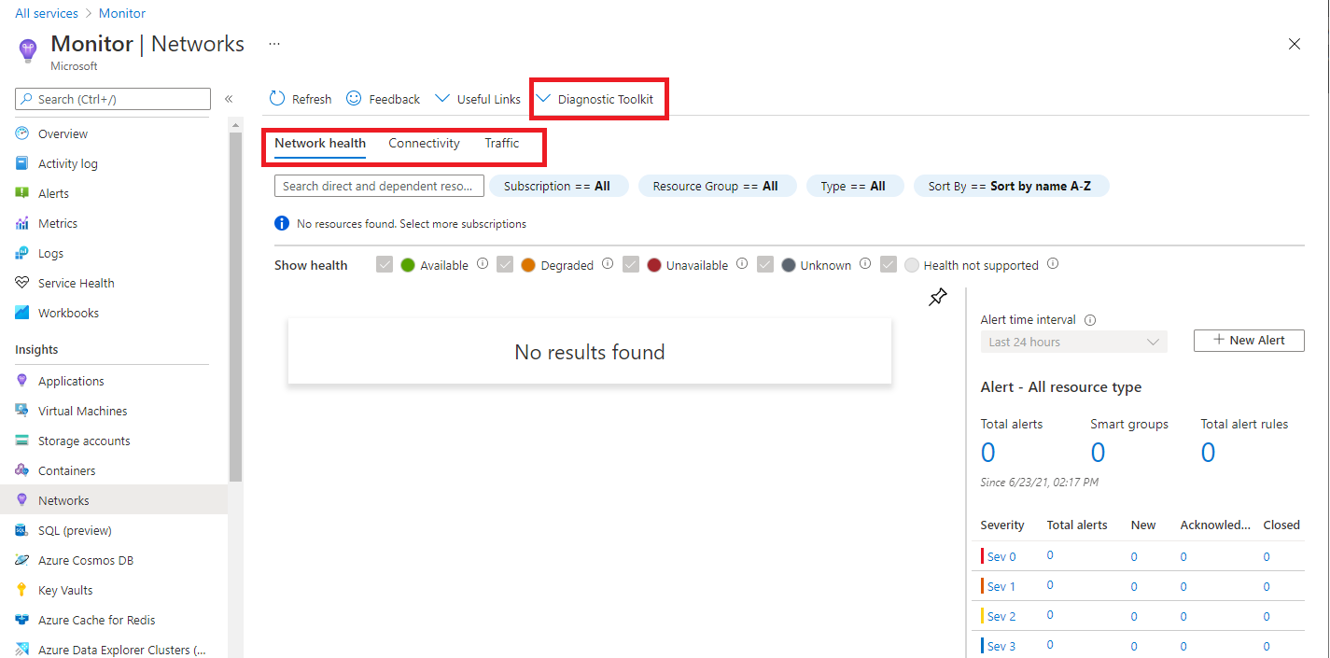

## Network health and metrics

The **Network health** tab of Azure Monitor Network Insights offers a simple method for visualizing an inventory of your networking resources, together with resource health and alerts. It is divided into four key functionality areas: search and filtering, resource health and metrics, alerts, and dependency view.

**Search and filtering**

You can customize the resource health and alerts view by using filters such as **Subscription**, **Resource Group**, and **Type**.

You can use the search box to search for network resources and their associated resources. For example, a public IP is associated with an application gateway, so a search for the public IP's DNS name would return both the public IP and the associated application gateway.

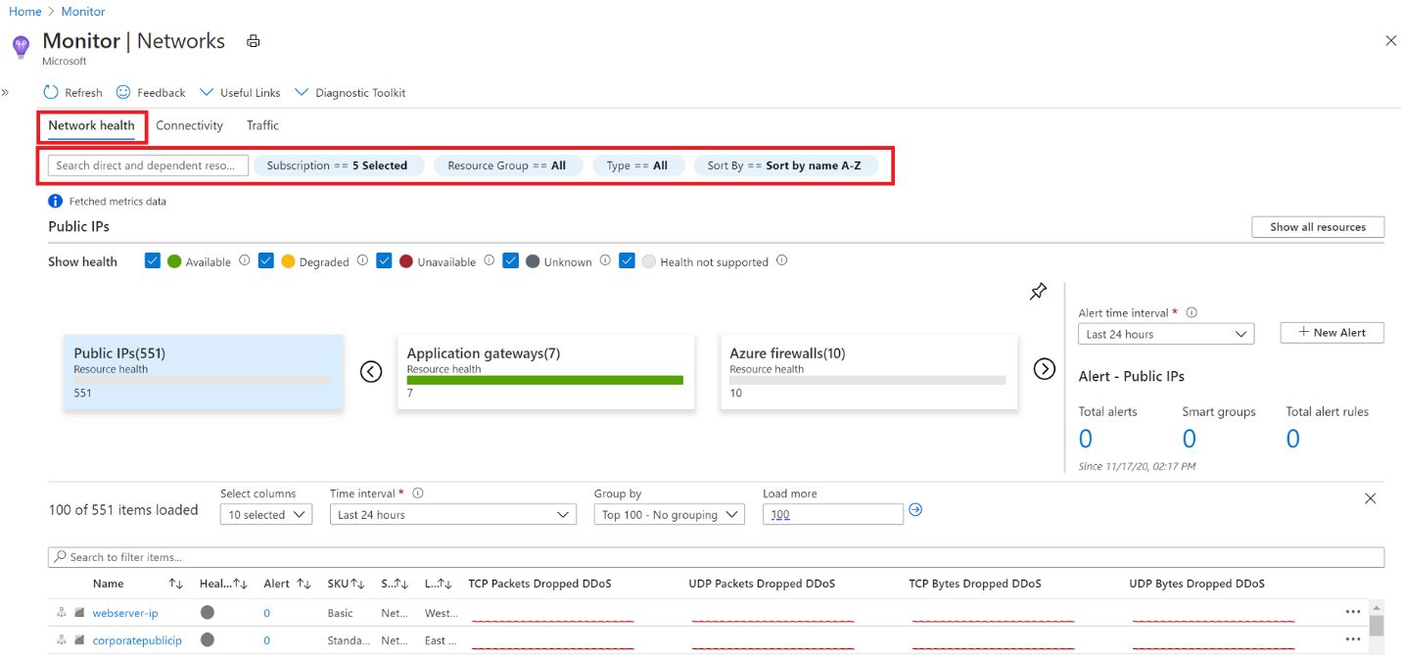

**Network resource health and metrics**

You can use the health and metrics information to get an overview of the health status of your various network resources.

In the example screenshot below, each tile represents a particular type of network resource. The tile displays the number of instances of that resource type that are deployed across all your selected subscriptions. It also displays the health status of the resource. Here you can see that there are 19 **Load balancers** deployed, 17 of which are healthy, 1 is degraded, and 1 is unavailable.

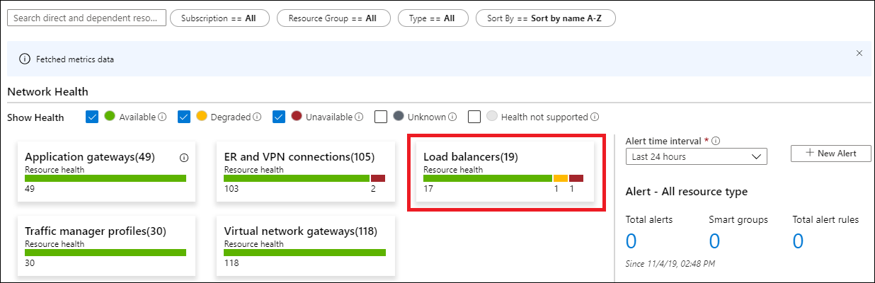

If you select one of the tiles, you get a view of the metrics for that network resource. In the example screenshot below, you can see the metrics for the **ER and VPN connections** resource.

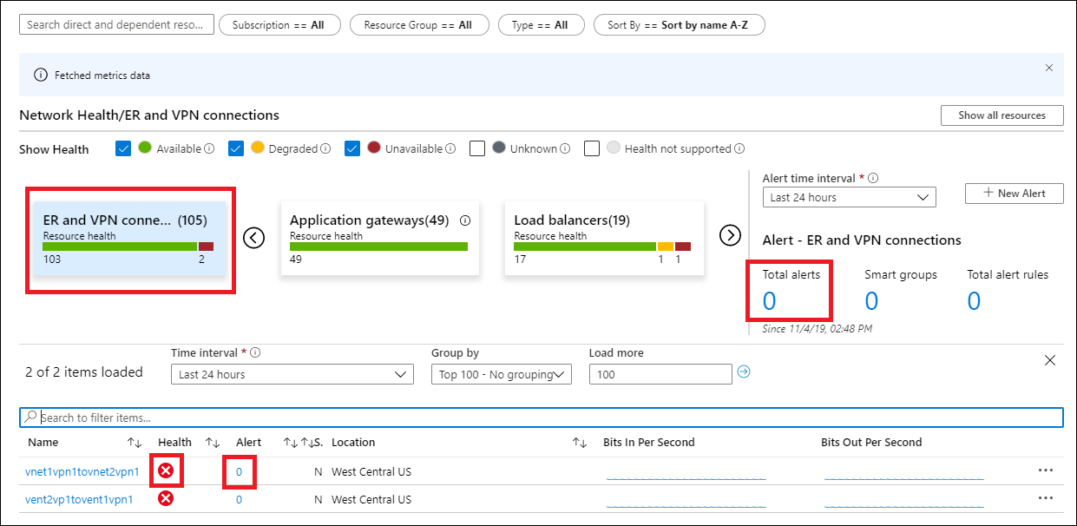

You can select any item in this grid view. For example, you could select the icon in the **Health** column to get resource health for that connection, or select the value in the **Alert** column to go to the alerts and metrics page for the connection.

**Alerts**

The **Alert** box on the right side of the page provides a view of all alerts generated for the selected resources across all your subscriptions. If there is a value for the alerts on an item, simply select the alert count for that item to go to a detailed alerts page for it.

**Dependency view**

Dependency view helps you visualize how a resource is configured. Dependency view is currently available for **Azure Application Gateway**, **Azure Virtual WAN**, and **Azure Load Balancer**. For example, for Application Gateway, you can access dependency view by selecting the Application Gateway resource name in the metrics grid view. You can do the same thing for Virtual WAN and Load Balancer.

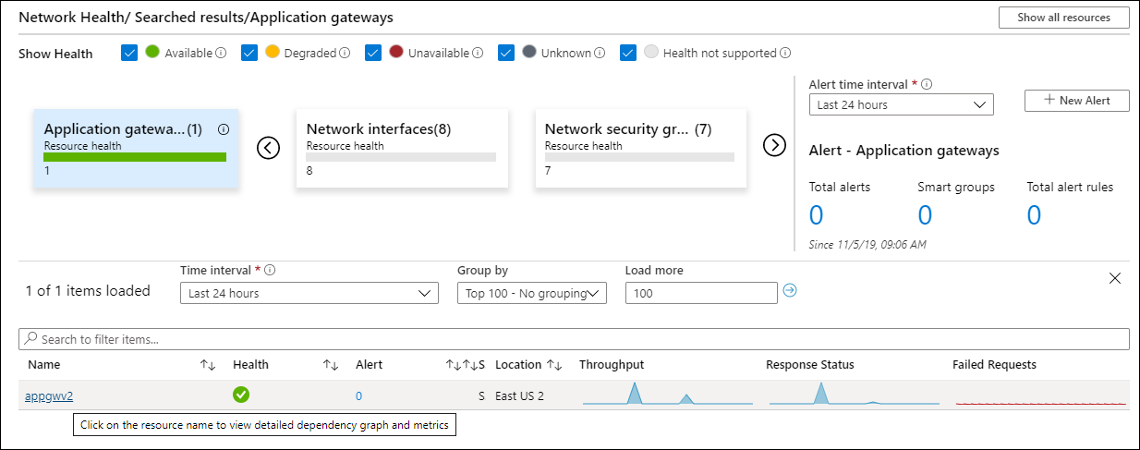

## Connectivity

The **Connectivity** tab of Azure Monitor Network Insights provides an easy way to visualize all tests configured via Connection Monitor and Connection Monitor (classic) for the selected set of subscriptions.

Tests are grouped by **Sources** and **Destinations** tiles and display the reachability status for each test. Reachable settings provide easy access to configurations for your reachability criteria, based on **Checks failed(%)** and **RTT(ms)**.

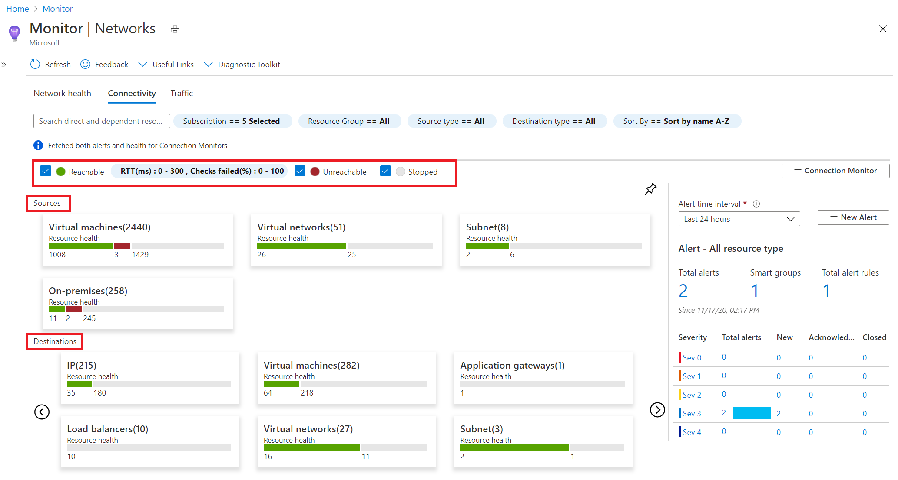

After you set the values, the status for each test updates based on the selection criteria.

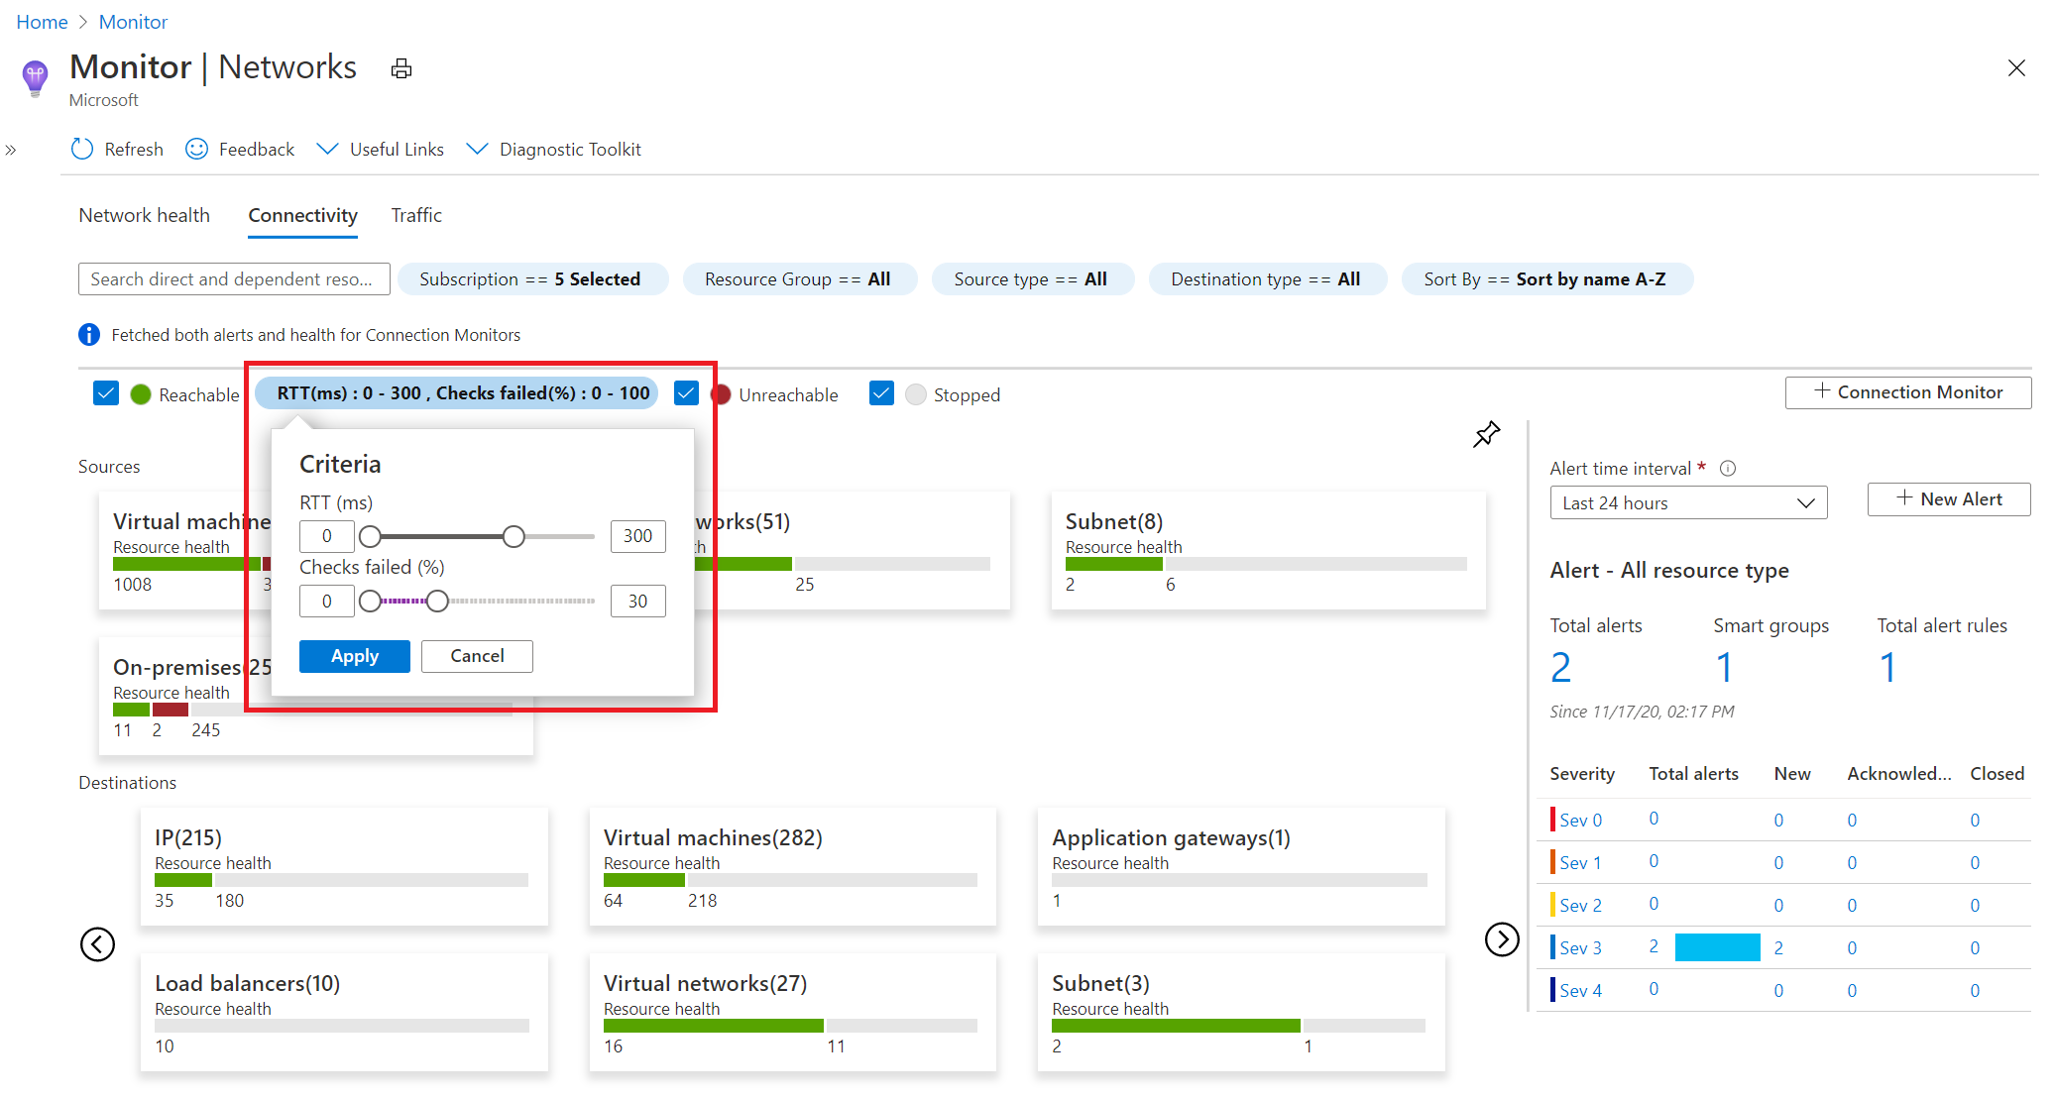

From here, you can then select any source or destination tile to open it up in metric view. In the example screenshot below, the metrics for the **Destinations>Virtual machines** tile are being displayed.

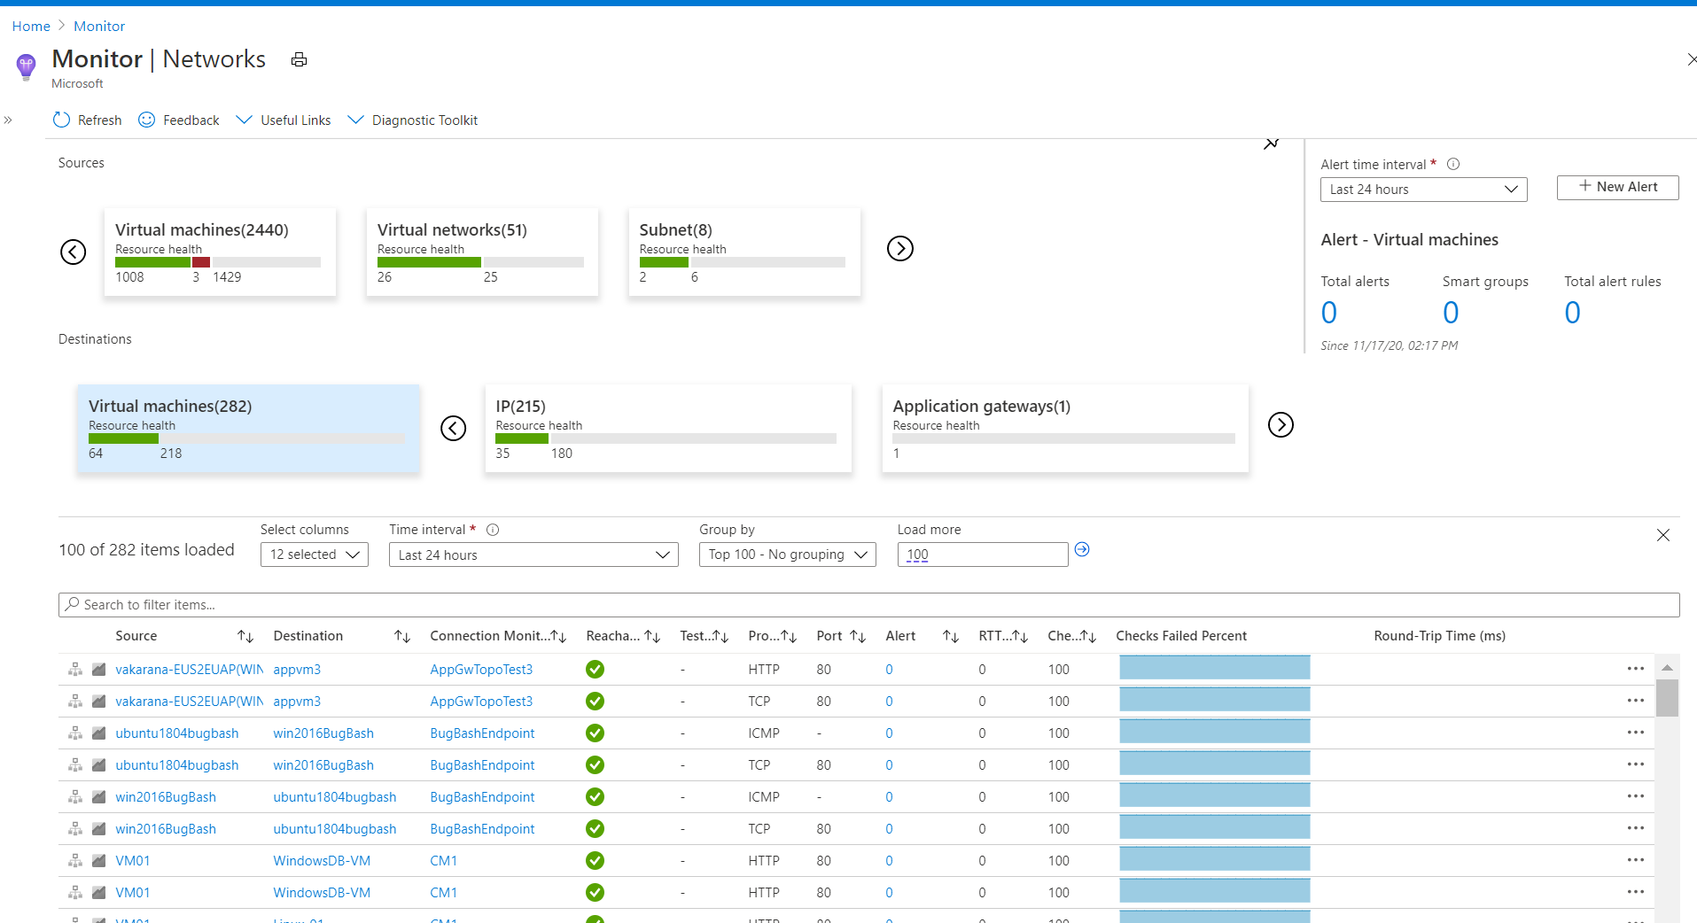

## Traffic

The **Traffic** tab of Azure Monitor Network Insights provides access to all NSGs configured for **NSG flow logs** and **Traffic Analytics** for the selected set of subscriptions, grouped by location. The search functionality provided on this tab enables you to identify the NSGs configured for the searched IP address. You can search for any IP address in your environment. The tiled regional view will display all NSGs along with the NSG flow logs and Traffic Analytics configuration status.

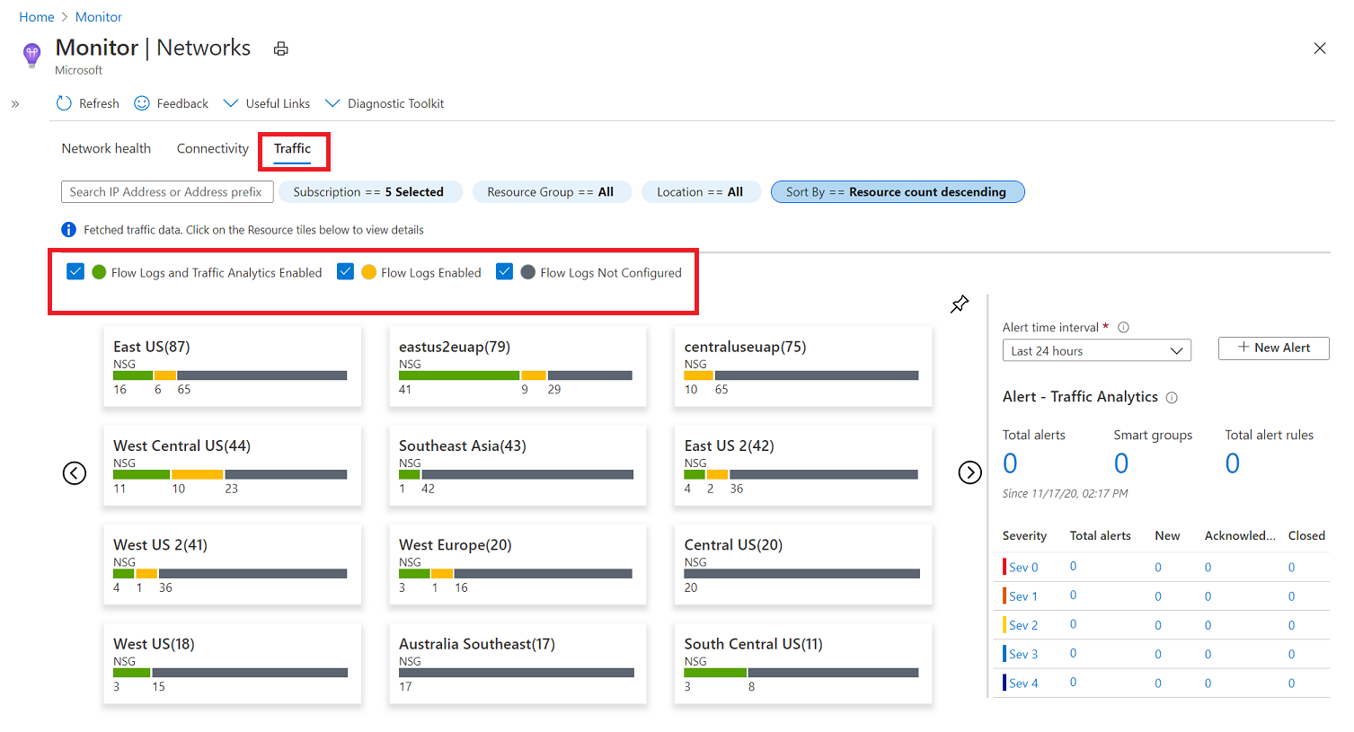

If you select any region tile, a grid view will appear which shows NSG flow logs and Traffic Analytics in a view that is simple to interpret and configure.

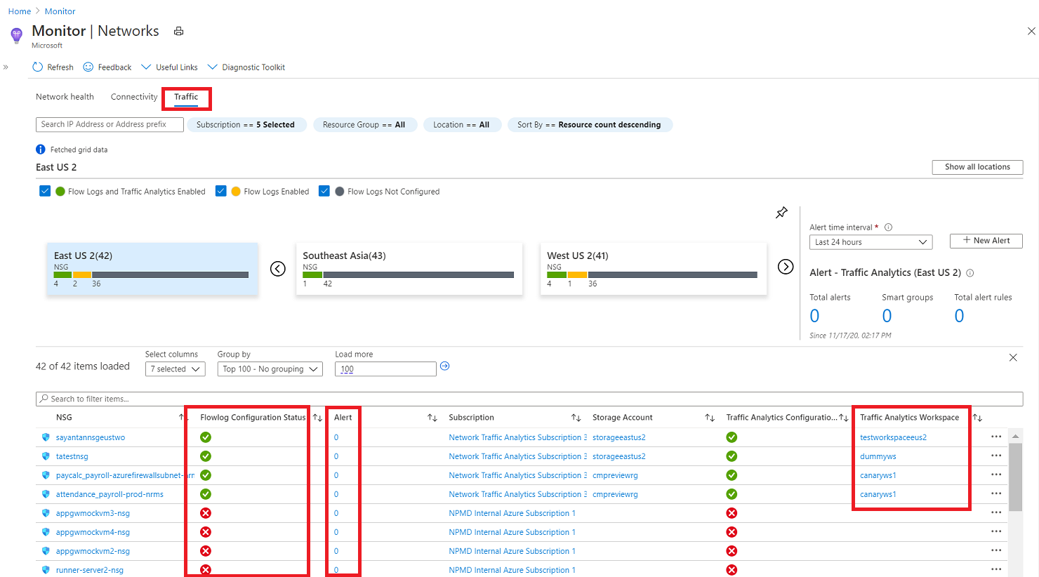

In this grid view you can select an icon in the **Flow log Configuration Status** column to edit the NSG flow log and Traffic Analytics configuration. Or you can select a value in the **Alert** column to go to the traffic alerts configured for that NSG, and you can navigate to the Traffic Analytics view by selecting the **Traffic Analytics Workspace**.

## Diagnostic Toolkit

The Diagnostic Toolkit feature in Azure Monitor Network Insights provides access to all the diagnostic features available for troubleshooting your networks and their components.

The **Diagnostic Toolkit** drop-down list provides to access to the following network monitoring features:

* Capture packets on virtual machines - opens the **Network Watcher packet capture** network diagnostic tool to enable you create capture sessions to track traffic to and from a virtual machine. Filters are provided for the capture session to ensure you capture only the traffic you want. Packet capture helps to diagnose network anomalies, both reactively, and proactively. Packet capture is a virtual machine extension that is remotely started through Network Watcher.
* Troubleshoot VPN - opens the **Network Watcher VPN Troubleshoot** tool to diagnose the health of a virtual network gateway or connection.
* Troubleshoot connectivity - opens the **Network Watcher Connection Troubleshoot** tool to check a direct TCP connection from a virtual machine (VM) to a VM, fully qualified domain name (FQDN), URI, or IPv4 address.
* Identify next hops - opens the **Network Watcher Next hop** network diagnostic tool to obtain the next hop type and IP address of a packet from a specific VM and NIC. Knowing the next hop can help you establish if traffic is being directed to the expected destination, or whether the traffic is being sent nowhere.
* Diagnose traffic filtering issues - opens the **Network Watcher IP flow verify** network diagnostic tool to verify if a packet is allowed or denied, to or from a virtual machine, based on 5-tuple information. The security group decision and the name of the rule that denied the packet is returned.

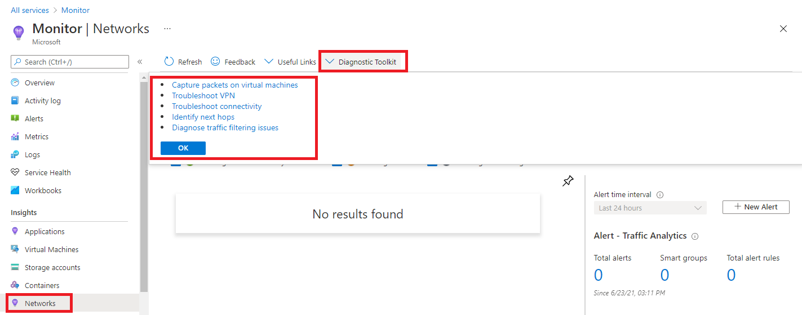

# Monitor your networks using Azure network watcher

## Azure Network Watcher

Azure Network Watcher is a regional service that enables you to monitor and diagnose conditions at a network scenario level in, to, and from Azure. Scenario level monitoring enables you to diagnose problems at an end-to-end network level view. Network diagnostic and visualization tools available with Network Watcher help you understand, diagnose, and gain insights to your network in Azure. Network Watcher is enabled through the creation of a Network Watcher resource, which allows you to utilize Network Watcher capabilities. Network Watcher is designed to monitor and repair the network health of IaaS products which includes Virtual Machines, Virtual Networks, Application Gateways, and Load Balancers.

* **Automate remote network monitoring with packet capture.** Monitor and diagnose networking issues without logging in to your virtual machines (VMs) using Network Watcher. Trigger packet capture by setting alerts, and gain access to real-time performance information at the packet level. When you observe an issue, you can investigate in detail for better diagnoses.
* **Gain insight into your network traffic using flow logs. Build a deeper understanding of your network traffic pattern using Network Security Group flow logs.** Information provided by flow logs helps you gather data for compliance, auditing and monitoring your network security profile.
* **Diagnose VPN connectivity issues. Network Watcher provides you the ability to diagnose your most common VPN Gateway and Connections issues.** Allowing you, not only, to identify the issue but also to use the detailed logs created to help further investigate.

**Network Topology:** The topology capability enables you to generate a visual diagram of the resources in a virtual network, and the relationships between the resources.

**Verify IP Flow:** Quickly diagnose connectivity issues from or to the internet and from or to the on-premises environment. For example, confirming if a security rule is blocking ingress or egress traffic to or from a virtual machine. IP flow verify is ideal for making sure security rules are being correctly applied. When used for troubleshooting, if IP flow verify doesn’t show a problem, you will need to explore other areas such as firewall restrictions.

**Next Hop:** To determine if traffic is being directed to the intended destination by showing the next hop. This will help determine if networking routing is correctly configured. Next hop also returns the route table associated with the next hop. If the route is defined as a user-defined route, that route is returned. Otherwise, next hop returns System Route. Depending on your situation the next hop could be Internet, Virtual Appliance, Virtual Network Gateway, VNet Local, VNet Peering, or None. None lets you know that while there may be a valid system route to the destination, there is no next hop to route the traffic to the destination. When you create a virtual network, Azure creates several default outbound routes for network traffic. The outbound traffic from all resources, such as VMs, deployed in a virtual network, are routed based on Azure's default routes. You might override Azure's default routes or create additional routes.

**Effective security rules:** Network Security groups are associated at a subnet level or at a NIC level. When associated at a subnet level, it applies to all the VM instances in the subnet. Effective security rules view returns all the configured NSGs and rules that are associated at a NIC and subnet level for a virtual machine providing insight into the configuration. In addition, the effective security rules are returned for each of the NICs in a VM. Using Effective security rules view, you can assess a VM for network vulnerabilities such as open ports.

**VPN Diagnostics:** Troubleshoot gateways and connections. VPN Diagnostics returns a wealth of information. Summary information is available in the portal and more detailed information is provided in log files. The log files are stored in a storage account and include things like connection statistics, CPU and memory information, IKE security errors, packet drops, and buffers and events.

**Packet Capture**: Network Watcher variable packet capture allows you to create packet capture sessions to track traffic to and from a virtual machine. Packet capture helps to diagnose network anomalies both reactively and proactively. Other uses include gathering network statistics, gaining information on network intrusions, to debug client-server communications and much more.

**Connection Troubleshoot:** Azure Network Watcher Connection Troubleshoot is a more recent addition to the Network Watcher suite of networking tools and capabilities. Connection Troubleshoot enables you to troubleshoot network performance and connectivity issues in Azure.

**NSG Flow Logs:** NSG Flow Logs maps IP traffic through a network security group. These capabilities can be used in security compliance and auditing. You can define a prescriptive set of security rules as a model for security governance in your organization. A periodic compliance audit can be implemented in a programmatic way by comparing the prescriptive rules with the effective rules for each of the VMs in your network.

## configure Network Watcher

When you create or update a virtual network in your subscription, Network Watcher will be enabled automatically in your Virtual Network's region. There is no impact to your resources or associated charge for automatically enabling Network Watcher.

To create a Network Watcher in the Azure portal:

1. Navigate to All services> Networking>Network Watcher.

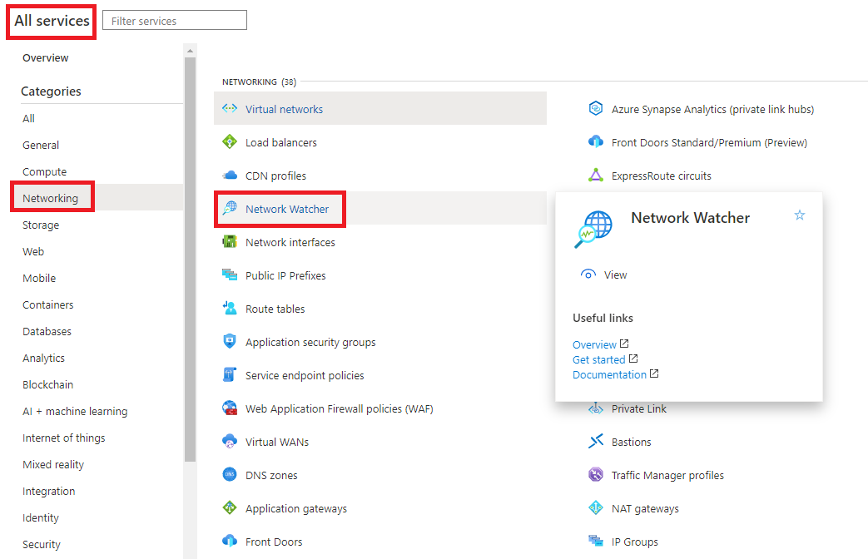

1. Right-click your subscription and choose **Enable network watcher in all regions**.

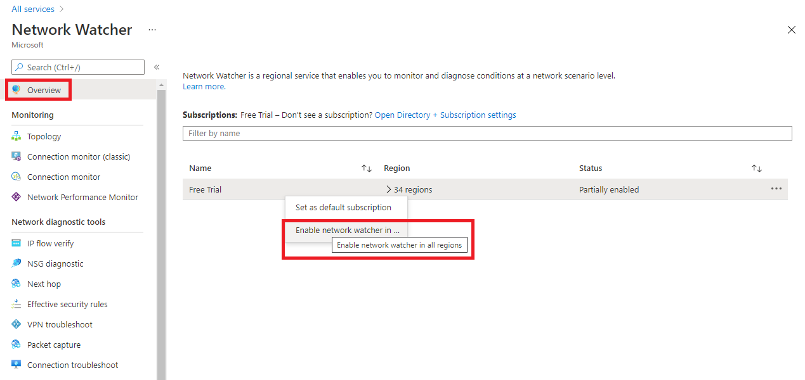

1. Note that the status is now showing as **Enabled**.

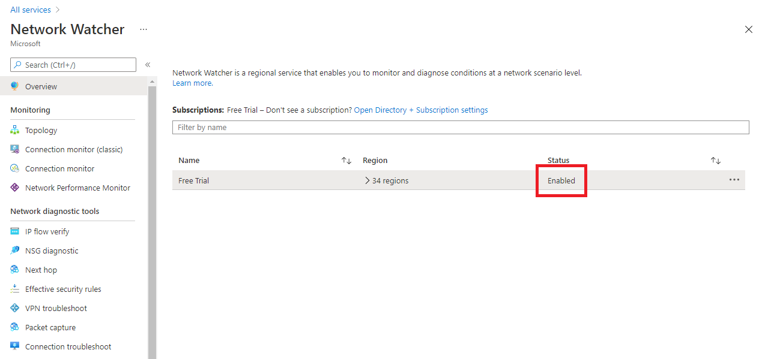

1. If you expand the regions, you will see that all regions within this subscription are enabled.

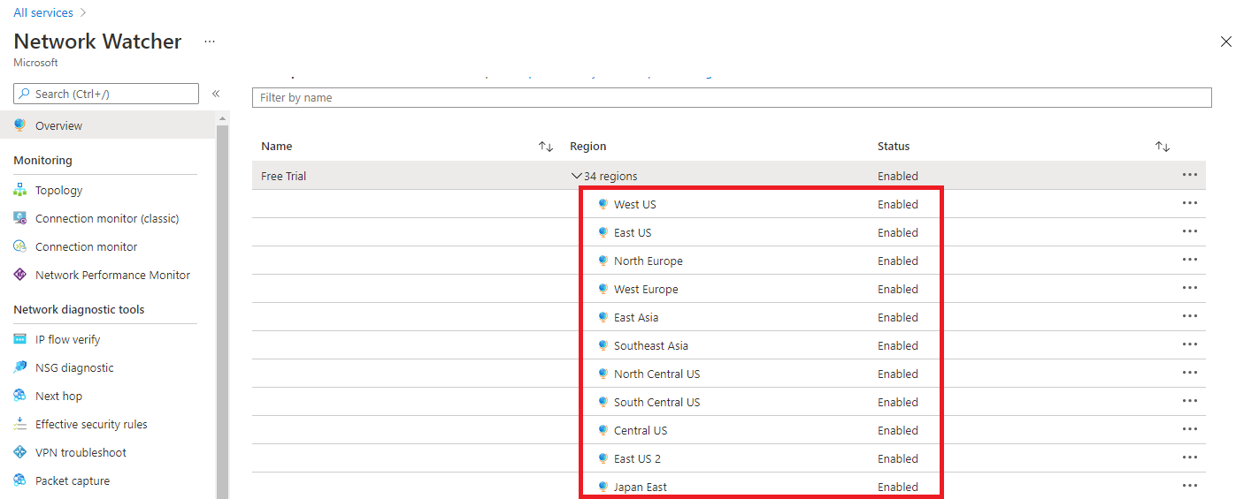

1. When you enable Network Watcher using the portal, the name of the Network Watcher instance is automatically set to NetworkWatcher_region_name where region_name corresponds to the Azure region where the instance is enabled. For example, a Network Watcher enabled in the West US region is named **NetworkWatcher_westus**.
2. The Network Watcher instance is automatically created in a resource group named **NetworkWatcherRG**. The resource group is created if it does not already exist.

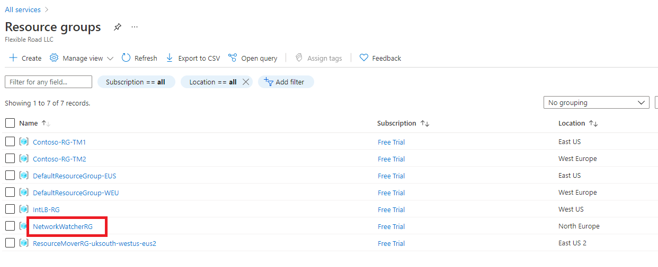

1. To disable a Network Watcher for a region in the Azure portal, expand the regions section, right click the name of the region you wish to disable the Network Watcher on, and click **Disable network watcher**.

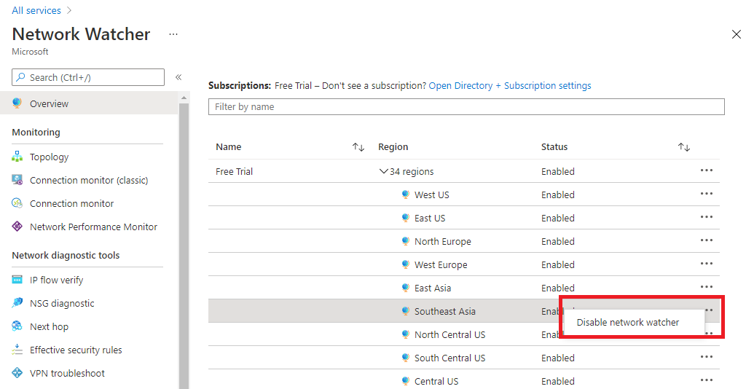

## Configure NSG Flow Logs

Network security groups (NSG) allow or deny inbound or outbound traffic to a network interface in a VM.

NSG flow logs is a feature of Azure Network Watcher that allows you to log information about IP traffic flowing through an NSG. The NSG flow log capability allows you to log the source and destination IP address, port, protocol, and whether traffic was allowed or denied by an NSG. You can analyze logs using a variety of tools, such as Power BI and the Traffic Analytics feature in Azure Network Watcher.

Common use cases for NSG flow logs are:

* **Network Monitoring** - Identify unknown or undesired traffic. Monitor traffic levels and bandwidth consumption. Filter flow logs by IP and port to understand application behavior. Export Flow Logs to analytics and visualization tools of your choice to set up monitoring dashboards.
* **Usage monitoring and optimization** - Identify top talkers in your network. Combine with GeoIP data to identify cross-region traffic. Understand traffic growth for capacity forecasting. Use data to remove overtly restrictive traffic rules.
* **Compliance** - Use flow data to verify network isolation and compliance with enterprise access rules.
* **Network forensics and security analysis** - Analyze network flows from compromised IPs and network interfaces. Export flow logs to any SIEM or IDS tool of your choice.

You can enable NSG flow logs from any of the following:

Azure CLI

Azure Portal

Power shell

Azure Resource Manager

1. To configure the parameters of NSG flow logs in the Azure portal, navigate to the NSG Flow Logs section in Network Watcher.
2. Click the name of the NSG to bring up the **Settings** pane for the Flow log.

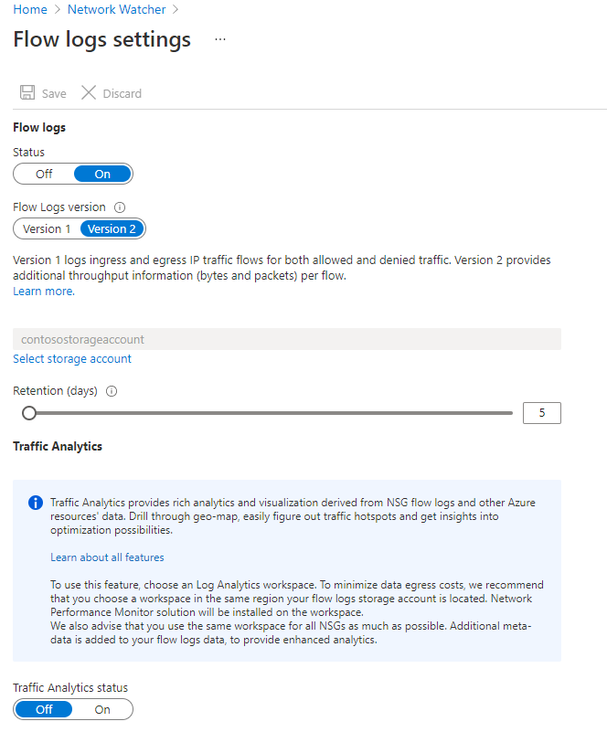

1. Change the parameters you want and click **Save** to deploy the changes.

## Connection Monitor

Connection Monitor provides unified end-to-end connection monitoring in Azure Network Watcher. The Connection Monitor feature supports hybrid and Azure cloud deployments. Network Watcher provides tools to monitor, diagnose, and view connectivity-related metrics for your Azure deployments.

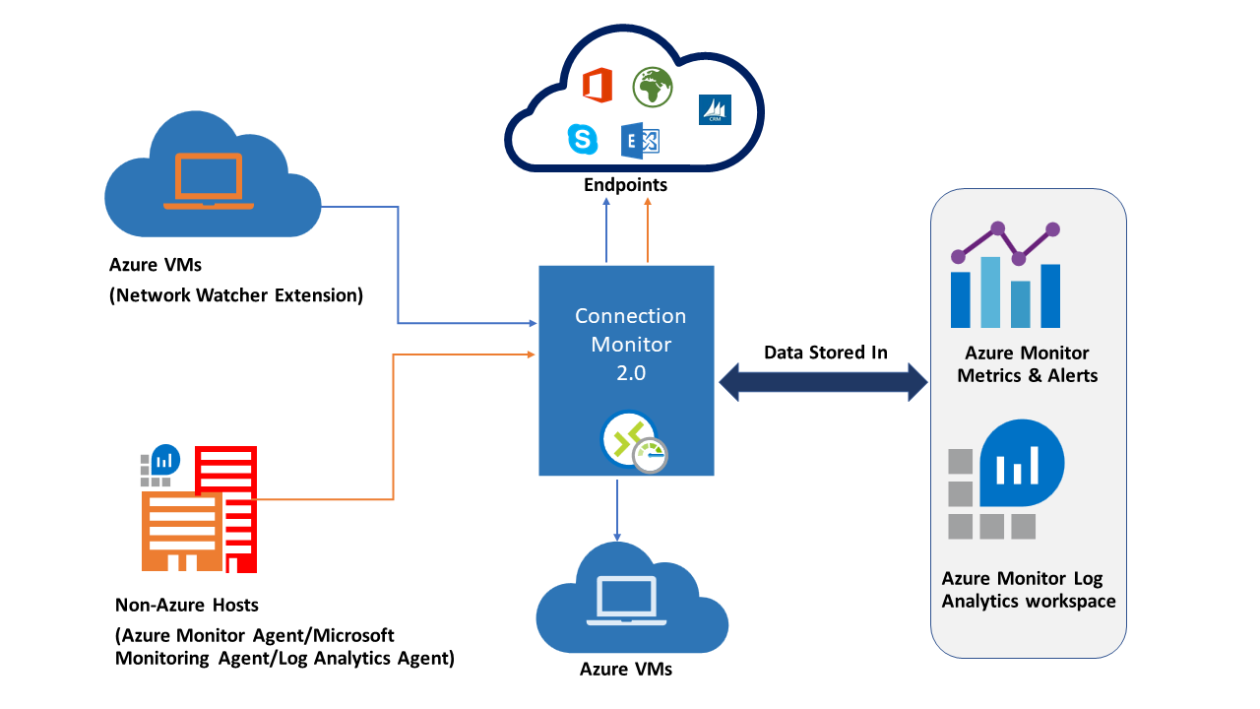

Here are some use cases for Connection Monitor:

* Your front-end web server VM communicates with a database server VM in a multi-tier application. You want to check network connectivity between the two VMs.
* You want VMs in the East US region to ping VMs in the Central US region, and you want to compare cross-region network latencies.
* You have multiple on-premises office sites in Seattle, Washington, and in Ashburn, Virginia. Your office sites connect to Microsoft 365 URLs. For your users of Microsoft 365 URLs, compare the latencies between Seattle and Ashburn.
* Your hybrid application needs connectivity to an Azure Storage endpoint. Your on-premises site and your Azure application connect to the same Azure Storage endpoint. You want to compare the latencies of the on-premises site to the latencies of the Azure application.
* You want to check the connectivity between your on-premises setups and the Azure VMs that host your cloud application.

Connection Monitor combines the best of two features: the Network Watcher Connection Monitor (Classic) feature and the Network Performance Monitor (NPM) Service Connectivity Monitor, ExpressRoute Monitoring, and Performance Monitoring feature.

Here are some benefits of Connection Monitor:

* Unified, intuitive experience for Azure and hybrid monitoring needs
* Cross-region, cross-workspace connectivity monitoring
* Higher probing frequencies and better visibility into network performance
* Faster alerting for your hybrid deployments
* Support for connectivity checks that are based on HTTP, TCP, and ICMP
* Metrics and Log Analytics support for both Azure and non-Azure test setups

# Configure NSG Flow Logs

Network security groups (NSG) allow or deny inbound or outbound traffic to a network interface in a VM.

NSG flow logs is a feature of Azure Network Watcher that allows you to log information about IP traffic flowing through an NSG. The NSG flow log capability allows you to log the source and destination IP address, port, protocol, and whether traffic was allowed or denied by an NSG. You can analyze logs using a variety of tools, such as Power BI and the Traffic Analytics feature in Azure Network Watcher.

Common use cases for NSG flow logs are:

* **Network Monitoring** - Identify unknown or undesired traffic. Monitor traffic levels and bandwidth consumption. Filter flow logs by IP and port to understand application behavior. Export Flow Logs to analytics and visualization tools of your choice to set up monitoring dashboards.
* **Usage monitoring and optimization** - Identify top talkers in your network. Combine with GeoIP data to identify cross-region traffic. Understand traffic growth for capacity forecasting. Use data to remove overtly restrictive traffic rules.
* **Compliance** - Use flow data to verify network isolation and compliance with enterprise access rules.
* **Network forensics and security analysis** - Analyze network flows from compromised IPs and network interfaces. Export flow logs to any SIEM or IDS tool of your choice.

You can enable NSG flow logs from any of the following:

* [Azure portal](https://learn.microsoft.com/en-us/azure/network-watcher/network-watcher-nsg-flow-logging-portal)
* [PowerShell](https://learn.microsoft.com/en-us/azure/network-watcher/network-watcher-nsg-flow-logging-powershell)
* [Azure CLI](https://learn.microsoft.com/en-us/azure/network-watcher/network-watcher-nsg-flow-logging-cli)
* [REST](https://learn.microsoft.com/en-us/azure/network-watcher/network-watcher-nsg-flow-logging-rest)
* [Azure Resource Manager](https://learn.microsoft.com/en-us/azure/network-watcher/network-watcher-nsg-flow-logging-azure-resource-manager)



1. To configure the parameters of NSG flow logs in the Azure portal, navigate to the **NSG Flow Logs** section in **Network Watcher**.
2. Click the name of the NSG to bring up the **Settings** pane for the Flow log.

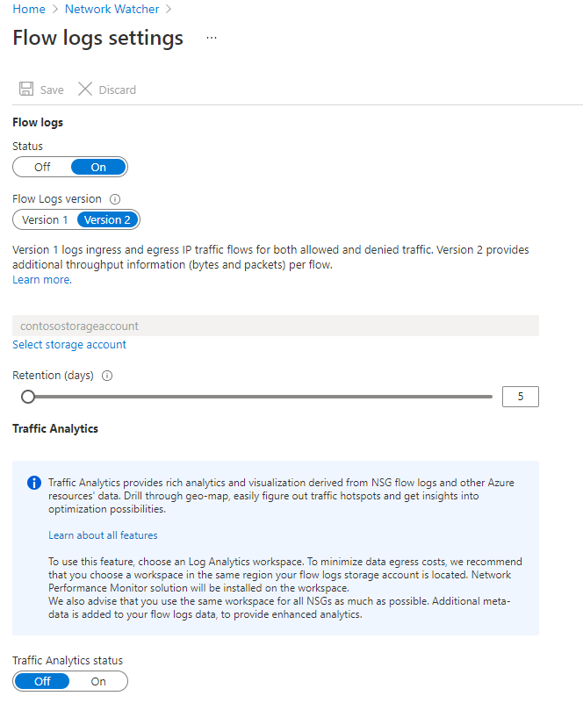

1. Change the parameters you want and click Save to deploy the changes.

# Connection Monitor

## Connection Monitor overview

Connection Monitor provides unified end-to-end connection monitoring in Azure Network Watcher. The Connection Monitor feature supports hybrid and Azure cloud deployments. Network Watcher provides tools to monitor, diagnose, and view connectivity-related metrics for your Azure deployments.

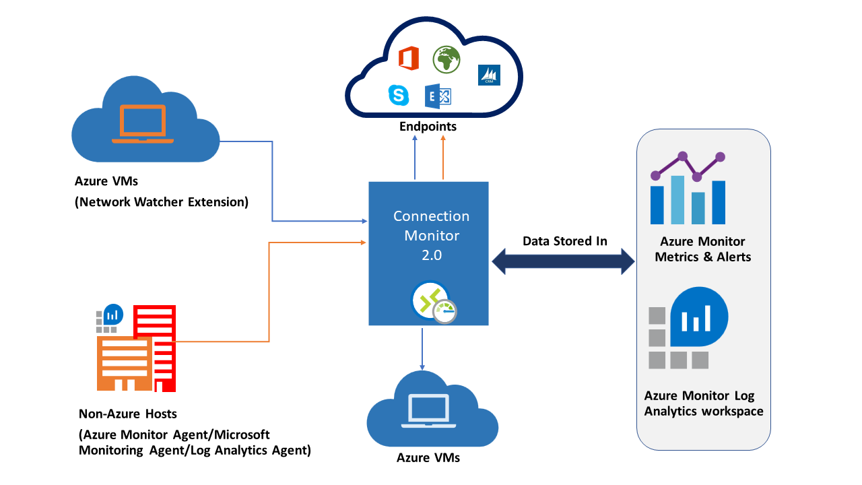

Here are some use cases for Connection Monitor:

* Your front-end web server VM communicates with a database server VM in a multi-tier application. You want to check network connectivity between the two VMs.
* You want VMs in the East US region to ping VMs in the Central US region, and you want to compare cross-region network latencies.
* You have multiple on-premises office sites in Seattle, Washington, and in Ashburn, Virginia. Your office sites connect to Microsoft 365 URLs. For your users of Microsoft 365 URLs, compare the latencies between Seattle and Ashburn.
* Your hybrid application needs connectivity to an Azure Storage endpoint. Your on-premises site and your Azure application connect to the same Azure Storage endpoint. You want to compare the latencies of the on-premises site to the latencies of the Azure application.
* You want to check the connectivity between your on-premises setups and the Azure VMs that host your cloud application.

Connection Monitor combines the best of two features: the Network Watcher Connection Monitor (Classic) feature and the Network Performance Monitor (NPM) Service Connectivity Monitor, ExpressRoute Monitoring, and Performance Monitoring feature.

Here are some benefits of Connection Monitor:

* Unified, intuitive experience for Azure and hybrid monitoring needs
* Cross-region, cross-workspace connectivity monitoring
* Higher probing frequencies and better visibility into network performance
* Faster alerting for your hybrid deployments
* Support for connectivity checks that are based on HTTP, TCP, and ICMP
* Metrics and Log Analytics support for both Azure and non-Azure test setups

## Set up Connection Monitor

There are several key steps you need to perform to setup Connection Monitor for monitoring:

1. **Install monitoring agents -** Connection Monitor relies on lightweight executable files to run connectivity checks. It supports connectivity checks from both Azure environments and on-premises environments. The executable file that you use depends on whether your VM is hosted on Azure or on-premises. For more information.
2. **Enable Network Watcher on your subscription -** All subscriptions that have a virtual network are enabled with Network Watcher. When you create a virtual network in your subscription, Network Watcher is automatically enabled in the virtual network's region and subscription. This automatic enabling doesn't affect your resources or incur a charge. Ensure that Network Watcher isn't explicitly disabled on your subscription.
3. **Create a connection monitor -** Connection Monitor monitors communication at regular intervals. It informs you of changes in reachability and latency. You can also check the current and historical network topology between source agents and destination endpoints. Sources can be Azure VMs or on-premises machines that have an installed monitoring agent. Destination endpoints can be Microsoft 365 URLs, Dynamics 365 URLs, custom URLs, Azure VM resource IDs, IPv4, IPv6, FQDN, or any domain name.
4. **Set up data analysis and alerts -** The data that Connection Monitor collects is stored in the Log Analytics workspace. You set up this workspace when you created the connection monitor. Monitoring data is also available in Azure Monitor Metrics. You can use Log Analytics to keep your monitoring data for as long as you want. Azure Monitor stores metrics for only 30 days by default.
5. **Diagnose issues in your network -** Connection Monitor helps you diagnose issues in your connection monitor and your network. Issues in your hybrid network are detected by the Log Analytics agents that you installed earlier. Issues in Azure are detected by the Network Watcher extension. You can view issues in the Azure network in the network topology.

## Create a Connection Monitor

In connection monitors that you create by using Connection Monitor, you can add both on-premises machines and Azure VMs as sources. These connection monitors can also monitor connectivity to endpoints. The endpoints can be on Azure or on any other URL or IP.

Connection Monitor includes the following entities:

* **Connection monitor resource** – A region-specific Azure resource. All of the following entities are properties of a connection monitor resource.
* **Endpoint** – A source or destination that participates in connectivity checks. Examples of endpoints include Azure VMs, on-premises agents, URLs, and IPs.
* **Test configuration** – A protocol-specific configuration for a test. Based on the protocol you chose, you can define the port, thresholds, test frequency, and other parameters.
* **Test group** – The group that contains source endpoints, destination endpoints, and test configurations. A connection monitor can contain more than one test group.
* **Test** – The combination of a source endpoint, destination endpoint, and test configuration. A test is the most granular level at which monitoring data is available. The monitoring data includes the percentage of checks that failed and the round-trip time (RTT).

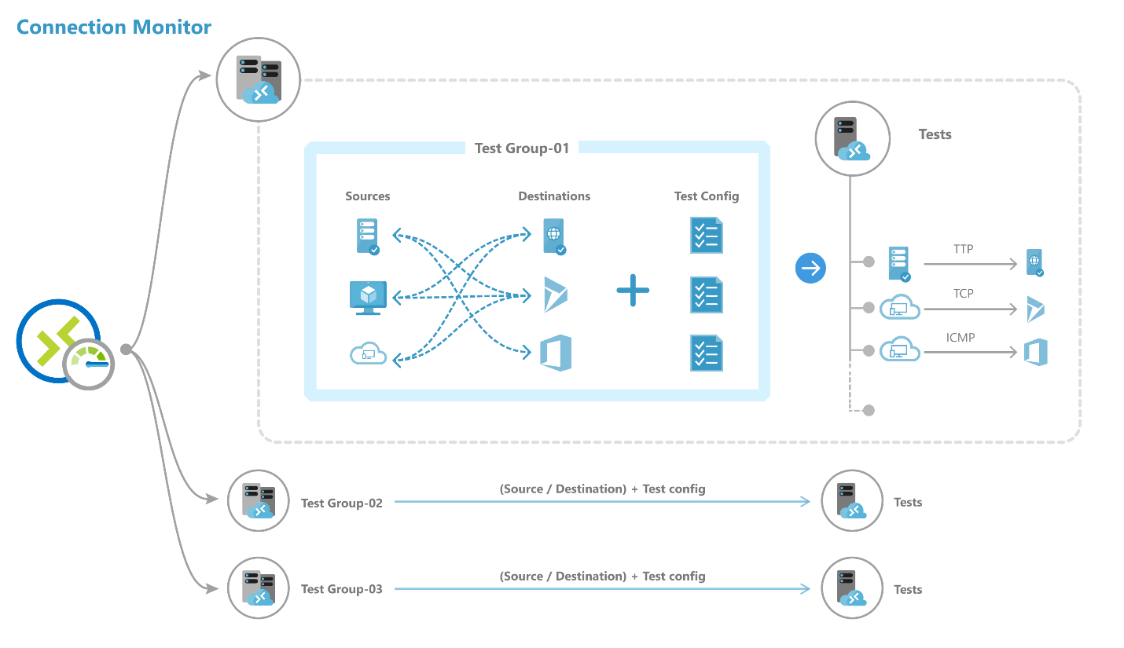

You can create a connection monitor using Azure portal, ARMClient or PowerShell.

To create a monitor in **Connection Monitor** by using the **Azure portal**:

1. On the Azure portal home page, go to Network Watcher.

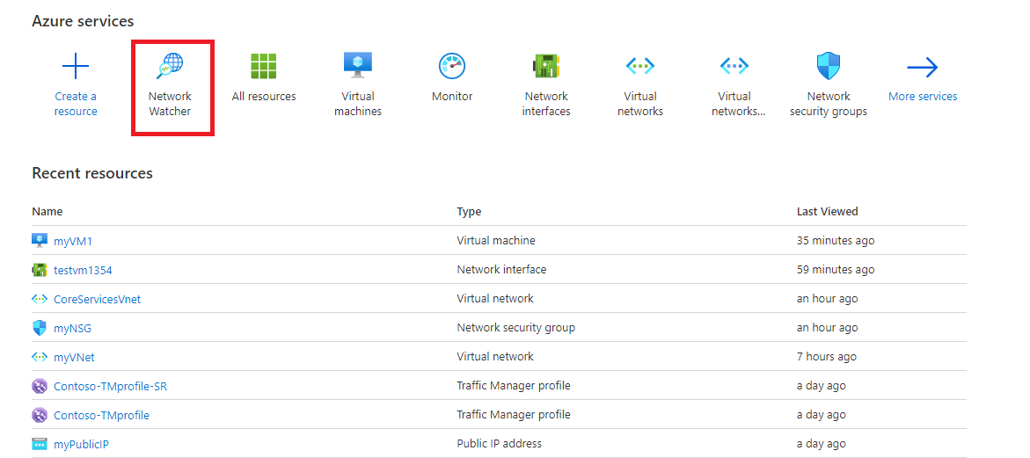

1. In the left pane, under Monitoring, select Connection monitor, and then click Create.

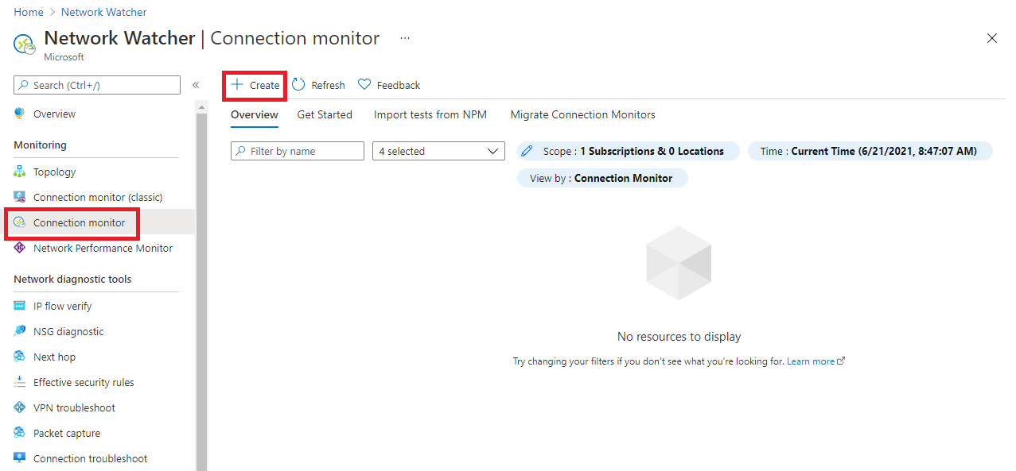

1. On the Basics tab of the Create Connection Monitor page, you need to enter the following information for your new connection monitor:

|  |  |
| --- | --- |
| **Field** | **Information** |
| Connection Monitor Name | Enter a name for your connection monitor. Use the standard naming rules for Azure resources. |
| Subscription | Select your Azure subscription from the list. |
| Region | Select a region for your connection monitor. You can select only the source VMs that are created in this region. |
| Workspace configuration | Choose a custom workspace or the default workspace. Your workspace holds your monitoring data.  To use the default workspace, select the check box.  To choose a custom workspace, clear the check box. Then select the subscription and region for your custom workspace. |

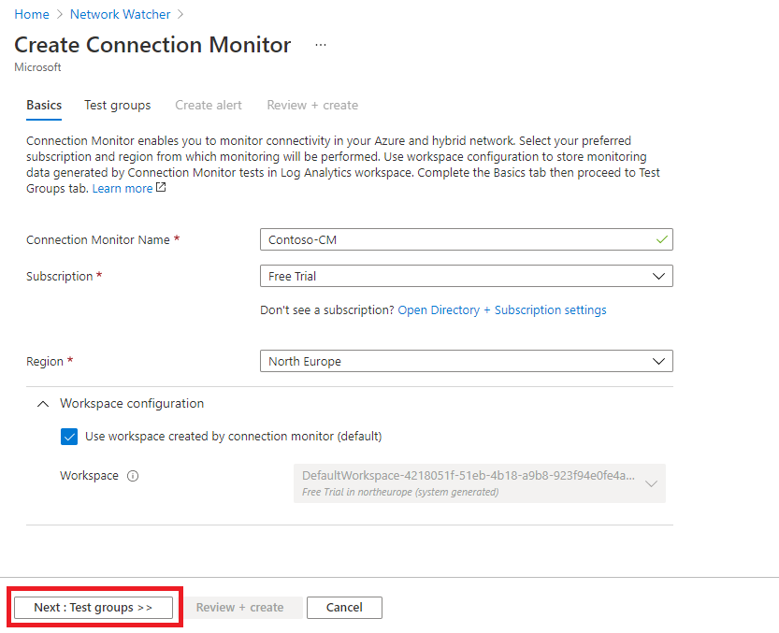

1. Click **Next: Test groups >>**.
2. On the next page, you can add sources, test configurations, and destinations in your test groups. Each test group in a connection monitor includes sources and destinations that get tested on network parameters. They are tested for the percentage of checks that fail and the round-trip-time (RTT) over test configurations.

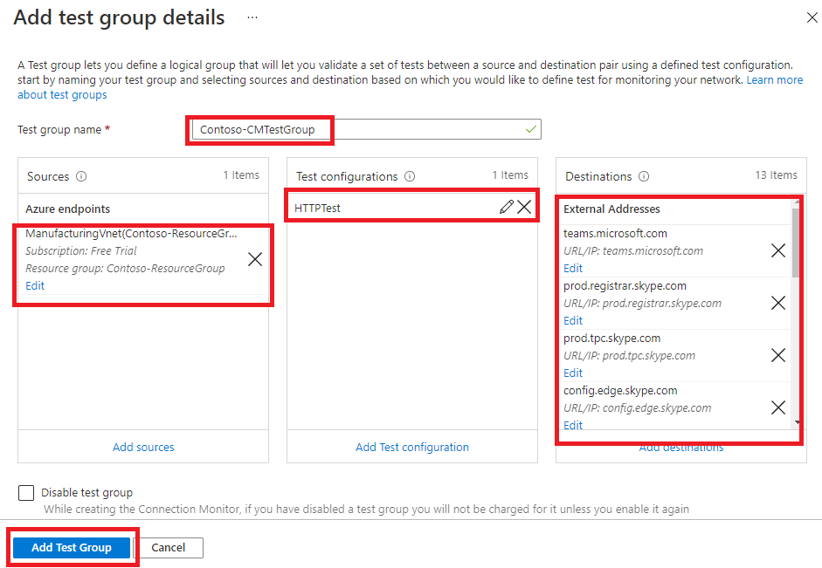

1. Click Add Test Group.

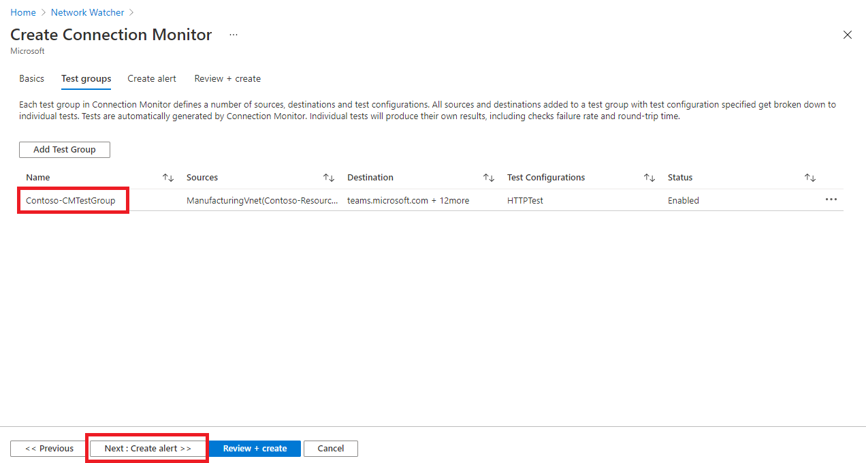

1. Click **Next: Create Alerts >>**.
2. On the Create alert tab, you can set up alerts on tests that are failing based on the thresholds set in test configurations.
3. You need to enter the following information for your alert:
   * Create alert (check box): You can select this check box to create a metric alert in Azure Monitor. When you select this check box, the other fields will be enabled for editing. (Note: Additional charges for the alert will be applicable.)
   * Scope (Resource/Hierarchy): The values here are automatically filled in for you, based on the values you specified on the **Basics** tab.
   * Condition: The alert is created on the Test Result(preview) metric. When the result of the connection monitor test is a failing result, the alert rule will fire.
   * Action group: You can enter your email directly or you can create alerts via action groups. If you enter your email directly, an action group with the name NPM Email ActionGroup is created. The email ID is added to that action group. If you choose to use action groups, you need to select a previously created action group.
   * Alert rule name: This is the name of the connection monitor and is already filled in for you.
   * Enable rule upon creation: Select this check box to enable the alert rule based on the condition (default setting). Disable this check box if you want to create the rule without enabling it - perhaps for evaluation and testing purposes, or because you are just not ready to deploy it yet.

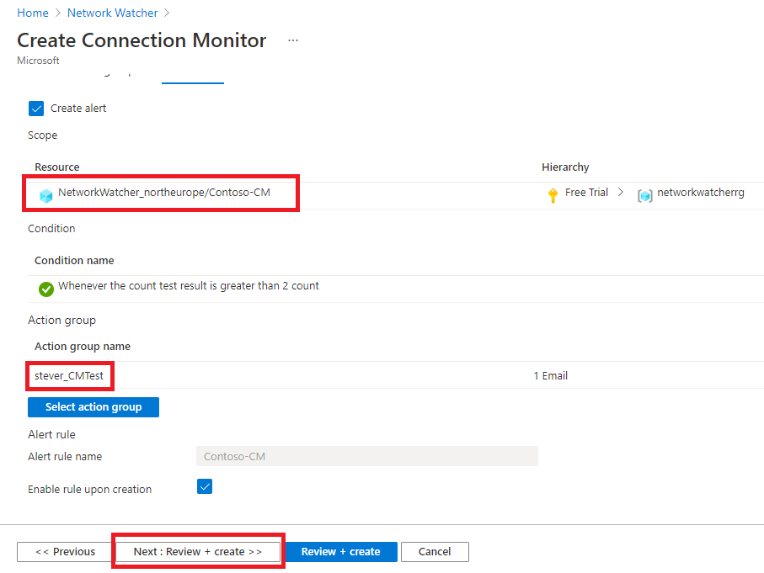

1. Click **Next: Review + create >>**.

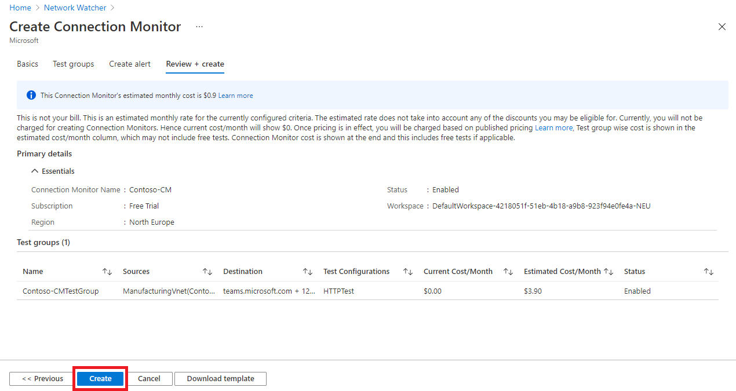

1. Review your information, and then click Create.

# Traffic Analytics

Traffic Analytics is a cloud-based solution that provides visibility into user and application activity in cloud networks. Traffic Analytics analyzes Network Watcher network security group (NSG) flow logs to provide insights into traffic flow in your Azure cloud and provide rich visualizations of data written to NSG flow logs.

With Traffic Analytics, you can:

* Visualize network activity across your Azure subscriptions and identify hot spots.
* Identify security threats to, and secure your network, with information such as open-ports, applications attempting internet access, and virtual machines (VM) connecting to rogue networks.
* Understand traffic flow patterns across Azure regions and the internet to optimize your network deployment for performance and capacity.
* Pinpoint network misconfigurations leading to failed connections in your network.

## Traffic Analytics works

Traffic analytics examines the raw NSG flow logs and captures reduced logs by aggregating common flows among the same source IP address, destination IP address, destination port, and protocol. For example, Host 1 (IP address: 10.10.10.10) communicating to Host 2 (IP address: 10.10.20.10), 100 times over 1 hour using port (for example, 80) and protocol (for example, http). The reduced log has one entry, that Host 1 & Host 2 communicated 100 times over a period of 1 hour using port 80 and protocol HTTP, instead of having 100 entries. Reduced logs are enhanced with geography, security, and topology information, and then stored in a Log Analytics workspace.

The diagram below illustrates the data flow:

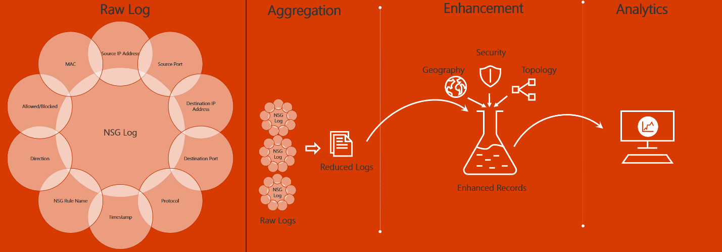

The key components of Traffic Analytics are:

* **Network security group (NSG)** - Contains a list of security rules that allow or deny network traffic to resources connected to an Azure Virtual Network. NSGs can be associated to subnets, individual VMs (classic), or individual network interfaces (NIC) attached to VMs (Resource Manager). For more information, see Network security group overview.
* **Network security group (NSG) flow logs** - Allow you to view information about ingress and egress IP traffic through a network security group. NSG flow logs are written in json format and show outbound and inbound flows on a per rule basis, the NIC the flow applies to, five-tuple information about the flow (source/destination IP address, source/destination port, and protocol), and if the traffic was allowed or denied. For more information about NSG flow logs, see NSG flow logs.
* **Log Analytics** - An Azure service that collects monitoring data and stores the data in a central repository. This data can include events, performance data, or custom data provided through the Azure API. Once collected, the data is available for alerting, analysis, and export. Monitoring applications such as network performance monitor and traffic analytics are built using Azure Monitor logs as a foundation. For more information, see Azure Monitor logs.
* **Log Analytics workspace** - An instance of Azure Monitor logs, where the data pertaining to an Azure account, is stored. For more information about Log Analytics workspaces, see Create a Log Analytics workspace.
* **Network Watcher** - A regional service that enables you to monitor and diagnose conditions at a network scenario level in Azure. You can turn NSG flow logs on and off with Network Watcher. For more information, see Network Watcher.

To analyze traffic, you need to have an existing network watcher, or enable a network watcher in each region that you have NSGs that you want to analyze traffic for. Traffic analytics can be enabled for NSGs hosted in any of the supported regions.

Before enabling NSG flow logging, you must have a network security group to log flows for. If you do not have a network security group, then you must create one using the Azure port, the Azure CLI, or PowerShell.

To view Traffic Analytics, search for **Network Watcher** in the portal search bar. In Network Watcher, to explore traffic analytics and its capabilities, select **Traffic Analytics** from the left menu.

The example screenshot below shows the Traffic Analytics dashboard.

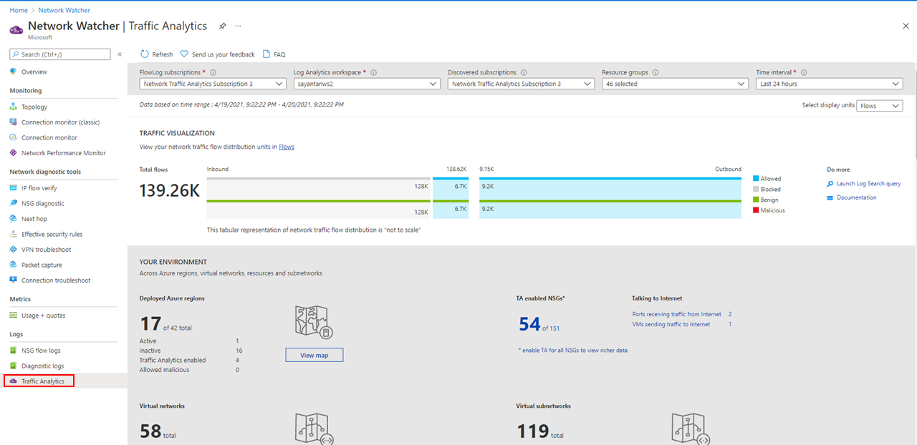

# Azure Backup service

The Azure Backup service provides simple, secure, and cost-effective solutions to back up your data and recover it from the Microsoft Azure cloud

## What can be back up

* **On-premises** - Back up files, folders, system state using the [Microsoft Azure Recovery Services (MARS) agent](https://learn.microsoft.com/en-us/azure/backup/backup-support-matrix-mars-agent). Or use the DPM or Azure Backup Server (MABS) agent to protect on-premises VMs ([Hyper-V](https://learn.microsoft.com/en-us/azure/backup/back-up-hyper-v-virtual-machines-mabs) and [VMware](https://learn.microsoft.com/en-us/azure/backup/backup-azure-backup-server-vmware)) and other [on-premises workloads](https://learn.microsoft.com/en-us/azure/backup/backup-mabs-protection-matrix)
* **Azure VMs** - [Back up entire Windows/Linux VMs](https://learn.microsoft.com/en-us/azure/backup/backup-azure-vms-introduction) (using backup extensions) or back up files, folders, and system state using the [MARS agent](https://learn.microsoft.com/en-us/azure/backup/backup-azure-manage-mars).
* **Azure Managed Disks** - [Back up Azure Managed Disks](https://learn.microsoft.com/en-us/azure/backup/backup-managed-disks)
* **Azure Files shares** - [Back up Azure File shares to a storage account](https://learn.microsoft.com/en-us/azure/backup/backup-afs)
* **SQL Server in Azure VMs** - [Back up SQL Server databases running on Azure VMs](https://learn.microsoft.com/en-us/azure/backup/backup-azure-sql-database)
* **SAP HANA databases in Azure VMs** - [Backup SAP HANA databases running on Azure VMs](https://learn.microsoft.com/en-us/azure/backup/backup-azure-sap-hana-database)
* **Azure Database for PostgreSQL servers** - [Back up Azure PostgreSQL databases and retain the backups for up to 10 years](https://learn.microsoft.com/en-us/azure/backup/backup-azure-database-postgresql)
* **Azure Blobs** - [Overview of operational backup for Azure Blobs](https://learn.microsoft.com/en-us/azure/backup/blob-backup-overview)
* **Azure Database for PostgreSQL Flexible server** - [Overview of Azure Database for PostgreSQL Flexible server backup (preview)](https://learn.microsoft.com/en-us/azure/backup/backup-azure-database-postgresql-flex-overview)
* **Azure Kubernetes service** - [Overview of AKS backup](https://learn.microsoft.com/en-us/azure/backup/azure-kubernetes-service-backup-overview)

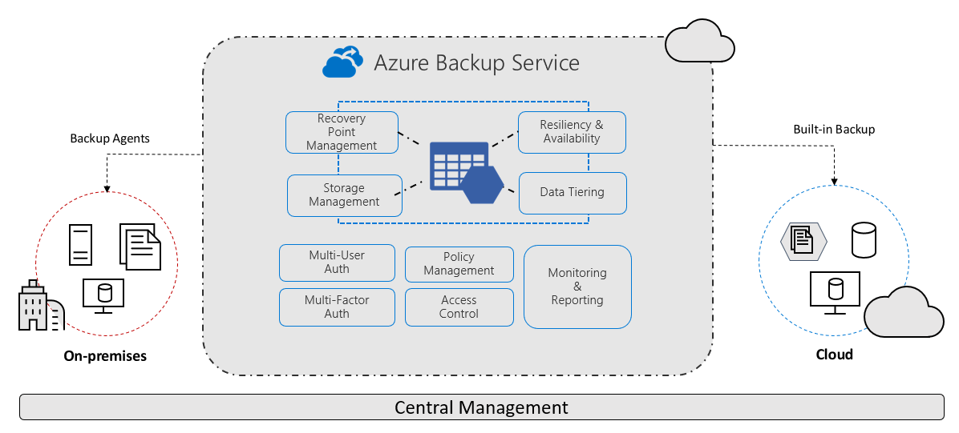

## Azure Backup Benifits

Azure Backup delivers these key benefits:

* **Offload on-premises backup**: Azure Backup offers a simple solution for backing up your on-premises resources to the cloud. Get short and long-term backup without the need to deploy complex on-premises backup solutions.
* **Back up Azure IaaS VMs**: Azure Backup provides independent and isolated backups to guard against accidental destruction of original data. Backups are stored in a Recovery Services vault with built-in management of recovery points. Configuration and scalability are simple, backups are optimized, and you can easily restore as needed.
* **Scale easily** - Azure Backup uses the underlying power and unlimited scale of the Azure cloud to deliver high-availability with no maintenance or monitoring overhead.
* **Get unlimited data transfer**: Azure Backup doesn't limit the amount of inbound or outbound data you transfer, or charge for the data that's transferred.Outbound data refers to data transferred from a Recovery Services vault during a restore operation.If you perform an offline initial backup using the Azure Import/Export service to import large amounts of data, there's a cost associated with inbound data.
* **Keep data secure**: Azure Backup provides solutions for securing data.
* **Centralized monitoring and management**: Azure Backup provides built-in monitoring and alerting capabilities in a Recovery Services vault. These capabilities are available without any additional management infrastructure. You can also increase the scale of your monitoring and reporting by using Azure Monitor.
* **Get app-consistent backups**: An application-consistent backup means a recovery point has all required data to restore the backup copy. Azure Backup provides application-consistent backups, which ensure additional fixes aren't required to restore the data. Restoring application-consistent data reduces the restoration time, allowing you to quickly return to a running state.
* **Retain short and long-term data**: You can use [Recovery Services vaults](https://learn.microsoft.com/en-us/azure/backup/backup-azure-recovery-services-vault-overview) for short-term and long-term data retention.
* **Automatic storage management** - Hybrid environments often require heterogeneous storage - some on-premises and some in the cloud. With Azure Backup, there's no cost for using on-premises storage devices. Azure Backup automatically allocates and manages backup storage, and it uses a pay-as-you-use model. So you only pay for the storage you consume.
* **Multiple storage options** - Azure Backup offers three types of replications to keep your storage/data highly available.
* [**Locally redundant storage (LRS)**](https://learn.microsoft.com/en-us/azure/storage/common/storage-redundancy#locally-redundant-storage) replicates your data three times (it creates three copies of your data) in a storage scale unit in a datacenter. All copies of the data exist within the same region. LRS is a low-cost option for protecting your data from local hardware failures.
* [**Geo-redundant storage (GRS)**](https://learn.microsoft.com/en-us/azure/storage/common/storage-redundancy#geo-redundant-storage)is the default and recommended replication option. GRS replicates your data to a secondary region (hundreds of miles away from the primary location of the source data). GRS costs more than LRS, but GRS provides a higher level of durability for your data, even if there's a regional outage.
* [**Zone-redundant storage (ZRS)**](https://learn.microsoft.com/en-us/azure/storage/common/storage-redundancy#zone-redundant-storage)replicates your data in availability zones, guaranteeing data residency and resiliency in the same region. ZRS has no downtime. So your critical workloads that require data residency, and must have no downtime, can be backed up in ZRS.

## How Azure Backup protects from ransomware

Azure Backup helps protect your critical business systems and backup data against a ransomware attack by implementing preventive measures and providing tools that protect your organization from every step that attackers take to infiltrate your systems. It provides security to your backup environment, both when your data is in transit and at rest.

In addition to various security features offered by default, you can also leverage several enhanced features that can provide you with highest levels of security for your backed-up data.

# Troubleshooting backup failures on Azure virtual machines

This section covers backup operation failure of Azure Virtual machine.

## Basic troubleshooting

* Ensure that the VM Agent (WA Agent) is the latest version.
* Ensure that the Windows or Linux VM OS version is supported, refer to the IaaS VM Backup Support Matrix.
* Verify that another backup service isn't running.
  + To ensure there are no snapshot extension issues, uninstall extensions to force reload and then retry the backup.
* Verify that the VM has internet connectivity.
  + Make sure another backup service isn't running.
* From Services.msc, ensure the **Windows Azure Guest Agent** service is **Running**. If the **Windows Azure Guest Agent** service is missing, install it from Back up Azure VMs in a Recovery Services vault
* The **Event log** may show backup failures that are from other backup products, for example, Windows Server backup aren't happening due to Azure Backup. Use the following steps to determine whether the issue is with Azure Backup:
* If there's an error with the entry **Backup** in the event source or message, check whether Azure IaaS VM Backup backups were successful, and whether a Restore Point was created with the desired snapshot type.
* If Azure Backup is working, then the issue is likely with another backup solution.
* If Azure Backup is failing, then look for the corresponding error code in the Common issues section.
* If you see Azure Backup option greyed out on an Azure VM, hover over the disabled menu to find the reason. The reasons could be "Not available with Ephemeral Disk" or "Not available with Ultra Disk".
* 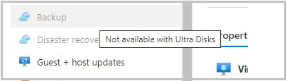

## Common issues with backup failure

The following are common issues with backup failures on Azure virtual machines.

### VMRestorePointInternalError

Antivirus configured in the VM is restricting the execution of backup extension

Error code: VMRestorePointInternalError

If at the time of backup, the **Event Viewer Application logs** displays the message **Faulting application name: IaaSBcdrExtension.exe** then it's confirmed that the antivirus configured in the VM is restricting the execution of backup extension. To resolve this issue, exclude the directories below in the antivirus configuration and retry the backup operation.

* C:\Packages\Plugins\Microsoft.Azure.RecoveryServices.VMSnapshot
* C:\WindowsAzure\Logs\Plugins\Microsoft.Azure.RecoveryServices.VMSnapshot

### CopyingVHDsFromBackUpVaultTakingLongTime

Copying backed up data from vault timed out

Error code: CopyingVHDsFromBackUpVaultTakingLongTime  
Error message: Copying backed up data from vault timed out

This could happen due to transient storage errors or insufficient storage account IOPS for backup service to transfer data to the vault within the timeout period. Configure VM backup with below suggestions

When you're configuring VM backups, we suggest following these practices:

* Modify the default schedule times that are set in a policy. For example, if the default time in the policy is 12:00 AM, increment the timing by several minutes so that resources are optimally used.
* If you're restoring VMs from a single vault, we highly recommend that you use different general-purpose v2 storage accounts to ensure that the target storage account doesn't get throttled. For example, each VM must have a different storage account. For example, if 10 VMs are restored, use 10 different storage accounts.
* For backup of VMs that are using premium storage with Instant Restore, we recommend allocating *50%* free space of the total allocated storage space, which is required **only** for the first backup. The 50% free space isn't a requirement for backups after the first backup is complete
* The limit on the number of disks per storage account is relative to how heavily the disks are being accessed by applications that are running on an infrastructure as a service (IaaS) VM. As a general practice, if 5 to 10 disks or more are present on a single storage account, balance the load by moving some disks to separate storage accounts.
* To restore VMs with managed disks using PowerShell, provide the additional parameter ***TargetResourceGroupName*** to specify the resource group to which managed disks will be restored

### UserErrorVmNotInDesirableState

VM is not in a state that allows backups

Error code: UserErrorVmNotInDesirableState  
Error message: VM is not in a state that allows backups.

The backup operation failed because the VM is in Failed state. For a successful backup, the VM state should be Running, Stopped, or Stopped (deallocated).

* If the VM is in a transient state between **Running** and **Shut down**, wait for the state to change. Then trigger the backup job.
* If the VM is a Linux VM and uses the Security-Enhanced Linux kernel module, exclude the Azure Linux Agent path **/var/lib/waagent** from the security policy and make sure the Backup extension is installed.

### UserErrorFsFreezeFailed

Failed to freeze one or more mount-points of the VM to take a file-system consistent snapshot

Error code: UserErrorFsFreezeFailed  
Error message: Failed to freeze one or more mount-points of the VM to take a file-system consistent snapshot.

**Step 1:**

* Unmount the devices for which the file system state wasn't cleaned, using the **umount** command.
* Run a file system consistency check on these devices by using the **fsck** command.
* Mount the devices again and retry backup operation.

If you can't un-mount the devices then you can update the VM backup configuration to ignore certain mount points. For example, if '/mnt/resource' mount point can't be un-mounted and causing the VM backup failures, you can update the VM backup configuration files with the MountsToSkip property as follows.

**Step 2:**

* Check if there are duplicate mount points present.

Identify the failed to freeze mount points from the extension log file.  
For example: /boot, /usr/sap in the below sample output.

### ExtensionFailedVssWriterInBadState

Snapshot operation failed because VSS writers were in a bad state

Error code: ExtensionFailedVssWriterInBadState  
Error message: Snapshot operation failed because VSS writers were in a bad state.

This error occurs because the VSS writers were in a bad state. Azure Backup extensions interact with VSS Writers to take snapshots of the disks. To resolve this issue, follow these steps:

**Step 1:** Check the **Free Disk Space**, **VM resources as RAM and page file**, and **CPU utilization percentage**.

* Increase the VM size to increase vCPUs and RAM space.
* Increase the disk size if the free disk space is low.

**Step 2:** Restart VSS writers that are in a bad state.

* From an elevated command prompt, run vssadmin list writers.
* The output contains all VSS writers and their state. For every VSS writer with a state that's not **[1] Stable**, restart the respective VSS writer's service.
* To restart the service, run the following commands from an elevated command prompt:

net stop serviceName  
net start serviceName

**Step 3:** If restarting the VSS writers did not resolve the issue, then run the following command from an elevated command-prompt (as an administrator) to prevent the threads from being created for blob-snapshots.

**Step 4:** If steps 1 and 2 did not resolve the issue, then the failure could be due to VSS writers timing out due to limited IOPS.

### UserErrorSkuNotAvailable

VM creation failed as VM size selected is not available

Error code: UserErrorSkuNotAvailable

Error message: VM creation failed as VM size selected is not available.

This error occurs because the VM size selected during the restore operation is an unsupported size.

To resolve this issue, use the [restore disks](https://learn.microsoft.com/en-us/azure/backup/backup-azure-arm-restore-vms#restore-disks) option during the restore operation. Use those disks to create a VM from the list of [available supported VM sizes](https://learn.microsoft.com/en-us/azure/backup/backup-support-matrix-iaas#vm-compute-support) using [PowerShell cmdlets](https://learn.microsoft.com/en-us/azure/backup/backup-azure-vms-automation#create-a-vm-from-restored-disks).

### UserErrorMarketPlaceVMNotSupported

VM creation failed due to Market Place purchase request being not present

**Error code**: UserErrorMarketPlaceVMNotSupported

**Error message**: VM creation failed due to Market Place purchase request being not present.

Azure Backup supports backup and restore of VMs that are available in Azure Marketplace. This error occurs when you try to restore a VM (with a specific Plan/Publisher setting), which is no longer available in Azure Marketplace.

In this scenario, a partial failure happens where the disks are restored, but the VM isn't restored. This is because it's not possible to create a new VM from the restored disks.

### ExtensionStuckInDeletionState

Extension state is not supportive to the backup operation

Error code: ExtensionStuckInDeletionState  
Error message: Extension state is not supportive to the backup operation

The Backup operation failed due to inconsistent state of Backup Extension. To resolve this issue, follow these steps:

* Ensure Guest Agent is installed and responsive
* From the Azure portal, go to **Virtual Machine** > **All Settings** > **Extensions**
* Select the backup extension VmSnapshot or VmSnapshotLinux and select **Uninstall**.
* After deleting backup extension, retry the backup operation
* The subsequent backup operation will install the new extension in the desired state

### ExtensionFailedSnapshotLimitReachedError

Snapshot operation failed as snapshot limit is exceeded for some of the disks attached

Error code: ExtensionFailedSnapshotLimitReachedError  
Error message: Snapshot operation failed as snapshot limit is exceeded for some of the disks attached

The snapshot operation failed as the snapshot limit has exceeded for some of the disks attached. Complete the following troubleshooting steps and then retry the operation.

* Delete the disk blob-snapshots that aren't required. Be careful to not delete disk blobs. Only snapshot blobs should be deleted.
* If Soft-delete is enabled on VM disk Storage-Accounts, configure soft-delete retention so existing snapshots are less than the maximum allowed at any point of time.
* If Azure Site Recovery is enabled in the backed-up VM, then perform the steps below:
  + Ensure the value of **isanysnapshotfailed** is set as false in /etc/azure/vmbackup.conf
  + Schedule Azure Site Recovery at a different time, so it doesn't conflict the backup operation.

### ExtensionFailedTimeoutVMNetworkUnresponsive

Snapshot operation failed due to inadequate VM resources

Error code: ExtensionFailedTimeoutVMNetworkUnresponsive  
Error message: Snapshot operation failed due to inadequate VM resources.

The backup operation on the VM failed due to delay in network calls while performing the snapshot operation. To resolve this issue, perform Step 1. If the issue persists, try steps 2 and 3.

**Step 1:** Create snapshot through Host

From an elevated (admin) command-prompt, run the following command:

REG ADD "HKLM\SOFTWARE\Microsoft\BcdrAgentPersistentKeys" /v SnapshotMethod /t REG_SZ /d firstHostThenGuest /f

REG ADD "HKLM\SOFTWARE\Microsoft\BcdrAgentPersistentKeys" /v CalculateSnapshotTimeFromHost /t REG_SZ /d True /f

This will ensure the snapshots are taken through host instead of Guest. Retry the backup operation.

**Step 2:** Try changing the backup schedule to a time when the VM is under less load (like less CPU or IOPS)

**Step 3:** Try increasing the size of the VM and retry the operation

### ResourceNotFound ,320001 / 400094, BCMV2VMNotFound

Could not perform the operation as VM no longer exists

The virtual machine doesn't exist / An Azure virtual machine wasn't found

Error code: 320001, ResourceNotFound  
Error message: Could not perform the operation as VM no longer exists.  
  
Error code: 400094, BCMV2VMNotFound  
Error message: The virtual machine doesn't exist  
An Azure virtual machine wasn't found.

This error happens when the primary VM is deleted, but the backup policy still looks for a VM to back up. To fix this error, take the following steps:

* Re-create the virtual machine with the same name and same resource group name, **cloud service name**,  
  or
* Stop protecting the virtual machine with or without deleting the backup data.

### UserErrorBCMPremiumStorageQuotaError

Could not copy the snapshot of the virtual machine, due to insufficient free space in the storage account

Error code: UserErrorBCMPremiumStorageQuotaError  
Error message: Could not copy the snapshot of the virtual machine, due to insufficient free space in the storage account

For premium VMs on VM backup stack V1, we copy the snapshot to the storage account. This step makes sure that backup management traffic, which works on the snapshot, doesn't limit the number of IOPS available to the application using premium disks.  
  
We recommend that you allocate only 50 percent, 17.5 TB, of the total storage account space. Then the Azure Backup service can copy the snapshot to the storage account and transfer data from this copied location in the storage account to the vault.

### AzureVmOffline , 380008

Failed to install Microsoft Recovery Services extension as virtual machine is not running

Error code: 380008, AzureVmOffline  
Error message: Failed to install Microsoft Recovery Services extension as virtual machine is not running

The VM Agent is a prerequisite for the Azure Recovery Services extension. Install the Azure Virtual Machine Agent and restart the registration operation.

* Check if the VM Agent is installed correctly.
* Make sure that the flag on the VM config is set correctly.

### ExtensionSnapshotBitlockerError

The snapshot operation failed with the Volume Shadow Copy Service (VSS) operation error

Error code: ExtensionSnapshotBitlockerError  
Error message: The snapshot operation failed with the Volume Shadow Copy Service (VSS) operation error **This drive is locked by BitLocker Drive Encryption. You must unlock this drive from the Control Panel.**

Turn off BitLocker for all drives on the VM and check if the VSS issue is resolved.

### VmNotInDesirableState

The VM isn't in a state that allows backups

Error code: VmNotInDesirableState  
Error message: The VM isn't in a state that allows backups.

* If the VM is in a transient state between **Running** and **Shut down**, wait for the state to change. Then trigger the backup job.
* If the VM is a Linux VM and uses the Security-Enhanced Linux kernel module, exclude the Azure Linux Agent path **/var/lib/waagent** from the security policy and make sure the Backup extension is installed.
* The VM Agent isn't present on the virtual machine:  
  Install any prerequisite and the VM Agent. Then restart the operation.

### ExtensionSnapshotFailedNoSecureNetwork

The snapshot operation failed because of failure to create a secure network communication channel

Error code: ExtensionSnapshotFailedNoSecureNetwork  
Error message: The snapshot operation failed because of failure to create a secure network communication channel.

* Open the Registry Editor by running **regedit.exe** in an elevated mode.
* Identify all versions of the .NET Framework present in your system. They're present under the hierarchy of registry key **HKEY_LOCAL_MACHINE\SOFTWARE\Microsoft**.
* For each .NET Framework present in the registry key, add the following key:  
  **SchUseStrongCrypto"=dword:00000001**.

### ExtensionVCRedistInstallationFailure

Error code: ExtensionVCRedistInstallationFailure  
Error message: The snapshot operation failed because of failure to install Visual C++ Redistributable for Visual Studio 2012.

* Navigate to C:\Packages\Plugins\Microsoft.Azure.RecoveryServices.VMSnapshot\agentVersion and install vcredist2013_x64.  
  Make sure that the registry key value that allows the service installation is set to the correct value. That is, set the **Start** value in **HKEY_LOCAL_MACHINE\SYSTEM\CurrentControlSet\Services\Msiserver** to **3** and not **4**.  
    
  If you still have issues with installation, restart the installation service by running **MSIEXEC /UNREGISTER** followed by **MSIEXEC /REGISTER** from an elevated command prompt.
* Check the event log to verify if you're noticing access related issues. For example: *Product: Microsoft Visual C++ 2013 x64 Minimum Runtime - 12.0.21005 -- Error 1401.Could not create key: Software\Classes. System error 5. Verify that you have sufficient access to that key, or contact your support personnel.*  
    
  Ensure the administrator or user account has sufficient permissions to update the registry key **HKEY_LOCAL_MACHINE\SOFTWARE\Classes**. Provide sufficient permissions and restart the Windows Azure Guest Agent.
* If you have antivirus products in place, ensure they have the right exclusion rules to allow the installation.

### UserErrorUnableToOpenMount

**Error code**: UserErrorUnableToOpenMount

**Cause**: Backups failed because the backup extensions on the VM were unable to open the mount points in the VM.

**Recommended action**: The backup extension on the VM must be able to access all mount points in the VM to determine the underlying disks, take snapshot, and calculate the size. Ensure that all mount points are accessible.

# Restore

## Disks appear offline after File Restore

If after restoring, you notice the disks are offline then:

* Verify if the machine where the script is executed meets the OS requirements.
* Ensure you are not restoring to the same source

## UserErrorInstantRpNotFound

Error code: UserErrorInstantRpNotFound  
Error message: Restore failed because the snapshot of the VM was not found. The snapshot could have been deleted, please check.

This error occurs when you are trying to restore a recovery point that was not transferred to the vault and was deleted in the snapshot phase.  
To resolve this issue, try to restore the VM from a different restore point.

## UserErrorMigrationFromTrustedLaunchVM ToNonTrustedVMNotAllowed

**Error code**: UserErrorMigrationFromTrustedLaunchVMToNonTrustedVMNotAllowed

**Error message**: Backup cannot be configured for the VM which has migrated from Trusted Launch mode to non Trusted Launch mode.

**Scenario 1**: Migration of Trusted Launch VM to Generation 2 VM is blocked.

Migration of Trusted Launch VM to Generation 2 VM is not supported. This is because the VM Guest State (VMGS) blob created for Trusted Launch VMs isn't present for Generation 2 VM. Therefore, the VM won't start.

**Scenario 2**: Unable to protect a Standard VM with the same name as of Trusted Launch VM that was previously deleted.

To resolve this issue:

1. [Disable soft delete](https://learn.microsoft.com/en-us/azure/backup/backup-azure-security-feature-cloud?tabs=azure-portal#disable-soft-delete).
2. [Stop VM protection with delete backup data](https://learn.microsoft.com/en-us/azure/backup/backup-azure-manage-vms#stop-protection-and-delete-backup-data).
3. Re-enable soft delete.
4. Configure VM protection again with the appropriate policy after the old backup data deletion is complete from the Recovery Services vault.

## UserErrorCrossSubscriptionRestoreNotSuppportedForUnManagedAzureVM

## 

**Error code**: UserErrorCrossSubscriptionRestoreNotSuppportedForUnManagedAzureVM

**Error message**: Operation failed as Cross Subscription Restore is not supported for Azure VMs with Unmanaged Disks.

**Resolution**: Perform standard restores within the same subscription instead.

## UserErrorCrossSubscriptionRestoreNotSuppportedForCRR

**Error code**: UserErrorCrossSubscriptionRestoreNotSuppportedForCRR

**Error message**: Operation failed as Cross Subscription Restore is not supported along-with Cross Region Restore.

**Resolution**: Use either Cross Subscription Restore' or Cross Region Restore.

## UserErrorCrossSubscriptionRestoreNotSuppportedFromSnapshot

**Error code**: UserErrorCrossSubscriptionRestoreNotSuppportedFromSnapshot

**Error message**: Operation failed as Cross Subscription Restore is not supported when restoring from a Snapshot recovery point.

**Resolution**: Select a different recovery point where Tier 2 (Vault-Tier) is available.

## UserErrorCrossSubscriptionRestoreInvalidTenant

**Error code**: UserErrorCrossSubscriptionRestoreInvalidTenant

**Error message**: Operation failed as the tenant IDs for source and target subscriptions don't match.

**Resolution**: Ensure that the source and target subscriptions belong to the same tenant.

## UserErrorCrossSubscriptionRestoreInvalidTargetSubscription

**Error code**: UserErrorCrossSubscriptionRestoreInvalidTargetSubscription

**Error message**: Operation failed as the target subscription specified for restore is not registered to the Azure Recovery Services Resource Provider.

**Resolution**: Ensure the target subscription is registered to the Recovery Services Resource Provider before you attempt a cross subscription restore. Creating a vault in the target Subscription should register the Subscription to Recovery Services Resource Provider.

## UserErrorCrossSubscriptionRestoreNotSuppportedForEncryptedAzureVM

**Error code**: UserErrorCrossSubscriptionRestoreNotSuppportedForEncryptedAzureVM

**Error message**: Operation failed as Cross Subscription Restore is not supported for Encrypted Azure VMs.

**Resolution**: Use the same subscription for Restore of Encrypted AzureVMs.

## UserErrorCrossSubscriptionRestoreNotSuppportedForTrustedLaunchAzureVM

**Error code**: UserErrorCrossSubscriptionRestoreNotSuppportedForTrustedLaunchAzureVM

**Error message**: Operation failed as Cross Subscription Restore is not supported for Trusted Launch Azure VMs (TVMs).

**Resolution**: Use the same subscription for Restore of Trusted Launch Azure VMs.

## UserErrorCrossSubscriptionRestoreInvalidTargetSubscription

**Error code**: UserErrorCrossSubscriptionRestoreInvalidTargetSubscription

**Error message**: Operation failed as the target subscription specified for restore is not registered to the Azure Recovery Services Resource Provider.

**Recommended action**: Ensure that the target subscription is registered to the Recovery Services Resource Provider before you attempt a cross subscription restore. Creating a vault in the target Subscription should typically register the Subscription to Recovery Services vault Provider.

# Backup or restore takes time

If your backup takes more than 12 hours or restore takes more than 6 hours then following are the best practices while configuring VM backups.

* Modify the default schedule times that are set in a policy. For example, if the default time in the policy is 12:00 AM, increment the timing by several minutes so that resources are optimally used.
* If you're restoring VMs from a single vault, we highly recommend that you use different **general-purpose v2 storage account** to ensure that the target storage account doesn't get throttled. For example, each VM must have a different storage account. For example, if 10 VMs are restored, use 10 different storage accounts.
* For backup of VMs that are using premium storage with Instant Restore, we recommend allocating 50% free space of the total allocated storage space, which is required **only** for the first backup. The 50% free space isn't a requirement for backups after the first backup is complete
* The limit on the number of disks per storage account is relative to how heavily the disks are being accessed by applications that are running on an infrastructure as a service (IaaS) VM. As a general practice, if 5 to 10 disks or more are present on a single storage account, balance the load by moving some disks to separate storage accounts.
* To restore VMs with managed disks using PowerShell, provide the additional parameter ***TargetResourceGroupName*** to specify the resource group to which managed disks will be restored.

# Troubleshoot VM snapshot issues

VM backup relies on issuing snapshot commands to underlying storage. Not having access to storage or delays in a snapshot task run can cause the backup job to fail. The following conditions can cause snapshot task failure:

* **VMs with SQL Server backup configured can cause snapshot task delay**. By default, VM backup creates a VSS full back up on Windows VMs. VMs that run SQL Server, with SQL Server backup configured, can experience snapshot delays. If snapshot delays cause backup failures, set following registry key:

REG ADD "HKLM\SOFTWARE\Microsoft\BcdrAgent" /v UseVssFullBackup /t REG_SZ /d True /f

* **VM status is reported incorrectly because the VM is shut down in RDP**. If you used the remote desktop to shut down the virtual machine, verify that the VM status in the portal is correct. If the status isn't correct, use the **Shutdown** option in the portal VM dashboard to shut down the VM
* **If more than four VMs share the same cloud service, spread the VMs across multiple backup policies**. Stagger the backup times, so no more than four VM backups start at the same time. Try to separate the start times in the policies by at least an hour.
* **The VM runs at high CPU or memory**. If the virtual machine runs at high memory or CPU usage, more than 90 percent, your snapshot task is queued and delayed. Eventually it times out. If this issue happens, try an on-demand backup.

# Troubleshoot Azure Backup failure: Issues with the agent or extension

Most common backup failures can be self-resolved by following the troubleshooting steps listed below.

Step 1: Check Azure VM health

* **Ensure Azure VM provisioning state is 'Running'**: If the **VM provisioning state**is in the **Stopped/Deallocated/Updating** state, then it will interfere with the backup operation. Open Azure portal > VM > Overview > and check the VM status to ensure it's **Running** and retry the backup operation.
* **Review pending OS updates or reboots**: Ensure there are no pending OS update or pending reboots on the VM.

Step 2: Check Azure VM Guest Agent service health

**Ensure Azure VM Guest Agent service is started and up-to-date**:

On a Windows VM:

* Navigate to **services.msc** and ensure **Windows Azure VM Guest Agent service** is up and running.
* The Azure VM Agent is installed by default on any Windows VM deployed from an Azure Marketplace image from the portal, PowerShell, Command Line Interface, or an Azure Resource Manager template.
* Review the support matrix to check if VM runs on the supported windows operating system.

On Linux VM,

* Ensure the Azure VM Guest Agent service is running by executing the command ps -e. Also, ensure the latest version is installed.
* Review the support matrix to check if VM runs on the supported linux operating system.

Step 3: Check Azure VM Extension health

* **Ensure all Azure VM Extensions are in 'provisioning succeeded' state**: If any extension is in a failed state, then it can interfere with the backup.
* Open Azure portal > VM > Settings > Extensions > Extensions status and check if all the extensions are in **provisioning succeeded** state.
* Ensure all extension issues are resolved and retry the backup operation.
* **Ensure COM+ System Application** is up and running. Also, the **Distributed Transaction Coordinator service** should be running as **Network Service account**.

Step 4: Check Azure Backup Extension health

Azure Backup uses the VM Snapshot Extension to take an application consistent backup of the Azure virtual machine. Azure Backup will install the extension as part of the first scheduled backup triggered after enabling backup

* **Ensure VMSnapshot extension isn't in a failed state**: Follow the steps listed below to verify and ensure the Azure Backup extension is healthy.
* **Check if antivirus is blocking the extension**: Certain antivirus software can prevent extensions from executing.

At the time of the backup failure, verify if there are log entries in ***Event Viewer Application logs*** with ***faulting application name: IaaSBcdrExtension.exe***. If you see entries, then it could be the antivirus configured in the VM is restricting the execution of the backup extension. Test by excluding the following directories in the antivirus configuration and retry the backup operation.

* C:\Packages\Plugins\Microsoft.Azure.RecoveryServices.VMSnapshot
* C:\WindowsAzure\Logs\Plugins\Microsoft.Azure.RecoveryServices.VMSnapshot
* **Check if network access is required**: Extension packages are downloaded from the Azure Storage extension repository and extension status uploads are posted to Azure Storage.
* If you're on a non-supported version of the agent, you need to allow outbound access to azure storage in that region from the VM.
* If you've blocked access to 168.63.129.16 using the guest firewall or with a proxy, extensions will fail regardless of the above. Ports 80, 443, and 32526 are required
* **Ensure DHCP is enabled inside the guest VM**: This is required to get the host or fabric address from DHCP for the IaaS VM backup to work. If you need a static private IP, you should configure it through the Azure portal or PowerShell and make sure the DHCP option inside the VM is enabled.

## UserErrorGuestAgentStatusUnavailable

VM agent unable to communicate with Azure Backup

**Error code**: UserErrorGuestAgentStatusUnavailable  
**Error message**: VM Agent unable to communicate with Azure Backup

The Azure VM agent might be stopped, outdated, in an inconsistent state, or not installed. These states prevent the Azure Backup service from triggering snapshots.

* **Open Azure portal > VM > Settings > Properties pane** > ensure VM **Status** is **Running** and **Agent status** is **Ready**. If the VM agent is stopped or is in an inconsistent state, restart the agent
* **Open Azure portal > VM > Settings > Extensions** > Ensure all extensions are in **provisioning succeeded** state.

# Step-by-step guide to troubleshoot backup failures

Most common backup failures can be self-resolved by following the troubleshooting steps listed below:

**Step 1: Check Azure VM health**

* **Ensure Azure VM provisioning state is 'Running'**: If the VM provisioning state is in the **Stopped/Deallocated/Updating** state, then it will interfere with the backup operation. Open *Azure portal > VM > Overview >* and check the VM status to ensure it's **Running** and retry the backup operation.
* **Review pending OS updates or reboots**: Ensure there are no pending OS update or pending reboots on the VM.

**Step 2: Check Azure VM Guest Agent service health**

* **Ensure Azure VM Guest Agent service is started and up-to-date**:
  + On a Windows VM:
    - Navigate to **services.msc** and ensure **Windows Azure VM Guest Agent service** is up and running. Also, ensure the latest version is installed. To learn more, see Windows VM guest agent issues.
    - The Azure VM Agent is installed by default on any Windows VM deployed from an Azure Marketplace image from the portal, PowerShell, Command Line Interface, or an Azure Resource Manager template. A manual installation of the Agent may be necessary when you create a custom VM image that's deployed to Azure.
    - Review the support matrix to check if VM runs on the supported Windows operating system
  + On Linux VM,
    - Ensure the Azure VM Guest Agent service is running by executing the command ps -e. Also, ensure the latest version is installed. To learn more, see Linux VM guest agent issues.
    - Ensure the Linux VM agent dependencies on system packages have the supported configuration. For example: Supported Python version is 2.6 and above.
    - Review the support matrix to check if VM runs on the supported Linux operating system.

**Step 3: Check Azure VM Extension health**

* **Ensure all Azure VM Extensions are in 'provisioning succeeded' state**: If any extension is in a failed state, then it can interfere with the backup.
* *Open  Azure portal > VM > Settings > Extensions > Extensions status* and check if all the extensions are in **provisioning succeeded** state.
* Ensure all extension issues are resolved and retry the backup operation.
* **Ensure COM+ System Application** is up and running. Also, the **Distributed Transaction Coordinator service** should be running as **Network Service account**. Follow the steps in this article to troubleshoot COM+ and MSDTC issues.

**Step 4: Check Azure Backup Extension health**

Azure Backup uses the VM Snapshot Extension to take an application consistent backup of the Azure virtual machine. Azure Backup will install the extension as part of the first scheduled backup triggered after enabling backup.

* **Ensure VMSnapshot extension isn't in a failed state**: Follow the steps listed in this section to verify and ensure the Azure Backup extension is healthy.
* **Check if antivirus is blocking the extension**: Certain antivirus software can prevent extensions from executing.

At the time of the backup failure, verify if there are log entries in ***Event Viewer Application logs*** with ***faulting application name: IaaSBcdrExtension.exe***. If you see entries, then it could be the antivirus configured in the VM is restricting the execution of the backup extension. Test by excluding the following directories in the antivirus configuration and retry the backup operation.

* + C:\Packages\Plugins\Microsoft.Azure.RecoveryServices.VMSnapshot
  + C:\WindowsAzure\Logs\Plugins\Microsoft.Azure.RecoveryServices.VMSnapshot

**Check if network access is required:** Extension packages are downloaded from the Azure Storage extension repository and extension status uploads are posted to Azure Storage.

* + If you're on a non-supported version of the agent, you need to allow outbound access to Azure storage in that region from the VM.
  + If you've blocked access to 168.63.129.16 using the guest firewall or with a proxy, extensions will fail regardless of the above. Ports 80, 443, and 32526 are required.
* **Ensure DHCP is enabled inside the guest VM**: This is required to get the host or fabric address from DHCP for the IaaS VM backup to work. If you need a static private IP, you should configure it through the Azure portal or PowerShell and make sure the DHCP option inside the VM is enabled.
* **Ensure the VSS writer service is up and running**:
* **Follow backup best practice guidelines**: Review the best practices to enable Azure VM backup.
* **Review guidelines for encrypted disks**: If you're enabling backup for VMs with encrypted disk, ensure you've provided all the required permissions. To learn more, see Back up and restore encrypted Azure VM.

## UserErrorGuestAgentStatusUnavailable

**VM agent unable to communicate with Azure Backup**

**Error code**: UserErrorGuestAgentStatusUnavailable  
**Error message**: VM Agent unable to communicate with Azure Backup

The Azure VM agent might be stopped, outdated, in an inconsistent state, or not installed. These states prevent the Azure Backup service from triggering snapshots.

* **Open Azure portal > VM > Settings > Properties pane** > ensure VM **Status** is **Running** and **Agent status** is **Ready**. If the VM agent is stopped or is in an inconsistent state, restart the agent.
* **Open Azure portal > VM > Settings > Extensions** > Ensure all extensions are in **provisioning succeeded** state.

## UserErrorVmProvisioningStateFailed

**The VM is in failed provisioning state**

**Error code**: UserErrorVmProvisioningStateFailed  
**Error message**: The VM is in failed provisioning state

This error occurs when one of the extension failures puts the VM into provisioning failed state.  
**Open  Azure portal > VM > Settings > Extensions > Extensions status** and check if all extensions are in **provisioning succeeded** state.

* If any extension is in a failed state, then it can interfere with the backup. Ensure those extension issues are resolved and retry the backup operation.
* If the VM provisioning state is in an updating state, it can interfere with the backup. Ensure that it's healthy and retry the backup operation.

## UserErrorRpCollectionLimitReached

**The Restore Point collection max limit has reached**

**Error code**: UserErrorRpCollectionLimitReached  
**Error message**: The Restore Point collection max limit has reached.

* This issue could happen if there's a lock on the recovery point resource group preventing automatic cleanup of recovery points.
* This issue can also happen if multiple backups are triggered per day. Currently we recommend only one backup per day, as the instant restore points are retained for 1-5 days per the configured snapshot retention and only 18 instant RPs can be associated with a VM at any given time.
* The number of restore points across restore point collections and resource groups for a VM can't exceed 18. To create a new restore point, delete existing restore points.

Recommended Action:  
To resolve this issue, remove the lock on the resource group of the VM, and retry the operation to trigger clean-up.

# Configure virtual network peering between two virtual networks

## Configure virtual network peering with hub-spoke topology that uses on-premises resources

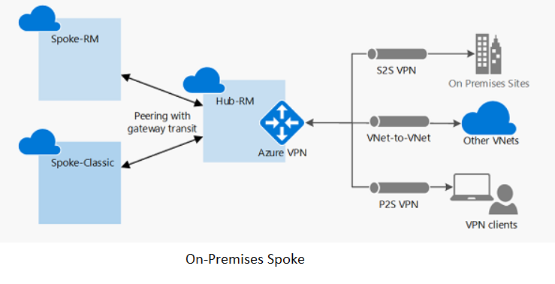

### For a site-to-site connection or an ExpressRoute connection

Follow the steps in: [Configure VPN gateway transit for virtual network peering](https://learn.microsoft.com/en-us/azure/vpn-gateway/vpn-gateway-peering-gateway-transit?toc=/azure/virtual-network/toc.json).

### For point-to-site connections

1. Follow the steps in: [Configure VPN gateway transit for virtual network peering](https://learn.microsoft.com/en-us/azure/vpn-gateway/vpn-gateway-peering-gateway-transit?toc=/azure/virtual-network/toc.json).
2. After virtual network peering is established or changed, download and reinstall the point-to-site package so that the point-to-site clients get the updated routes to the spoke virtual network.

## Configure virtual network peering with hub-spoke topology virtual network

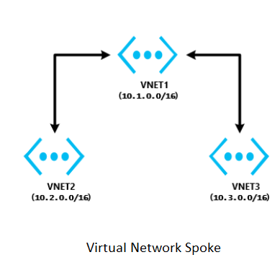

### The virtual networks are in the same region

1. In the hub virtual network, configure a network virtual appliance (NVA).
2. In the spoke virtual networks, have user-defined routes with the next hop type "network virtual appliance" applied.

### The virtual networks are in different regions

Transit over global virtual network peering is now supported. Connectivity does not work over global virtual network peering for the following resources:

* VMs behind Basic ILB SKU
* Redis cache (uses Basic ILB SKU)
* Application gateway (uses Basic ILB SKU)
* Scale sets (uses Basic ILB SKU)
* Service Fabric clusters (uses Basic ILB SKU)
* SQL Server Always On (uses Basic ILB SKU)
* App Service Environment (uses Basic ILB SKU)
* API Management (uses Basic ILB SKU)
* Microsoft Entra Domain Services (uses Basic ILB SKU)

## Troubleshoot a connectivity issue between two peered virtual networks

Sign in to the [Azure portal](https://portal.azure.com/) with an account that has the necessary [roles and permissions](https://learn.microsoft.com/en-us/azure/virtual-network/virtual-network-manage-peering#permissions). Select the virtual network, select **Peering**, and then check the **Status** field. What is the status?

### The peering status is "Connected"

To troubleshoot this issue:

1. Check the network traffic flows:

Use [Connection Troubleshoot](https://learn.microsoft.com/en-us/azure/network-watcher/network-watcher-connectivity-overview) and [IP flow verify](https://learn.microsoft.com/en-us/azure/network-watcher/network-watcher-ip-flow-verify-overview) from the source VM to the destination VM to determine whether there is an NSG or UDR that is causing interference in traffic flows.

If you're using a firewall or NVA:

1. Document the UDR parameters so that you can restore them after this step is complete.
2. Remove the UDR from the source VM subnet or NIC that points to the NVA as the next hop. Verify connectivity from the source VM directly to the destination that is bypassing the NVA. If this step doesn't work, see the [NVA troubleshooter](https://learn.microsoft.com/en-us/azure/virtual-network/virtual-network-troubleshoot-nva).
3. Take a network trace:
4. Start a network trace on the destination VM. For Windows, you can use **Netsh**. For Linux, use **TCPDump**.
5. Run **TcpPing** or **PsPing** from the source to the destination IP.

This is an example of a **TcpPing** command: tcping64.exe -t <destination VM address> 3389

1. After the **TcpPing** is complete, stop the network trace on the destination.
2. If packets arrive from the source, there is no networking issue. Examine both the VM firewall and the application listening on that port to locate the configuration issue.

Note:

You can't connect to the following resource types over global virtual network peering (virtual networks in different regions):

* VMs behind Basic ILB SKU
* Redis cache (uses Basic ILB SKU)
* Application gateway (uses Basic ILB SKU)
* Scale sets (uses Basic ILB SKU)
* Service Fabric clusters (uses Basic ILB SKU)
* SQL Server Always On (uses Basic ILB SKU)
* App Service Environment (uses Basic ILB SKU)
* API Management (uses Basic ILB SKU)
* Microsoft Entra Domain Services (uses Basic ILB SKU)

## Both the hub virtual network and the spoke virtual network do not have a VPN gateway

For site-to-site or Azure ExpressRoute connections, check the following primary causes of connectivity issues to the remote virtual network from on-premises:

* On the virtual network that has a gateway, verify that the **Allow forwarded traffic** check box is selected.
* On the virtual network that doesn't have a gateway, verify that the **Use remote gateway** check box is selected.
* Have your network administrator check your on-premises devices to verify that they all have the remote virtual network address space added.

For point-to-site connections:

* On the virtual network that has a gateway, verify that the **Allow forwarded traffic** check box is selected.
* On the virtual network that doesn't have a gateway, verify that the **Use remote gateway** check box is selected.
* Download and reinstall the point-to-site client package. Virtual network routes that are newly peered don't automatically add routes to point-to-site clients.

# Configure and validate virtual network or VPN connections

Azure VPN gateways enable flexibility in arranging almost any kind of connected virtual network topology in Azure. For example, you can connect virtual networks:

* Across regions.
* Between virtual network types (Azure Resource Manager versus classic).
* Within Azure or within an on-premises hybrid environment.
* In different subscriptions.

## Network-to-network VPN connection

Connecting a virtual network to another virtual network (network-to-network) via VPN is similar to connecting a virtual network to an on-premises site location. Both connectivity types use a VPN gateway to provide a secure tunnel through IPsec and IKE. The virtual networks can be in the same or different regions, and from the same or different subscriptions.

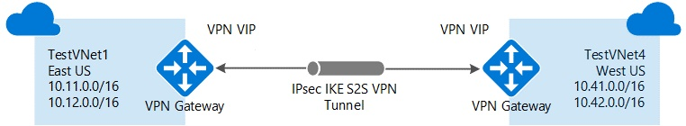

If your virtual networks are in the same region, you might want to consider connecting them by using virtual network peering. Virtual network peering doesn't use a VPN gateway. It increases throughput and decreases latency. To configure a virtual network peering connection, select **Configure and validate VNet Peering**.

If your virtual networks were created through the Azure Resource Manger deployment model, select **Configure and validate a Resource Manager VNet to a Resource Manager VNet connection** to configure a VPN connection.

If one of the virtual networks was created through the Azure classic deployment model, and the other was created through Resource Manager, select **Configure and validate a classic VNet to a Resource Manager VNet connection** to configure a VPN connection.

## Configure virtual network peering for two virtual networks in the same region

Before you start to implement and configure Azure virtual network peering, make sure that you meet the following prerequisites:

* The peered virtual networks must exist in the same Azure region.
* The peered virtual networks must have IP address spaces that don't overlap.
* Virtual network peering is between two virtual networks. There's no derived transitive relationship across peerings. For example, if VNetA is peered with VNetB, and VNetB is peered with VNetC, VNetA is *not* peered with VNetC.

To check the peering configuration, use the following method:

1. Sign in to the Azure Portal by using an account that has the necessary roles and permissions.
2. In the box that contains the text **Search resources** at the top of the portal, type **virtual networks**. When **Virtual networks** appears in the search results, select it.
3. In the **Virtual networks** blade that appears, select the virtual network for which you want to create a peering.
4. In the pane that appears for the virtual network, select **Peerings** in the **Settings** section.
5. Select a peering and view the configuration results.

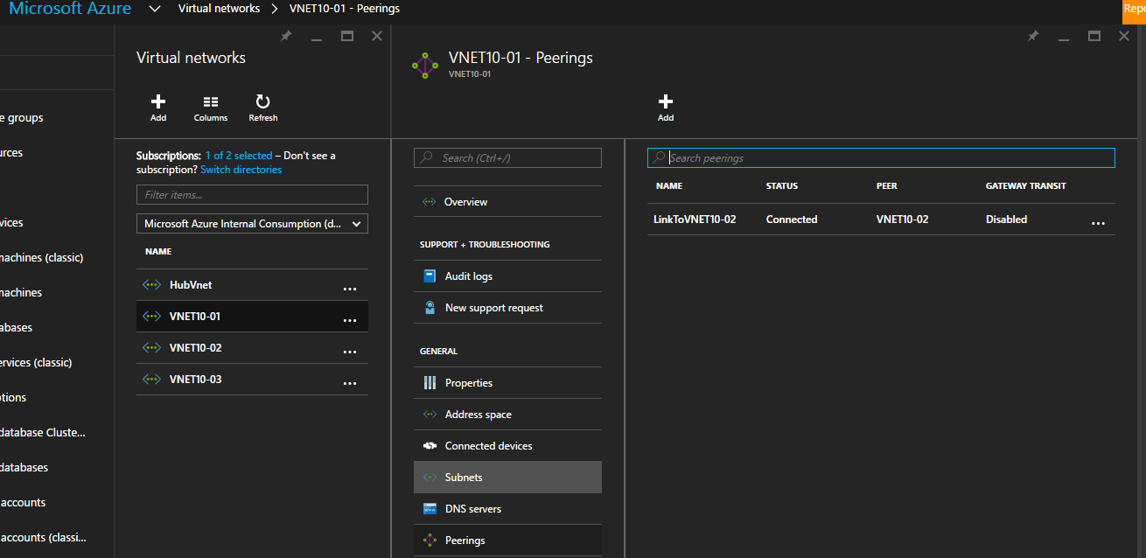

For Azure PowerShell, run the command [Get-AzureRmVirtualNetworkPeering](https://learn.microsoft.com/en-us/powershell/module/azurerm.network/get-azurermvirtualnetworkpeering) to get the virtual network peering.

## Connect a Resource Manager virtual network to another Resource Manager virtual network

You can configure a connection from one Resource Manager virtual network to another Resource Manager virtual network directly. Or you can configure the connection by using IPsec.

## Validate the VPN connection between Resource Manager virtual networks

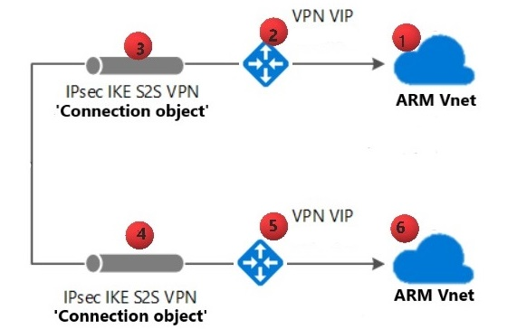

To check that your VPN connection is configured correctly, follow these instructions.

1. Make sure there are no overlapping address spaces in the connected virtual networks.
2. Verify that the address range for the Azure Resource Manager virtual network (1) is defined accurately in the **Connection object** instance (4).
3. Verify that the address range for the Azure Resource Manager virtual network (6) is defined accurately in the **Connection object** instance (3).
4. Verify that the pre-shared keys are matching on the connection objects.
5. Verify that the Azure Resource Manager virtual network gateway VIP (2) is defined accurately in the **Connection object** instance (4).
6. Verify that the Azure Resource Manager virtual network gateway VIP (5) is defined accurately in the **Connection object** instance (3).

## Connect a classic virtual network to a Resource Manager virtual network

You can create a connection between virtual networks that are in different subscriptions and in different regions. You can also connect virtual networks that already have connections to on-premises networks, as long as you have configured the gateway type as route-based.

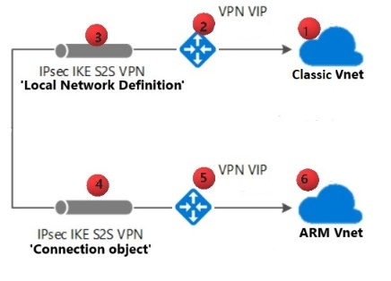

To check the configuration when you connect a classic virtual network to an Azure Resource Manager virtual network, follow these instructions.

1. Make sure there are no overlapping address spaces in the connected virtual networks.
2. Verify that the address range for the Azure Resource Manager virtual network (6) is defined accurately in the classic local network definition (3).
3. Verify that the address range for the classic virtual network (1) is defined accurately in the Azure Resource Manager **Connection object** instance (4).
4. Verify that the classic virtual network gateway VIP (2) is defined accurately in the Azure Resource Manager **Connection object** instance (4).
5. Verify that the Azure Resource Manager virtual network gateway (5) is defined accurately in the classic **Local Network Definition** instance (3).
6. Verify that the pre-shared keys are matching on both connected virtual networks:
   * Classic virtual network: **Local Network Definition** (3)
   * Azure Resource Manager virtual network: **Connection object** (4)

## Create a point-to-site VPN connection

A point-to-site (P2S in the following diagram) configuration lets you create a secure connection from an individual client computer to a virtual network. Point-to-site connections are useful when you want to connect to your virtual network from a remote location, such as from home or a conference. They're also useful when you have only a few clients that need to connect to a virtual network.

The point-to-site VPN connection is initiated from the client computer through the native Windows VPN client. Connecting clients use certificates to authenticate.

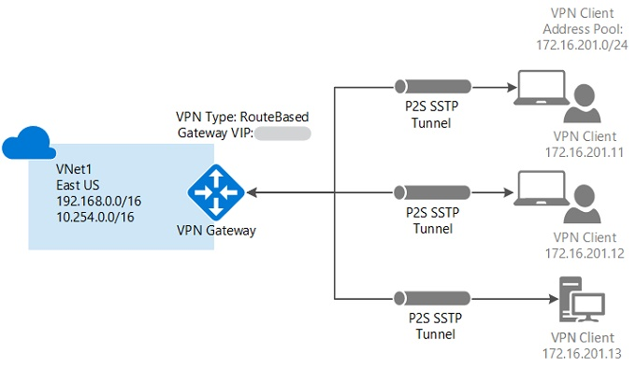

Point-to-site connections don't require a VPN device. They create the VPN connection over Secure Socket Tunneling Protocol (SSTP). You can connect a point-to-site connection to a virtual network by using various deployment tools and deployment models:

## Configure server settings for P2S VPN Gateway connections - certificate authentication - Azure portal

This article helps you configure the necessary VPN Gateway point-to-site (P2S) server settings to let you securely connect individual clients running Windows, Linux, or macOS to an Azure VNet. P2S VPN connections are useful when you want to connect to your VNet from a remote location, such as when you're telecommuting from home or a conference. You can also use P2S instead of a site-to-site (S2S) VPN when you have only a few clients that need to connect to a virtual network (VNet). P2S connections don't require a VPN device or a public-facing IP address.

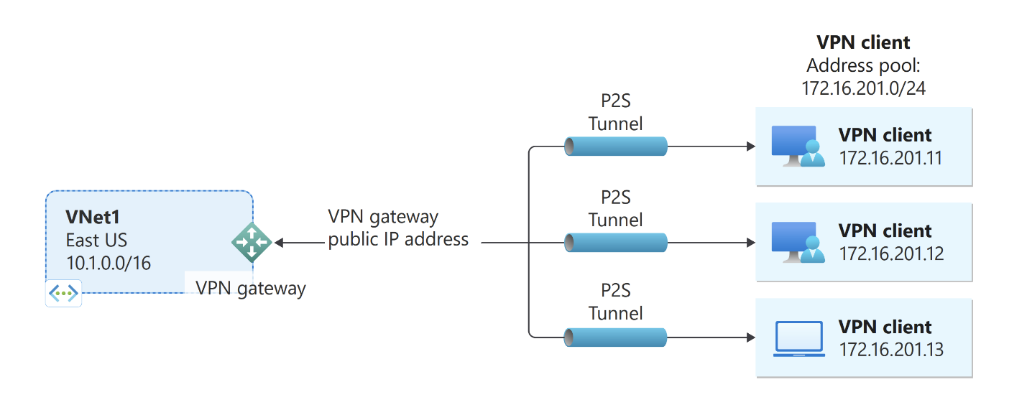

P2S Azure certificate authentication connections use the following items, which you'll configure in this exercise:

* A route-based VPN gateway (not policy-based). For more information about VPN type.
* The public key (.cer file) for a root certificate, which is uploaded to Azure. Once the certificate is uploaded, it's considered a trusted certificate and is used for authentication.
* A client certificate that is generated from the root certificate. The client certificate installed on each client computer that will connect to the VNet. This certificate is used for client authentication.
* VPN client configuration files. The VPN client is configured using VPN client configuration files. These files contain the necessary information for the client to connect to the VNet. Each client that connects must be configured using the settings in the configuration files.

**Example values**

You can use the following values to create a test environment, or refer to these values to better understand the examples in this article:

**VNet**

* **VNet Name:** VNet1
* **Address space:** 10.1.0.0/16  
  For this example, we use only one address space. You can have more than one address space for your VNet.
* **Subnet name:** FrontEnd
* **Subnet address range:** 10.1.0.0/24
* **Subscription:** If you have more than one subscription, verify that you're using the correct one.
* **Resource Group:** TestRG1
* **Location:** East US

**Virtual network gateway**

* **Virtual network gateway name:** VNet1GW
* **Gateway type:** VPN
* **VPN type:** Route-based
* **SKU:** VpnGw2
* **Generation:** Generation2
* **Gateway subnet address range:** 10.1.255.0/27
* **Public IP address name:** VNet1GWpip

**Connection type and client address pool**

* **Connection type:** Point-to-site
* **Client address pool:** 172.16.201.0/24  
  VPN clients that connect to the VNet using this point-to-site connection receive an IP address from the client address pool.

### Create a VNet

1. Sign in to the Azure portal.
2. In **Search resources, service, and docs (G+/)** at the top of the portal page, enter **virtual network**. Select **Virtual network** from the **Marketplace** search results to open the **Virtual network** page.
3. On the **Virtual network** page, select **Create** to open the **Create virtual network** page.
4. On the **Basics** tab, configure the virtual network settings for **Project details** and **Instance details**. You see a green check mark when the values you enter are validated. You can adjust the values shown in the example according to the settings that you require.

[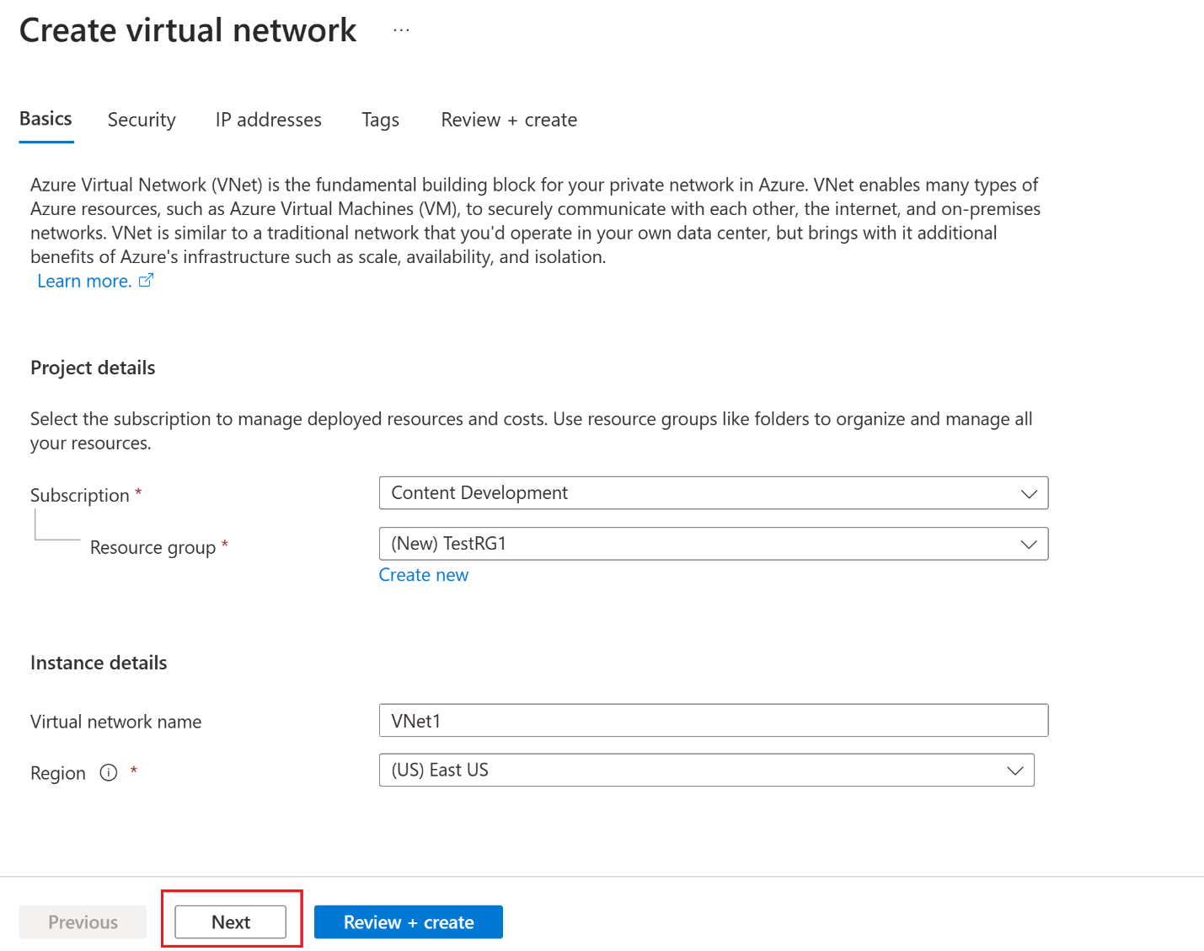](https://learn.microsoft.com/en-us/azure/includes/media/vpn-gateway-basic-vnet-rm-portal-include/basics.png#lightbox)

* + **Subscription**: Verify that the subscription listed is the correct one. You can change subscriptions by using the dropdown box.
  + **Resource group**: Select an existing resource group or select **Create new** to create a new one. For more information about resource groups.
  + **Name**: Enter the name for your virtual network.
  + **Region**: Select the location for your virtual network. The location determines where the resources that you deploy to this virtual network will reside.

1. Select **Next** or **Security** to go to the **Security** tab. For this exercise, leave the default values for all the services on this page.
2. Select **IP Addresses** to go to the **IP Addresses** tab. On the **IP Addresses** tab, configure the settings.
   * **IPv4 address space**: By default, an address space is automatically created. You can select the address space and adjust it to reflect your own values. You can also add a different address space and remove the default that was automatically created. For example, you can specify the starting address as **10.1.0.0** and specify the address space size as **/16**. Then select **Add** to add that address space.
   * **+ Add subnet**: If you use the default address space, a default subnet is created automatically. If you change the address space, add a new subnet within that address space. Select **+ Add subnet** to open the **Add subnet** window. Configure the following settings, and then select **Add** at the bottom of the page to add the values.
     + **Subnet name**: An example is **FrontEnd**.
     + **Subnet address range**: The address range for this subnet. Examples are **10.1.0.0** and **/24**.
3. Review the **IP addresses** page and remove any address spaces or subnets that you don't need.
4. Select **Review + create** to validate the virtual network settings.
5. After the settings are validated, select **Create** to create the virtual network.

### Create the VPN gateway

The virtual network gateway requires a specific subnet named **GatewaySubnet**. The gateway subnet is part of the IP address range for your virtual network and contains the IP addresses that the virtual network gateway resources and services use.

When you create the gateway subnet, you specify the number of IP addresses that the subnet contains. The number of IP addresses needed depends on the VPN gateway configuration that you want to create. Some configurations require more IP addresses than others. It's best to specify /27 or larger (/26, /25, etc.) for your gateway subnet.

If you see an error that specifies that the address space overlaps with a subnet, or that the subnet isn't contained within the address space for your virtual network, check your virtual network address range. You might not have enough IP addresses available in the address range you created for your virtual network. For example, if your default subnet encompasses the entire address range, there are no IP addresses left to create more subnets. You can either adjust your subnets within the existing address space to free up IP addresses or specify another address range and create the gateway subnet there.

1. In **Search resources, services, and docs (G+/)**, enter **virtual network gateway**. Locate **Virtual network gateway** in the **Marketplace** search results and select it to open the **Create virtual network gateway** page.
2. On the **Basics** tab, fill in the values for **Project details** and **Instance details**.

[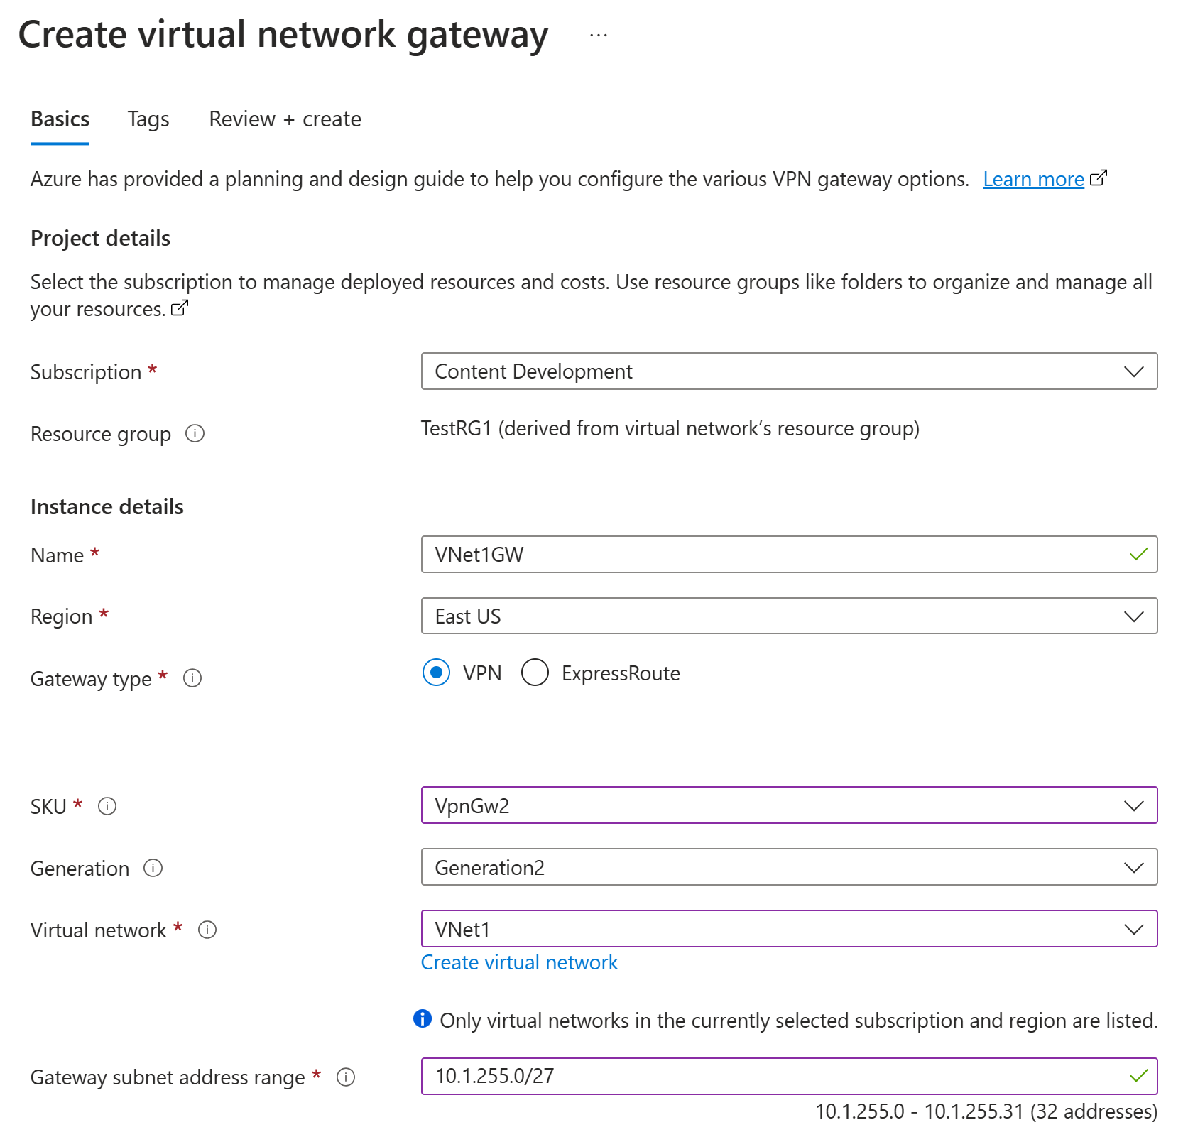](https://learn.microsoft.com/en-us/azure/includes/media/vpn-gateway-add-gw-portal/instance-details.png#lightbox)

* + **Subscription**: Select the subscription you want to use from the dropdown list.
  + **Resource group**: This setting is autofilled when you select your virtual network on this page.
  + **Name**: Name your gateway. Naming your gateway isn't the same as naming a gateway subnet. It's the name of the gateway object you're creating.
  + **Region**: Select the region in which you want to create this resource. The region for the gateway must be the same as the virtual network.
  + **Gateway type**: Select **VPN**. VPN gateways use the virtual network gateway type **VPN**.
  + **SKU**: From the dropdown list, select the gateway SKU that supports the features you want to use. See [Gateway SKUs](https://learn.microsoft.com/en-us/azure/vpn-gateway/vpn-gateway-about-vpn-gateway-settings#gwsku). In the portal, the SKUs available in the dropdown list depend on the VPN type you select. The Basic SKU can only be configured using Azure CLI or PowerShell. You can't configure the Basic SKU in the Azure portal.
  + **Generation**: Select the generation you want to use. We recommend using a Generation2 SKU.
  + **Virtual network**: From the dropdown list, select the virtual network to which you want to add this gateway. If you can't see the virtual network for which you want to create a gateway, make sure you selected the correct subscription and region in the previous settings.
  + **Gateway subnet address range** or **Subnet**: The gateway subnet is required to create a VPN gateway.

At this time, this field can show various different settings options, depending on the virtual network address space and whether you already created a subnet named **GatewaySubnet** for your virtual network.

If you don't have a gateway subnet and you don't see the option to create one on this page, go back to your virtual network and create the gateway subnet. Then, return to this page and configure the VPN gateway.

1. Specify the values for **Public IP address**. These settings specify the public IP address object that gets associated to the VPN gateway. The public IP address is assigned to this object when the VPN gateway is created. The only time the primary public IP address changes is when the gateway is deleted and re-created. It doesn't change across resizing, resetting, or other internal maintenance/upgrades of your VPN gateway.

[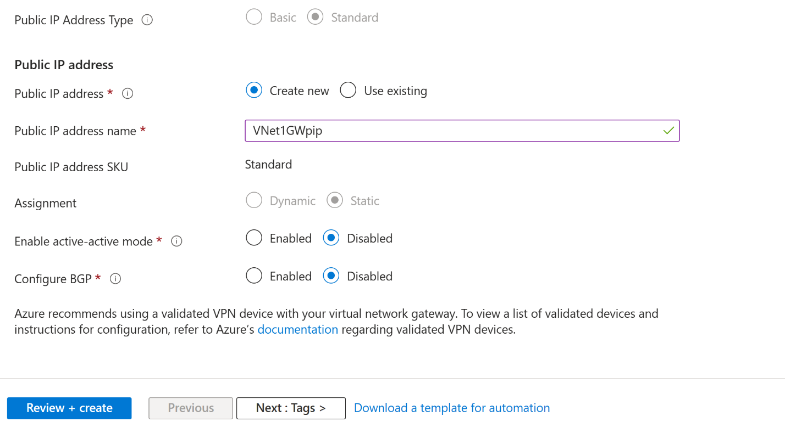](https://learn.microsoft.com/en-us/azure/includes/media/vpn-gateway-add-gw-pip-portal/pip-values.png#lightbox)

* + **Public IP address type**: If you are presented with this option, select **Standard**. The **Basic** public IP address SKU is only supported for **Basic** SKU VPN gateways.
  + **Public IP address**: Leave **Create new** selected.
  + **Public IP address name**: In the text box, enter a name for your public IP address instance.
  + **Public IP address SKU**: Setting is autoselected.
  + **Assignment**: The assignment is typically autoselected. For the Standard SKU, assignment is always Static.
  + **Enable active-active mode**: Select **Disabled**. Only enable this setting if you're creating an active-active gateway configuration.
  + **Configure BGP**: Select **Disabled**, unless your configuration specifically requires this setting. If you do require this setting, the default ASN is 65515, although this value can be changed.

1. Select **Review + create** to run validation.
2. After validation passes, select **Create** to deploy the VPN gateway.

You can see the deployment status on the **Overview** page for your gateway. After the gateway is created, you can view the IP address that has been assigned to it by looking at the VNet in the portal. The gateway appears as a connected device.

## Generate certificates

Certificates are used by Azure to authenticate clients connecting to a VNet over a point-to-site VPN connection. Once you obtain a root certificate, you [upload](https://learn.microsoft.com/en-us/azure/vpn-gateway/vpn-gateway-howto-point-to-site-resource-manager-portal#uploadfile) the public key information to Azure. The root certificate is then considered 'trusted' by Azure for connection over P2S to the VNet.

You also generate client certificates from the trusted root certificate, and then install them on each client computer. The client certificate is used to authenticate the client when it initiates a connection to the VNet.

The root certificate must be generated and extracted before you configure the point-to-site gateway settings.

## Generate a root certificate

Obtain the .cer file for the root certificate. You can use either a root certificate that was generated with an enterprise solution (recommended), or generate a self-signed certificate. After you create the root certificate, export the public certificate data (not the private key) as a Base64 encoded X.509 .cer file. You upload this file later to Azure.

* **Enterprise certificate:** If you're using an enterprise solution, you can use your existing certificate chain. Acquire the .cer file for the root certificate that you want to use.
* **Self-signed root certificate:** If you aren't using an enterprise certificate solution, create a self-signed root certificate. Otherwise, the certificates you create won't be compatible with your P2S connections and clients receive a connection error when they try to connect. You can use Azure PowerShell, MakeCert, or OpenSSL. The steps in the following articles describe how to generate a compatible self-signed root certificate:
  + [PowerShell instructions for Windows 10 or later](https://learn.microsoft.com/en-us/azure/vpn-gateway/vpn-gateway-certificates-point-to-site): These instructions require PowerShell on a computer running Windows 10 or later. Client certificates generated from the root certificate can be installed on any supported P2S client.
  + [MakeCert instructions](https://learn.microsoft.com/en-us/azure/vpn-gateway/vpn-gateway-certificates-point-to-site-makecert): Use MakeCert to generate certificates if you don't have access to a computer running Windows 10 or later. Although MakeCert is deprecated, you can still use it to generate certificates. Client certificates that you generate from the root certificate can be installed on any supported P2S client.

## Generate client certificates

Each client computer that you connect to a VNet with a point-to-site connection must have a client certificate installed. You generate it from the root certificate and install it on each client computer. If you don't install a valid client certificate, authentication will fail when the client tries to connect to the VNet.

You can either generate a unique certificate for each client or use it for multiple clients. The advantage to generating unique client certificates is the ability to revoke a single certificate. Otherwise, if multiple clients use the same client certificate to authenticate and you revoke it, you'll need to generate and install new certificates for every client that uses that certificate.

You can generate client certificates by using the following methods:

* **Enterprise certificate:**
  + If you're using an enterprise certificate solution, generate a client certificate with the common name value format [*name@yourdomain.com*](mailto:name@yourdomain.com). Use this format instead of the *domain name\username* format.
  + Make sure the client certificate is based on a user certificate template that has *Client Authentication* listed as the first item in the user list. Check the certificate by double-clicking it and viewing **Enhanced Key Usage** in the **Details** tab.
* **Self-signed root certificate:** Follow the steps in one of the following P2S certificate articles so that the client certificates you create will be compatible with your P2S connections.

When you generate a client certificate from a self-signed root certificate, it's automatically installed on the computer that you used to generate it. If you want to install a client certificate on another client computer, export it as a .pfx file, along with the entire certificate chain. Doing so will create a .pfx file that contains the root certificate information required for the client to authenticate.

The steps in these articles generate a compatible client certificate, which you can then export and distribute.

* + Windows 10 or later PowerShell instructions: These instructions require Windows 10 or later, and PowerShell to generate certificates. The generated certificates can be installed on any supported P2S client.
  + MakeCert instructions: Use MakeCert if you don't have access to a Windows 10 or later computer for generating certificates. Although MakeCert is deprecated, you can still use it to generate certificates. You can install the generated certificates on any supported P2S client.

## Add the address pool

The **Point-to-site configuration** page contains the configuration information that's needed for the P2S VPN. Once all the P2S settings have been configured and the gateway has been updated, the Point-to-site configuration page is used to view or change P2S VPN settings.

1. Go to the gateway you created in the previous section.
2. In the left pane, select Point-to-site configuration.
3. Click Configure now to open the configuration page.

The client address pool is a range of private IP addresses that you specify. The clients that connect over a point-to-site VPN dynamically receive an IP address from this range. Use a private IP address range that doesn't overlap with the on-premises location that you connect from, or the VNet that you want to connect to. If you configure multiple protocols and SSTP is one of the protocols, then the configured address pool is split between the configured protocols equally.

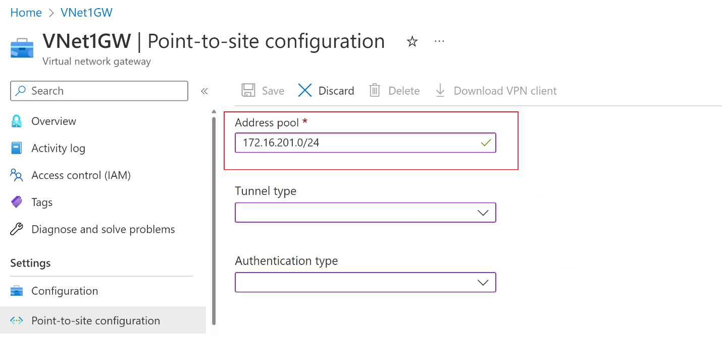

1. On the Point-to-site configuration page, in the Address pool box, add the private IP address range that you want to use. VPN clients dynamically receive an IP address from the range that you specify. The minimum subnet mask is 29 bit for active/passive and 28 bit for active/active configuration.
2. Next, configure the tunnel and authentication type.

## Specify tunnel and authentication type

**Note**

If you don't see tunnel type or authentication type on the **Point-to-site configuration** page, your gateway is using the Basic SKU. The Basic SKU doesn't support IKEv2 or RADIUS authentication. If you want to use these settings, you need to delete and re-create the gateway using a different gateway SKU.

In this section, you specify the tunnel type and the authentication type. These settings can become complex, depending on the tunnel type you require and the VPN client software that will be used to make the connection from the user's operating system. The steps in this article walk you through basic configuration settings and choices.

You can select options that contain multiple tunnel types from the dropdown - such as *IKEv2 and OpenVPN(SSL)* or *IKEv2 and SSTP (SSL)*, however, only certain combinations of tunnel types and authentication types are supported. For example, Microsoft Entra authentication can only be used when you select *OpenVPN (SSL)* from the tunnel type dropdown, and not *IKEv2 and OpenVPN(SSL)*.

Additionally, the tunnel type and the authentication type correspond to the VPN client software that can be used to connect to Azure. For example, one VPN client software application might be only able to connect via IKEv2, while another can only connect via OpenVPN. And some client software, while it supports a certain tunnel type, might not support the authentication type you choose.

As you can tell, planning the tunnel type and authentication type is important when you have various VPN clients connecting from different operating systems. Consider the following criteria when you choose your tunnel type in combination with **Azure certificate** authentication. Other authentication types have different considerations.

* **Windows**:
  + Windows computers connecting via the native VPN client already installed in the operating system try IKEv2 first and, if that doesn't connect, they fall back to SSTP (if you selected both IKEv2 and SSTP from the tunnel type dropdown).
  + If you select the OpenVPN tunnel type, you can connect using an OpenVPN Client or the Azure VPN Client.
* **macOS and iOS**:
  + The native VPN client for iOS and macOS can only use the IKEv2 tunnel type to connect to Azure.
  + The Azure VPN Client isn't supported for certificate authentication at this time, even if you select the OpenVPN tunnel type.
  + If you want to use the OpenVPN tunnel type with certificate authentication, you can use an OpenVPN client.
  + For macOS, you can use the Azure VPN Client with the OpenVPN tunnel type and Microsoft Entra ID authentication (not certificate authentication).
* **Linux**:
  + The Azure VPN Client for Linux supports the OpenVPN tunnel type.
  + The strongSwan client on Android and Linux can use only the IKEv2 tunnel type to connect.

## Tunnel type

On the **Point-to-site configuration** page, select the **Tunnel type**. For this exercise, from the dropdown, select **IKEv2 and OpenVPN(SSL)**.

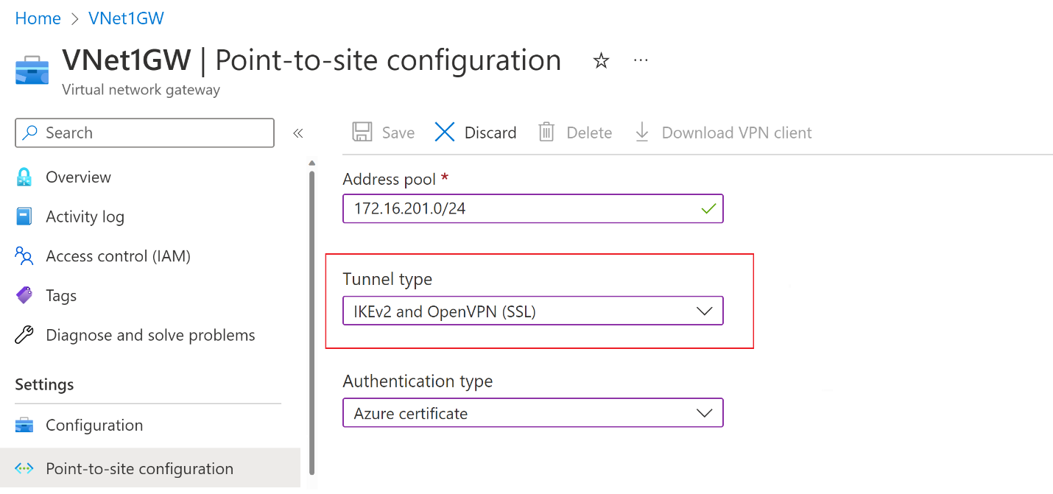

## Authentication type

For this exercise, select **Azure certificate** for the authentication type. If you're interested in other authentication types.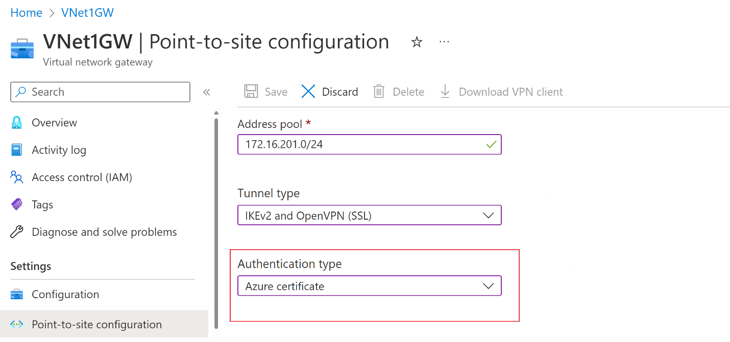

## Upload root certificate public key information

In this section, you upload public root certificate data to Azure. Once the public certificate data is uploaded, Azure can use it to authenticate clients that have installed a client certificate generated from the trusted root certificate.

1. Make sure that you exported the root certificate as a **Base-64 encoded X.509 (.CER)** file in the previous steps. You need to export the certificate in this format so you can open the certificate with text editor. You don't need to export the private key.
2. Open the certificate with a text editor, such as Notepad. When copying the certificate data, make sure that you copy the text as one continuous line without carriage returns or line feeds. You might need to modify your view in the text editor to 'Show Symbol/Show all characters' to see the carriage returns and line feeds. Copy only the following section as one continuous line:

[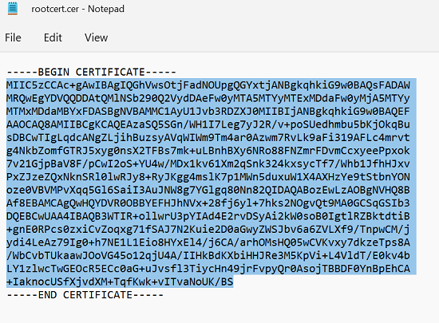](https://learn.microsoft.com/en-us/azure/vpn-gateway/media/vpn-gateway-howto-point-to-site-resource-manager-portal/notepad-root-cert-expand.png#lightbox)

1. Navigate to your **Virtual network gateway -> Point-to-site configuration** page in the **Root certificate** section. This section is only visible if you have selected **Azure certificate** for the authentication type.
2. In the **Root certificate** section, you can add up to 20 trusted root certificates.
   * Paste the certificate data into the **Public certificate data** field.
   * **Name** the certificate.

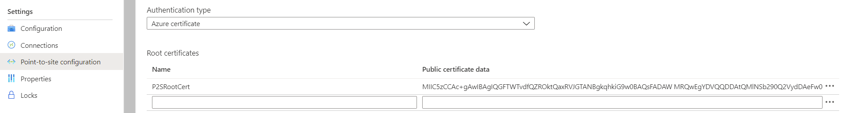

1. Additional routes aren't necessary for this exercise.
2. Select **Save** at the top of the page to save all of the configuration settings.

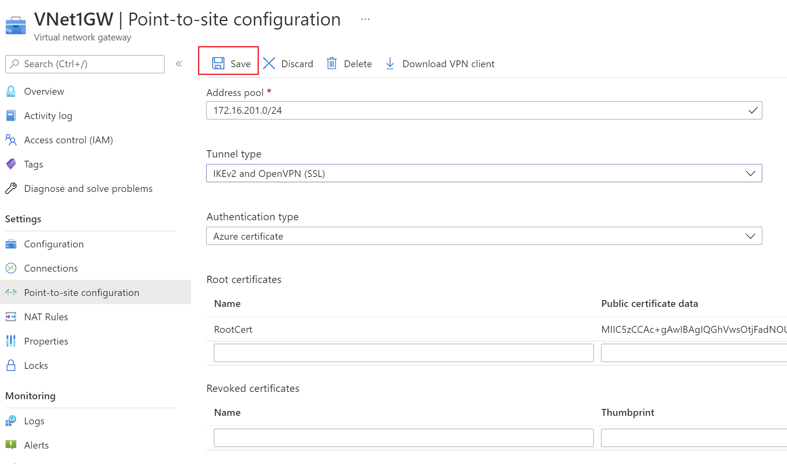

## Generate VPN client profile configuration files

All the necessary configuration settings for the VPN clients are contained in a VPN client profile configuration zip file. VPN client profile configuration files are specific to the P2S VPN gateway configuration for the VNet. If there are any changes to the P2S VPN configuration after you generate the files, such as changes to the VPN protocol type or authentication type, you need to generate new VPN client profile configuration files and apply the new configuration to all of the VPN clients that you want to connect. For more information about P2S connections.

You can generate client profile configuration files using PowerShell, or by using the Azure portal. The following examples show both methods. Either method returns the same zip file.

**Azure portal**

1. In the Azure portal, go to the virtual network gateway for the virtual network to which you want to connect.
2. On the virtual network gateway page, select **Point-to-site configuration** to open the Point-to-site configuration page.
3. At the top of the **Point-to-site configuration** page, select **Download VPN client**. This doesn't download VPN client software, it generates the configuration package used to configure VPN clients. It takes a few minutes for the client configuration package to generate. During this time, you might not see any indications until the packet generates.

[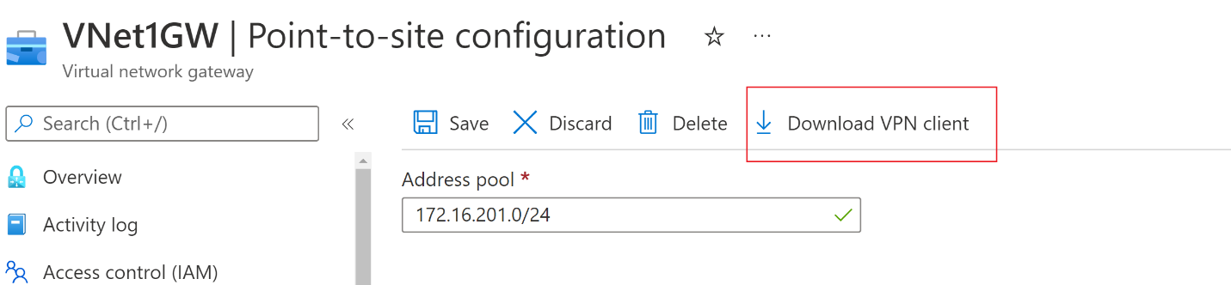](https://learn.microsoft.com/en-us/azure/includes/media/vpn-gateway-generate-profile-portal/download-configuration.png#lightbox)

1. Once the configuration package is generated, your browser indicates that a client configuration zip file is available. It's named the same name as your gateway.
2. Unzip the file to view the folders. You'll use some, or all, of these files to configure your VPN client. The files that are generated correspond to the authentication and tunnel type settings that you configured on the P2S server.

## Configure VPN clients and connect to Azure

## Verify your connection

These instructions apply to Windows clients.

1. To verify that your VPN connection is active, open an elevated command prompt, and run ipconfig/all.
2. View the results. Notice that the IP address you received is one of the addresses within the point-to-site VPN Client Address Pool that you specified in your configuration.

These instructions apply to Windows clients.

You can connect to a VM that's deployed to your virtual network by creating a Remote Desktop Connection to your VM. The best way to initially verify that you can connect to your VM is to connect by using its private IP address, rather than computer name. That way, you're testing to see if you can connect, not whether name resolution is configured properly.

1. Locate the private IP address. You can find the private IP address of a VM by either looking at the properties for the VM in the Azure portal or by using PowerShell.
   * **Azure portal**: Locate your VM in the Azure portal. View the properties for the VM. The private IP address is listed.
2. Verify that you're connected to your virtual network.
3. Open **Remote Desktop Connection** by entering **RDP** or **Remote Desktop Connection** in the search box on the taskbar. Then select **Remote Desktop Connection**. You can also open **Remote Desktop Connection** by using the mstsc command in PowerShell.
4. In **Remote Desktop Connection**, enter the private IP address of the VM. You can select **Show Options** to adjust other settings and then connect.

If you're having trouble connecting to a VM over your VPN connection, check the following points:

* Verify that your VPN connection is successful.
* Verify that you're connecting to the private IP address for the VM.
* If you can connect to the VM by using the private IP address but not the computer name, verify that you've configured DNS properly. For more information about how name resolution works for VMs

Note:

* Verify that the VPN client configuration package was generated after the DNS server IP addresses were specified for the VNet. If you updated the DNS server IP addresses, generate and install a new VPN client configuration package.
* Use 'ipconfig' to check the IPv4 address assigned to the Ethernet adapter on the computer from which you're connecting. If the IP address is within the address range of the VNet that you're connecting to, or within the address range of your VPNClientAddressPool, this is referred to as an overlapping address space. When your address space overlaps in this way, the network traffic doesn't reach Azure, it stays on the local network.

## Add or remove trusted root certificates

You can add and remove trusted root certificates from Azure. When you remove a root certificate, clients that have a certificate generated from that root won't be able to authenticate, and thus won't be able to connect. If you want a client to authenticate and connect, you need to install a new client certificate generated from a root certificate that is trusted (uploaded) to Azure.

You can add up to 20 trusted root certificate .cer files to Azure. For instructions.

To remove a trusted root certificate:

1. Navigate to the **Point-to-site configuration** page for your virtual network gateway.
2. In the **Root certificate** section of the page, locate the certificate that you want to remove.
3. Select the ellipsis next to the certificate, and then select **Remove**.

## Revoke a client certificate

You can revoke client certificates. The certificate revocation list allows you to selectively deny P2S connectivity based on individual client certificates. This is different than removing a trusted root certificate. If you remove a trusted root certificate .cer from Azure, it revokes the access for all client certificates generated/signed by the revoked root certificate. When you revoke a client certificate, rather than the root certificate, it allows the other certificates that were generated from the root certificate to continue to be used for authentication.

The common practice is to use the root certificate to manage access at team or organization levels, while using revoked client certificates for fine-grained access control on individual users.

You can revoke a client certificate by adding the thumbprint to the revocation list.

1. Retrieve the client certificate thumbprint.
2. Copy the information to a text editor and remove all spaces so that it's a continuous string.
3. Navigate to the virtual network gateway **Point-to-site-configuration** page.
4. In the **Revoked certificates** section, input a friendly name for the certificate (it doesn't have to be the certificate CN).
5. Copy and paste the thumbprint string to the **Thumbprint** field.
6. The thumbprint validates and is automatically added to the revocation list. A message appears on the screen that the list is updating.
7. After updating has completed, the certificate can no longer be used to connect. Clients that try to connect using this certificate receive a message saying that the certificate is no longer valid.

# Configure a Point-to-Site connection by using certificate authentication (classic)

You use a Point-to-Site (P2S) VPN gateway to create a secure connection to your virtual network from an individual client computer. Point-to-Site VPN connections are useful when you want to connect to your VNet from a remote location. When you have only a few clients that need to connect to a VNet, a P2S VPN is a useful solution to use instead of a Site-to-Site VPN. A P2S VPN connection is established by starting it from the client computer.

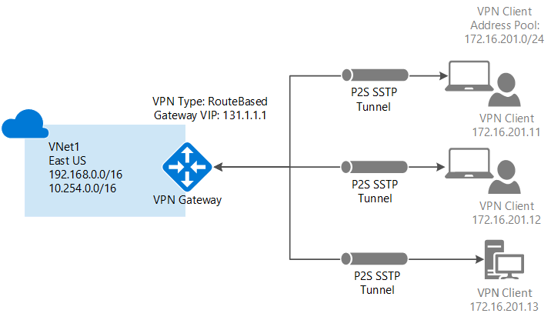

## Settings and requirements

### Requirements

Point-to-Site certificate authentication connections require the following items. There are steps in this article that will help you create them.

* A Dynamic VPN gateway.
* The public key (.cer file) for a root certificate, which is uploaded to Azure. This key is considered a trusted certificate and is used for authentication.
* A client certificate generated from the root certificate, and installed on each client computer that will connect. This certificate is used for client authentication.
* A VPN client configuration package must be generated and installed on every client computer that connects. The client configuration package configures the native VPN client that's already on the operating system with the necessary information to connect to the VNet.

Point-to-Site connections don't require a VPN device or an on-premises public-facing IP address. The VPN connection is created over SSTP (Secure Socket Tunneling Protocol). On the server side, we support SSTP versions 1.0, 1.1, and 1.2. The client decides which version to use. For Windows 8.1 and above, SSTP uses 1.2 by default.

### Example settings

Use the following values to create a test environment, or refer to these values to better understand the examples in this article:

* **Resource Group:** TestRG
* **VNet Name:** VNet1
* **Address space:** 192.168.0.0/16  
  For this example, we use only one address space. You can have more than one address space for your VNet.
* **Subnet name:** FrontEnd
* **Subnet address range:** 192.168.1.0/24
* **GatewaySubnet:** 192.168.200.0/24
* **Region:** (US) East US
* **Client address space:** 172.16.201.0/24  
  VPN clients that connect to the VNet by using this Point-to-Site connection receive an IP address from the specified pool.
* **Connection type**: Select **Point-to-site**.

## Create a virtual network

If you already have a VNet, verify that the settings are compatible with your VPN gateway design. Pay attention to subnets that might overlap with other networks.

1. From a browser, navigate to the [Azure portal](https://portal.azure.com/) and, if necessary, sign in with your Azure account.
2. Select +Create a resource. In the Search the marketplace field, type 'Virtual Network'. Locate Virtual Network from the returned list and select it to open the Virtual Network page.
3. On the Virtual Network page, under the Create button, you see "Deploy with Resource Manager (change to Classic)". Resource Manager is the default for creating a VNet. You don't want to create a Resource Manager VNet. Select (change to Classic) to create a Classic VNet. Then, select the Overview tab and select Create.
4. On the Create virtual network(classic) page, on the Basics tab, configure the VNet settings with the example values.
5. Select Review + create to validate your VNet.
6. Validation runs. After the VNet is validated, select Create.

DNS settings are not a required part of this configuration, but DNS is necessary if you want name resolution between your VMs. Specifying a value does not create a new DNS server. The DNS server IP address that you specify should be a DNS server that can resolve the names for the resources you are connecting to.

After you create your virtual network, you can add the IP address of a DNS server to handle name resolution. Open the settings for your virtual network, select DNS servers, and add the IP address of the DNS server that you want to use for name resolution.

1. Locate the virtual network in the portal.
2. On the page for your virtual network, under the Settings section, select DNS servers.
3. Add a DNS server.
4. To save your settings, select Save at the top of the page.

## Create a VPN gateway

1. Navigate to the VNet that you created.
2. On the VNet page, under Settings, select Gateway. On the Gateway page, you can view the gateway for your virtual network. This virtual network doesn't yet have a gateway. Click the note that says Click here to add a connection and a gateway.
3. On the Configure a VPN connection and gateway page, select the following settings:
   * Connection type: Point-to-site
   * Client address space: Add the IP address range from which the VPN clients receive an IP address when connecting. Use a private IP address range that doesn't overlap with the on-premises location that you connect from, or with the VNet that you connect to.
4. Leave the checkbox for Do not configure a gateway at this time unselected. We will create a gateway.
5. At the bottom of the page, select Next: Gateway >.
6. On the Gateway tab, select the following values:
   * **Size:** The size is the gateway SKU for your virtual network gateway. In the Azure portal, the default SKU is **Default**. For more information about gateway SKUs, see [About VPN gateway settings](https://learn.microsoft.com/en-us/azure/vpn-gateway/vpn-gateway-about-vpn-gateway-settings#gwsku).
   * **Routing Type:** You must select **Dynamic** for a point-to-site configuration. Static routing won't work.
   * **Gateway subnet:** This field is already autofilled. You can't change the name. If you try to change the name using PowerShell or any other means, the gateway won't work properly.
   * **Address range (CIDR block):** While it's possible to create a gateway subnet as small as /29, we recommend that you create a larger subnet that includes more addresses by selecting at least /28 or /27. Doing so will allow for enough addresses to accommodate possible additional configurations that you might want in the future. When working with gateway subnets, avoid associating a network security group (NSG) to the gateway subnet. Associating a network security group to this subnet might cause your VPN gateway to not function as expected.
7. Select Review + create to validate your settings.
8. Once validation passes, select Create. A VPN gateway can take up to 45 minutes to complete, depending on the gateway SKU that you select.

## Create certificates

Azure uses certificates to authenticate VPN clients for Point-to-Site VPNs. You upload the public key information of the root certificate to Azure. The public key is then considered *trusted*. Client certificates must be generated from the trusted root certificate, and then installed on each client computer in the Certificates-Current User\Personal\Certificates certificate store. The certificate is used to authenticate the client when it connects to the VNet.

It's important to follow the steps in these instructions when you use self-signed root certificates and generate client certificates from the self-signed root certificate. Otherwise, the certificates you create won't be compatible with P2S connections and you'll receive a connection error.

### Acquire the public key (.cer) for the root certificate

Obtain the .cer file for the root certificate. You can use either a root certificate that was generated with an enterprise solution (recommended), or generate a self-signed certificate. After you create the root certificate, export the public certificate data (not the private key) as a Base64 encoded X.509 .cer file. You upload this file later to Azure.

* **Enterprise certificate:** If you're using an enterprise solution, you can use your existing certificate chain. Acquire the .cer file for the root certificate that you want to use.
* **Self-signed root certificate:** If you aren't using an enterprise certificate solution, create a self-signed root certificate. Otherwise, the certificates you create won't be compatible with your P2S connections and clients receive a connection error when they try to connect. You can use Azure PowerShell, MakeCert, or OpenSSL. The steps in the following articles describe how to generate a compatible self-signed root certificate:
  + [PowerShell instructions for Windows 10 or later](https://learn.microsoft.com/en-us/azure/vpn-gateway/vpn-gateway-certificates-point-to-site): These instructions require PowerShell on a computer running Windows 10 or later. Client certificates generated from the root certificate can be installed on any supported P2S client.
  + [MakeCert instructions](https://learn.microsoft.com/en-us/azure/vpn-gateway/vpn-gateway-certificates-point-to-site-makecert): Use MakeCert to generate certificates if you don't have access to a computer running Windows 10 or later. Although MakeCert is deprecated, you can still use it to generate certificates. Client certificates that you generate from the root certificate can be installed on any supported P2S client.
  + [Linux - OpenSSL instructions](https://learn.microsoft.com/en-us/azure/vpn-gateway/point-to-site-certificates-linux-openssl)
  + [Linux - strongSwan instructions](https://learn.microsoft.com/en-us/azure/vpn-gateway/vpn-gateway-certificates-point-to-site-linux)

### Generate a client certificate

Each client computer that you connect to a VNet with a point-to-site connection must have a client certificate installed. You generate it from the root certificate and install it on each client computer. If you don't install a valid client certificate, authentication will fail when the client tries to connect to the VNet.

You can either generate a unique certificate for each client or use it for multiple clients. The advantage to generating unique client certificates is the ability to revoke a single certificate. Otherwise, if multiple clients use the same client certificate to authenticate and you revoke it, you'll need to generate and install new certificates for every client that uses that certificate.

You can generate client certificates by using the following methods:

* **Enterprise certificate:**
  + If you're using an enterprise certificate solution, generate a client certificate with the common name value format [*name@yourdomain.com*](mailto:name@yourdomain.com). Use this format instead of the *domain name\username* format.
  + Make sure the client certificate is based on a user certificate template that has *Client Authentication* listed as the first item in the user list. Check the certificate by double-clicking it and viewing **Enhanced Key Usage** in the **Details** tab.
* **Self-signed root certificate:** Follow the steps in one of the following P2S certificate articles so that the client certificates you create will be compatible with your P2S connections.

When you generate a client certificate from a self-signed root certificate, it's automatically installed on the computer that you used to generate it. If you want to install a client certificate on another client computer, export it as a .pfx file, along with the entire certificate chain. Doing so will create a .pfx file that contains the root certificate information required for the client to authenticate.

The steps in these articles generate a compatible client certificate, which you can then export and distribute.

* + [Windows 10 or later PowerShell instructions](https://learn.microsoft.com/en-us/azure/vpn-gateway/vpn-gateway-certificates-point-to-site#clientcert): These instructions require Windows 10 or later, and PowerShell to generate certificates. The generated certificates can be installed on any supported P2S client.
  + [MakeCert instructions](https://learn.microsoft.com/en-us/azure/vpn-gateway/vpn-gateway-certificates-point-to-site-makecert): Use MakeCert if you don't have access to a Windows 10 or later computer for generating certificates. Although MakeCert is deprecated, you can still use it to generate certificates. You can install the generated certificates on any supported P2S client.

# Azure DNS troubleshooting

## can't create a DNS zone

To resolve common issues, try one or more of the following steps:

1. Review the Azure DNS audit logs to determine the failure reason.
2. Each DNS zone name must be unique within its resource group. That is, two DNS zones with the same name can't share a resource group. Try using a different zone name, or a different resource group.
3. You may see an error "You have reached or exceeded the maximum number of zones in subscription {subscription ID}." Either use a different Azure subscription, delete some zones, or contact Azure Support to raise your subscription limit.
4. You may see an error "The zone '{zone name}' is not available." This error means that Azure DNS was unable to allocate name servers for this DNS zone. Try using a different zone name. Or, if you are the domain name owner you can contact Azure support to allocate name servers for you.

## can't create a DNS record

To resolve common issues, try one or more of the following steps:

1. Review the Azure DNS audit logs to determine the failure reason.
2. Does the record set exist already? Azure DNS manages records using record *sets*, which are the collection of records of the same name and the same type. If a record with the same name and type already exists, then to add another such record you should edit the existing record set.
3. Are you trying to create a record at the DNS zone apex (the ‘root’ of the zone)? If so, the DNS convention is to use the ‘@’ character as the record name. Also note that the DNS standards don't permit CNAME records at the zone apex.
4. Do you have a CNAME conflict? The DNS standards don't allow a CNAME record with the same name as a record of any other type. If you have an existing CNAME, creating a record with the same name of a different type fails. Likewise, creating a CNAME fails if the name matches an existing record of a different type. Remove the conflict by removing the other record or choosing a different record name.
5. Have you reached the limit on the number of record sets permitted in a DNS zone? The current number of record sets and the maximum number of record sets are shown in the Azure portal, under the 'Properties' for the zone. If you've reached this limit, then either delete some record sets or contact Azure Support to raise your record set limit for this zone, then try again.

## can't resolve my DNS record

DNS name resolution is a multi-step process, which can fail for many reasons. The following steps help you investigate why DNS resolution is failing for a DNS record in a zone hosted in Azure DNS.

1. Confirm that the DNS records are configured correctly in Azure DNS. Review the DNS records in the Azure portal, checking that the zone name, record name, and record type are correct.
2. Confirm that the DNS records resolve correctly on the Azure DNS name servers.
   * If you make DNS queries from your local PC, you may see cached results that don’t reflect the current state of the name servers. Also, corporate networks often use DNS proxy servers, which prevent DNS queries from being directed to specific name servers. To avoid these problems, use a web-based name resolution service.
   * Be sure to specify the correct name servers for your DNS zone, as shown in the Azure portal.
   * Check that the DNS name is correct (you have to specify the fully qualified name, including the zone name) and the record type is correct
3. Confirm that the DNS domain name is correctly [delegated to the Azure DNS name servers](https://learn.microsoft.com/en-us/azure/dns/dns-domain-delegation) There are a [many 3rd-party web sites that offer DNS delegation validation](https://www.bing.com/search?q=dns+check+tool). This test is a zone delegation test, so you should only enter the DNS zone name and not the fully qualified record name.
4. Having completed the above, your DNS record should now resolve correctly, this time using the default name server settings.

# DNS zone status and unhealthy delegation scenarios

DNS zone status indicates the current status of the zone. DNS zone status can be **Unknown**, **Available**, and **Degraded**.

## Unknown

When a resource is newly created, health signals for these new resources aren't available immediately. A maximum of 24 hours may pass to get the correct health signals for DNS zones. Until this time, the health of the DNS zones will be shown as **Unknown**.

When resource health check hasn't received information about DNS zones for more than 6 hours, the zones are marked Unknown. Although this status isn't a definitive indication of the state of the resource, it's an important data point in the troubleshooting process. Once the signal is received and the resource is running as expected, the status of the resource will change to **Available** after a few minutes.

The following screenshot is an example of the resource health check message.

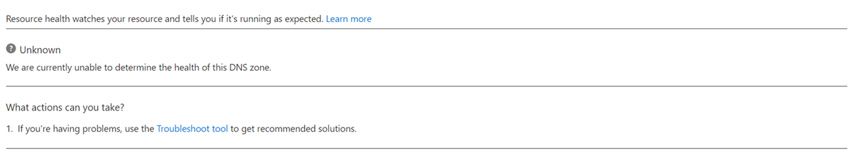

## Available

An **Available** status indicates that the resource health check hasn't detected a delegation issue with your DNS zones. This status means that NS delegation records are appropriately maintained in your primary zone and records meant for child zones aren't present in your primary zone.

The following screenshot is an example of the resource health check message.

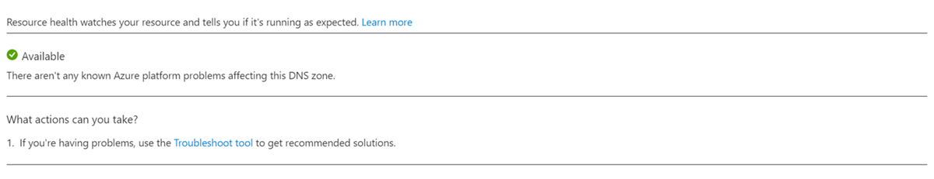

## Degraded

A **Degraded** status indicates that the resource health check has detected a delegation issue with your DNS zones. Correct the delegation configuration and wait 24 hours for the status to change to **Available**.

The following screenshot is an example of the resource health check message.

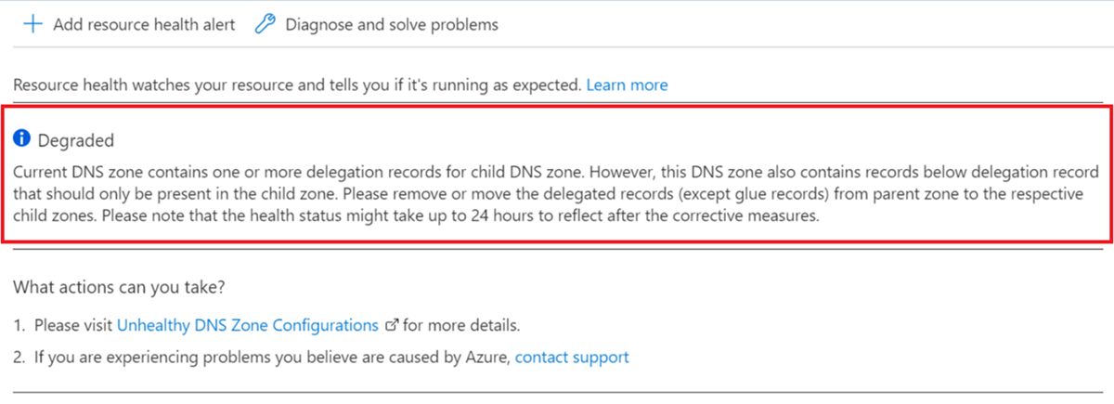

If 24 hours have elapsed after correcting the configuration and the DNS zones are still degraded, contact support.

## Configuration error scenario

The following scenario demonstrates where a configuration error has led to the unhealthy state of the DNS zones.

### Unhealthy Delegation

A primary zone contains NS delegation records, which help delegate traffic from the primary to the child zones. If any NS delegation record is present in the parent zone, the DNS server is supposed to mask all other records below the NS delegation record (except glue records) and direct traffic to the respective child zone based on the user query. If a parent zone contains other records meant for the child zones (delegated zones) below the NS delegation record, the zone will be marked unhealthy and its status is **Degraded**.

**What are glue records?** - These are records under the delegation record, which help direct traffic to the delegated/child zones using their IP addresses and are configured as seen in the following.

|  |  |
| --- | --- |
| **Setting** | **Value** |
| **Zone** | contoso.com |
| **Delegation record** | Child NS ns1.child.contoso.com |
| **Glue record** | ns1.child A 1.1.1.1 |

#### Example of an unhealthy zone

The following is an example of a zone containing records below NS delegation.

* Zone Name: contoso.com

|  |  |  |  |
| --- | --- | --- | --- |
| **Name** | **Type** | **TTL** | **Value** |
| @ | NS | 3600 | ns1-04.azure-dns.com. |
| @ | SOA | 3600 | *SOA values* |
| * | A | 3600 | 255.255.255.255 |
| **child** | **NS** | **3600** | **ns1-08.azure-dns.com** (NS delegation record) |
| ***foo.child*** | ***A*** | ***3600*** | ***10.10.10.10*** |
| ***txt.child*** | ***TXT*** | ***3600*** | ***"text record"*** |
| abc.test | A | 3600 | 5.5.5.5 |

In the preceding example, **child** is the NS delegation records. The records ***foo.child*** and ***txt.child*** are records that should only be present in the child zone, **child.contoso.com**. These records might cause inconsistencies if they aren't removed from the parent zone, **contoso.com**. These inconsistencies could cause the zone to be considered as unhealthy with a **Degraded** status.

#### Examples of when a zone is considered healthy or unhealthy

|  |  |
| --- | --- |
| **Example** | **Status** |
| Zone doesn't contain NS delegation records, glue records, and other records. | **Healthy** |
| Zone only contains NS delegation records. | **Healthy** |
| Zone only contains NS delegation records and glue records. | **Healthy** |
| Zone contains NS delegation records and other records (except glue records) below delegation record, that should be present in the child zone. | **Unhealthy** |
| Zone contains NS delegation Records, glue records, and other records (except glue records). | **Unhealthy** |

**How can you fix it?** - To resolve, locate and remove all records except glue records under NS delegation records in your parent zone.

**How to locate unhealthy delegation records?** - A script is provided to find the unhealthy delegation records in your zone. The script will report records, which are unhealthy.

1. Save the script located at: Find unhealthy DNS records in Azure DNS - PowerShell script sample
2. Execute the script as mentioned in the script editor. Script can be edited to meet your requirements.

**Historical information** - You can access up to 14 days of health history in the health history section of resource health. This section will also contain the reason for the downtime (when available) for the downtimes reported by resource health. Currently, Azure shows the downtime for your DNS zones resource at a 24-hour granularity.

## How do I specify the ‘service’ and ‘protocol’ for an SRV record?

Azure DNS manages DNS records as record sets—the collection of records with the same name and the same type. For an SRV record set, the 'service' and 'protocol' need to be specified as part of the record set name. The other SRV parameters ('priority', 'weight', 'port' and 'target') are specified separately for each record in the record set.

Example SRV record names (service name 'sip', protocol 'tcp'):

* _sip._tcp (creates a record set at the zone apex)
* _sip._tcp.sipservice (creates a record set named 'sipservice')

# Use Azure DNS to provide custom domain settings for an Azure service

Azure DNS provides naming resolution for any of your Azure resources that support custom domains or that have a fully qualified domain name (FQDN). For example, you have an Azure web app you want your users to access using contoso.com or www.contoso.com as the FQDN. This article walks you through configuring your Azure service with Azure DNS for using custom domains.

## Azure Function App

To configure a custom domain for Azure function apps, a CNAME record is created and configured on the function app itself.

1. Navigate to Function App and select your function app. Select Custom domains under Settings. Note the current url under assigned custom domains, this address is used as the alias for the DNS record created.

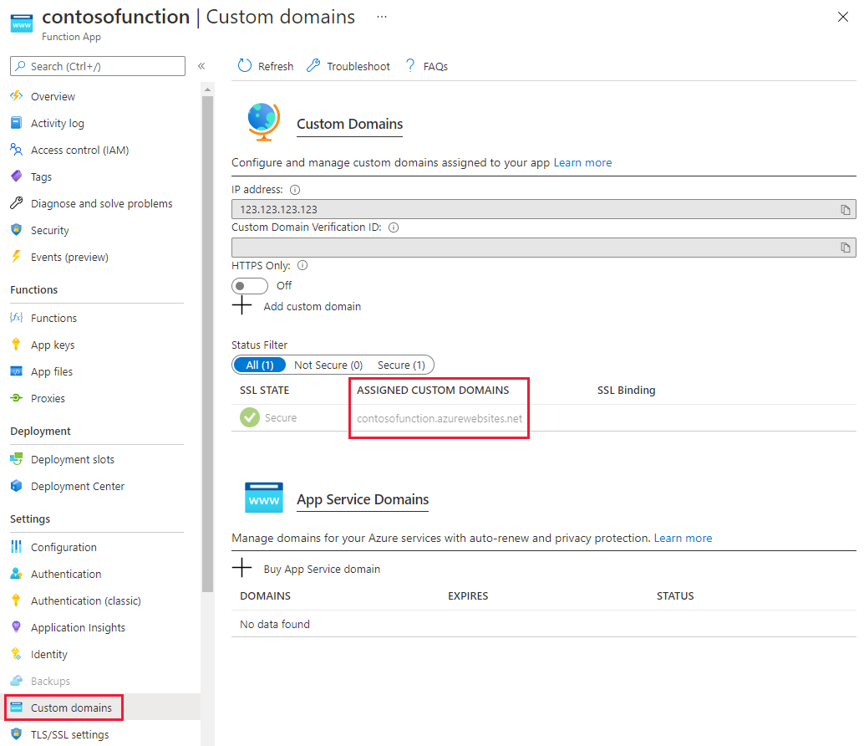

1. Navigate to your DNS Zone and select + Record set. Enter the following information on the Add record set page and select OK to create it.

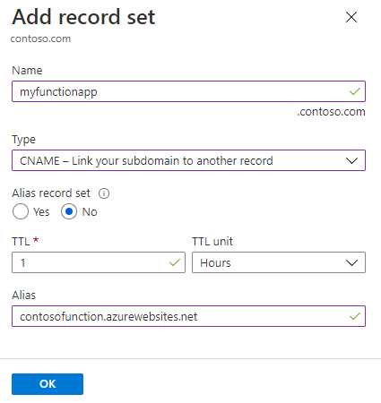

|  |  |  |
| --- | --- | --- |
| **Property** | **Value** | **Description** |
| Name | myfunctionapp | This value along with the domain name label is the FQDN for the custom domain name. |
| Type | CNAME | Use a CNAME record is using an alias. |
| TTL | 1 | 1 is used for 1 hour |
| TTL unit | Hours | Hours are used as the time measurement |
| Alias | contosofunction.azurewebsites.net | The DNS name you're creating the alias for, in this example it's the contosofunction.azurewebsites.net DNS name provided by default to the function app. |

1. Navigate back to your function app, select **Custom domains** under *Settings*. Then select **+ Add custom domain**.

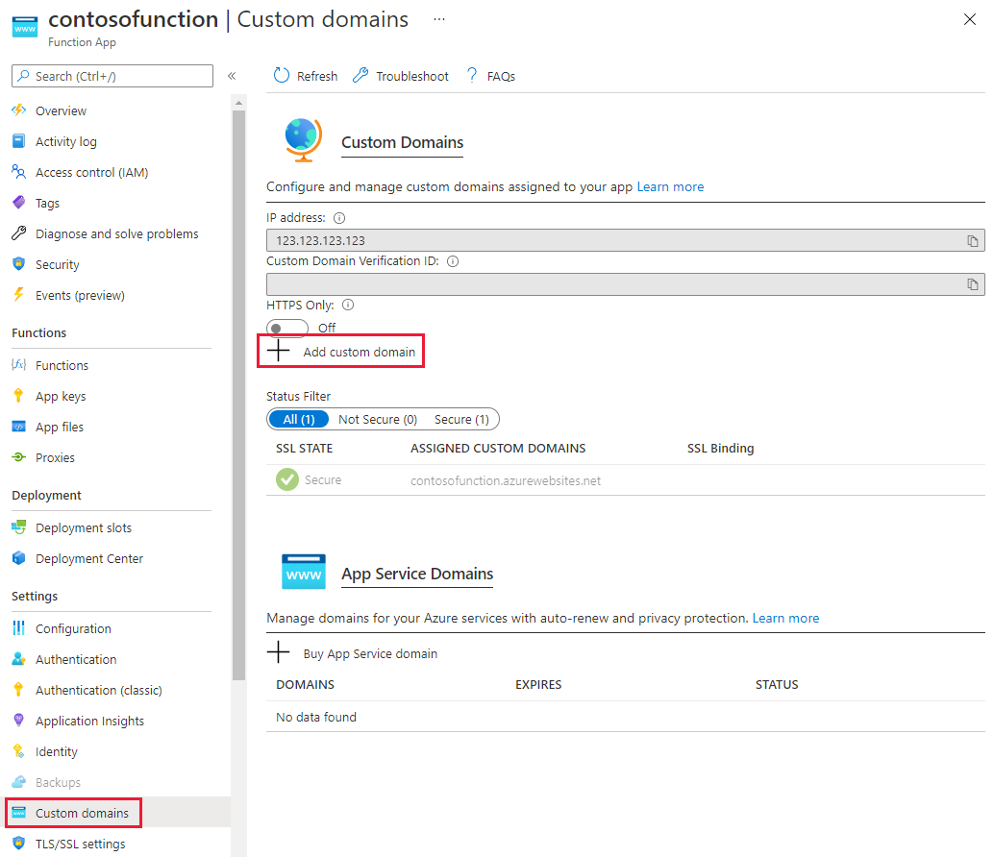

1. On the **Add custom domain** page, enter the CNAME record in the **Custom domain** text field and select **Validate**. If the record is found, the **Add custom domain** button appears. Select **Add custom domain** to add the alias.

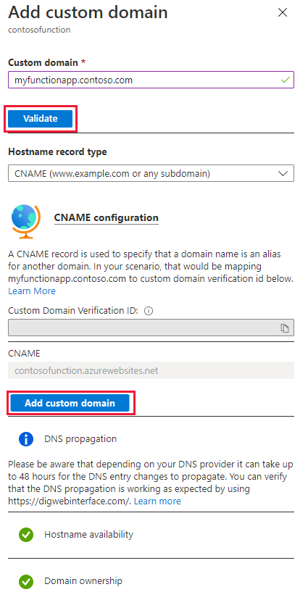

## Public IP address

To configure a custom domain for services that use a public IP address resource such as Application Gateway, Load Balancer, Cloud Service, Resource Manager VMs, and, Classic VMs, an A record is used.

1. Navigate to the Public IP resource and select Configuration. Note the IP address shown.

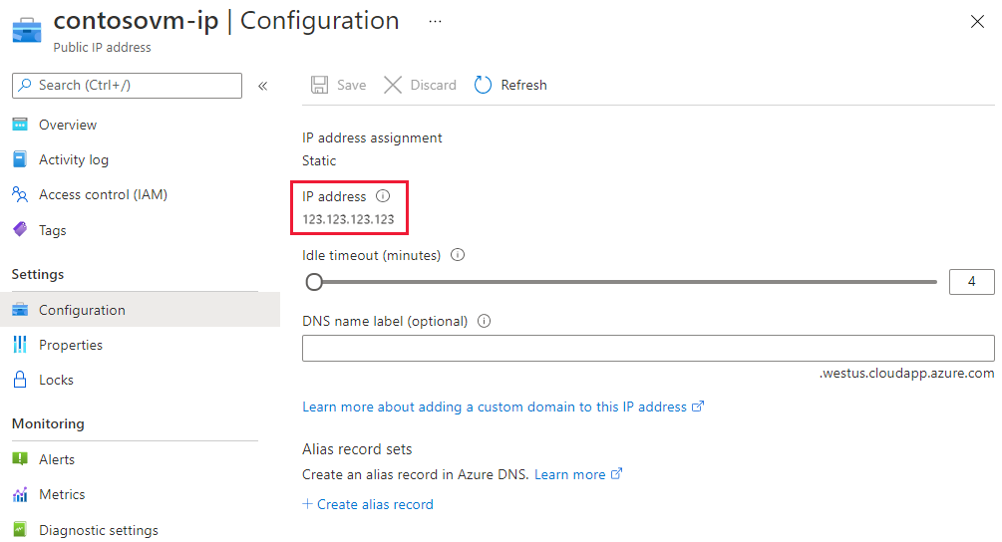

1. Navigate to your DNS Zone and select + Record set. Enter the following information on the Add record set page and select OK to create it.

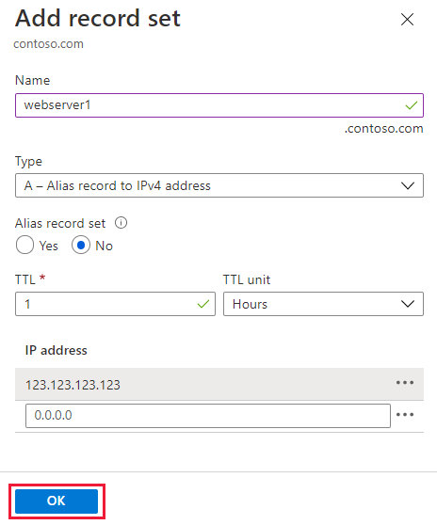

|  |  |  |
| --- | --- | --- |
| **Property** | **Value** | **Description** |
| Name | webserver1 | This value along with the domain name label is the FQDN for the custom domain name. |
| Type | A | Use an A record as the resource is an IP address. |
| TTL | 1 | 1 is used for 1 hour |
| TTL unit | Hours | Hours are used as the time measurement |
| IP Address | <your ip address> | The public IP address. |

1. Once the A record is created, run nslookup to validate the record resolves.

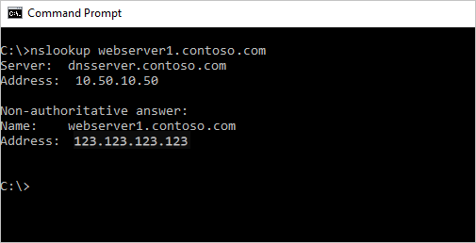

# Name resolution for resources in Azure virtual networks

Azure provided name resolution provides only basic authoritative DNS capabilities. Azure manages the DNS zone names and records if you use the DNS provided by Azure. You aren't able to control the DNS zone names or the life cycle of DNS records.

Along with resolution of public DNS names, Azure provides internal name resolution for VMs and role instances that reside within the same virtual network or cloud service. VMs and instances in a cloud service share the same DNS suffix, so the host name alone is sufficient. But in virtual networks deployed using the classic deployment model, different cloud services have different DNS suffixes. In this situation, you need the FQDN to resolve names between different cloud services. In virtual networks deployed using the Azure Resource Manager deployment model, the DNS suffix is consistent across the all virtual machines within a virtual network, so the FQDN isn't needed. DNS names can be assigned to both VMs and network interfaces. Although Azure-provided name resolution doesn't require any configuration, it's not the appropriate choice for all deployment scenarios, as detailed in the previous table.

## Features

Azure-provided name resolution includes the following features:

* Ease of use. No configuration is required.
* High availability. You don't need to create and manage clusters of your own DNS servers.
* You can use the service with your own DNS servers, to resolve both on-premises and Azure host names.
* You can use name resolution between VMs and role instances within the same cloud service, without the need for an FQDN.
* You can use name resolution between VMs in virtual networks that use the Azure Resource Manager deployment model, without need for an FQDN. Virtual networks in the classic deployment model require an FQDN when you're resolving names in different cloud services.
* You can use host names that best describe your deployments, rather than working with autogenerated names.

## Considerations

Points to consider when you're using Azure-provided name resolution:

* The Azure-created DNS suffix can't be modified.
* DNS lookup is scoped to a virtual network. DNS names created for one virtual network can't be resolved from other virtual networks.
* You can't manually register your own records.
* WINS and NetBIOS aren't supported. You can't see your VMs in Windows Explorer.
* Host names must be DNS-compatible. Names must use only 0-9, a-z, and '-', and can't start or end with a '-'.
* DNS query traffic is throttled for each VM. Throttling shouldn't affect most applications. If request throttling is observed, ensure that client-side caching is enabled. For more information.
* Use a different name for each virtual machine in a virtual network to avoid DNS resolution issues.
* Only VMs in the first 180 cloud services are registered for each virtual network in a classic deployment model. This limit doesn't apply to virtual networks in Azure Resource Manager.
* The Azure DNS IP address is 168.63.129.16. This address is a static IP address and doesn't change.

C:\>nslookup -type=ptr 10.11.0.4

Server: UnKnown

Address: 168.63.129.16

Non-authoritative answer:

4.0.11.10.in-addr.arpa name = myeastspokevm1.internal.cloudapp.net

The **internal.cloudapp.net** reverse DNS zone is Azure-managed and can't be directly viewed or edited. Forward lookup on the FQDN of form **[vmname].internal.cloudapp.net** resolves to the IP address assigned to the virtual machine.

If an [Azure DNS private zone](https://learn.microsoft.com/en-us/azure/dns/private-dns-overview) is linked to the virtual network with a [virtual network link](https://learn.microsoft.com/en-us/azure/dns/private-dns-virtual-network-links) and [autoregistration](https://learn.microsoft.com/en-us/azure/dns/private-dns-autoregistration) is enabled on that link, then reverse DNS queries return two records. One record is of the form **[vmname].[privatednszonename]** and the other is of the form **[vmname].internal.cloudapp.net**. See the following example:

C:\>nslookup -type=ptr 10.20.2.4

Server: UnKnown

Address: 168.63.129.16

Non-authoritative answer:

4.2.20.10.in-addr.arpa name = mywestvm1.internal.cloudapp.net

4.2.20.10.in-addr.arpa name = mywestvm1.azure.contoso.com

When two PTR records are returned as shown previously, then forward lookup of either FQDN returns the IP address of the VM.

Reverse DNS lookups are scoped to a given virtual network, even if it's peered to other virtual networks. Reverse DNS queries for IP addresses of virtual machines located in peered virtual networks return **NXDOMAIN**.

Note

Reverse DNS (PTR) records are not stored in a forward private DNS zone. Reverse DNS records are stored in a reverse DNS (in-addr.arpa) zone. The default reverse DNS zone associated with a vnet isn't viewable or editable.

You can disable the reverse DNS function in a virtual network by creating your own reverse lookup zone using [Azure DNS private zones](https://learn.microsoft.com/en-us/azure/dns/private-dns-overview), and then linking this zone to your virtual network. For example, if the IP address space of your virtual network is 10.20.0.0/16, then you can create an empty private DNS zone **20.10.in-addr.arpa** and link it to the virtual network. This zone overrides the default reverse lookup zones for the virtual network. This zone is empty. Reverse DNS returns **NXDOMAIN** unless you manually create these entries.

## DNS client configuration

This section covers client-side caching and client-side retries.

### Client-side caching

Not every DNS query needs to be sent across the network. Client-side caching helps reduce latency and improve resilience to network blips, by resolving recurring DNS queries from a local cache. DNS records contain a time-to-live (TTL) mechanism, which allows the cache to store the record for as long as possible without impacting record freshness. Thus, client-side caching is suitable for most situations.

The default Windows DNS client has a DNS cache built-in. Some Linux distributions don't include caching by default. If you find that there isn't a local cache already, add a DNS cache to each Linux VM.

There are many different DNS caching packages available (such as dnsmasq). Here's how to install dnsmasq on the most common distributions:

There are many different DNS caching packages available (such as dnsmasq). Here's how to install dnsmasq on the most common distributions:

* [RHEL, CentOS](https://learn.microsoft.com/en-us/azure/virtual-network/virtual-networks-name-resolution-for-vms-and-role-instances#tabpanel_1_redhat)
* [openSUSE, SLES](https://learn.microsoft.com/en-us/azure/virtual-network/virtual-networks-name-resolution-for-vms-and-role-instances#tabpanel_1_suse)
* [Ubuntu, Debian](https://learn.microsoft.com/en-us/azure/virtual-network/virtual-networks-name-resolution-for-vms-and-role-instances#tabpanel_1_ubuntu)

**RHEL/zCentOS (uses NetworkManager)**:

1. Install the dnsmasq package with the following command:
2. sudo yum install dnsmasq
3. Enable the dnsmasq service with the following command:
4. systemctl enable dnsmasq.service
5. Start the dnsmasq service with the following command:
6. systemctl start dnsmasq.service
7. Use a text editor to add **prepend domain-name-servers 127.0.0.1;** to **/etc/dhclient-eth0.conf**:
8. Use the following command to restart the network service:
9. service network restart

Note

The dnsmasq package is only one of many DNS caches available for Linux. Before using it, check its suitability for your particular needs, and check that no other cache is installed.

### Client-side retries

DNS is primarily a UDP protocol. Because the UDP protocol doesn't guarantee message delivery, retry logic is handled in the DNS protocol itself. Each DNS client (operating system) can exhibit different retry logic, depending on the creator's preference:

* Windows operating systems retry after one second, and then again after another two seconds, four seconds, and another four seconds.
* The default Linux setup retries after five seconds. We recommend changing the retry specifications to five times, at one-second intervals.

Check the current settings on a Linux VM with cat /etc/resolv.conf. Look at the options line, for example:

options timeout:1 attempts:5

The resolv.conf file is autogenerated, and shouldn't be edited. The specific steps for adding the options line vary by distribution:

* [RHEL, CentOS](https://learn.microsoft.com/en-us/azure/virtual-network/virtual-networks-name-resolution-for-vms-and-role-instances#tabpanel_2_redhat)
* [openSUSE, SLES](https://learn.microsoft.com/en-us/azure/virtual-network/virtual-networks-name-resolution-for-vms-and-role-instances#tabpanel_2_suse)
* [Ubuntu, Debian](https://learn.microsoft.com/en-us/azure/virtual-network/virtual-networks-name-resolution-for-vms-and-role-instances#tabpanel_2_ubuntu)

**RHEL/CentOS (uses NetworkManager)**:

1. Use a text editor to add the line **RES_OPTIONS="options timeout:1 attempts:5"** to the file **/etc/sysconfig/network-scripts/ifcfg-eth0**.
2. Use the following command to restart the NetworkManager service:
3. systemctl restart NetworkManager.service

## Name resolution that uses your own DNS server

This section covers VMs, role instances, and web apps.

Note

[Azure DNS Private Resolver](https://learn.microsoft.com/en-us/azure/dns/dns-private-resolver-overview) replaces the need to use VM-based DNS servers in a virtual network. The following section is provided if you wish to use a VM-based DNS solution, however there are many benefits to using Azure DNS Private Resolver, including cost reduction, built-in high availability, scalability, and flexibility.

### VMs and role instances

Your name resolution needs might go beyond the features provided by Azure. For example, you might need to use Microsoft Windows Server Active Directory domains, resolve DNS names between virtual networks. To cover these scenarios, Azure enables you to use your own DNS servers.

DNS servers within a virtual network can forward DNS queries to the recursive resolvers in Azure. This procedure enables you to resolve host names within that virtual network. For example, a domain controller (DC) running in Azure can respond to DNS queries for its domains, and forward all other queries to Azure. Forwarding queries allows VMs to see both your on-premises resources (via the DC) and Azure-provided host names (via the forwarder). Access to the recursive resolvers in Azure is provided via the virtual IP 168.63.129.16.

Important

If VPN Gateway is being used in this set up along with custom DNS Server IP's on VNet then Azure DNS IP (168.63.129.16) needs to be added in the list as well to maintain undisrupted service.

DNS forwarding also enables DNS resolution between virtual networks, and allows your on-premises machines to resolve Azure-provided host names. In order to resolve a VM's host name, the DNS server VM must reside in the same virtual network, and be configured to forward host name queries to Azure. Because the DNS suffix is different in each virtual network, you can use conditional forwarding rules to send DNS queries to the correct virtual network for resolution. The following image shows two virtual networks and an on-premises network doing DNS resolution between virtual networks, by using this method. An example DNS forwarder is available in the [Azure Quickstart Templates gallery](https://azure.microsoft.com/resources/templates/dns-forwarder) and [GitHub](https://github.com/Azure/azure-quickstart-templates/tree/master/demos/dns-forwarder).

Note

A role instance can perform name resolution of VMs within the same virtual network. It does so by using the FQDN, which consists of the VM's host name and **internal.cloudapp.net** DNS suffix. However, in this case, name resolution is only successful if the role instance has the VM name defined in the [Role Schema (.cscfg file)](https://learn.microsoft.com/en-us/previous-versions/azure/reference/jj156212(v=azure.100)). <Role name="<role-name>" vmName="<vm-name>">

Role instances that need to perform name resolution of VMs in another virtual network (FQDN by using the **internal.cloudapp.net** suffix) have to do so by using the method described in this section (custom DNS servers forwarding between the two virtual networks).

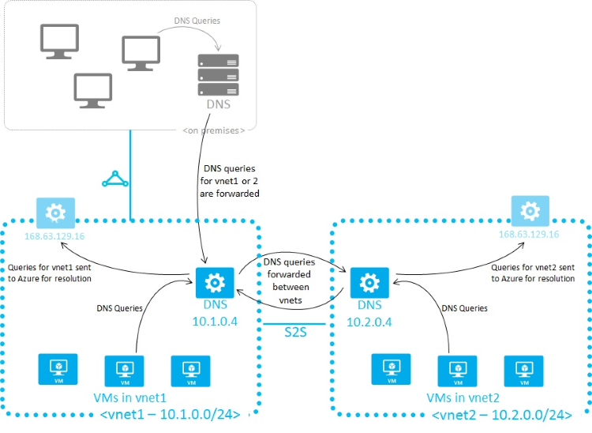

When you're using Azure-provided name resolution, Azure Dynamic Host Configuration Protocol (DHCP) provides an internal DNS suffix (**.internal.cloudapp.net**) to each VM. This suffix enables host name resolution because the host name records are in the **internal.cloudapp.net** zone. When you're using your own name resolution solution, this suffix isn't supplied to VMs because it interferes with other DNS architectures (like domain-joined scenarios). Instead, Azure provides a nonfunctioning placeholder (reddog.microsoft.com).

If necessary, you can determine the internal DNS suffix by using PowerShell or the API:

* For virtual networks in Azure Resource Manager deployment models, the suffix is available via the [network interface REST API](https://learn.microsoft.com/en-us/rest/api/virtualnetwork/networkinterfaces), the [Get-AzNetworkInterface](https://learn.microsoft.com/en-us/powershell/module/az.network/get-aznetworkinterface) PowerShell cmdlet, and the [az network nic show](https://learn.microsoft.com/en-us/cli/azure/network/nic#az-network-nic-show) Azure CLI command.

If forwarding queries to Azure doesn't suit your needs, provide your own DNS solution or deploy an [Azure DNS Private Resolver](https://learn.microsoft.com/en-us/azure/dns/dns-private-resolver-overview).

If you provide your own DNS solution, it needs to:

* Provide appropriate host name resolution, via [DDNS](https://learn.microsoft.com/en-us/azure/virtual-network/virtual-networks-name-resolution-ddns), for example. If you're using DDNS, you might need to disable DNS record scavenging. Azure DHCP leases are long, and scavenging might remove DNS records prematurely.
* Provide appropriate recursive resolution to allow resolution of external domain names.
* Be accessible (TCP and UDP on port 53) from the clients it serves, and be able to access the internet.
* Be secured against access from the internet, to mitigate threats posed by external agents.

Note

* For best performance, when you're using Azure VMs as DNS servers, IPv6 should be disabled.
* NSGs act as firewalls for your DNS resolver endpoints. You should modify or override your NSG security rules to allow access for UDP Port 53 (and optionally TCP Port 53) to your DNS listener endpoints. Once custom DNS servers are set on a network, then the traffic through port 53 will bypass the NSG's of the subnet.

Important

If you're using Windows DNS Servers as Custom DNS Servers forwarding DNS requests to Azure DNS Servers, make sure you increase the Forwarding Timeout value more than 4 seconds to allow Azure Recursive DNS Servers to perform proper recursion operations.

## Web apps

Suppose you need to perform name resolution from your web app built by using App Service, linked to a virtual network, to VMs in the same virtual network. In addition to setting up a custom DNS server that has a DNS forwarder that forwards queries to Azure (virtual IP 168.63.129.16), perform the following steps:

Enable virtual network integration for your web app, if not done already, as described in [Integrate your app with a virtual network](https://learn.microsoft.com/en-us/azure/app-service/overview-vnet-integration?toc=/azure/virtual-network/toc.json).

If you need to perform name resolution from your vnet-linked web app (built by using App Service) to VMs in a different vnet that is **not linked** to the same private zone, use custom DNS servers or [Azure DNS Private Resolvers](https://learn.microsoft.com/en-us/azure/dns/dns-private-resolver-overview) on both vnets.

To use custom DNS servers:

* Set up a DNS server in your target virtual network, on a VM that can also forward queries to the recursive resolver in Azure (virtual IP 168.63.129.16). An example DNS forwarder is available in the [Azure Quickstart Templates gallery](https://azure.microsoft.com/resources/templates/dns-forwarder/) and [GitHub](https://github.com/Azure/azure-quickstart-templates/tree/master/demos/dns-forwarder).
* Set up a DNS forwarder in the source virtual network on a VM. Configure this DNS forwarder to forward queries to the DNS server in your target virtual network.
* Configure your source DNS server in your source virtual network's settings.
* Enable virtual network integration for your web app to link to the source virtual network, following the instructions in [Integrate your aquerypp with a virtual network](https://learn.microsoft.com/en-us/azure/app-service/overview-vnet-integration?toc=/azure/virtual-network/toc.json).

## Specify DNS servers

When you're using your own DNS servers, Azure enables you to specify multiple DNS servers per virtual network. You can also specify multiple DNS servers per network interface (for Azure Resource Manager), or per cloud service (for the classic deployment model). DNS servers specified for a network interface or cloud service get precedence over DNS servers specified for the virtual network.

# Azure DNS metrics and alerts

Azure DNS is a hosting service for DNS domains that provides name resolution using the Microsoft Azure infrastructure. This article describes metrics and alerts for the Azure DNS service.

## Azure DNS metrics

Azure DNS provides metrics for you to monitor specific aspects of your DNS zones. With the metrics in Azure DNS, you can configure alerting based on conditions that are met. The metrics provided use the [Azure Monitor service](https://learn.microsoft.com/en-us/azure/azure-monitor/) to display the data. For more information on the Metrics Explorer experience and charting, see [Azure Monitor Metrics Explorer](https://learn.microsoft.com/en-us/azure/azure-monitor/essentials/metrics-charts).

Azure DNS provides the following metrics to Azure Monitor for your DNS zones:

* QueryVolume
* RecordSetCount
* RecordSetCapacityUtilization

## Query volume

The *Query Volume* metric shows the number of DNS queries received by Azure DNS for your DNS zone. The unit of measurement is Count and the aggregation is the Sum of all the queries received over a period of time.

To view this metric, select **Metrics** explorer experience from the **Monitor** page in the Azure portal. Scope down to your DNS zone and then select **Apply**. In the drop-down for *Metrics*, selectQuery Volume, and then select Sum from the drop-down for *Aggregation*.

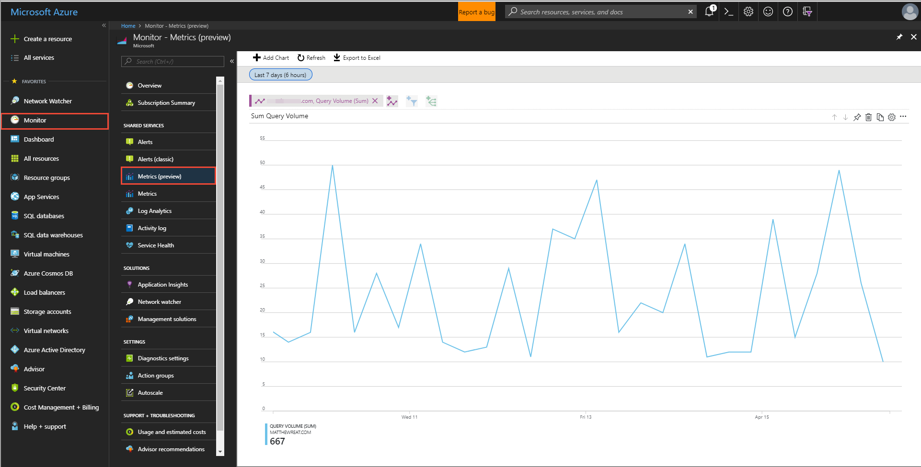

*Figure: Azure DNS Query Volume metrics*

## Record Set Count

The *Record Set Count* metric shows the number of Record sets in Azure DNS for your DNS zone. All the Record sets defined in your zone are counted. The unit of measurement is Count and the aggregation is the Maximum of all the Record sets.

To view this metric, select **Metrics** explorer experience from the **Monitor** tab in the Azure portal. Scope down to your DNS zone and then select **Apply**. In the drop-down for *Metrics*, select Query Volume, and then select Sum from the drop-down for *Aggregation*.

Select your DNS zone from the **Resource** drop-down, select the **Record Set Count** metric, and then select **Max** as the **Aggregation**.

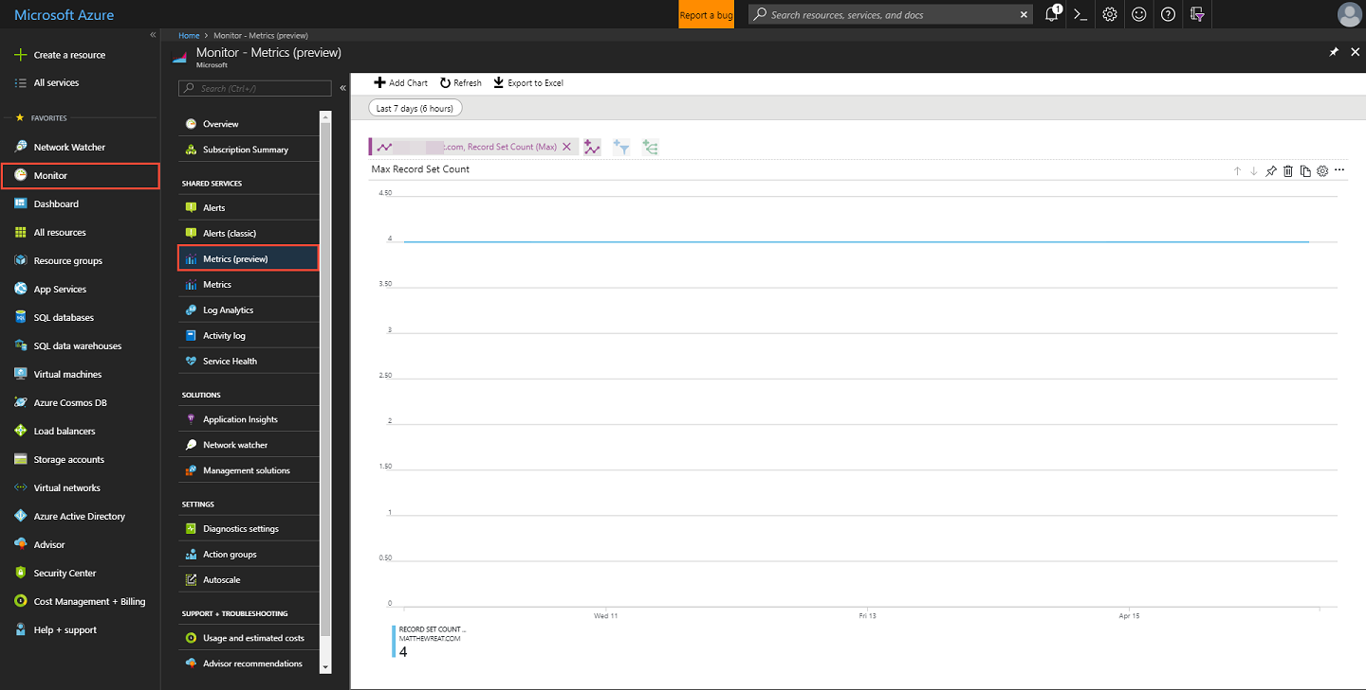

*Figure: Azure DNS Record Set Count metrics*

## Record Set Capacity Utilization

The *Record Set Capacity Utilization* metric shows the percentage used of your Record set capacity for a DNS Zone. Each Azure DNS zone has a Recordset limit that defines the maximum number of Record sets allowed for the zone. For more information, see [DNS limits](https://learn.microsoft.com/en-us/azure/dns/dns-zones-records#limits) section. The unit of measurement is a Percentage and the aggregation type is Maximum.

For example, if you have 500 Record sets configured in your DNS zone, and the zone has the default Record set limit of 5000. The RecordSetCapacityUtilization metric will show the value of 10%, which is obtained by dividing 500 by 5000.

To view this metric, select **Metrics** explorer experience from the **Monitor** tab in the Azure portal. Scope down to your DNS zone and then select **Apply**. In the drop-down for *Metrics*, select Record Set Capacity Utilization, and then select Sum from the drop-down for *Aggregation*.

## Alerts in Azure DNS

Azure Monitor has alerting that you can configure for each available metric value. For more information, see [Azure Monitor alerts](https://learn.microsoft.com/en-us/azure/azure-monitor/alerts/alerts-metric).

1. To configure alerting for Azure DNS zones, select Alerts from Monitor page in the Azure portal. Then select + New alert rule.

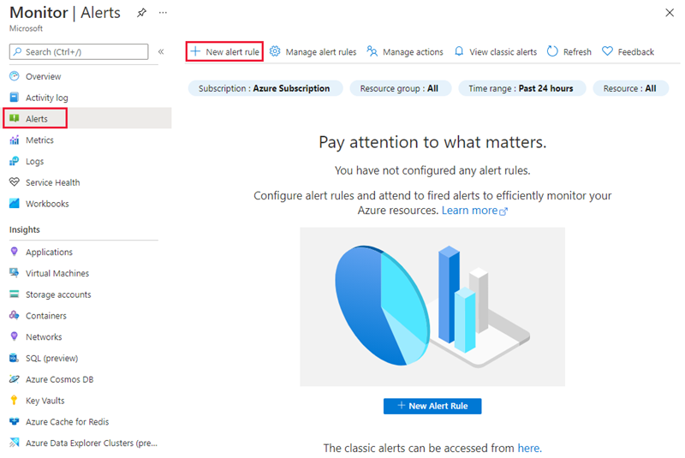

1. Click the Select resource link in the Scope section to open the Select a resource page. Filter by DNS zones and then select the Azure DNS zone you want as the target resource. Select Done once you've chosen the zone.

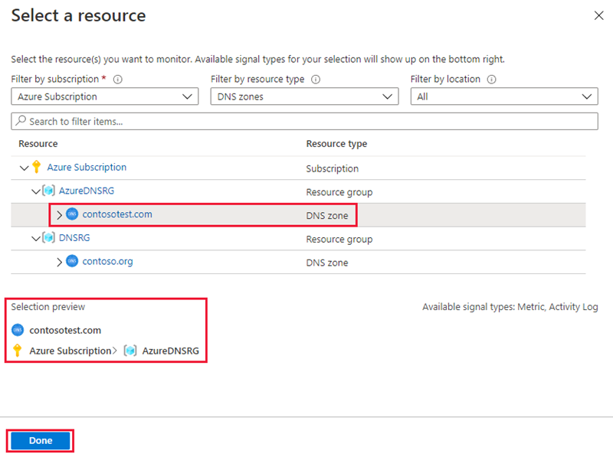

1. Next, click the Add condition link in the Conditions section to open the Select a signal page. Select one of the three Metric signal types you want to configure the alert for.

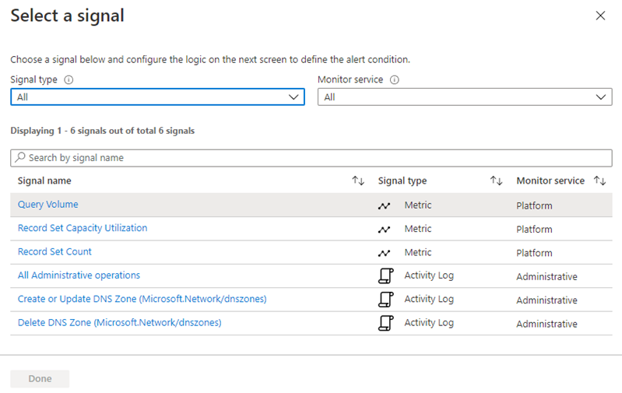

1. On the Configure signal logic page, configure the threshold and frequency of evaluation for the metric selected.

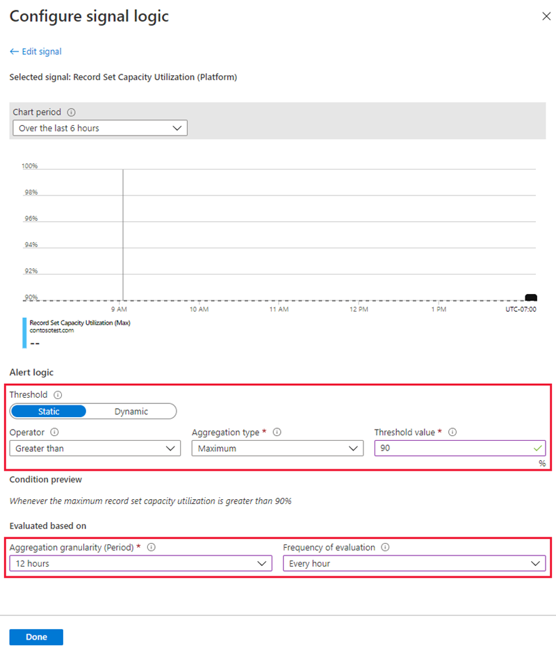

1. To send a notification or invoke an action triggered by the alert, click the Add action groups. On the Add action groups page, select + Create action group. For more information, see [Action Group](https://learn.microsoft.com/en-us/azure/azure-monitor/alerts/action-groups).
2. Enter an Alert rule name then select Create alert rule to save your configuration.

